Appendix

Current and Future Use and Costs for Long-Term Services and Supports among People Age 65 and Older in Minnesota

LTSS Projections Study, Phase 2 Report

Prepared by:
Greg Arling and Zachary Hass, Purdue University
Mark Woodhouse and Lynn Blewett, University of Minnesota

Draft June 5, 2025

Table of Contents
Table of Contents 2
Tables and Figures 2
LTSS Population 6
Users of Nursing Facility Care while Not Enrolled in Medicaid 6
Older Participants in the Disability Waiver 6
Gaps in Information about Private Sources of LTSS 6
Racial and Ethnic Categories 7
Major Variables and Data Sources 7
LTSS Program and Setting 7
Demographic Characteristics and Functional Need of the Older LTSS Population 7
LTSS Services and Medicaid Payments 8
Population Projections for Minnesota’s Older Population 2025-2035. 8
Study Time Periods 9
Analysis Strategies 9

Tables and Figures
Table A.1 Monthly Deaths/1000 LTSS Users by LTSS Type (averaged across calendar quarters) 14
Table A.2 Number and Percentage of Monthly LTSS Users by Age Group, Gender and Period 17
Table A.3 Monthly LTSS Users per Year in 2016-2023 by LTSS Category, Age, and Gender 20
Table A.4 Minnesota Total Population by Age and Gender 24
Table A.5 Rate of Monthly LTSS Use per 1,000 People in the Population by LTSS Setting and Program, Age, and Gender by Year 25
Table A.6 Pre-COVID Period (2018-2019) Average Annual Users and Medicaid Payments by LTSS Service, Age, and Gender 29
Table A.7 Post-COVID Period (2022) Average Annual Users and Medicaid Payments by LTSS Service , Age, and Gender 36
Table A.8 Transition Pattern Between LTSS Subgroups Observed in the Data 43
Table A.9 DHS Forecast Numbers used in Cost to Medicaid and Cost to Medicaid Growth Assumptions by Year and LTSS subgroup 69

Figure A 1. Elderly Waiver Community to Death Time to Transition Distribution 44
Figure A 2. Elderly Waiver Community to Elderly Waiver Residential Time to Transition Distribution 44
Figure A 3. Elderly Waiver Community to Medicaid Nursing Facility Time to Transition Distribution 45
Figure A 4. Elderly Waiver Community to Medicaid without LTSS Time to Transition Distribution 45
Figure A 5. Elderly Waiver Community to Personal Care Assistant without Waiver Time to Transition Distribution 46
Figure A 6. Elderly Waiver Community to Alternative Care Time to Transition Distribution 46
Figure A 7. Elderly Waiver Residential to Death Time to Transition Distribution 47
Figure A 8. Elderly Waiver Residential to Elderly Waiver Community Time to Transition Distribution 47
Figure A 9. Elderly Waiver Residential to Medicaid Nursing Facility Time to Transition Distribution 48
Figure A 10. Elderly Waiver Residential to Medicaid without LTSS Time to Transition Distribution 48
Figure A 11. Medicaid Nursing Facility (91+ Day Stay) to Death Time to Transition Distribution 49
Figure A 12. Medicaid Nursing Facility (91+ Day Stay) to Elderly Waiver Community Time to Transition Distribution 49
Figure A 13. Medicaid Nursing Facility (91+ Day Stay) to Elderly Waiver Residential Time to Transition Distribution 50
Figure A 14. Medicaid Nursing Facility (91+ Day Stay) to Medicaid without LTSS Time to Transition Distribution 50
Figure A 15. Medicaid Nursing Facility (91+ Day Stay) to Personal Care Assistant without a Waiver Time to Transition Distribution 51
Figure A 16. Medicaid Nursing Facility (91+ Day Stay) to Alternative Care Time to Transition Distribution 51
Figure A 17. Medicaid without LTSS to Death Time to Transition Distribution 52
Figure A 18. Medicaid without LTSS to Elderly Waiver Community Time to Transition Distribution 52
Figure A 19. Medicaid without LTSS to Elderly Waiver Residential Time to Transition Distribution 53
Figure A 20. Medicaid without LTSS to Medicaid Nursing Facility Time to Transition Distribution 53
Figure A 21. Medicaid without LTSS to Personal Care Assistant without a Waiver Time to Transition Distribution 54
Figure A 22. Medicaid without LTSS to Alternative Care Time to Transition Distribution 54
Figure A 23 Personal Care Assistant without a Waiver to Death Time to Transition Distribution 55
Figure A 24 Personal Care Assistant without a Waiver to Elderly Waiver Community Time to Transition Distribution 55
Figure A 25 Personal Care Assistant without a Waiver to Elderly Waiver Residential Time to Transition Distribution 56
Figure A 26 Personal Care Assistant without a Waiver to Medicaid without LTSS Time to Transition Distribution 56
Figure A 27 Personal Care Assistant without a Waiver to Alternative Care Time to Transition Distribution 57
Figure A 28 Alternative Care to Death Time to Transition Distribution 57
Figure A 29 Alternative Care Time to Elderly Waiver Community Time to Transition Distribution 58
Figure A 30 Alternative Care Time to Elderly Waiver Residential Time to Transition Distribution 58
Figure A 31 Alternative Care Time to Medicaid Nursing Facility Time to Transition Distribution 59
Figure A 32 Alternative Care Time to Medicaid without LTSS Time to Transition Distribution 59
Figure A 33 Alternative Care Time to Personal Care Assistant without Waiver Time to Transition Distribution 60
Figure A 34 Alternative Care Time to Non-Medicaid Nursing Facility Time to Transition Distribution 60
Figure A 35 Alternative Care Time to Non-Medicaid no LTSS Time to Transition Distribution 61
Figure A 36 Non-Medicaid Nursing Facility (91+ Day Stay) to Death Transition Distribution 61
Figure A 37 Non-Medicaid Nursing Facility (91+ Day Stay) to Elderly Waiver Residential Time to Transition Distribution 62
Figure A 38 Non-Medicaid Nursing Facility (91+ Day Stay) to Medicaid Nursing Facility Time to Transition Distribution 62
Figure A 39 Non-Medicaid Nursing Facility (91+ Day Stay) to Medicaid no LTSS Time to Transition Distribution 63
Figure A 40 Non-Medicaid Nursing Facility (91+ Day Stay) to Alternative Care Time to Transition Distribution 63
Figure A 41 Non-Medicaid Nursing Facility (91+ Day Stay) to Non-Medicaid no LTSS Time to Transition Distribution 64
Figure A 42 Non-Medicaid no LTSS to Death Time to Transition Distribution 64
Figure A 43 Non-Medicaid no LTSS to Elderly Waiver Community Time to Transition Distribution 65
Figure A 44 Non-Medicaid no LTSS to Elderly Waiver Residential Time to Transition Distribution 65
Figure A 45 Non-Medicaid no LTSS to Medicaid Nursing Facility Time to Transition Distribution 66
Figure A 46 Non-Medicaid no LTSS to Medicaid no LTSS Time to Transition Distribution 66
Figure A 47 Non-Medicaid no LTSS to Personal Care without a Waiver Time to Transition Distribution 67
Figure A 48. Non-Medicaid no LTSS to Alternative Care Time to Transition Distribution 67
Figure A 49 Non-Medicaid no LTSS to Non-Medicaid Nursing Facility Time to Transition Distribution 68
Figure A 50. Assumed Monthly Nursing Facility Users per 1 Million Population for Females Age 65-74 across Scenarios 70
Figure A 51. Assumed Monthly Nursing Facility Users per 1 Million Population for Females Age 75-84 across Scenarios 71
Figure A 52. Assumed Monthly Nursing Facility Users per 1 Million Population for Females Age 85 and above across Scenarios 73
Figure A 53. Assumed Monthly Nursing Facility Users per 1 Million Population for Males Age 65-74 across Scenarios 74
Figure A 54. Assumed Monthly Nursing Facility Users per 1 Million Population for Males Age 75-84 across Scenarios 76
Figure A 55. Assumed Monthly Nursing Facility Users per 1 Million Population for Males Age 85 and above across Scenarios 77
Figure A 56. Projected Monthly User Count by Scenario (Usage Rate*Population): Elderly Waiver Community 79
Figure A 57. Projected Monthly User Count by Scenario (Usage Rate*Population): Elderly Waiver Residential 79
Figure A 58. Projected Monthly User Count by Scenario (Usage Rate*Population): Medicaid Nursing Facility 0-29 Day Stay 79
Figure A 59. Projected Monthly User Count by Scenario (Usage Rate*Population):Medicaid Nursing Facility 30-90 Day Stay 80
Figure A 60. Projected Monthly User Count by Scenario (Usage Rate*Population): Medicaid Nursing Facility Stay of 91 or more days 80
Figure A 61. Projected Monthly User Count by Scenario (Usage Rate*Population): Personal Care Assistant without Waiver 81
Figure A 62. Projected Monthly User Count by Scenario (Usage Rate*Population): Alternative Care 81
Figure A 63. Projected Monthly User Count by Scenario (Usage Rate*Population): Nursing Facility Stay of 0-29 Days 82
Figure A 64. Projected Monthly User Count by Scenario (Usage Rate*Population): Nursing Facility Stay of 30-90 Days 83
Figure A 65. Projected Monthly User Count by Scenario (Usage Rate*Population): Nursing Facility Stay of 91 or more Days 83

LTSS Population
The study covers Minnesota’s older LTSS population which consists of people aged 65 and older who have used LTSS or demonstrate a need for this care, and for whom we have available data. The population consists of Medicaid and non-Medicaid nursing facility (NF) users, Medicaid Elderly Waiver (EW) program participants (EW – Assisted Living, EW – HCBS), Alternative Care waiver participants, and a Medicaid Personal Care Assistant without a waiver. The population is divided into these categories representing types of LTSS that are referred to throughout the report.
- Nursing facility residents enrolled in Medicaid.
- Nursing facility residents NOT enrolled in Medicaid, includes all other nursing facility residents.
- Medicaid Elderly Waiver - Assisted Living – residents of assisted living facilities who receive a package of Medicaid LTSS through the Elderly Waiver (primarily Customized Living).
- Medicaid Elderly Waiver - Home and Community – home and community-based services for people living in a non-residential setting (not in nursing facility or assisted living). These services include adult day services, chore services, homemaker, personal care, home delivered meals, and consumer-directed community supports.
- Medicaid Personal Care Assistant (PCA) without a Waiver – care from a personal care assistant outside of an Elderly Waiver program.
- Alternative Care (AC) – Medicaid waiver program which provides Medicaid-funded, non-residential HCBS to older people not enrolled in Medicaid but who meet financial eligibility criteria in a limited range above the Medicaid threshold.

Users of Nursing Facility Care while Not Enrolled in Medicaid
Although the LTSS population can be broadly defined to include users of all types of nursing facility care, findings regarding Medicaid LTSS costs exclude nursing facility residents who were not enrolled in Medicaid because no cost data were available for them. However, we track these individuals and include them in utilization and cost analysis if they become Medicaid enrolled while in the nursing home, assisted living, or a community setting.

Older Participants in the Disability Waiver
People aged 65 and older participating in a Disability Waiver were excluded from the analysis. They have significantly different characteristics and service use patterns than Elderly Waiver participants or other members of the LTSS population. Although it would have been informative to conduct a sub-group analysis of the older disabled population, it was not feasible within the scope of the study or available resources.

Gaps in Information about Private Sources of LTSS
We have a gap in data on people aged 65 and older who have significant long-term care needs but who have no history of nursing facility use or enrollment in Medicaid. They may be receiving care in the community exclusively through family or other informal sources, formal HCBS that is paid for privately, or privately paid for assisted living, memory center, or other residential setting. We also do not have information about care received for privately paying nursing facility users if they return to a community setting without becoming enrolled in Medicaid.

Racial and Ethnic Categories
The racial and ethnic categories in the report (described below) are based on information collected through the Medicaid administrative system. These categories are the same as those used in the US Census. We recognize that designations for “race” and “ethnicity” are overly simplistic. The concept of race has a questionable biological foundation. Even as cultural categorization, race is an anachronism. Moreover, there are important social and cultural differences between people in each of the arbitrarily defined racial and ethnic categories. A major limitation of the study is our inability to consider the rich cultural differences among ethnic groups.

Major Variables and Data Sources

LTSS Program and Setting
The LTSS population was categorized into mutually exclusive programs and settings for ease of analysis. These categories (also listed above) are nursing facility (Medicaid or non-Medicaid); Medicaid Elderly Waiver – Assisted Living; Medicaid Elderly Waiver – Home and Community; Medicaid Personal Care Assistant (PCA) without a waiver; and Alternative Care waiver. The Medicaid claims and other administrative files from the Medicaid Management Information System (MMIS) were used to categorize Medicaid enrollees (see Appendix – Chapter 2 Methods), while the Nursing Home Minimum Data Set (MDS) was the major source of information about nursing facility residents not Medicaid enrolled. Information on Medicaid enrollment came from Medicaid enrollment files.

Demographic Characteristics and Functional Need of the Older LTSS Population
Information on demographic characteristics and functional needs of individual members of the LTSS are drawn from the MMIS, MNChoices Long-Term Care Screening Document, or nursing home Minimum Data Set (MDS). Demographic characteristics came from the MMIS for Medicaid enrollees and MDS for nursing facility residents not enrolled in Medicaid. Information on functional needs came from the MDS for people with a nursing facility stay, while information for users of Medicaid waiver services or PCA came from the MNChoices screening document. The two sources required harmonization because the MDS and MNChoices screening documents use a similar but not exact set of items.
Demographic Characteristics
- Age
- Gender
- Race/ethnicity -White non-Hispanic, Black/African American, Asian or Pacific Islander, American Indian or Alaska native, Hispanic, Multiple races/ethnicities
- Urban or rural county of residence: Twin Cities, other metropolitan area, or rural

Functional Needs
- Dependency in activities of daily living: extensive assistance or total dependence in eating, bed mobility, transferring, walking, toileting, bathing, dressing, and grooming (MDS and MNChoices)
- Cognitive status – diagnosis of Alzheimer’s disease or other dementia (MDS or MMIS), impaired cognition (MNChoices), or moderate to severe cognitive impairment on the Cognitive Functional Scale (MDS).
- Behaviorally challenged – frequent history of behavioral symptoms (MNChoices) or overall presence of behavioral symptoms (MDS)

LTSS Services and Medicaid Payments
Minnesota’s MMIS was the primary source of information on LTSS service use and Medicaid payments. The individual categories of service for the individual Medicaid claims were grouped into the following categories.
- Nursing Facilities (COS 89 and 122)
- Elderly Waiver Assisted Living Facility (customized living COS 108)
- Elderly Waiver Home and Community-Based Services (HCBS) – adult day services (COS 102), chore services (COS 93), home delivered meals (COS 95), personal care (COS 38), homemaker (COS 96), and consumer-directed community supports (COS 21).
- Personal Care Assistant outside of an Elderly Waiver (COS 119)
- Home Health and Skilled Nursing (COS 89, 122, 20, and 114)
- Hospice (COS 72)
- Case Management (COS 44 and 71)
- Access Services (COS 100)
Service category definitions can be found in Minnesota DHS Provider Manual.

Population Projections for Minnesota’s Older Population 2025-2039.
Annual state demographic projections by age and gender for 2025-2039 (May 2024 projections), were downloaded from the Minnesota State Demographic Center.

Study Time Periods
The study had four major time periods:
We began with a Pre-COVID period from 2016 to 2019. We chose this period because the available data were consistent over this period, it allowed enough time to assess multiyear trends in LTSS, and it represented the LTSS experience prior to disruption caused by the COVID-19 pandemic.
The COVID period from 2020 to 2021 took into account changes in LTSS taking place during the peak years of the COVID-19 pandemic.
The Post-COVID period from 2022 to June 2024 represented use of care and costs to Medicaid during the 30 months following the approximate end of the pandemic.
The straight-line projections of LTSS use and costs to Medicaid covered the period from 2025 to 2035. The micro-simulations included an additional 5 years from 2035 to 2039 for cohorts beginning in 2035.

Analysis Strategies
We conducted both cross-sectional and longitudinal/cohort analyses. The cross-sectional analyses describe characteristics of the LTSS population and their use of care at a point in time, such as January 1 of each year, or on average during a month, calendar quarter or year. In the longitudinal analysis we followed individuals from a specific time point to a future time point, such as the month they entered LTSS until they died or the data period ended.
We tracked their use of different types of LTSS, Medicaid conversion, and survival. Chapter 3 of the main report presents findings from a combination of cross-sectional and longitudinal analyses. We draw comparisons between quarterly, annual and period cross-sections. We also report on care outcomes tracked longitudinally. The figures presented in Chapters 3 are mainly in the form of descriptive graphics (line or bar graphs) or tables. The micro-simulations relied on multivariable statistical analysis, semi-Markov transition modeling, and survival analysis.
Straight Line Projections
The straight-line projections of future LTSS service use and payments, reported in the LTSS Projections Phase 2 Report , took place in steps.
- Calculate the average annual per person months of Medicaid LTSS use and average monthly payments for users of LTSS by age group (age 65-74, 75-84, and 85 and older) and categories of service in the baseline period of 2016-2019.
- Estimate the annual rate of Medicaid LTSS use per 1000 persons by age group in the Minnesota population in 2019.
- Apply the annual rates of LTSS use to the annual population projections from 2025-2035, to estimate the annual number of user months for LTSS.
- Using patterns of LTSS service use during the Baseline, allocate the projected increase in total user months across categories of service to project the total user months of LTSS services per year from 2025-2035.
- Estimate annual projected Medicaid payments by multiplying average monthly payments for LTSS services during the Baseline period by projected months of future LTSS services, then adjust future payments for rates of LTSS cost inflation.
The Micro-Simulation
The micro-simulation used the data described above to build models of the movement of individuals between different LTSS subgroups. The models were trained to learn the patterns of how likely individuals were to move between specific subgroups and given that they were going between two specific subgroups, how many months the transition tends to take. Multinomial logistic regression models which adjusted for individual characteristics were used to model transition patterns. Right skewed probability distributions were used to model the amount of time individuals took to transition.
The micro-simulation generated case histories for LTSS utilization beginning in 2025, 2030, and 2035 and extending for 5 years each. Simulations were organized around two main questions: How do the assumptions around usage rates impact the number of users and costs to Medicaid? How would expanding the AC program in terms of number of users impact overall Medicaid usage, costs to Medicaid, and privately paid nursing facility usage?

The usage rate question comprised three scenarios:
- Base Case assuming LTSS usage rates would remain and post-COVID levels (2022-June 2023).
- A return to the pre-COVID level of LTSS usage rates (2019), which began at the post-COVID rates and returned linearly to the pre-COVID rates over a 10 year period (blended scenario).
- The nursing facility decline scenario assumed a decline in nursing facility usage rates (estimated from observed data) and a shift to other LTSS settings, which were the two main changes observed during the pandemic.
Case histories were generated under the base case (150 full simulations). Each simulation was bootstrapped to follow the assumed usage rates under the three scenarios and summarized across simulations for the final results.
The AC expansion question was comprised of 7 scenarios which tested questions about the size of the expansion and the effect of the LTSS subgroups from which new enrollees were drawn:
- Base case with no AC expansion and post-COVID usage rates.
- 100 additional AC enrollees per year with 70% drawn from individuals with no prior nursing facility use, 15% from individuals discharged from the nursing facility to the community and not enrolled in Medicaid, and 15% from individuals currently in the nursing facility.
- 150 additional AC enrollees per year with 70% drawn from individuals with no prior nursing facility use, 15% from individuals discharged from the nursing facility to the community and not enrolled in Medicaid, and 15% from individuals currently in the nursing facility.
- 300 additional AC enrollees per year with 70% drawn from individuals with no prior nursing facility use, 15% from individuals discharged from the nursing facility to the community and not enrolled in Medicaid, and 15% from individuals currently in the nursing facility.
- 100 additional AC enrollees per year with 25% drawn from individuals with no prior nursing facility use, 35% from individuals discharged from the nursing facility to the community and not enrolled in Medicaid, and 40% from individuals currently in the nursing facility.
- 150 additional AC enrollees per year with 25% drawn from individuals with no prior nursing facility use, 35% from individuals discharged from the nursing facility to the community and not enrolled in Medicaid, and 40% from individuals currently in the nursing facility.
- 300 additional AC enrollees per year with 25% drawn from individuals with no prior nursing facility use, 35% from individuals discharged from the nursing facility to the community and not enrolled in Medicaid, and 40% from individuals currently in the nursing facility.

The number of individuals and the age and gender group distributions in each future year are based on population projections. Each cohort within each scenario was simulated 150 times and results were summarized by mean. Costs to Medicaid are based on averages for each LTSS subgroup and inflated annual using assumptions based on DHS forecasts.

Panel A.1 Number of Average Monthly LTSS Users by Calendar Quarter
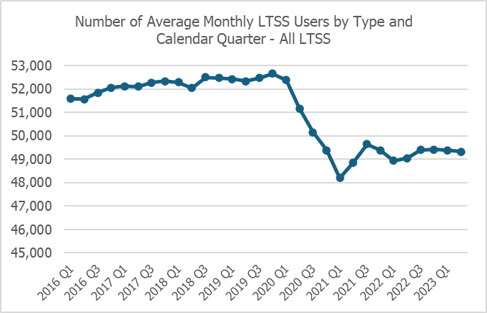
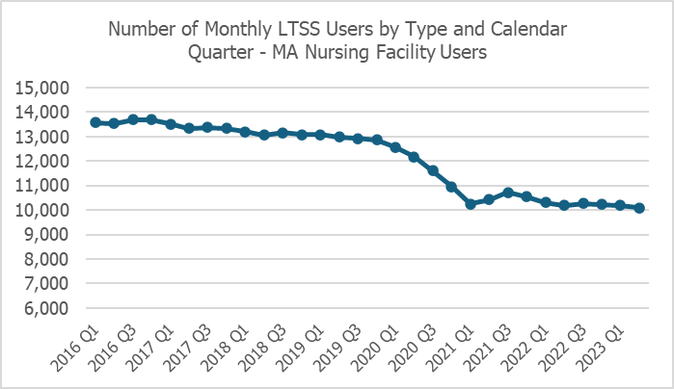
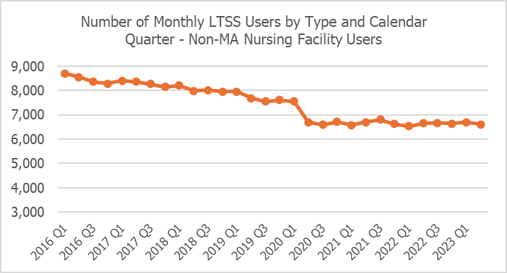
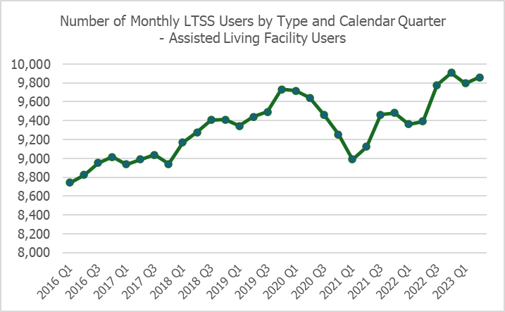
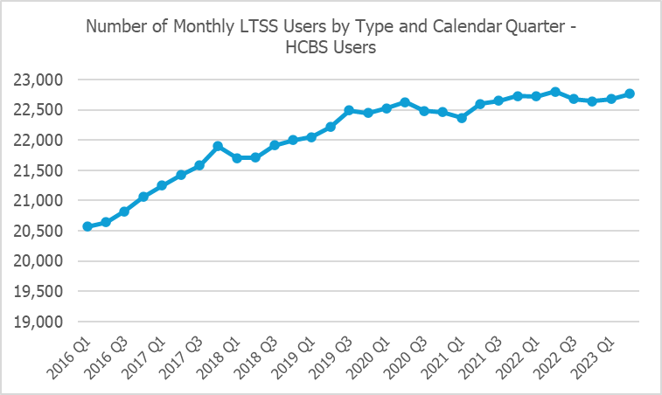
Note: HCBS = Home and community-based services Elderly Waiver (Community), Alternative Care or PCA

Table A.1 Monthly Deaths/1000 LTSS Users by LTSS Type (averaged across calendar quarters)
Abbreviations
MA NF = Medicaid resident in a nursing facility
ALF = Medicaid resident in assisted living facility with an Elderly Waiver
HCBS = Home and community-based services Elderly Waiver (Community), Alternative Care or PCA
Non-MA NF = Non-Medicaid resident in a nursing facility

Calendar  Quarter | MA NF  Deaths | MA NF  Residents | MA NF  Deaths/1000 | ALF  Deaths | ALF  Residents | MA ALF  Deaths/1000
2016.1 | 467 | 13,566 | 34 | 114 | 8,742 | 13
2016.2 | 400 | 13,541 | 30 | 104 | 8,824 | 12
2016.3 | 403 | 13,695 | 29 | 113 | 8,953 | 13
2016.4 | 481 | 13,689 | 35 | 128 | 9,015 | 14
2017.1 | 530 | 13,521 | 39 | 134 | 8,937 | 15
2017.2 | 408 | 13,342 | 31 | 126 | 8,989 | 14
2017.3 | 411 | 13,372 | 31 | 109 | 9,037 | 12
2017.4 | 444 | 13,330 | 33 | 134 | 8,939 | 15
2018.1 | 496 | 13,201 | 38 | 148 | 9,167 | 16
2018.2 | 381 | 13,062 | 29 | 113 | 9,275 | 12
2018.3 | 404 | 13,160 | 31 | 112 | 9,408 | 12
2018.4 | 439 | 13,092 | 34 | 146 | 9,413 | 16
2019.1 | 464 | 13,076 | 36 | 133 | 9,345 | 14
2019.2 | 392 | 12,981 | 30 | 127 | 9,439 | 13
2019.3 | 415 | 12,935 | 32 | 117 | 9,494 | 12
2019.4 | 456 | 12,868 | 35 | 157 | 9,734 | 16
2020.1 | 471 | 12,575 | 37 | 147 | 9,716 | 15
2020.2 | 511 | 12,185 | 42 | 170 | 9,643 | 18
2020.3 | 356 | 11,610 | 31 | 151 | 9,461 | 16
2020.4 | 569 | 10,960 | 52 | 220 | 9,253 | 24
2021.1 | 288 | 10,260 | 28 | 125 | 8,988 | 14
2021.2 | 240 | 10,429 | 23 | 111 | 9,124 | 12
2021.3 | 328 | 10,730 | 31 | 146 | 9,462 | 15
2021.4 | 386 | 10,551 | 37 | 181 | 9,484 | 19
2022.1 | 344 | 10,315 | 33 | 168 | 9,361 | 18
2022.2 | 312 | 10,190 | 31 | 144 | 9,394 | 15
2022.3 | 291 | 10,270 | 28 | 146 | 9,777 | 15
2022.4 | 377 | 10,235 | 37 | 174 | 9,908 | 18
2023.1 | 342 | 10,201 | 33 | 168 | 9,795 | 17
2023.2 | 322 | 10,124 | 32 | 144 | 9,854 | 15

Table A.1 (cont.) Monthly Deaths/1000 LTSS Users by LTSS Type (averaged across calendar quarters)
Year.  Quarter | HCBS  Deaths | HBCS Users | HCBS Death/  1000 | Non-MA NF Deaths | Non-MA NF  Residents | Non-MA NF Deaths/  1000 | Total LTSS Deaths | Total LTSS | Total LTSS Deaths/  1000
2016.1 | 132 | 20,566 | 6 | 435 | 8,702 | 50 | 1,149 | 51,576 | 22
2016.2 | 106 | 20,641 | 5 | 414 | 8,552 | 48 | 1,024 | 51,559 | 20
2016.3 | 105 | 20,823 | 5 | 404 | 8,366 | 48 | 1,024 | 51,837 | 20
2016.4 | 112 | 21,058 | 5 | 432 | 8,289 | 52 | 1,154 | 52,051 | 22
2017.1 | 126 | 21,247 | 6 | 430 | 8,405 | 51 | 1,221 | 52,110 | 23
2017.2 | 120 | 21,420 | 6 | 391 | 8,355 | 47 | 1,045 | 52,107 | 20
2017.3 | 111 | 21,584 | 5 | 386 | 8,274 | 47 | 1,017 | 52,268 | 19
2017.4 | 122 | 21,899 | 6 | 410 | 8,159 | 50 | 1,110 | 52,327 | 21
2018.1 | 140 | 21,702 | 6 | 442 | 8,211 | 54 | 1,225 | 52,282 | 23
2018.2 | 116 | 21,712 | 5 | 363 | 7,991 | 45 | 973 | 52,041 | 19
2018.3 | 109 | 21,914 | 5 | 386 | 8,013 | 48 | 1,012 | 52,494 | 19
2018.4 | 126 | 22,000 | 6 | 422 | 7,960 | 53 | 1,132 | 52,464 | 22
2019.1 | 111 | 22,048 | 5 | 409 | 7,952 | 51 | 1,117 | 52,422 | 21
2019.2 | 116 | 22,216 | 5 | 377 | 7,689 | 49 | 1,012 | 52,326 | 19
2019.3 | 104 | 22,491 | 5 | 365 | 7,552 | 48 | 1,002 | 52,471 | 19
2019.4 | 128 | 22,444 | 6 | 383 | 7,609 | 50 | 1,124 | 52,655 | 21
2020.1 | 133 | 22,529 | 6 | 406 | 7,552 | 54 | 1,156 | 52,372 | 22
2020.2 | 159 | 22,628 | 7 | 423 | 6,706 | 63 | 1,264 | 51,162 | 25
2020.3 | 130 | 22,486 | 6 | 337 | 6,591 | 51 | 975 | 50,148 | 19
2020.4 | 181 | 22,462 | 8 | 476 | 6,707 | 71 | 1,447 | 49,383 | 29
2021.1 | 133 | 22,365 | 6 | 384 | 6,580 | 58 | 931 | 48,193 | 19
2021.2 | 117 | 22,598 | 5 | 368 | 6,706 | 55 | 835 | 48,857 | 17
2021.3 | 130 | 22,648 | 6 | 322 | 6,801 | 47 | 926 | 49,642 | 19
2021.4 | 192 | 22,727 | 8 | 393 | 6,616 | 59 | 1,153 | 49,379 | 23
2022.1 | 176 | 22,719 | 8 | 352 | 6,534 | 54 | 1,040 | 48,929 | 21
2022.2 | 138 | 22,800 | 6 | 336 | 6,654 | 50 | 930 | 49,037 | 19
2022.3 | 147 | 22,680 | 6 | 324 | 6,668 | 49 | 909 | 49,395 | 18
2022.4 | 160 | 22,642 | 7 | 370 | 6,631 | 56 | 1,080 | 49,417 | 22
2023.1 | 142 | 22,680 | 6 | 362 | 6,702 | 54 | 1,014 | 49,378 | 21
2023.2 | 119 | 22,725 | 5 | 340 | 6,600 | 51 | 923 | 49,303 | 19

Table A.2 Number and Percentage of Monthly LTSS Users by Age Group, Gender and Period
Abbreviations
MA NF = Medicaid resident in a nursing facility
ALF = Medicaid resident in assisted living facility with an Elderly Waiver
HCBS = Home and community-based services Elderly Waiver (Community), Alternative Care or PCA
Non-MA NF = Non-Medicaid resident in a nursing facility

Table A.2.1 Number Monthly LTSS Users by Age Group and Period
 |  | Pre-COVID  (2016-2019) | COVID  (2020-2021) | Post-COVID (2022-2023)
MA NF | Age 65-74 | 1,806 | 1,706 | 1,631
 | Age75-84 | 3,511 | 3,243 | 3,187
 | Age 85+ | 8,169 | 6,213 | 5,411
 | Total | 13,486 | 11,163 | 10,228
ALF | Age 65-74 | 911 | 1,028 | 1,142
 | Age75-84 | 2,833 | 3,135 | 3,443
 | Age 85+ | 5,631 | 5,229 | 5,086
 | Total | 9,375 | 9,391 | 9,671
HCBS | Age 65-74 | 6,811 | 7,041 | 6,895
 | Age75-84 | 9,124 | 9,491 | 9,719
 | Age 85+ | 6,152 | 6,024 | 6,092
 | Total | 22,086 | 22,556 | 22,707
Non-MA NF | Age 65-74 | 720 | 623 | 588
 | Age75-84 | 1,821 | 1,674 | 1,779
 | Age 85+ | 5,726 | 4,485 | 4,267
 | Total | 8,268 | 6,782 | 6,633
All LTSS | Age 65-74 | 10,249 | 10,398 | 10,256
 | Age75-84 | 17,289 | 17,544 | 18,128
 | Age 85+ | 25,678 | 21,950 | 20,855
 | Total | 53,215 | 49,892 | 49,240

Table A.2.2. Percentage of Monthly LTSS Users by Age Group and Period
 |  | Pre-COVID  (2016-2019) | COVID  (2020-2021) | Post-COVID (2022-2023)
MA NF | Age 65-74 | 13% | 15% | 16%
 | Age75-84 | 26% | 29% | 31%
 | Age 85+ | 61% | 56% | 53%
 | Total | 100% | 100% | 100%
ALF | Age 65-74 | 10% | 11% | 12%
 | Age75-84 | 30% | 33% | 36%
 | Age 85+ | 60% | 56% | 53%
 | Total | 100% | 100% | 100%
HCBS | Age 65-74 | 31% | 31% | 30%
 | Age75-84 | 41% | 42% | 43%
 | Age 85+ | 28% | 27% | 27%
 | Total | 100% | 100% | 100%
Non-MA NF | Age 65-74 | 9% | 9% | 9%
 | Age75-84 | 22% | 25% | 27%
 | Age 85+ | 69% | 66% | 64%
 | Total | 100% | 100% | 100%
All LTSS | Age 65-74 | 19% | 21% | 21%
 | Age75-84 | 32% | 35% | 37%
 | Age 85+ | 48% | 44% | 42%
 | Total | 100% | 100% | 100%

Table A.2.3. Number of LTSS Users by Gender and Period
 |  | Pre-COVID  (2016-2019) | COVID  (2020-2021) | Post-COVID (2022-2023)
MA NF | Male | 4,108 | 3,646 | 3,412
 | Female | 9,371 | 7,512 | 6,813
 | Total | 13,479 | 11,157 | 10,225
ALF | Male | 2,300 | 2,521 | 2,760
 | Female | 7,072 | 6,869 | 6,910
 | Total | 9,372 | 9,390 | 9,670
HCBS | Male | 6,823 | 7,173 | 7,362
 | Female | 15,262 | 15,381 | 15,344
 | Total | 22,085 | 22,553 | 22,706
Non-MA NF | Male | 3,185 | 2,763 | 2,735
 | Female | 5,080 | 4,019 | 3,898
 | Total | 8,265 | 6,782 | 6,633
All LTSS | Male | 16,417 | 16,102 | 16,269
 | Female | 36,785 | 33,781 | 32,965
 | Total | 53,201 | 49,883 | 49,234

Table A.2.4. Percentage of LTSS Users by Gender and Period
 |  | Pre-COVID  (2016-2019) | COVID  (2020-2021) | Post-COVID (2022-2023)
MA NF | Male | 30% | 33% | 33%
 | Female | 70% | 67% | 67%
 | Total | 100% | 100% | 100%
ALF | Male | 25% | 27% | 29%
 | Female | 75% | 73% | 71%
 | Total | 100% | 100% | 100%
HCBS | Male | 31% | 32% | 32%
 | Female | 69% | 68% | 68%
 | Total | 100% | 100% | 100%
Non-MA NF | Male | 39% | 41% | 41%
 | Female | 61% | 59% | 59%
 | Total | 100% | 100% | 100%
All LTSS | Male | 31% | 32% | 33%
 | Female | 69% | 68% | 67%
 | Total | 100% | 100% | 100%

Table A.3 Monthly LTSS Users per Year in 2016-2023 by LTSS Category, Age, and Gender
Nursing Facility Medicaid Residents
Male | 65-74 | 75-84 | 85+ | Total
2016 | 1,040 | 1,340 | 1,378 | 3,757
2017 | 1,112 | 1,397 | 1,351 | 3,861
2018 | 1,142 | 1,470 | 1,347 | 3,959
2019 | 1,218 | 1,524 | 1,317 | 4,058
2020 | 1,163 | 1,400 | 1,197 | 3,760
2021 | 1,086 | 1,239 | 980 | 3,305
2022 | 1,090 | 1,261 | 963 | 3,314
2023 | 1,111 | 1,302 | 944 | 3,358
Female | 65-74 | 75-84 | 85+ | Total
2016 | 1,284 | 2,479 | 5,854 | 9,617
2017 | 1,255 | 2,448 | 5,587 | 9,290
2018 | 1,215 | 2,463 | 5,243 | 8,921
2019 | 1,225 | 2,482 | 4,937 | 8,643
2020 | 1,159 | 2,334 | 4,343 | 7,836
2021 | 1,129 | 2,068 | 3,757 | 6,955
2022 | 1,127 | 2,101 | 3,520 | 6,748
2023 | 1,135 | 2,171 | 3,397 | 6,702
Total | 65-74 | 75-84 | 85+ | Total
2016 | 2,324 | 3,819 | 7,231 | 13,374
2017 | 2,367 | 3,845 | 6,939 | 13,151
2018 | 2,356 | 3,934 | 6,590 | 12,880
2019 | 2,442 | 4,006 | 6,254 | 12,702
2020 | 2,321 | 3,734 | 5,540 | 11,595
2021 | 2,215 | 3,307 | 4,737 | 10,259
2022 | 2,217 | 3,362 | 4,483 | 10,061
2023 | 2,246 | 3,473 | 4,341 | 10,060

Assisted Living Facility Residents
Male | 65-74 | 75-84 | 85+ | Total
2016 | 579 | 812 | 718 | 2,109
2017 | 595 | 847 | 713 | 2,155
2018 | 636 | 921 | 742 | 2,299
2019 | 675 | 950 | 775 | 2,400
2020 | 745 | 966 | 784 | 2,495
2021 | 823 | 975 | 749 | 2,547
2022 | 893 | 1,081 | 760 | 2,734
2023 | 931 | 1,135 | 763 | 2,828
Female | 65-74 | 75-84 | 85+ | Total
2016 | 910 | 2,082 | 3,777 | 6,770
2017 | 912 | 2,163 | 3,741 | 6,817
2018 | 966 | 2,331 | 3,718 | 7,014
2019 | 987 | 2,415 | 3,699 | 7,101
2020 | 1,015 | 2,410 | 3,597 | 7,022
2021 | 1,052 | 2,326 | 3,337 | 6,716
2022 | 1,070 | 2,483 | 3,322 | 6,875
2023 | 1,068 | 2,609 | 3,320 | 6,997
Total | 65-74 | 75-84 | 85+ | Total
2016 | 1,490 | 2,894 | 4,495 | 8,879
2017 | 1,507 | 3,010 | 4,454 | 8,971
2018 | 1,601 | 3,252 | 4,460 | 9,313
2019 | 1,662 | 3,365 | 4,474 | 9,501
2020 | 1,760 | 3,377 | 4,381 | 9,517
2021 | 1,875 | 3,301 | 4,086 | 9,263
2022 | 1,963 | 3,563 | 4,083 | 9,609
2023 | 1,999 | 3,744 | 4,083 | 9,826

HCBS - Elderly Waiver – Community, Alternative Care or PCA
Male | 65-74 | 75-84 | 85+ | Total
2016 | 2,647 | 2,380 | 1,017 | 6,044
2017 | 2,845 | 2,466 | 1,048 | 6,359
2018 | 2,947 | 2,541 | 1,080 | 6,569
2019 | 3,049 | 2,625 | 1,105 | 6,779
2020 | 3,080 | 2,666 | 1,130 | 6,876
2021 | 3,229 | 2,619 | 1,133 | 6,981
2022 | 3,369 | 2,655 | 1,175 | 7,199
2023 | 3,467 | 2,702 | 1,179 | 7,348
Female | 65-74 | 75-84 | 85+ | Total
2016 | 5,669 | 5,315 | 3,154 | 14,138
2017 | 5,913 | 5,467 | 3,173 | 14,553
2018 | 5,985 | 5,550 | 3,042 | 14,577
2019 | 6,172 | 5,674 | 2,989 | 14,835
2020 | 6,177 | 5,782 | 3,016 | 14,974
2021 | 6,129 | 5,857 | 2,990 | 14,976
2022 | 6,120 | 6,052 | 2,961 | 15,133
2023 | 6,110 | 6,197 | 2,945 | 15,252
Total | 65-74 | 75-84 | 85+ | Total
2016 | 8,316 | 7,695 | 4,170 | 20,182
2017 | 8,758 | 7,932 | 4,221 | 20,912
2018 | 8,932 | 8,091 | 4,122 | 21,146
2019 | 9,222 | 8,299 | 4,094 | 21,614
2020 | 9,257 | 8,448 | 4,145 | 21,851
2021 | 9,358 | 8,475 | 4,124 | 21,957
2022 | 9,489 | 8,707 | 4,136 | 22,332
2023 | 9,577 | 8,899 | 4,124 | 22,600

Nursing Facility – Non-Medicaid Residents
Male | 65-74 | 75-84 | 85+ | Total
2016 | 485 | 968 | 16,26 | 3,079
2017 | 525 | 989 | 16,20 | 3,135
2018 | 537 | 972 | 15,73 | 3,082
2019 | 578 | 953 | 15,52 | 3,083
2020 | 520 | 874 | 13,72 | 2,766
2021 | 550 | 903 | 12,54 | 2,707
2022 | 496 | 941 | 12,61 | 2,698
2023 | 499 | 999 | 12,83 | 2,781
Female | 65-74 | 75-84 | 85+ | Total
2016 | 471 | 1,331 | 3,543 | 5,345
2017 | 467 | 1,319 | 3,326 | 5,111
2018 | 486 | 1,275 | 3,147 | 4,908
2019 | 458 | 1,206 | 2,901 | 4,565
2020 | 400 | 1,063 | 2,610 | 4,073
2021 | 438 | 1,063 | 2,423 | 3,924
2022 | 428 | 1,073 | 2,399 | 3,900
2023 | 439 | 1,076 | 2,343 | 3,858
Total | 65-74 | 75-84 | 85+ | Total
2016 | 956 | 2,298 | 5,169 | 8,424
2017 | 992 | 2,309 | 4,946 | 8,247
2018 | 1,023 | 2,247 | 4,720 | 7,990
2019 | 1,036 | 2,159 | 4,453 | 7,648
2020 | 920 | 1,937 | 3,982 | 6,839
2021 | 988 | 1,966 | 3,677 | 6,630
2022 | 925 | 2,014 | 3,660 | 6,598
2023 | 938 | 2,075 | 3,627 | 6,639

Table A.4 Minnesota Total Population by Age and Gender
Male | 65-74 | 75-84 | 85+ | Total
2016 | 226,843 | 105,731 | 41,358 | 373,932
2017 | 237,014 | 109,258 | 42,074 | 388,346
2018 | 245,564 | 114,772 | 43,031 | 403,367
2019 | 255,839 | 119,359 | 44,007 | 419,205
2020 | 269,806 | 119,246 | 40,327 | 429,379
2021 | 281,218 | 121,670 | 40,661 | 443,549
2022 | 286,520 | 131,042 | 40,968 | 458,530
2023 | 294,083 | 138,430 | 42,031 | 474,544
Female | 65-74 | 75-84 | 85+ | Total
2016 | 244,500 | 133,240 | 78,018 | 455,758
2017 | 255,183 | 136,355 | 78,461 | 469,999
2018 | 264,231 | 142,249 | 78,647 | 485,127
2019 | 275,220 | 147,354 | 78,603 | 501,177
2020 | 283,769 | 144,839 | 73,351 | 501,959
2021 | 295,234 | 147,507 | 73,282 | 516,023
2022 | 300,717 | 157,574 | 73,295 | 531,586
2023 | 309,060 | 165,561 | 74,082 | 548,703
Total | 65-74 | 75-84 | 85+ | Total
2016 | 471,343 | 238,971 | 119,376 | 829,690
2017 | 492,197 | 245,613 | 120,535 | 858,345
2018 | 509,795 | 257,021 | 121,678 | 888,494
2019 | 531,059 | 266,713 | 122,610 | 920,382
2020 | 553,575 | 264,085 | 113,678 | 931,338
2021 | 576,452 | 269,177 | 113,943 | 959,572
2022 | 587,237 | 288,616 | 114,263 | 990,116
2023 | 603,143 | 303,991 | 116,113 | 1,023,247

Table A.5 Rate of Monthly LTSS Use per 1,000 People in the Population by LTSS Setting and Program, Age, and Gender by Year
Nursing Facility – Medicaid Residents
Male | 65-74 | 75-84 | 85+ | Total
2016 | 4.6 | 12.7 | 33.3 | 10.0
2017 | 4.7 | 12.8 | 32.1 | 9.9
2018 | 4.6 | 12.8 | 31.3 | 9.8
2019 | 4.8 | 12.8 | 29.9 | 9.7
2020 | 4.3 | 11.7 | 29.7 | 8.8
2021 | 3.9 | 10.2 | 24.1 | 7.5
2022 | 3.8 | 9.6 | 23.5 | 7.2
2023 | 3.8 | 9.4 | 22.5 | 7.1
Female | 65-74 | 75-84 | 85+ | Total
2016 | 5.3 | 18.6 | 75.0 | 21.1
2017 | 4.9 | 18.0 | 71.2 | 19.8
2018 | 4.6 | 17.3 | 66.7 | 18.4
2019 | 4.5 | 16.8 | 62.8 | 17.2
2020 | 4.1 | 16.1 | 59.2 | 15.6
2021 | 3.8 | 14.0 | 51.3 | 13.5
2022 | 3.7 | 13.3 | 48.0 | 12.7
2023 | 3.7 | 13.1 | 45.8 | 12.2
Total | 65-74 | 75-84 | 85+ | Total
2016 | 4.9 | 16.0 | 60.6 | 16.1
2017 | 4.8 | 15.7 | 57.6 | 15.3
2018 | 4.6 | 15.3 | 54.2 | 14.5
2019 | 4.6 | 15.0 | 51.0 | 13.8
2020 | 4.2 | 14.1 | 48.7 | 12.4
2021 | 3.8 | 12.3 | 41.6 | 10.7
2022 | 3.8 | 11.6 | 39.2 | 10.2
2023 | 3.7 | 11.4 | 37.4 | 9.8

Assisted Living Facility
Male | 65-74 | 75-84 | 85+ | Total
2016 | 2.6 | 7.7 | 17.3 | 5.6
2017 | 2.5 | 7.7 | 16.9 | 5.5
2018 | 2.6 | 8.0 | 17.3 | 5.7
2019 | 2.6 | 8.0 | 17.6 | 5.7
2020 | 2.8 | 8.1 | 19.4 | 5.8
2021 | 2.9 | 8.0 | 18.4 | 5.7
2022 | 3.1 | 8.2 | 18.6 | 6.0
2023 | 3.2 | 8.2 | 18.1 | 6.0
Female | 65-74 | 75-84 | 85+ | Total
2016 | 3.7 | 15.6 | 48.4 | 14.9
2017 | 3.6 | 15.9 | 47.7 | 14.5
2018 | 3.7 | 16.4 | 47.3 | 14.5
2019 | 3.6 | 16.4 | 47.1 | 14.2
2020 | 3.6 | 16.6 | 49.0 | 14.0
2021 | 3.6 | 15.8 | 45.5 | 13.0
2022 | 3.6 | 15.8 | 45.3 | 12.9
2023 | 3.5 | 15.8 | 44.8 | 12.8
Total | 65-74 | 75-84 | 85+ | Total
2016 | 3.2 | 12.1 | 37.7 | 10.7
2017 | 3.1 | 12.3 | 37.0 | 10.5
2018 | 3.1 | 12.7 | 36.7 | 10.5
2019 | 3.1 | 12.6 | 36.5 | 10.3
2020 | 3.2 | 12.8 | 38.5 | 10.2
2021 | 3.3 | 12.3 | 35.9 | 9.7
2022 | 3.3 | 12.3 | 35.7 | 9.7
2023 | 3.3 | 12.3 | 35.2 | 9.6

HCBS - Elderly Waiver – Community, Alternative Care or PCA
Male | 65-74 | 75-84 | 85+ | Total
2016 | 11.7 | 22.5 | 24.6 | 16.2
2017 | 12.0 | 22.6 | 24.9 | 16.4
2018 | 12.0 | 22.1 | 25.1 | 16.3
2019 | 11.9 | 22.0 | 25.1 | 16.2
2020 | 11.4 | 22.4 | 28.0 | 16.0
2021 | 11.5 | 21.5 | 27.9 | 15.7
2022 | 11.8 | 20.3 | 28.7 | 15.7
2023 | 11.8 | 19.5 | 28.0 | 15.5
Female | 65-74 | 75-84 | 85+ | Total
2016 | 23.2 | 39.9 | 40.4 | 31.0
2017 | 23.2 | 40.1 | 40.4 | 31.0
2018 | 22.6 | 39.0 | 38.7 | 30.0
2019 | 22.4 | 38.5 | 38.0 | 29.6
2020 | 21.8 | 39.9 | 41.1 | 29.8
2021 | 20.8 | 39.7 | 40.8 | 29.0
2022 | 20.4 | 38.4 | 40.4 | 28.5
2023 | 19.8 | 37.4 | 39.8 | 27.8
Total | 65-74 | 75-84 | 85+ | Total
2016 | 17.6 | 32.2 | 34.9 | 24.3
2017 | 17.8 | 32.3 | 35.0 | 24.4
2018 | 17.5 | 31.5 | 33.9 | 23.8
2019 | 17.4 | 31.1 | 33.4 | 23.5
2020 | 16.7 | 32.0 | 36.5 | 23.5
2021 | 16.2 | 31.5 | 36.2 | 22.9
2022 | 16.2 | 30.2 | 36.2 | 22.6
2023 | 15.9 | 29.3 | 35.5 | 22.1

Nursing Facility – Non-Medicaid Residents
Male | 65-74 | 75-84 | 85+ | Total
2016 | 2.1 | 9.2 | 39.3 | 8.2
2017 | 2.2 | 9.1 | 38.5 | 8.1
2018 | 2.2 | 8.5 | 36.6 | 7.6
2019 | 2.3 | 8.0 | 35.3 | 7.4
2020 | 1.9 | 7.3 | 34.0 | 6.4
2021 | 2.0 | 7.4 | 30.8 | 6.1
2022 | 1.7 | 7.2 | 30.8 | 5.9
2023 | 1.7 | 7.2 | 30.5 | 5.9
Female | 65-74 | 75-84 | 85+ | Total
2016 | 1.9 | 10.0 | 45.4 | 11.7
2017 | 1.8 | 9.7 | 42.4 | 10.9
2018 | 1.8 | 9.0 | 40.0 | 10.1
2019 | 1.7 | 8.2 | 36.9 | 9.1
2020 | 1.4 | 7.3 | 35.6 | 8.1
2021 | 1.5 | 7.2 | 33.1 | 7.6
2022 | 1.4 | 6.8 | 32.7 | 7.3
2023 | 1.4 | 6.5 | 31.6 | 7.0

Table A.6 Pre-COVID Period (2018-2019) Average Annual Users and Medicaid Payments by LTSS Service, Age, and Gender

LTSS Service | Age Category | Total Payments per Year | Total Months of LTSS Use per Year | People using the Service during the Year | Months per User | Payment per Month | Payment per User per Year
Access | Male 65-74 | $2,171,240 | 12,567 | 2,828 | 4.44 | $173 | $768
 | Male 75-84 | $1,639,730 | 11,489 | 2,618 | 4.39 | $143 | $627
 | Male 85+ | $704,429 | 5,361 | 1,383 | 3.88 | $131 | $509
 | Male Total | $4,515,399 | 29,417 | 6,829 | 4.31 | $154 | $661
 | Female 65-74 | $3,459,934 | 23,337 | 4,722 | 4.94 | $148 | $732
 | Female 75-84 | $3,108,175 | 23,029 | 4,914 | 4.69 | $135 | $632
 | Female 85+ | $1,476,403 | 13,947 | 4,062 | 3.43 | $106 | $363
 | Female Total | $8,044,512 | 60,313 | 13,698 | 4.40 | $133 | $587
 | All 65-74 | $5,631,174 | 35,904 | 7,550 | 4.76 | $157 | $746
 | All 75-84 | $4,747,905 | 34,518 | 7,532 | 4.58 | $138 | $630
 | All 85+ | $2,180,832 | 19,308 | 5,445 | 3.55 | $113 | $400
 | All Users | $12,559,910 | 89,729 | 20,527 | 4.37 | $140 | $612
Case Mgmt | Male 65-74 | $2,676,159 | 9,581 | 1,715 | 5.59 | $279 | $1,562
 | Male 75-84 | $2,987,007 | 11,528 | 1,906 | 6.05 | $259 | $1,568
 | Male 85+ | $1,747,235 | 7,368 | 1,297 | 5.68 | $237 | $1,348
 | Male Total | $7,410,401 | 28,476 | 4,918 | 5.79 | $260 | $1,507
 | Female 65-74 | $4,812,404 | 17,950 | 2,926 | 6.14 | $268 | $1,646
 | Female 75-84 | $6,619,409 | 27,208 | 4,284 | 6.35 | $243 | $1,545
 | Female 85+ | $6,885,742 | 30,451 | 5,097 | 5.98 | $226 | $1,351
 | Female Total | $18,317,555 | 75,608 | 12,307 | 6.14 | $242 | $1,489
 | All 65-74 | $7,488,563 | 27,530 | 4,641 | 5.94 | $272 | $1,615
 | All 75-84 | $9,606,417 | 38,736 | 6,190 | 6.26 | $248 | $1,552
 | All 85+ | $8,632,977 | 37,818 | 6,394 | 5.92 | $228 | $1,351
 | All Users | $25,727,956 | 104,084 | 17,224 | 6.04 | $247 | $1,494
Assisted Living Facility | Male 65-74 | $17,505,681 | 7,510 | 948 | 7.92 | $2,330 | $18,459
 | Male 75-84 | $27,125,150 | 10,940 | 1,307 | 8.37 | $2,479 | $20,756
 | Male 85+ | $21,782,538 | 9,022 | 1,105 | 8.16 | $2,413 | $19,695
 | Male Total | $66,413,369 | 27,471 | 3,360 | 8.18 | $2,416 | $19,757
 | Female 65-74 | $27,576,709 | 11,468 | 1,394 | 8.23 | $2,404 | $19,788
 | Female 75-84 | $70,356,142 | 27,973 | 3,203 | 8.73 | $2,514 | $21,959
 | Female 85+ | $114,061,510 | 44,271 | 4,936 | 8.97 | $2,577 | $23,112
 | Female Total | $211,994,360 | 83,711 | 9,532 | 8.78 | $2,532 | $22,236
 | All 65-74 | $45,082,389 | 18,977 | 2,342 | 8.11 | $2,375 | $19,249
 | All 75-84 | $97,481,292 | 38,912 | 4,510 | 8.63 | $2,504 | $21,608
 | All 85+ | $135,844,047 | 53,293 | 6,041 | 8.82 | $2,549 | $22,487
 | All Users | $278,407,729 | 111,182 | 12,892 | 8.62 | $2,503 | $21,589
In-Home Care | Male 65-74 | $14,427,105 | 28,319 | 2,562 | 11.06 | $509 | $5,633
 | Male 75-84 | $16,474,149 | 29,776 | 2,292 | 12.99 | $553 | $7,181
 | Male 85+ | $7,093,900 | 12,679 | 955 | 13.28 | $559 | $7,427
 | Male Total | $37,995,153 | 70,774 | 5,808 | 12.19 | $537 | $6,539
 | Female 65-74 | $28,532,295 | 61,488 | 5,316 | 11.57 | $464 | $5,366
 | Female 75-84 | $31,069,475 | 65,020 | 5,056 | 12.86 | $478 | $6,144
 | Female 85+ | $13,924,251 | 33,749 | 2,682 | 12.58 | $413 | $5,198
 | Female Total | $73,526,021 | 160,256 | 13,054 | 12.28 | $459 | $5,632
 | All 65-74 | $42,959,400 | 89,807 | 7,877 | 11.40 | $478 | $5,453
 | All 75-84 | $47,543,623 | 94,795 | 7,348 | 12.90 | $501 | $6,468
 | All 85+ | $21,018,151 | 46,428 | 3,637 | 12.77 | $453 | $5,784
 | All Users | $111,521,174 | 231,030 | 18,862 | 12.25 | $483 | $5,911
Home Health | Male 65-74 | $6,861,139 | 8,366 | 1,516 | 5.52 | $820 | $4,531
 | Male 75-84 | $7,888,985 | 9,546 | 1,531 | 6.24 | $826 | $5,155
 | Male 85+ | $3,751,256 | 4,742 | 834 | 5.69 | $791 | $4,501
Home Health cont’d. | Male Total | $18,501,380 | 22,654 | 3,880 | 5.84 | $817 | $4,770
 | Female 65-74 | $13,622,826 | 16,679 | 2,866 | 5.82 | $817 | $4,755
 | Female 75-84 | $17,831,205 | 21,639 | 3,512 | 6.16 | $824 | $5,078
 | Female 85+ | $13,057,791 | 15,511 | 2,882 | 5.38 | $842 | $4,530
 | Female Total | $44,511,823 | 53,829 | 9,259 | 5.81 | $827 | $4,808
 | All 65-74 | $20,483,965 | 25,045 | 4,381 | 5.72 | $818 | $4,677
 | All 75-84 | $25,720,190 | 31,185 | 5,043 | 6.18 | $825 | $5,102
 | All 85+ | $16,809,048 | 20,253 | 3,715 | 5.45 | $830 | $4,523
 | All Users | $63,013,203 | 76,483 | 13,139 | 5.82 | $824 | $4,797
PCA | Male 65-74 | $40,883,439 | 16,768 | 1,779 | 9.43 | $2,438 | $22,986
 | Male 75-84 | $33,899,101 | 14,094 | 1,386 | 10.17 | $2,405 | $24,461
 | Male 85+ | $17,303,409 | 6,677 | 605 | 11.04 | $2,592 | $28,605
 | Male Total | $92,085,950 | 37,539 | 3,770 | 9.96 | $2,453 | $24,429
 | Female 65-74 | $78,261,819 | 33,736 | 3,470 | 9.72 | $2,319 | $22,547
 | Female 75-84 | $71,917,614 | 30,026 | 2,894 | 10.38 | $2,395 | $24,852
 | Female 85+ | $42,413,410 | 15,427 | 1,442 | 10.70 | $2,749 | $29,424
 | Female Total | $192,592,843 | 79,188 | 7,805 | 10.15 | $2,432 | $24,672
 | All 65-74 | $119,145,259 | 50,504 | 5,249 | 9.62 | $2,359 | $22,696
 | All 75-84 | $105,816,715 | 44,120 | 4,280 | 10.31 | $2,398 | $24,726
 | All 85+ | $59,716,819 | 22,103 | 2,047 | 10.80 | $2,702 | $29,181
 | All Users | $284,678,792 | 116,727 | 11,575 | 10.09 | $2,439 | $24,593
Hospice | Male 65-74 | $5,243,756 | 1,024 | 386 | 2.66 | $5,115 | $13,628
 | Male 75-84 | $9,553,835 | 1,726 | 591 | 2.93 | $5,528 | $16,196
 | Male 85+ | $10,229,813 | 1,888 | 667 | 2.83 | $5,403 | $15,280
 | Male Total | $25,027,404 | 4,638 | 1,644 | 2.83 | $5,386 | $15,216
 | Female 65-74 | $7,104,980 | 1,324 | 475 | 2.79 | $5,366 | $14,988
 | Female 75-84 | $15,661,463 | 2,900 | 999 | 2.91 | $5,387 | $15,651
Hospice cont’d. | Female 85+ | $42,698,541 | 7,696 | 2,373 | 3.24 | $5,539 | $17,967
 | Female Total | $65,464,984 | 11,920 | 3,846 | 3.10 | $5,483 | $16,999
 | All 65-74 | $12,348,736 | 2,348 | 861 | 2.74 | $5,257 | $14,379
 | All 75-84 | $25,215,298 | 4,626 | 1,590 | 2.91 | $5,439 | $15,847
 | All 85+ | $52,928,354 | 9,584 | 3,039 | 3.15 | $5,512 | $17,380
 | All Users | $90,492,388 | 16,557 | 5,490 | 3.02 | $5,456 | $16,465
Nursing Facility | Male 65-74 | $87,258,429 | 13,374 | 1,966 | 6.80 | $6,517 | $44,322
 | Male 75-84 | $110,884,663 | 16,752 | 2,284 | 7.33 | $6,618 | $48,537
 | Male 85+ | $93,570,970 | 14,673 | 1,971 | 7.44 | $6,383 | $47,509
 | Male Total | $291,714,062 | 44,799 | 6,221 | 7.20 | $6,511 | $46,886
 | Female 65-74 | $99,927,471 | 14,544 | 2,325 | 6.26 | $6,870 | $42,979
 | Female 75-84 | $198,968,141 | 29,450 | 4,061 | 7.25 | $6,756 | $49,003
 | Female 85+ | $370,488,572 | 57,649 | 7,096 | 8.12 | $6,434 | $52,270
 | Female Total | $669,384,185 | 101,643 | 13,482 | 7.54 | $6,590 | $49,680
 | All 65-74 | $187,185,899 | 27,918 | 4,291 | 6.51 | $6,701 | $43,599
 | All 75-84 | $309,852,805 | 46,202 | 6,345 | 7.28 | $6,706 | $48,836
 | All 85+ | $464,059,542 | 72,321 | 9,067 | 7.98 | $6,423 | $51,234
 | All Users | $961,098,246 | 146,441 | 19,703 | 7.43 | $6,566 | $48,799
Total any Use | Male 65-74 | $177,026,947 | 97,508 | 6,031 | 16.17 | $1,815 | $29,351
 | Male 75-84 | $210,452,621 | 105,850 | 5,977 | 17.71 | $1,987 | $35,200
 | Male 85+ | $156,183,549 | 62,408 | 4,000 | 15.60 | $2,503 | $39,051
 | Male Total | $543,663,117 | 265,765 | 16,008 | 16.60 | $2,045 | $33,956
 | Female 65-74 | $263,298,438 | 180,524 | 9,906 | 18.23 | $1,458 | $26,581
 | Female 75-84 | $415,531,624 | 227,244 | 12,139 | 18.72 | $1,828 | $34,232
 | Female 85+ | $605,006,220 | 218,699 | 14,274 | 15.32 | $2,768 | $42,409
 | Female Total | $1,283,836,282 | 626,466 | 36,318 | 17.25 | $2,050 | $35,354
 | All 65-74 | $440,325,385 | 278,032 | 15,937 | 17.45 | $1,583 | $27,629
Total any Use cont’d. | All 75-84 | $625,984,246 | 333,093 | 18,116 | 18.39 | $1,879 | $34,552
 | All 85+ | $761,189,769 | 281,106 | 18,273 | 15.38 | $2,709 | $41,673
 | All Users | $1,827,499,400 | 892,231 | 52,325 | 17.05 | $2,048 | $34,926

Table A.7 Post-COVID Period (2022) Average Annual Users and Medicaid Payments by LTSS Service , Age, and Gender

LTSS Service | Age Category | Total Payments per Year | Total Months of LTSS Use per Year | People using the Service during the Year | Months per User | Payment per Month | Payment per User per Year
Access | Male 65-74 | $2,047,844 | 10,706 | 2,661 | 4.02 | $191 | $770
 | Male 75-84 | $1,486,081 | 8,517 | 2,078 | 4.10 | $174 | $715
 | Male 85+ | $684,480 | 4,094 | 1,039 | 3.94 | $167 | $659
 | Male Total | $4,218,405 | 23,317 | 5,778 | 4.04 | $181 | $730
 | Female 65-74 | $3,115,678 | 17,810 | 3,973 | 4.48 | $175 | $784
 | Female 75-84 | $2,802,079 | 17,935 | 4,130 | 4.34 | $156 | $678
 | Female 85+ | $1,264,513 | 9,339 | 2,865 | 3.26 | $135 | $441
 | Female Total | $7,182,269 | 45,084 | 10,968 | 4.11 | $159 | $655
 | All 65-74 | $5,163,521 | 28,516 | 6,634 | 4.30 | $181 | $778
 | All 75-84 | $4,288,160 | 26,452 | 6,208 | 4.26 | $162 | $691
 | All 85+ | $1,948,993 | 13,433 | 3,904 | 3.44 | $145 | $499
 | All Users | $11,400,674 | 68,401 | 16,746 | 4.08 | $167 | $681
Case Mgmt | Male 65-74 | $2,867,462 | 9,465 | 1,848 | 5.12 | $303 | $1,552
 | Male 75-84 | $2,773,623 | 10,000 | 1,786 | 5.60 | $277 | $1,553
 | Male 85+ | $1,405,298 | 5,685 | 1,066 | 5.33 | $247 | $1,318
 | Male Total | $7,046,383 | 25,150 | 4,700 | 5.35 | $280 | $1,499
 | Female 65-74 | $4,475,288 | 15,114 | 2,731 | 5.53 | $296 | $1,639
 | Female 75-84 | $6,503,307 | 24,029 | 4,054 | 5.93 | $271 | $1,604
 | Female 85+ | $5,576,653 | 22,378 | 4,213 | 5.31 | $249 | $1,324
 | Female Total | $16,555,248 | 61,521 | 10,998 | 5.59 | $269 | $1,505
 | All 65-74 | $7,342,750 | 24,579 | 4,579 | 5.37 | $299 | $1,604
 | All 75-84 | $9,276,930 | 34,029 | 5,840 | 5.83 | $273 | $1,589
 | All 85+ | $6,981,951 | 28,063 | 5,279 | 5.32 | $249 | $1,323
 | All Users | $23,601,631 | 86,671 | 15,698 | 5.52 | $272 | $1,503
Assisted Living Facility | Male 65-74 | $32,415,320 | 10,493 | 1,278 | 8.21 | $3,089 | $25,364
Assisted Living cont’d. | Male 75-84 | $40,802,866 | 12,684 | 1,441 | 8.80 | $3,217 | $28,316
 | Male 85+ | $29,246,137 | 9,032 | 1,036 | 8.72 | $3,238 | $28,230
 | Male Total | $102,464,324 | 32,209 | 3,755 | 8.58 | $3,181 | $27,287
 | Female 65-74 | $39,575,965 | 12,698 | 1,531 | 8.29 | $3,117 | $25,850
 | Female 75-84 | $95,655,783 | 29,427 | 3,296 | 8.93 | $3,251 | $29,022
 | Female 85+ | $130,709,454 | 39,663 | 4,416 | 8.98 | $3,296 | $29,599
 | Female Total | $265,941,202 | 81,788 | 9,243 | 8.85 | $3,252 | $28,772
 | All 65-74 | $71,991,285 | 23,191 | 2,809 | 8.26 | $3,104 | $25,629
 | All 75-84 | $136,458,650 | 42,111 | 4,737 | 8.89 | $3,240 | $28,807
 | All 85+ | $159,955,591 | 48,695 | 5,452 | 8.93 | $3,285 | $29,339
 | All Users | $368,405,526 | 113,997 | 12,998 | 8.77 | $3,232 | $28,343
In-Home Care | Male 65-74 | $17,689,451 | 25,449 | 2,477 | 10.27 | $695 | $7,141
 | Male 75-84 | $21,297,843 | 27,014 | 2,220 | 12.17 | $788 | $9,594
 | Male 85+ | $9,834,392 | 12,745 | 919 | 13.87 | $772 | $10,701
 | Male Total | $48,821,686 | 65,208 | 5,616 | 11.61 | $749 | $8,693
 | Female 65-74 | $32,598,865 | 51,217 | 4,687 | 10.93 | $636 | $6,955
 | Female 75-84 | $39,279,414 | 60,435 | 4,822 | 12.53 | $650 | $8,146
 | Female 85+ | $17,870,612 | 28,187 | 2,325 | 12.12 | $634 | $7,686
 | Female Total | $89,748,891 | 139,839 | 11,834 | 11.82 | $642 | $7,584
 | All 65-74 | $50,288,316 | 76,666 | 7,164 | 10.70 | $656 | $7,020
 | All 75-84 | $60,577,257 | 87,449 | 7,042 | 12.42 | $693 | $8,602
 | All 85+ | $27,705,005 | 40,932 | 3,244 | 12.62 | $677 | $8,540
 | All Users | $138,570,577 | 205,047 | 17,450 | 11.75 | $676 | $7,941
Home Health | Male 65-74 | $5,091,278 | 6,636 | 1,221 | 5.43 | $767 | $4,170
 | Male 75-84 | $5,824,109 | 7,449 | 1,249 | 5.96 | $782 | $4,663
 | Male 85+ | $2,819,980 | 3,443 | 625 | 5.51 | $819 | $4,512
 | Male Total | $13,735,367 | 17,528 | 3,095 | 5.66 | $784 | $4,438
Home Health cont’d. | Female 65-74 | $9,003,673 | 11,520 | 2,089 | 5.51 | $782 | $4,310
 | Female 75-84 | $13,944,398 | 17,645 | 2,946 | 5.99 | $790 | $4,733
 | Female 85+ | $9,259,532 | 10,838 | 2,078 | 5.22 | $854 | $4,456
 | Female Total | $32,207,603 | 40,003 | 7,113 | 5.62 | $805 | $4,528
 | All 65-74 | $14,094,951 | 18,156 | 3,310 | 5.49 | $776 | $4,258
 | All 75-84 | $19,768,507 | 25,094 | 4,195 | 5.98 | $788 | $4,712
 | All 85+ | $12,079,512 | 14,281 | 2,703 | 5.28 | $846 | $4,469
 | All Users | $45,942,969 | 57,531 | 10,208 | 5.64 | $799 | $4,501
PCA | Male 65-74 | $52,730,148 | 17,967 | 1,944 | 9.24 | $2,935 | $27,125
 | Male 75-84 | $41,470,438 | 13,635 | 1,349 | 10.11 | $3,041 | $30,742
 | Male 85+ | $22,966,373 | 7,300 | 649 | 11.25 | $3,146 | $35,387
 | Male Total | $117,166,960 | 38,902 | 3,942 | 9.87 | $3,012 | $29,723
 | Female 65-74 | $94,645,249 | 33,252 | 3,471 | 9.58 | $2,846 | $27,267
 | Female 75-84 | $93,163,159 | 31,384 | 2,958 | 10.61 | $2,968 | $31,495
 | Female 85+ | $53,561,139 | 16,305 | 1,502 | 10.86 | $3,285 | $35,660
 | Female Total | $241,369,547 | 80,941 | 7,931 | 10.21 | $2,982 | $30,434
 | All 65-74 | $147,375,397 | 51,219 | 5,415 | 9.46 | $2,877 | $27,216
 | All 75-84 | $134,633,597 | 45,019 | 4,307 | 10.45 | $2,991 | $31,259
 | All 85+ | $76,527,512 | 23,605 | 2,151 | 10.97 | $3,242 | $35,578
 | All Users | $358,536,507 | 119,843 | 11,873 | 10.09 | $2,992 | $30,198
Hospice | Male 65-74 | $6,459,849 | 984 | 348 | 2.83 | $6,565 | $18,563
 | Male 75-84 | $12,349,477 | 1,701 | 534 | 3.19 | $7,260 | $23,126
 | Male 85+ | $13,635,760 | 1,908 | 607 | 3.14 | $7,147 | $22,464
 | Male Total | $32,445,087 | 4,593 | 1,489 | 3.08 | $7,064 | $21,790
 | Female 65-74 | $8,083,677 | 1,219 | 418 | 2.92 | $6,631 | $19,339
 | Female 75-84 | $21,549,414 | 3,092 | 958 | 3.23 | $6,969 | $22,494
 | Female 85+ | $51,217,001 | 6,950 | 1,975 | 3.52 | $7,369 | $25,933
Hospice cont’d. | Female Total | $80,850,091 | 11,261 | 3,351 | 3.36 | $7,180 | $24,127
 | All 65-74 | $14,543,526 | 2,203 | 766 | 2.88 | $6,602 | $18,986
 | All 75-84 | $33,898,891 | 4,793 | 1,492 | 3.21 | $7,073 | $22,720
 | All 85+ | $64,852,761 | 8,858 | 2,582 | 3.43 | $7,321 | $25,117
 | All Users | $113,295,178 | 15,854 | 4,840 | 3.28 | $7,146 | $23,408
Nursing Facility | Male 65-74 | $107,079,490 | 12,524 | 1,855 | 6.75 | $8,550 | $57,725
 | Male 75-84 | $119,216,667 | 13,874 | 1,902 | 7.29 | $8,593 | $62,680
 | Male 85+ | $85,145,140 | 10,053 | 1,345 | 7.47 | $8,470 | $63,305
 | Male Total | $311,441,298 | 36,451 | 5,102 | 7.14 | $8,544 | $61,043
 | Female 65-74 | $117,711,616 | 13,185 | 2,045 | 6.45 | $8,928 | $57,561
 | Female 75-84 | $217,255,171 | 24,345 | 3,334 | 7.30 | $8,924 | $65,164
 | Female 85+ | $334,813,456 | 38,416 | 4,803 | 8.00 | $8,715 | $69,709
 | Female Total | $669,780,243 | 75,946 | 10,182 | 7.46 | $8,819 | $65,781
 | All 65-74 | $224,791,107 | 25,709 | 3,900 | 6.59 | $8,744 | $57,639
 | All 75-84 | $336,471,838 | 38,219 | 5,236 | 7.30 | $8,804 | $64,261
 | All 85+ | $419,958,596 | 48,469 | 6,148 | 7.88 | $8,664 | $68,308
 | All Users | $981,221,541 | 112,397 | 15,284 | 7.35 | $8,730 | $64,199
Total any Use | Male 65-74 | $226,380,844 | 94,224 | 6,540 | 14.41 | $2,403 | $34,615
 | Male 75-84 | $245,221,105 | 94,874 | 5,819 | 16.30 | $2,585 | $42,141
 | Male 85+ | $165,737,561 | 54,260 | 3,479 | 15.60 | $3,055 | $47,639
 | Male Total | $637,339,510 | 243,358 | 15,838 | 15.37 | $2,619 | $40,241
 | Female 65-74 | $309,210,011 | 156,015 | 9,731 | 16.03 | $1,982 | $31,776
 | Female 75-84 | $490,152,724 | 208,292 | 11,934 | 17.45 | $2,353 | $41,072
 | Female 85+ | $604,272,360 | 172,076 | 11,748 | 14.65 | $3,512 | $51,436
 | Female Total | $1,403,635,094 | 536,383 | 33,413 | 16.05 | $2,617 | $42,009
 | All 65-74 | $535,590,855 | 250,239 | 16,271 | 15.38 | $2,140 | $32,917
 | All 75-84 | $735,373,829 | 303,166 | 17,753 | 17.08 | $2,426 | $41,423
Total any Use cont’d. | All 85+ | $770,009,920 | 226,336 | 15,227 | 14.86 | $3,402 | $50,569
 | All Users | $2,040,974,604 | 779,741 | 49,251 | 15.83 | $2,618 | $41,440

Table A.8 Transition Pattern Between LTSS Subgroups Observed in the Data
 | Death | EWC | EWR | MA NF | MANon-LTSS | MA PCA W/O Waiver | NON-MA AC | Non-MA NF | NON-MA NON-LTSS
EWC | 26% | 0% | 34% | 26% | 12% | 2% | 0% | 0% | 0%
EWR | 38% | 36% | 0% | 20% | 6% | 0% | 0% | 0% | 0%
MA NF | 51% | 11% | 16% | 0% | 21% | 0% | 0% | 0% | 0%
MA Non-LTSS | 11% | 34% | 11% | 34% | 0% | 8% | 1% | 0% | 0%
MA PCA W/O Waiver | 14% | 39% | 1% | 6% | 39% | 0% | 0% | 0% | 0%
NON-MA AC | 16% | 4% | 9% | 6% | 17% | 2% | 0% | 20% | 26%
Non-MA NF | 20% | 0% | 0% | 5% | 0% | 0% | 1% | 0% | 75%
NON-MA NON-LTSS | 19% | 2% | 4% | 1% | 7% | 0% | 3% | 64% | 0%
MA NF = Medicaid enrolled and residing in a Nursing Facility. EWR = Elderly Waiver Residential (primarily assisted living). EWC = Elderly Waiver living in Community setting. AC = Alternative Care. PCA = Personal Car Assistant not enrolled in a waiver program. NOT-MA NF = not Medicaid enrolled while residing in a Nursing Facility. LTSS = Long Term Services and Supports.

Figure A 1. Elderly Waiver Community to Death Time to Transition Distribution
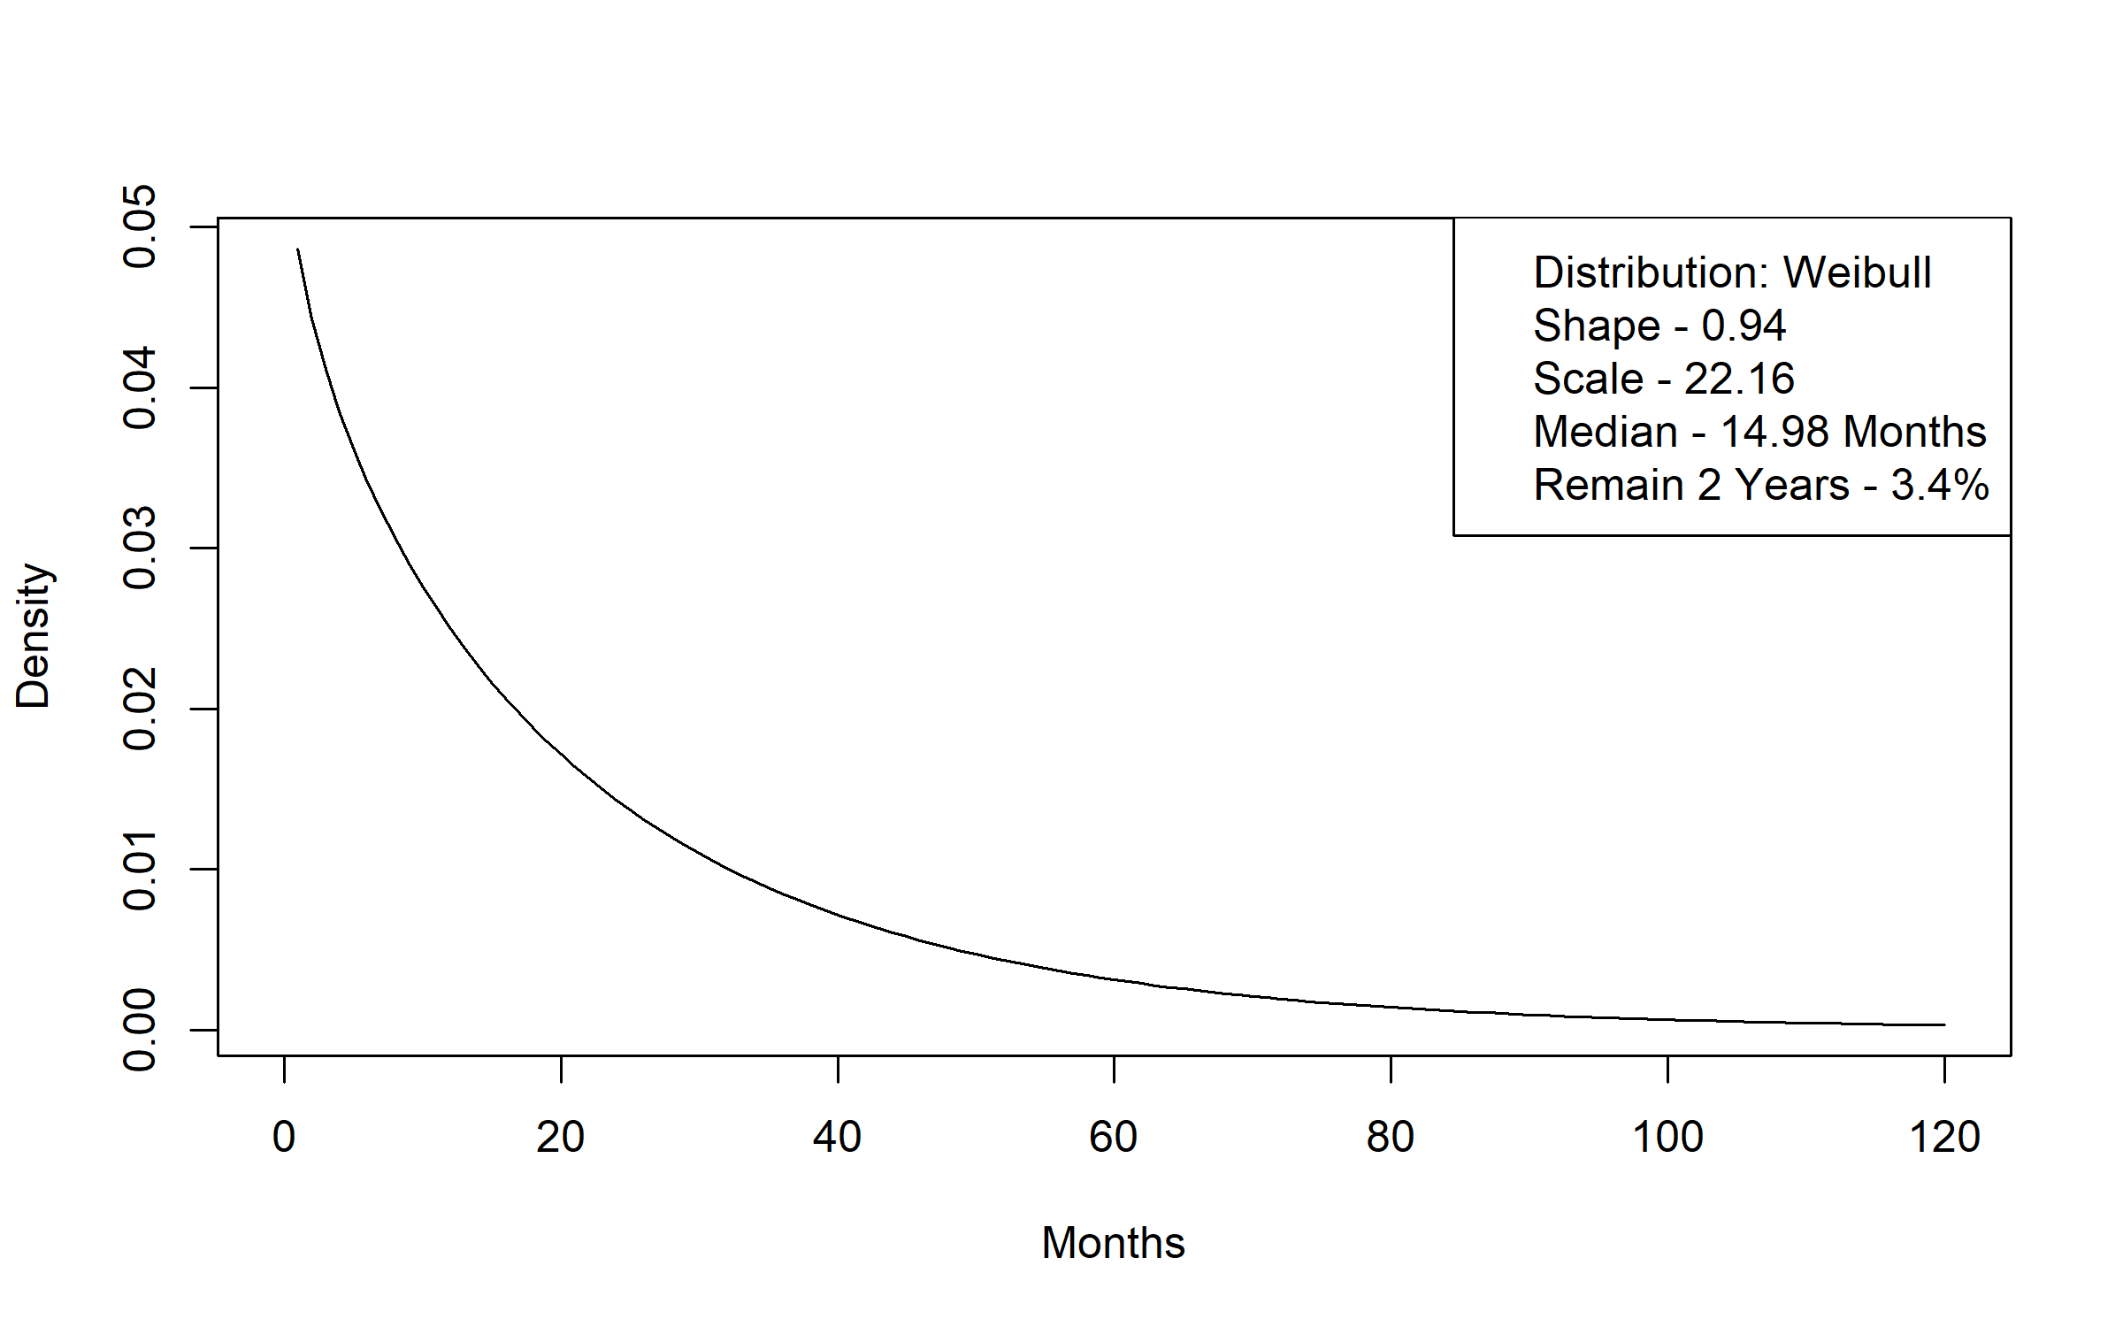
Figure A 2. Elderly Waiver Community to Elderly Waiver Residential Time to Transition Distribution
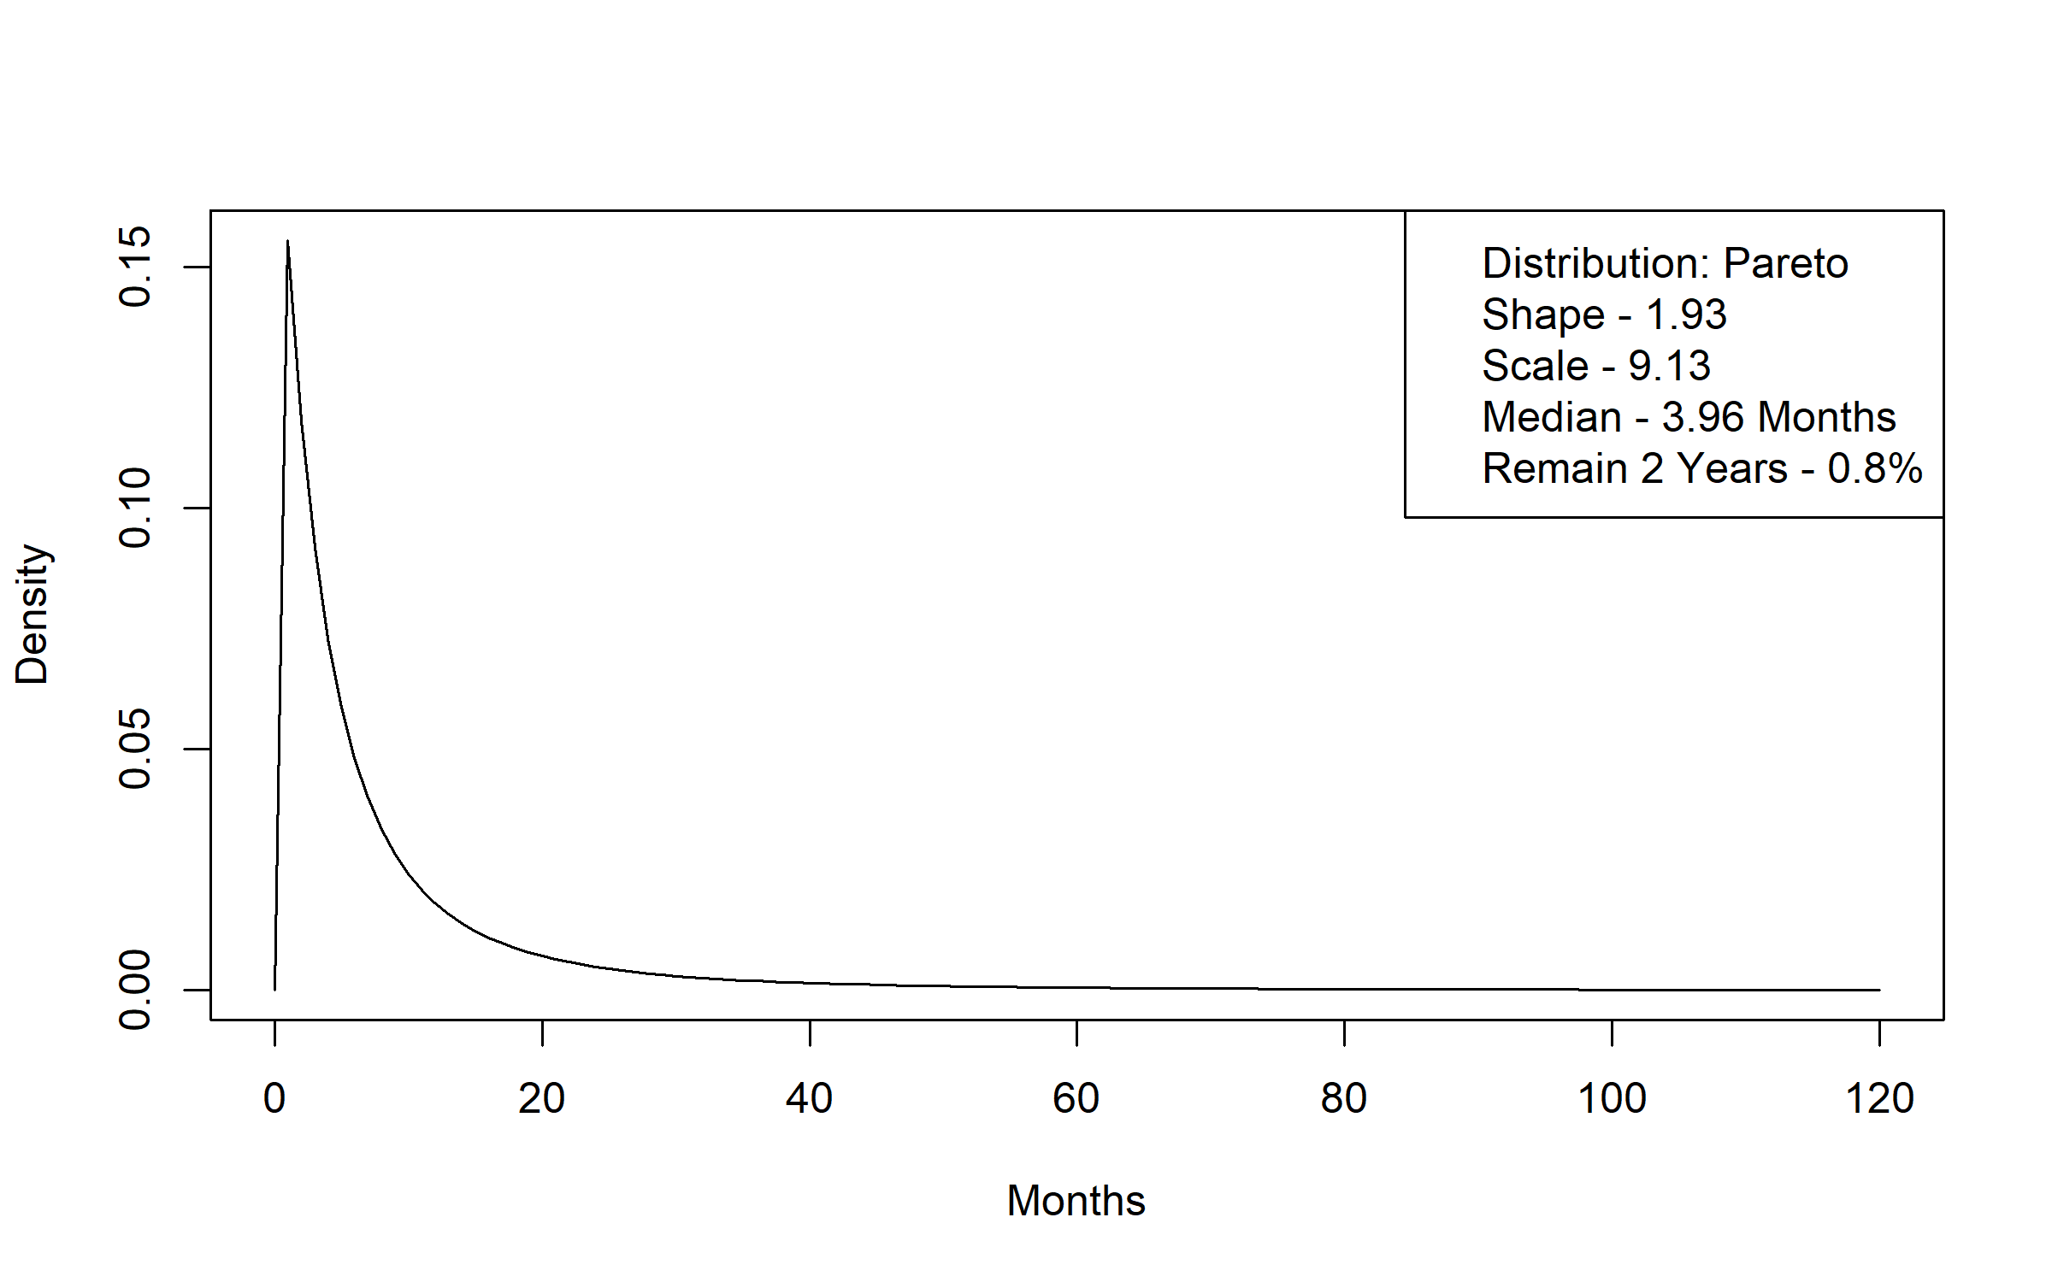
Figure A 3. Elderly Waiver Community to Medicaid Nursing Facility Time to Transition Distribution
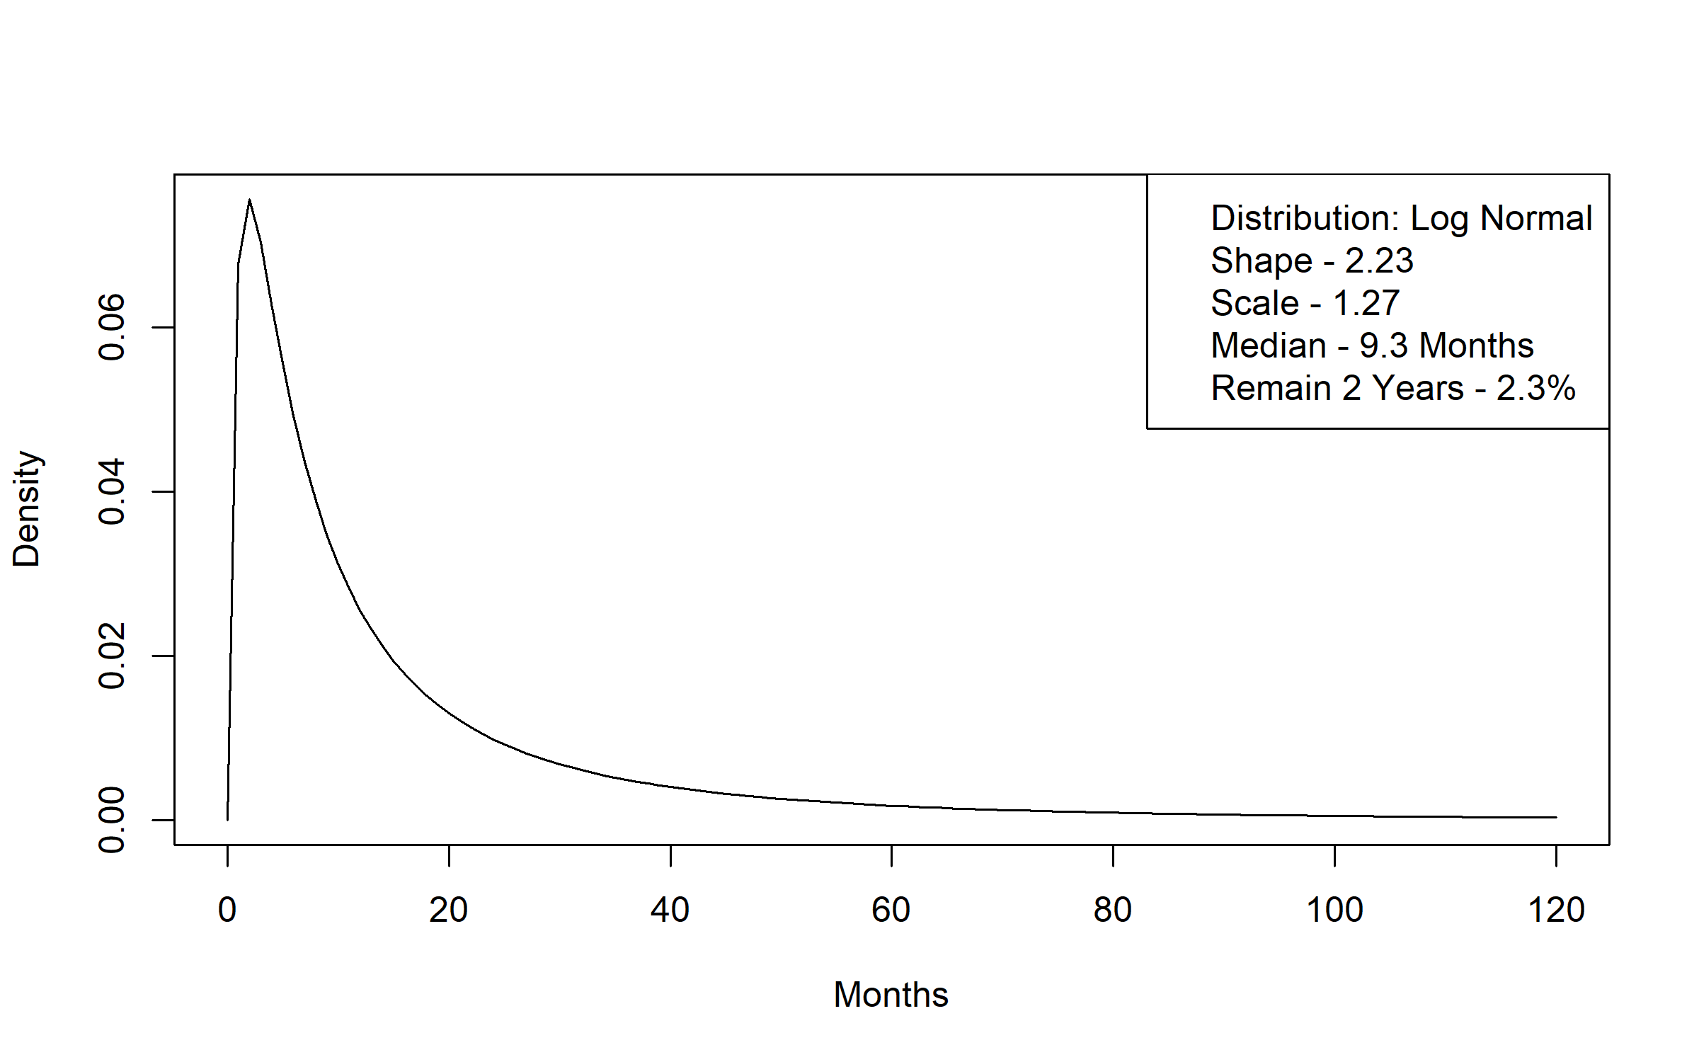
Figure A 4. Elderly Waiver Community to Medicaid without LTSS Time to Transition Distribution
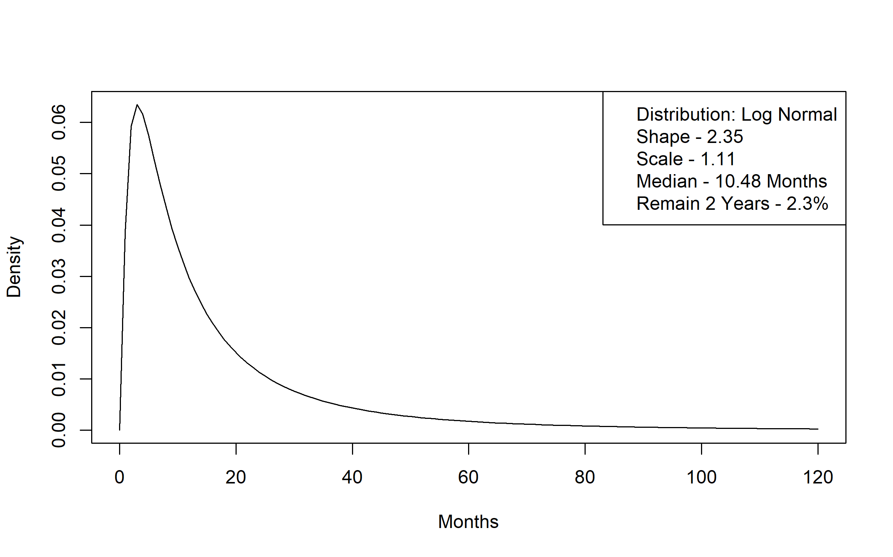
Figure A 5. Elderly Waiver Community to Personal Care Assistant without Waiver Time to Transition Distribution
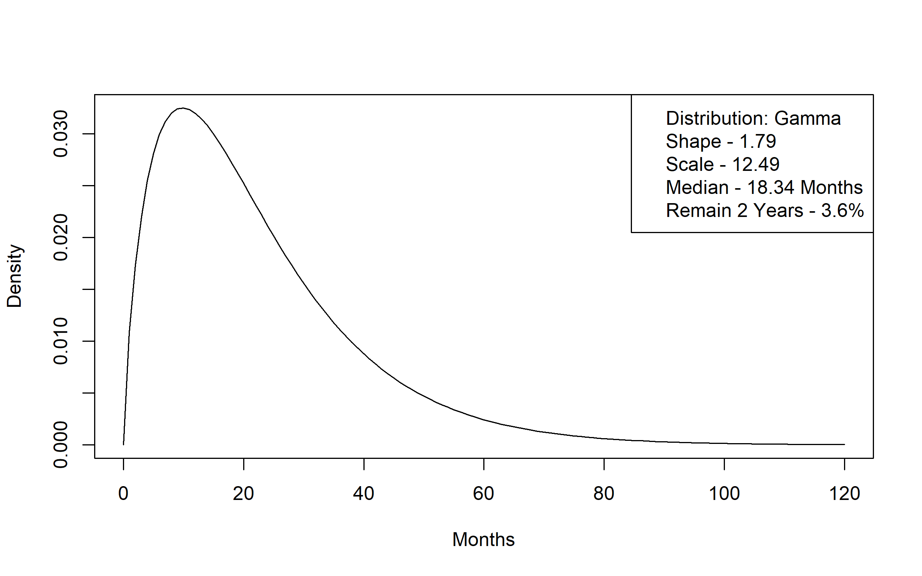
Figure A 6. Elderly Waiver Community to Alternative Care Time to Transition Distribution
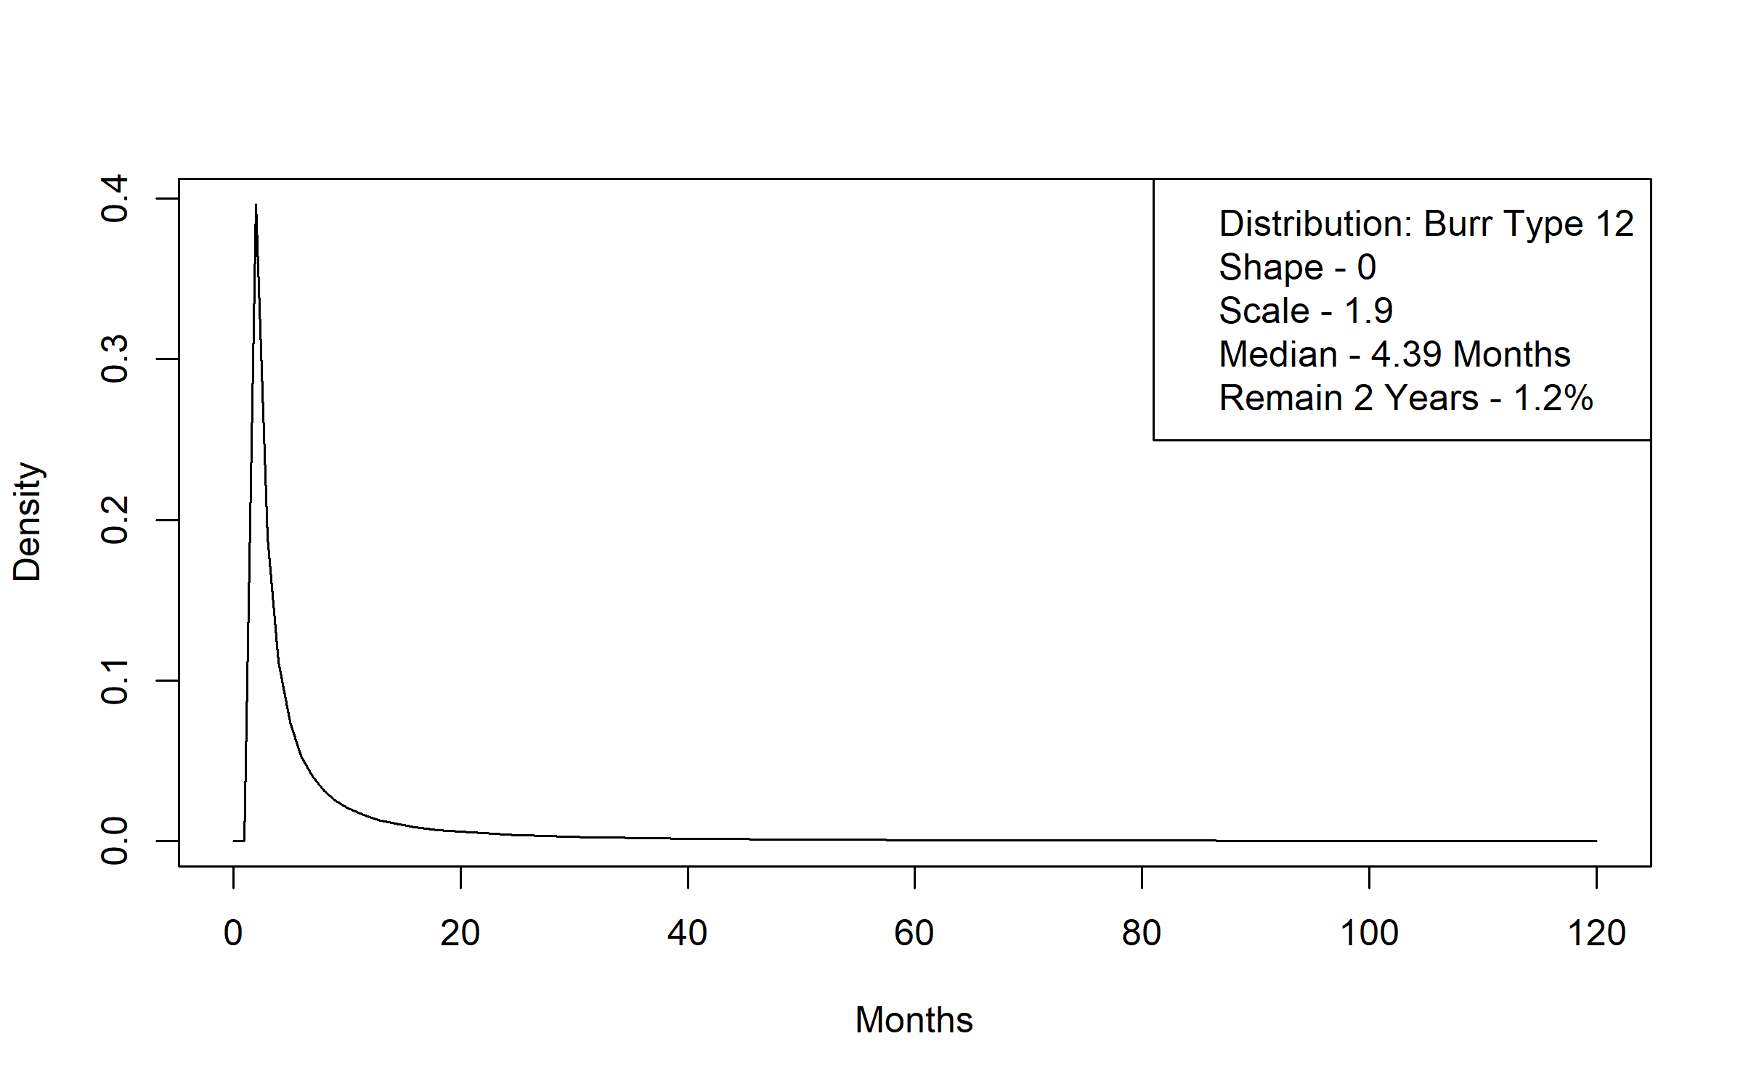
Figure A 7. Elderly Waiver Residential to Death Time to Transition Distribution
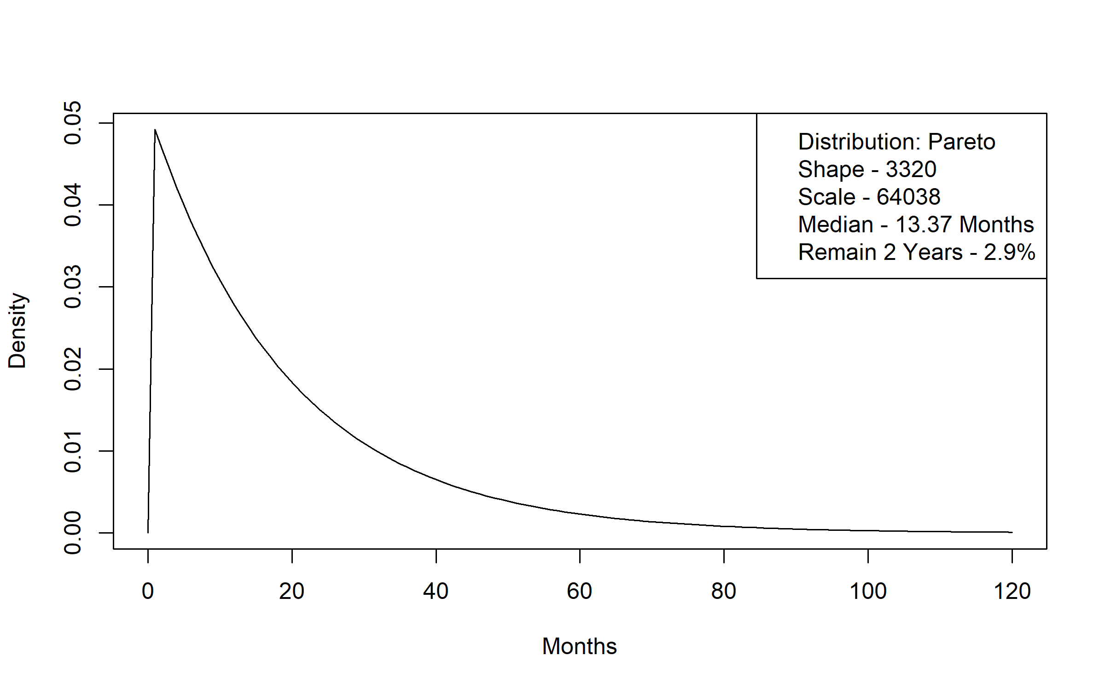
Figure A 8. Elderly Waiver Residential to Elderly Waiver Community Time to Transition Distribution
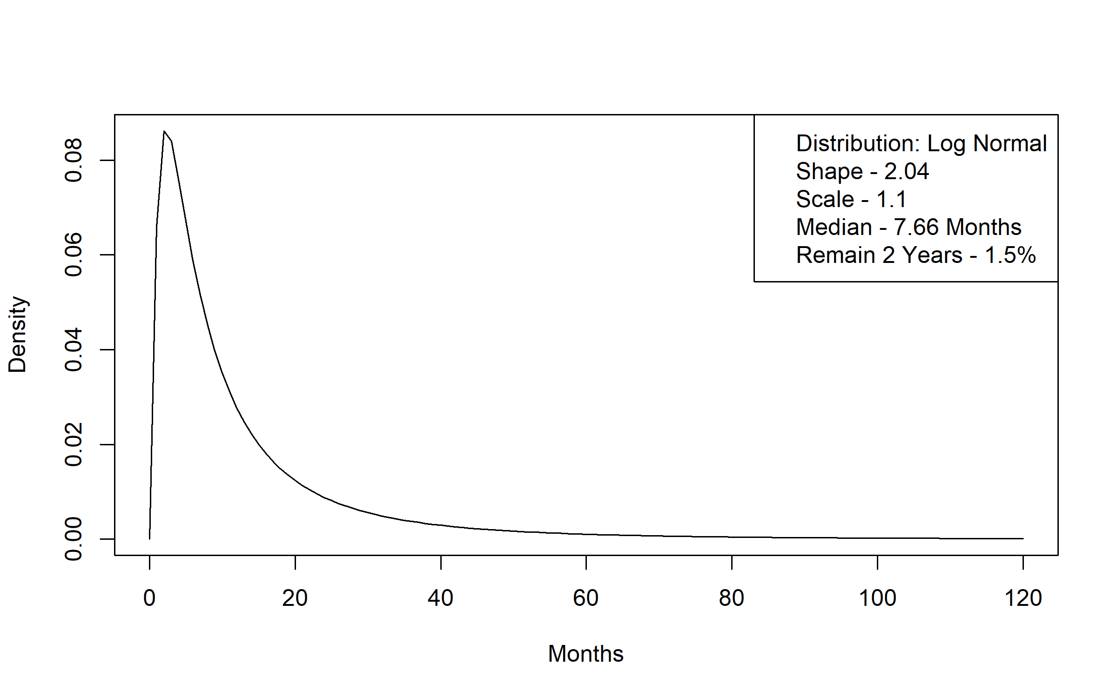
Figure A 9. Elderly Waiver Residential to Medicaid Nursing Facility Time to Transition Distribution
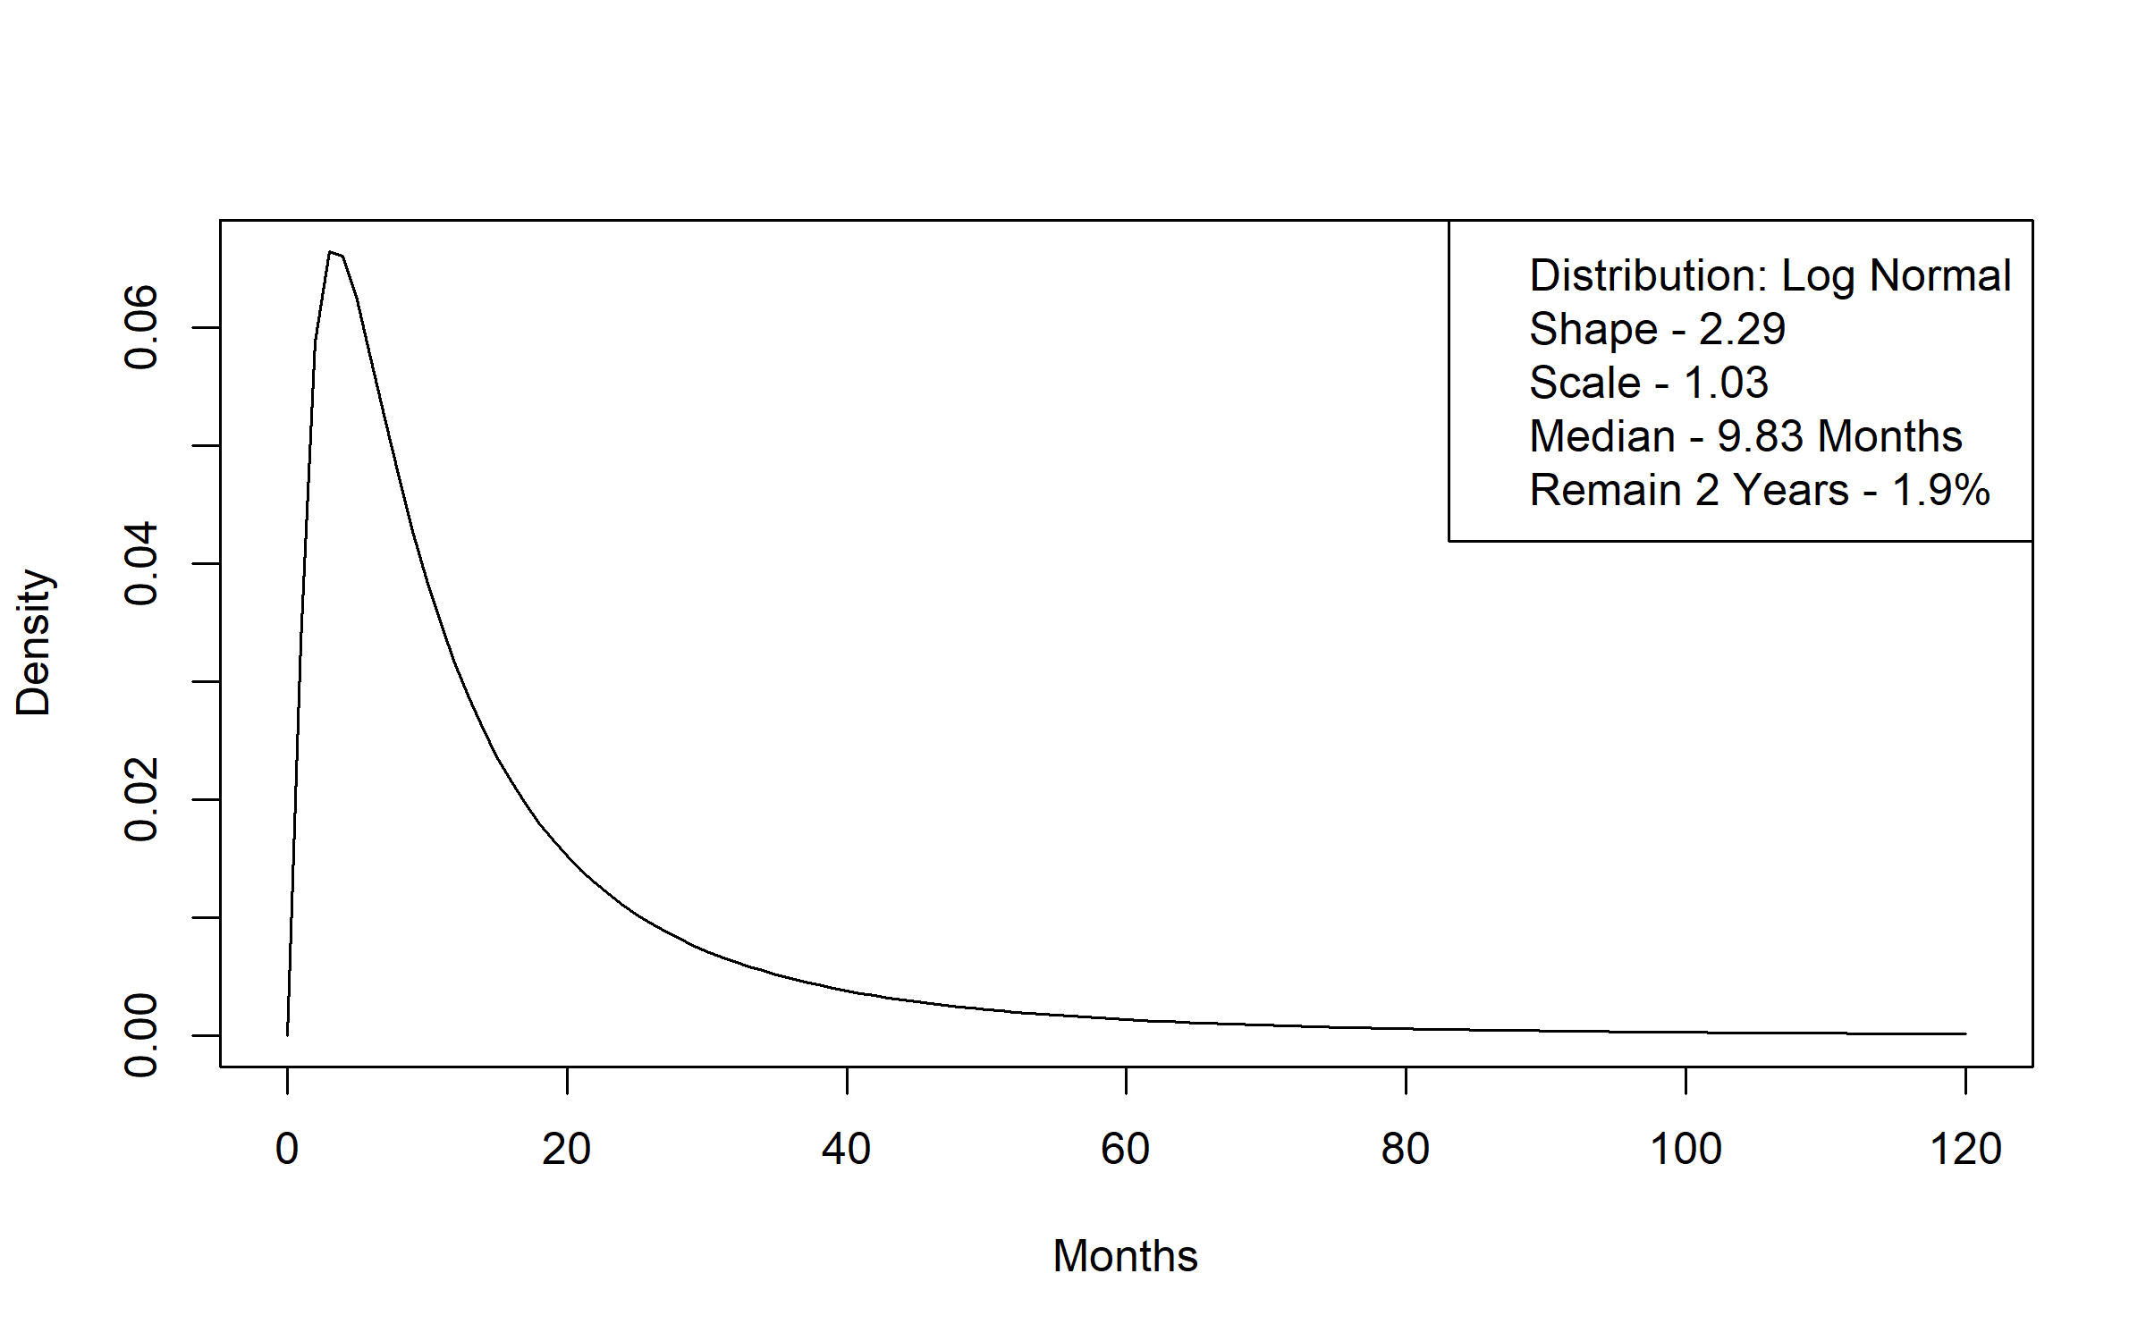
Figure A 10. Elderly Waiver Residential to Medicaid without LTSS Time to Transition Distribution
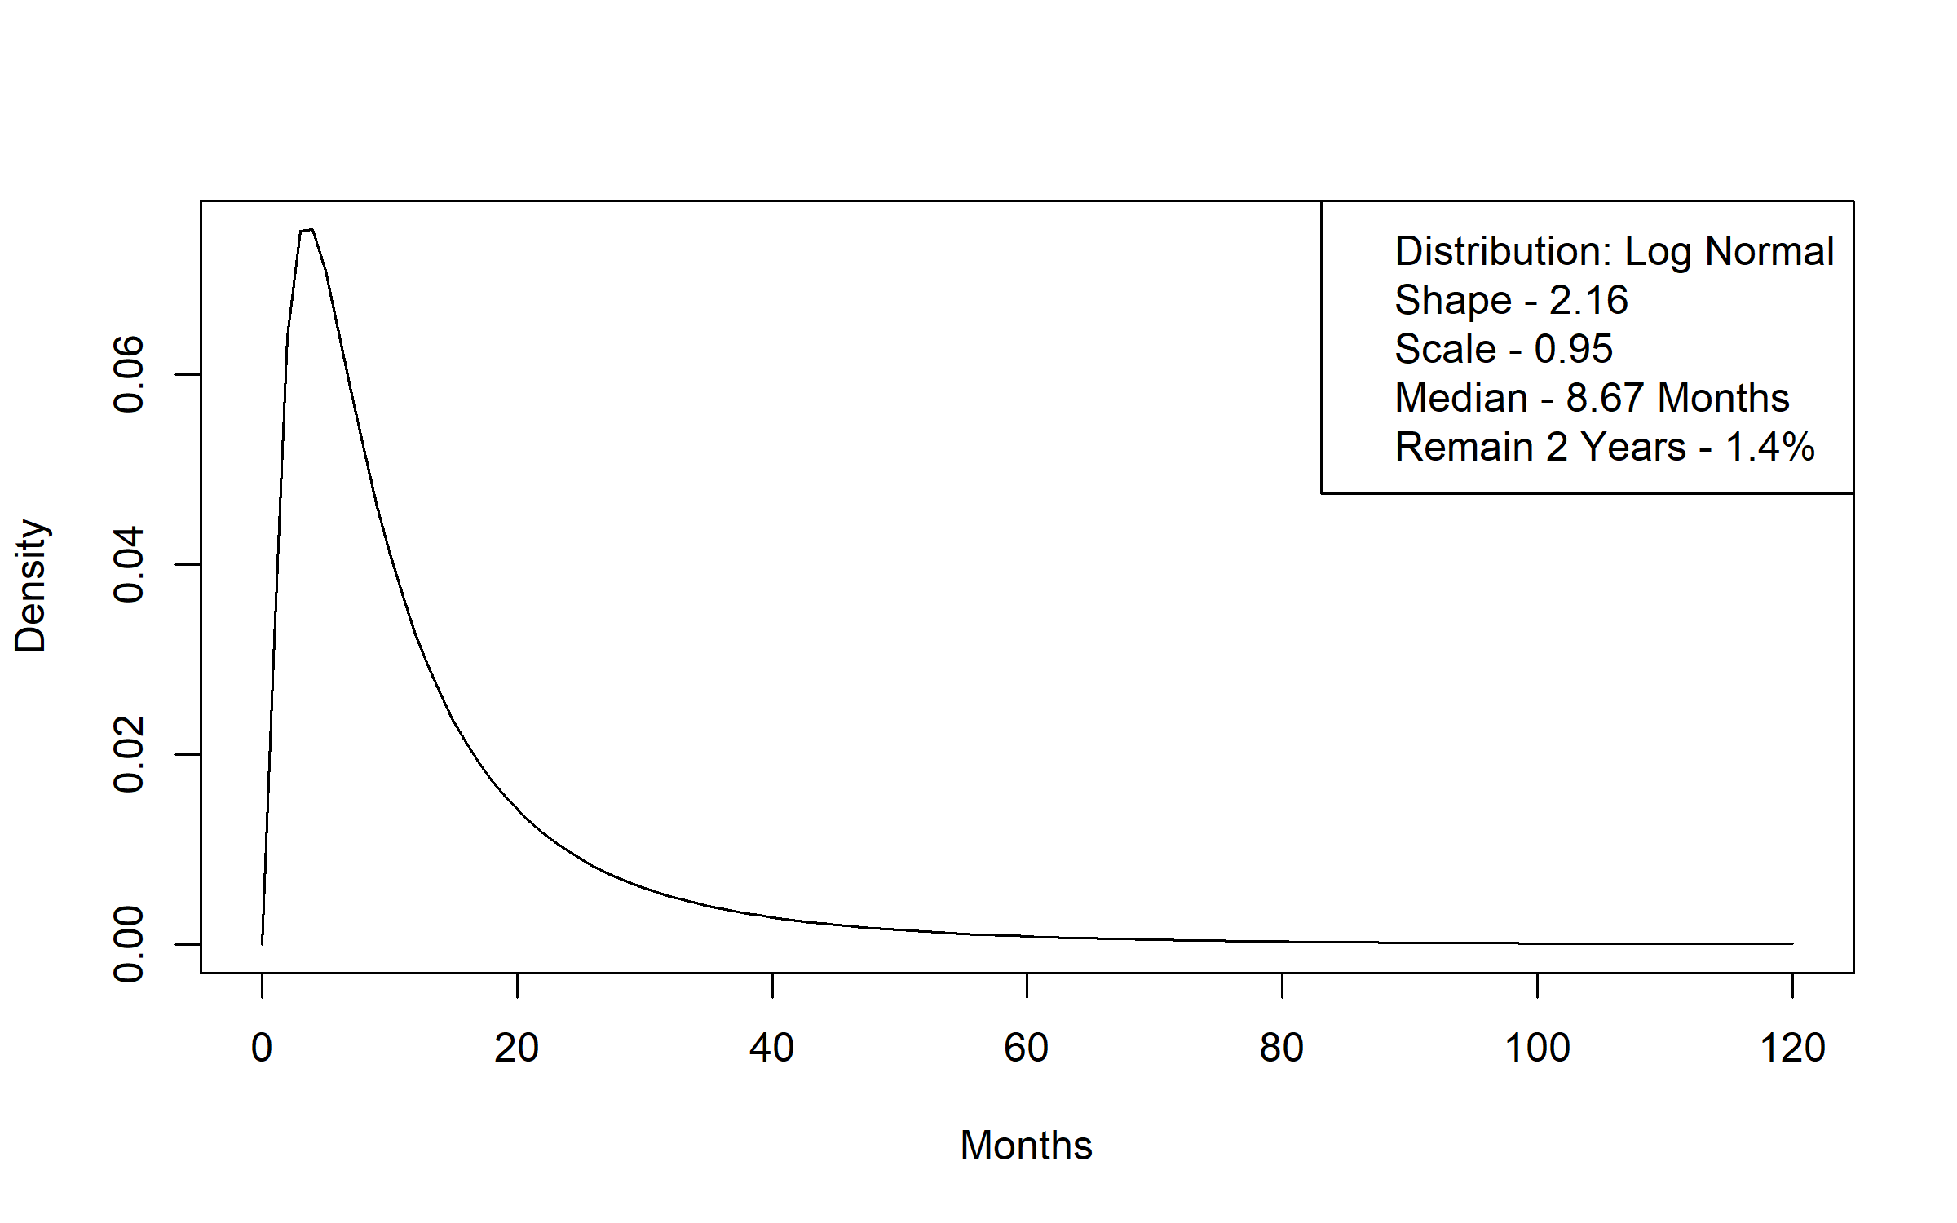
Figure A 11. Medicaid Nursing Facility (91+ Day Stay) to Death Time to Transition Distribution
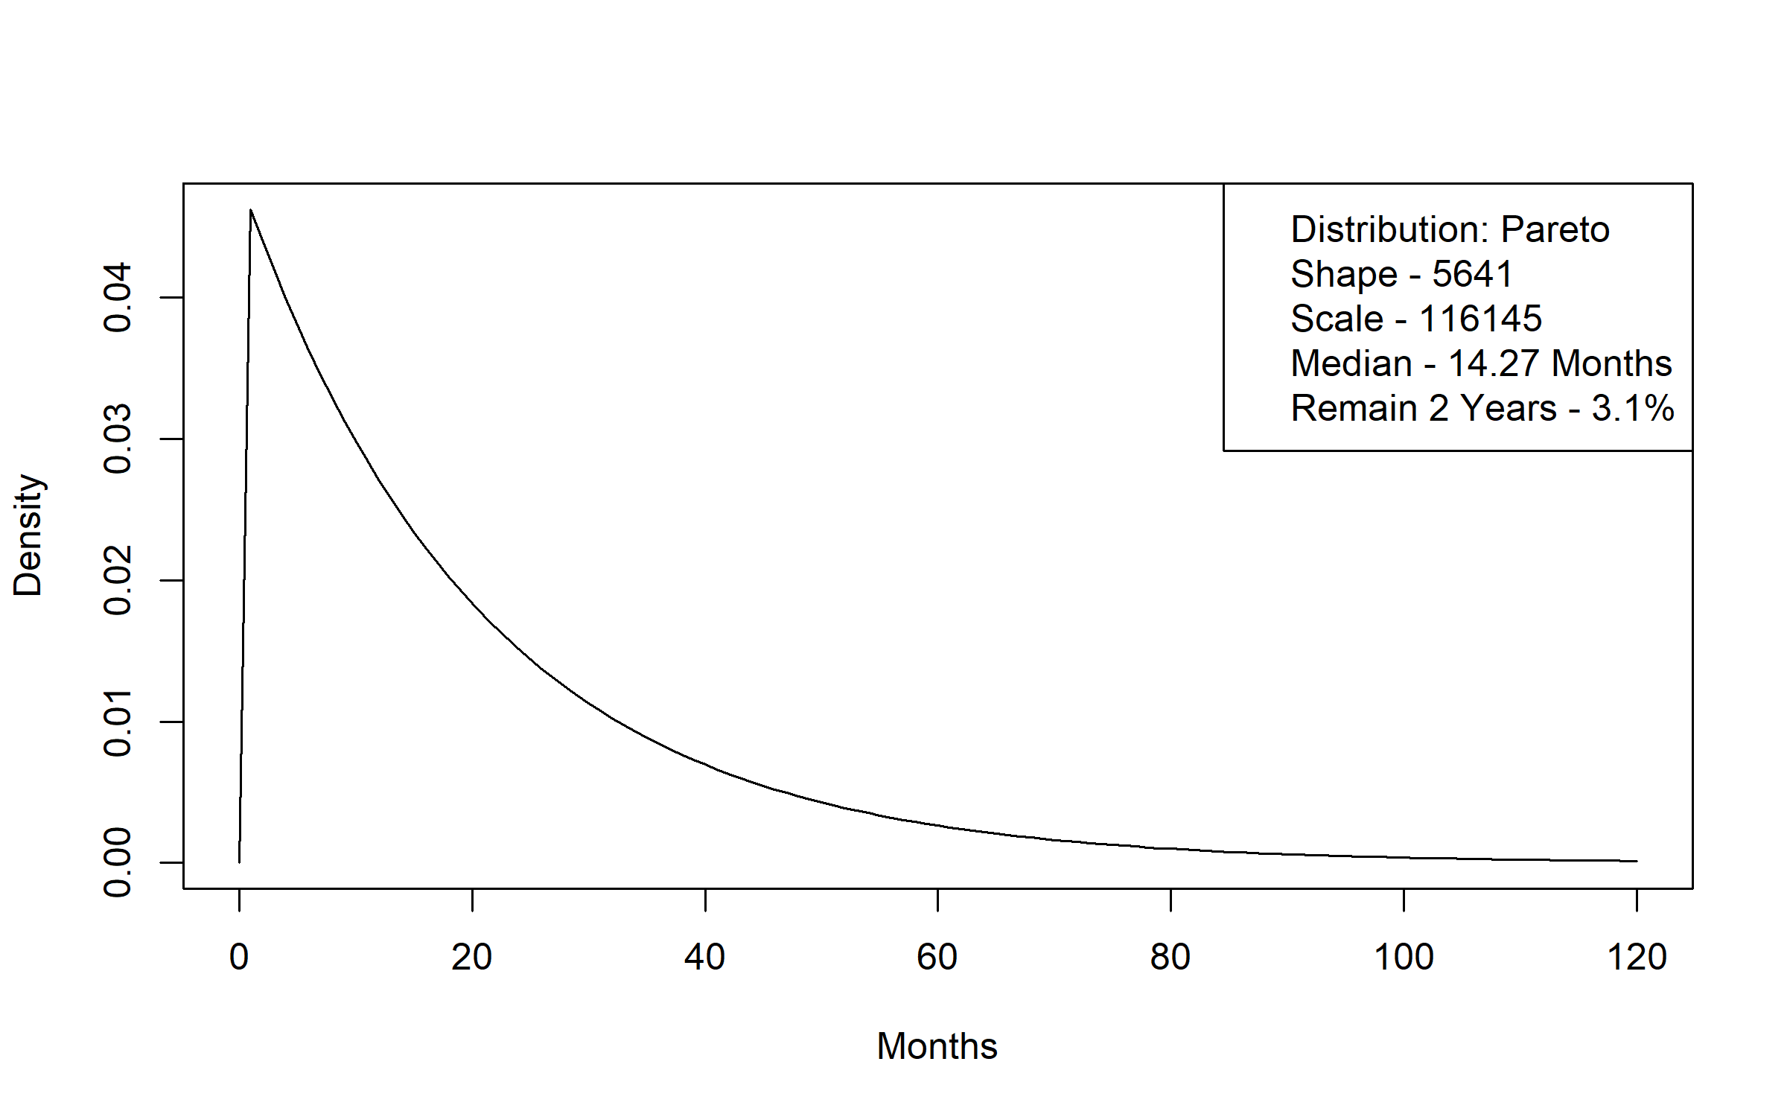
Figure A 12. Medicaid Nursing Facility (91+ Day Stay) to Elderly Waiver Community Time to Transition Distribution
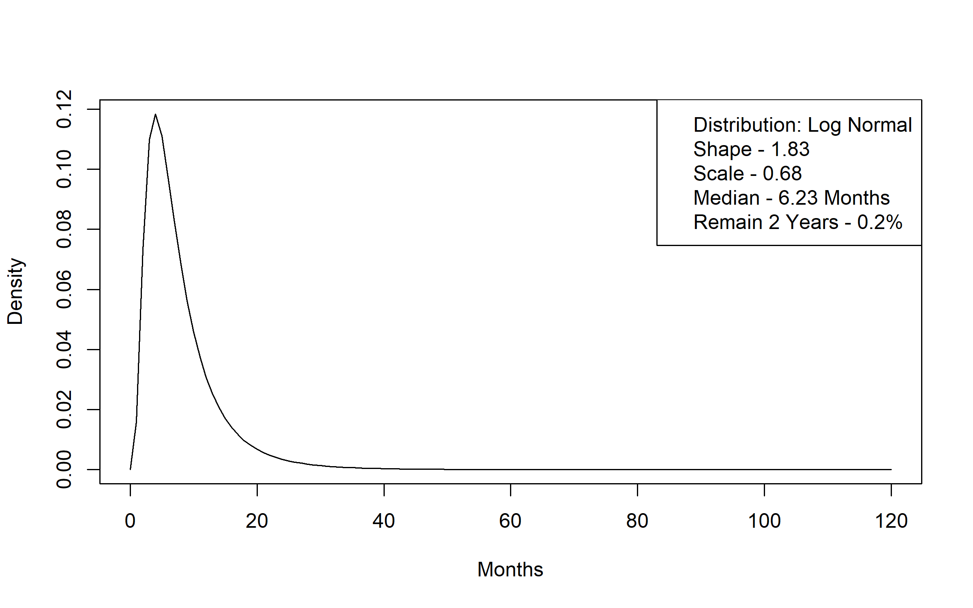
Figure A 13. Medicaid Nursing Facility (91+ Day Stay) to Elderly Waiver Residential Time to Transition Distribution
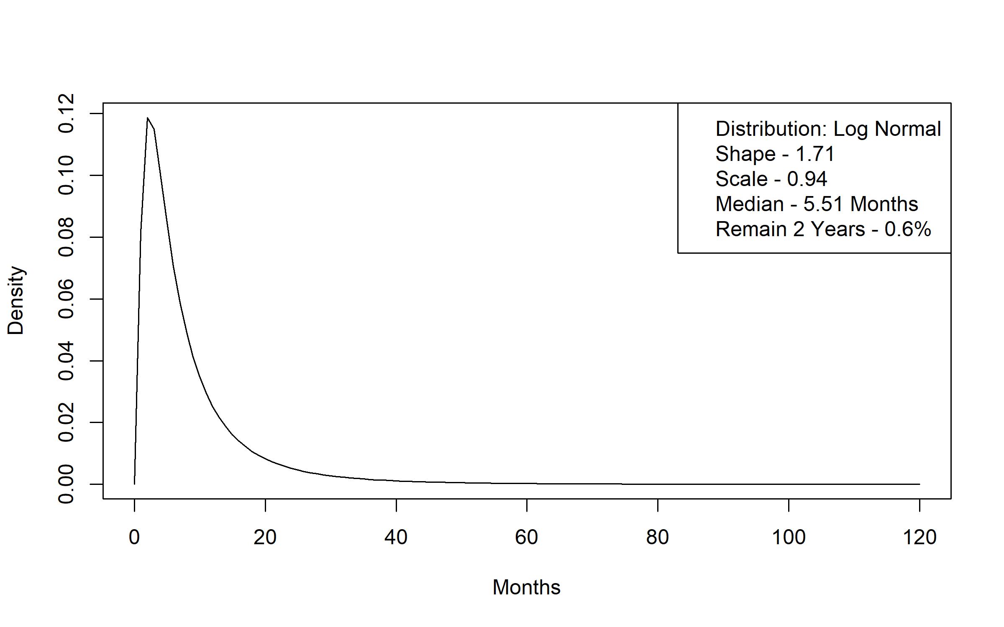
Figure A 14. Medicaid Nursing Facility (91+ Day Stay) to Medicaid without LTSS Time to Transition Distribution
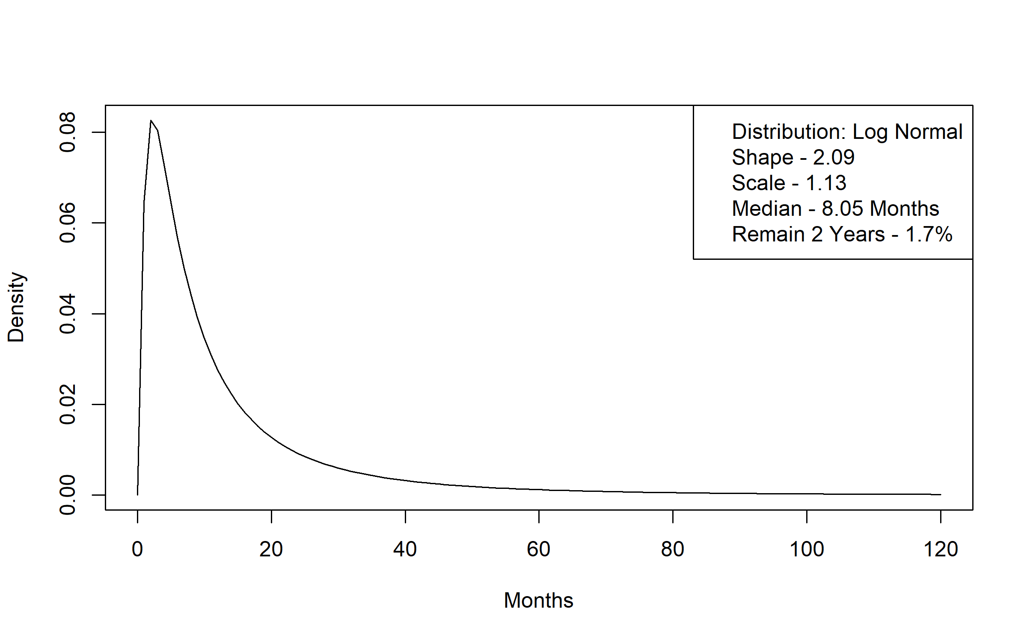
Figure A 15. Medicaid Nursing Facility (91+ Day Stay) to Personal Care Assistant without a Waiver Time to Transition Distribution
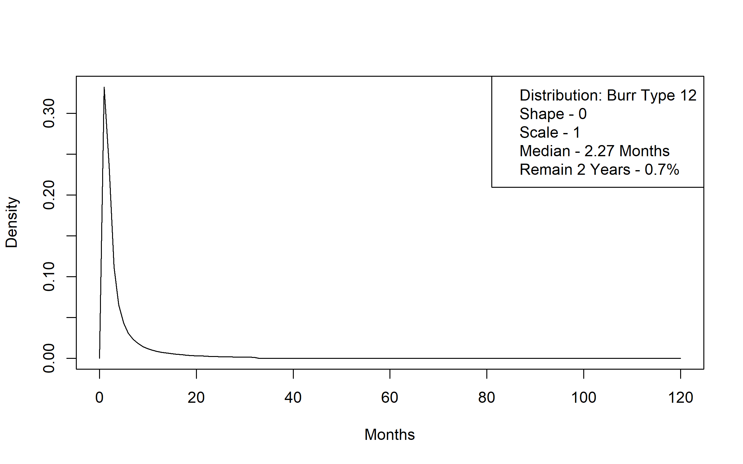
Figure A 16. Medicaid Nursing Facility (91+ Day Stay) to Alternative Care Time to Transition Distribution
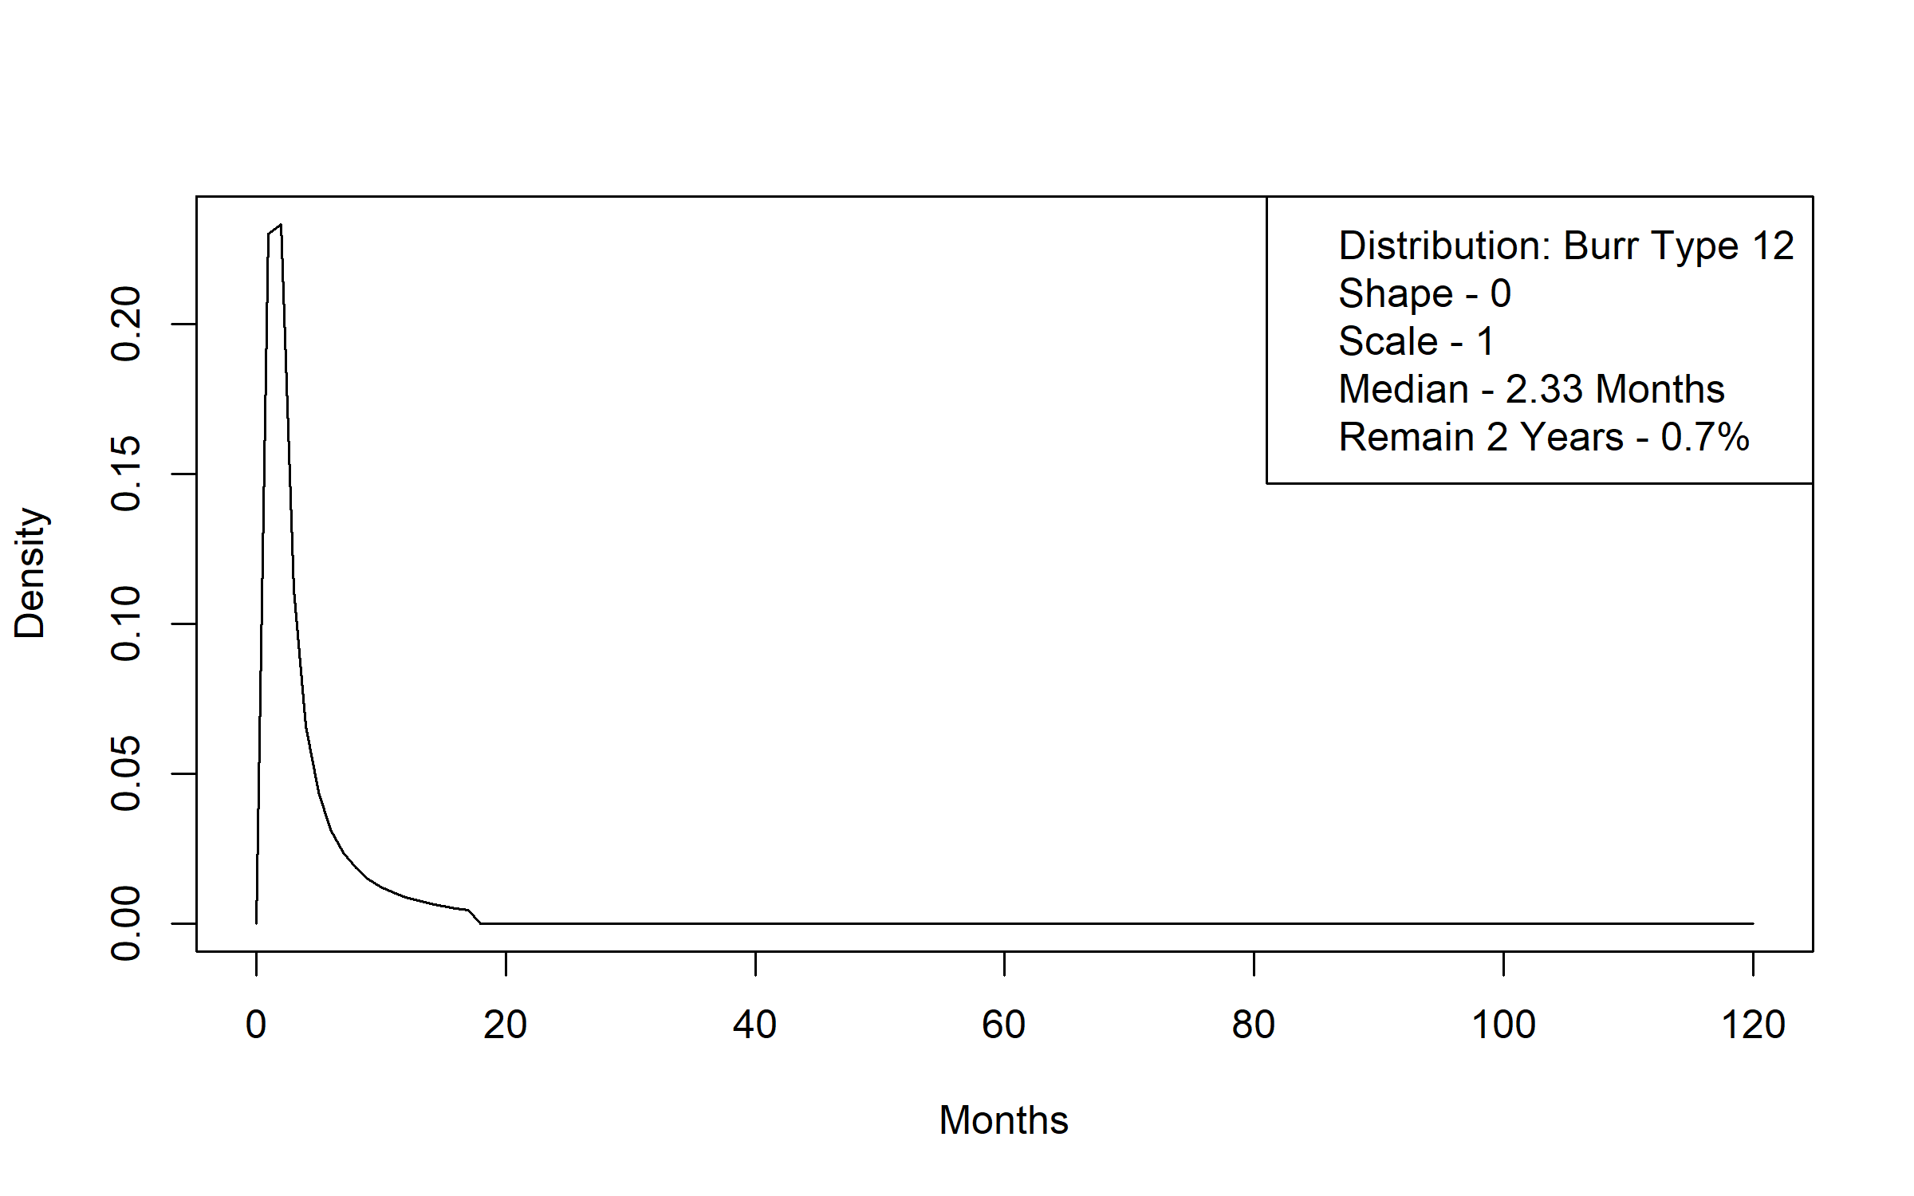
Figure A 17. Medicaid without LTSS to Death Time to Transition Distribution
Figure A 18. Medicaid without LTSS to Elderly Waiver Community Time to Transition Distribution
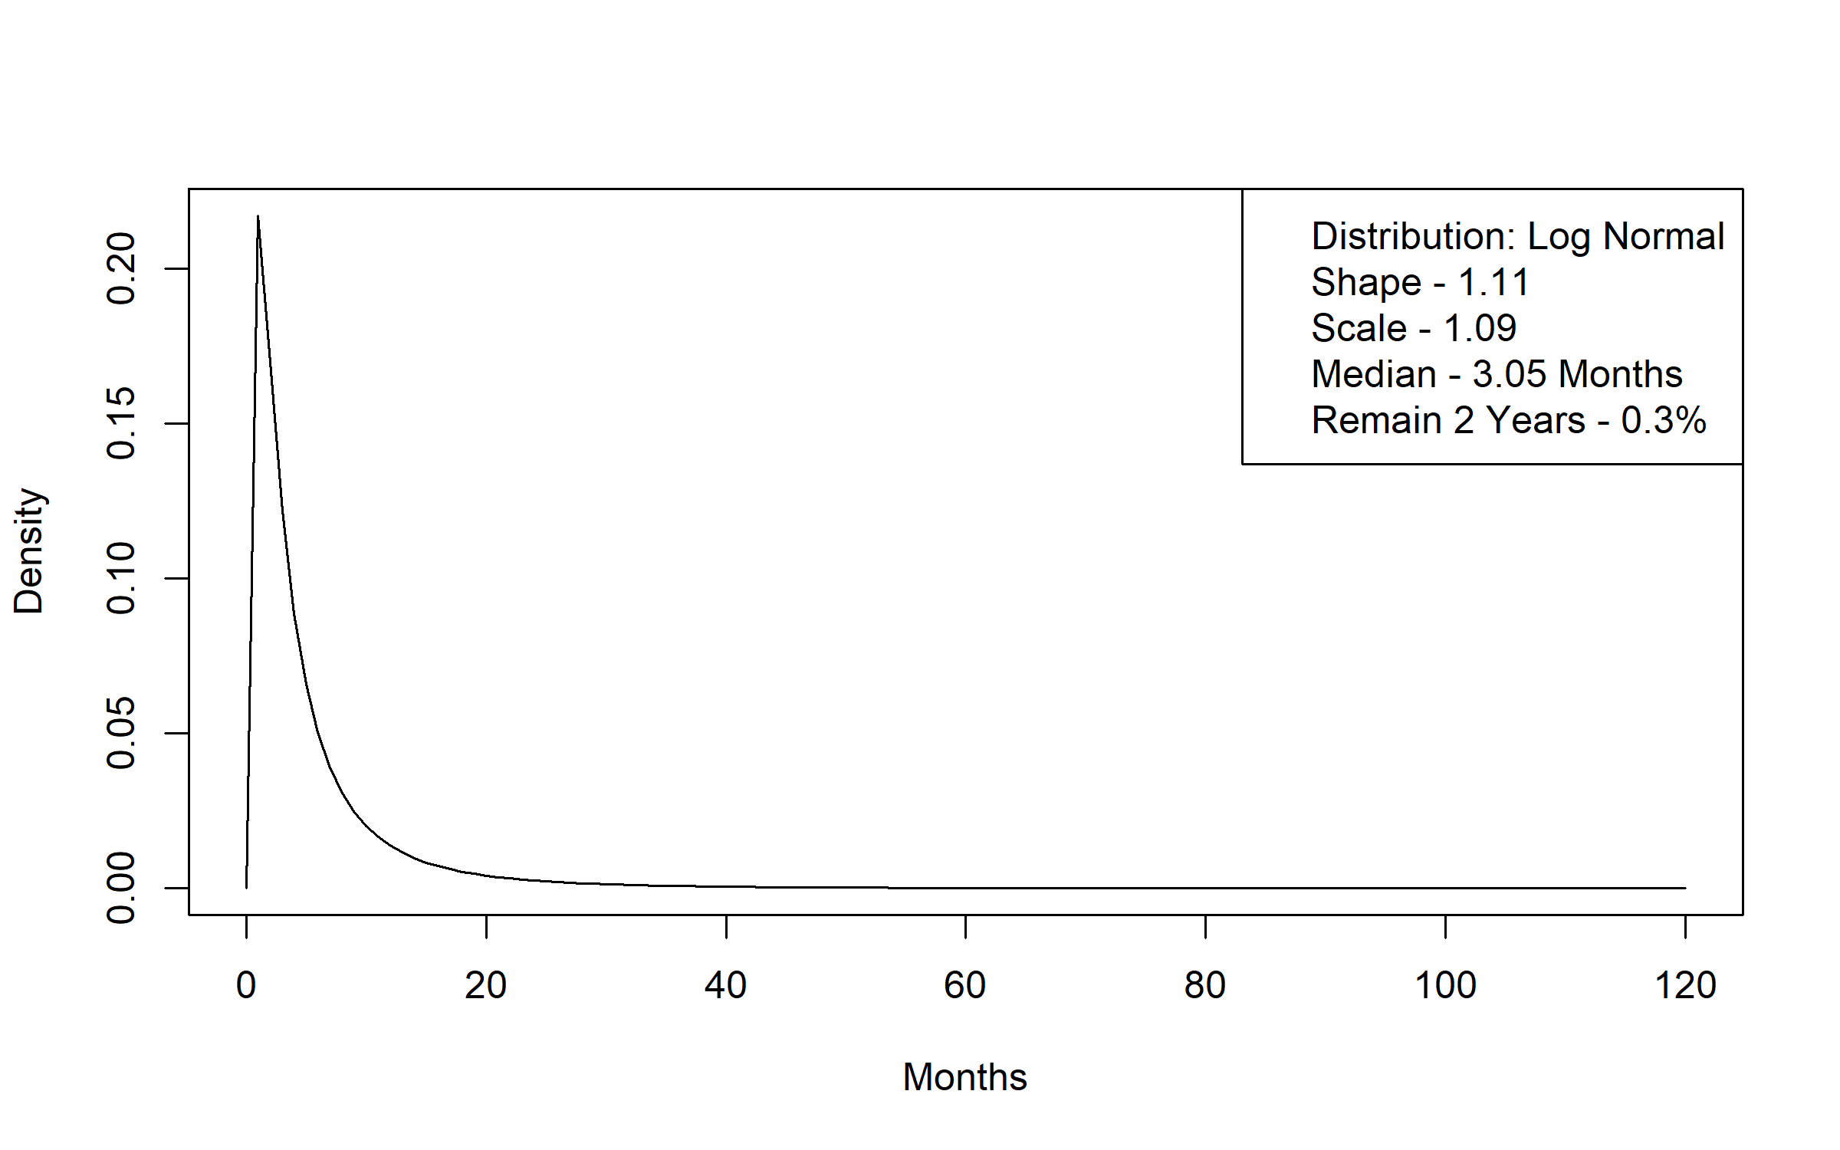
Figure A 19. Medicaid without LTSS to Elderly Waiver Residential Time to Transition Distribution
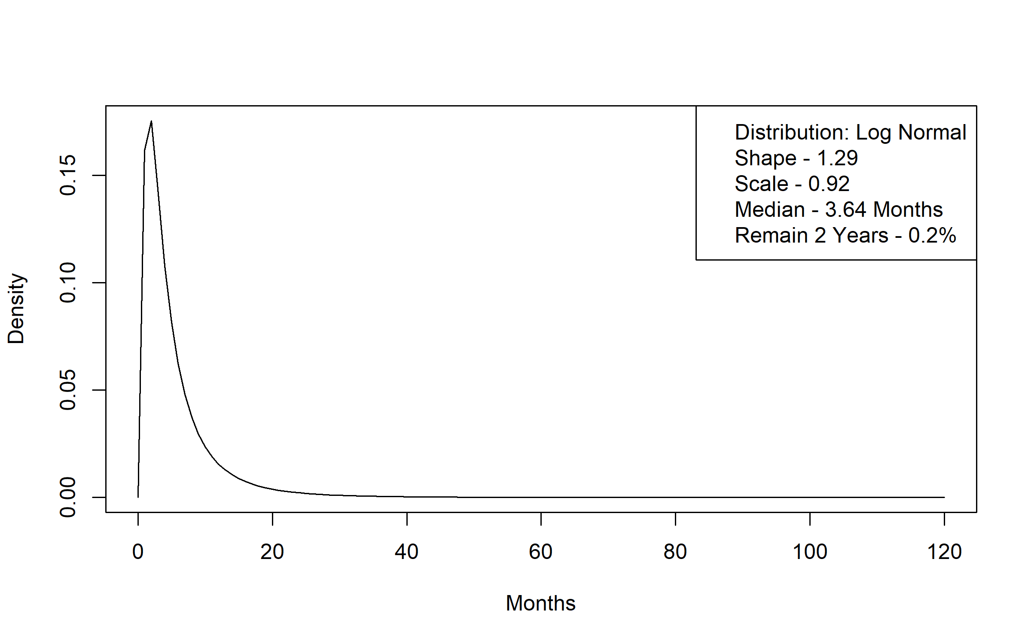
Figure A 20. Medicaid without LTSS to Medicaid Nursing Facility Time to Transition Distribution
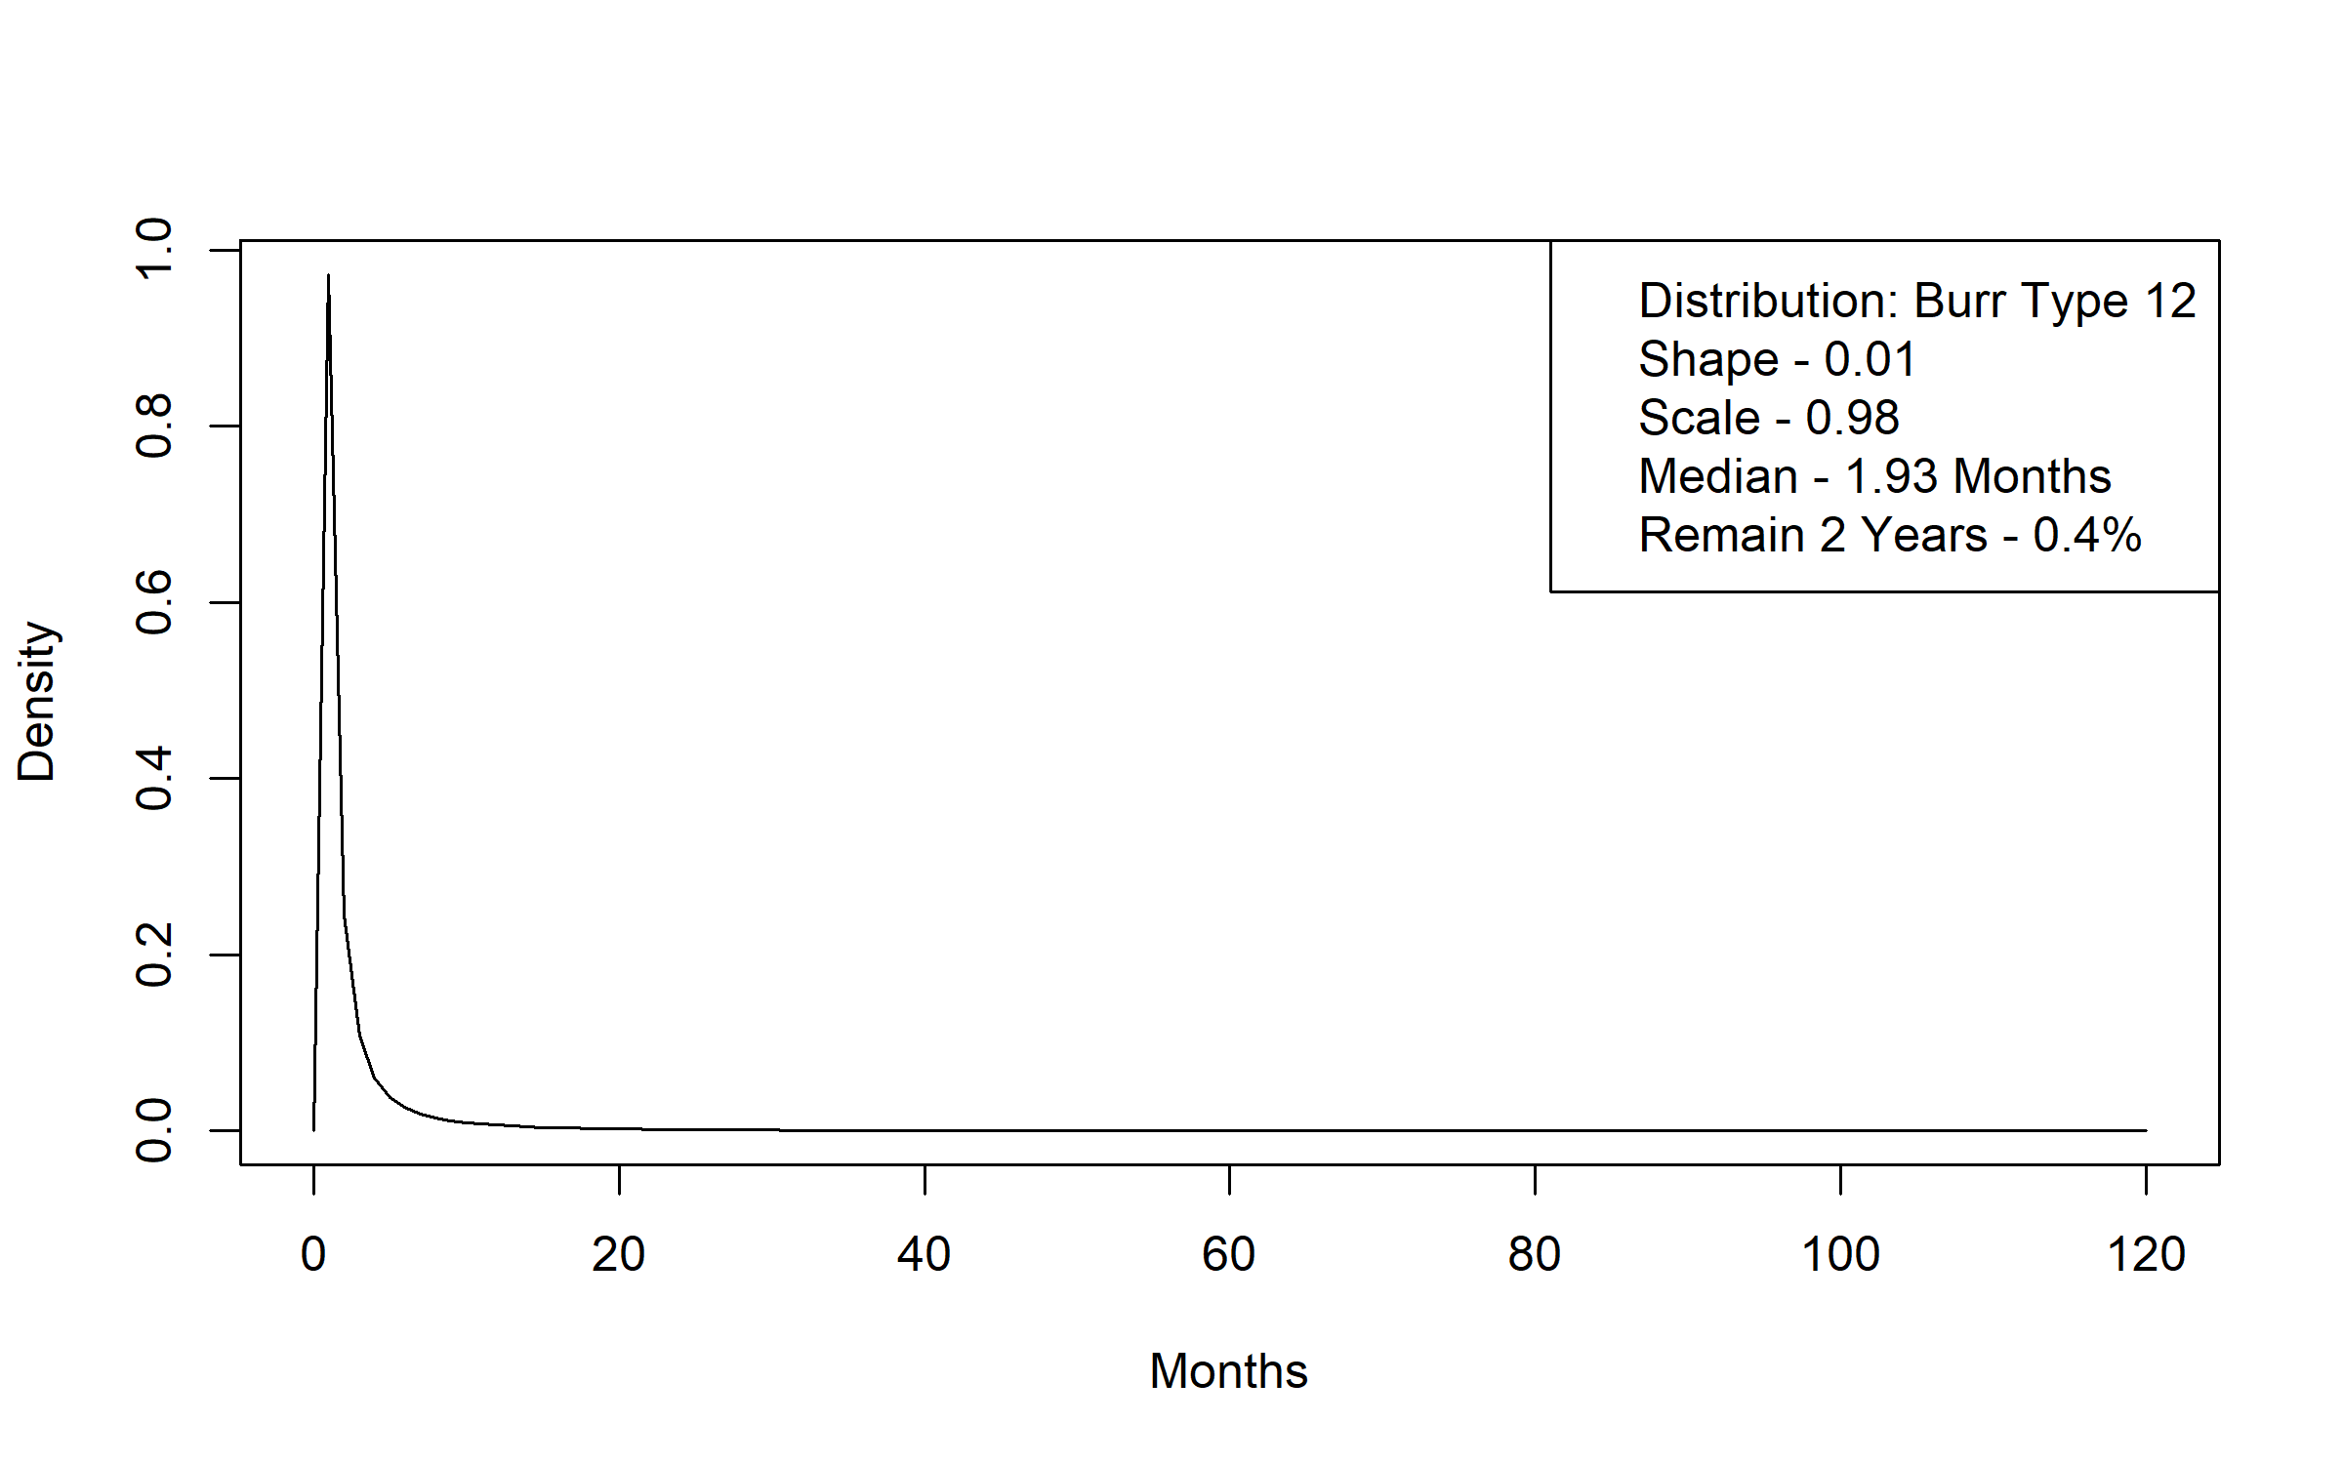
Figure A 21. Medicaid without LTSS to Personal Care Assistant without a Waiver Time to Transition Distribution
Figure A 22. Medicaid without LTSS to Alternative Care Time to Transition Distribution
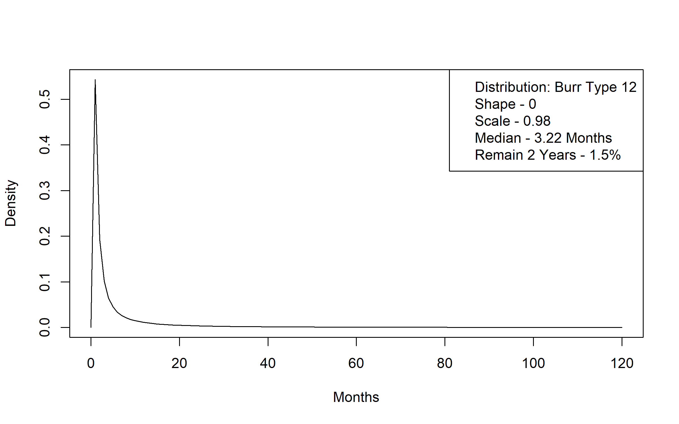
Figure A 23 Personal Care Assistant without a Waiver to Death Time to Transition Distribution
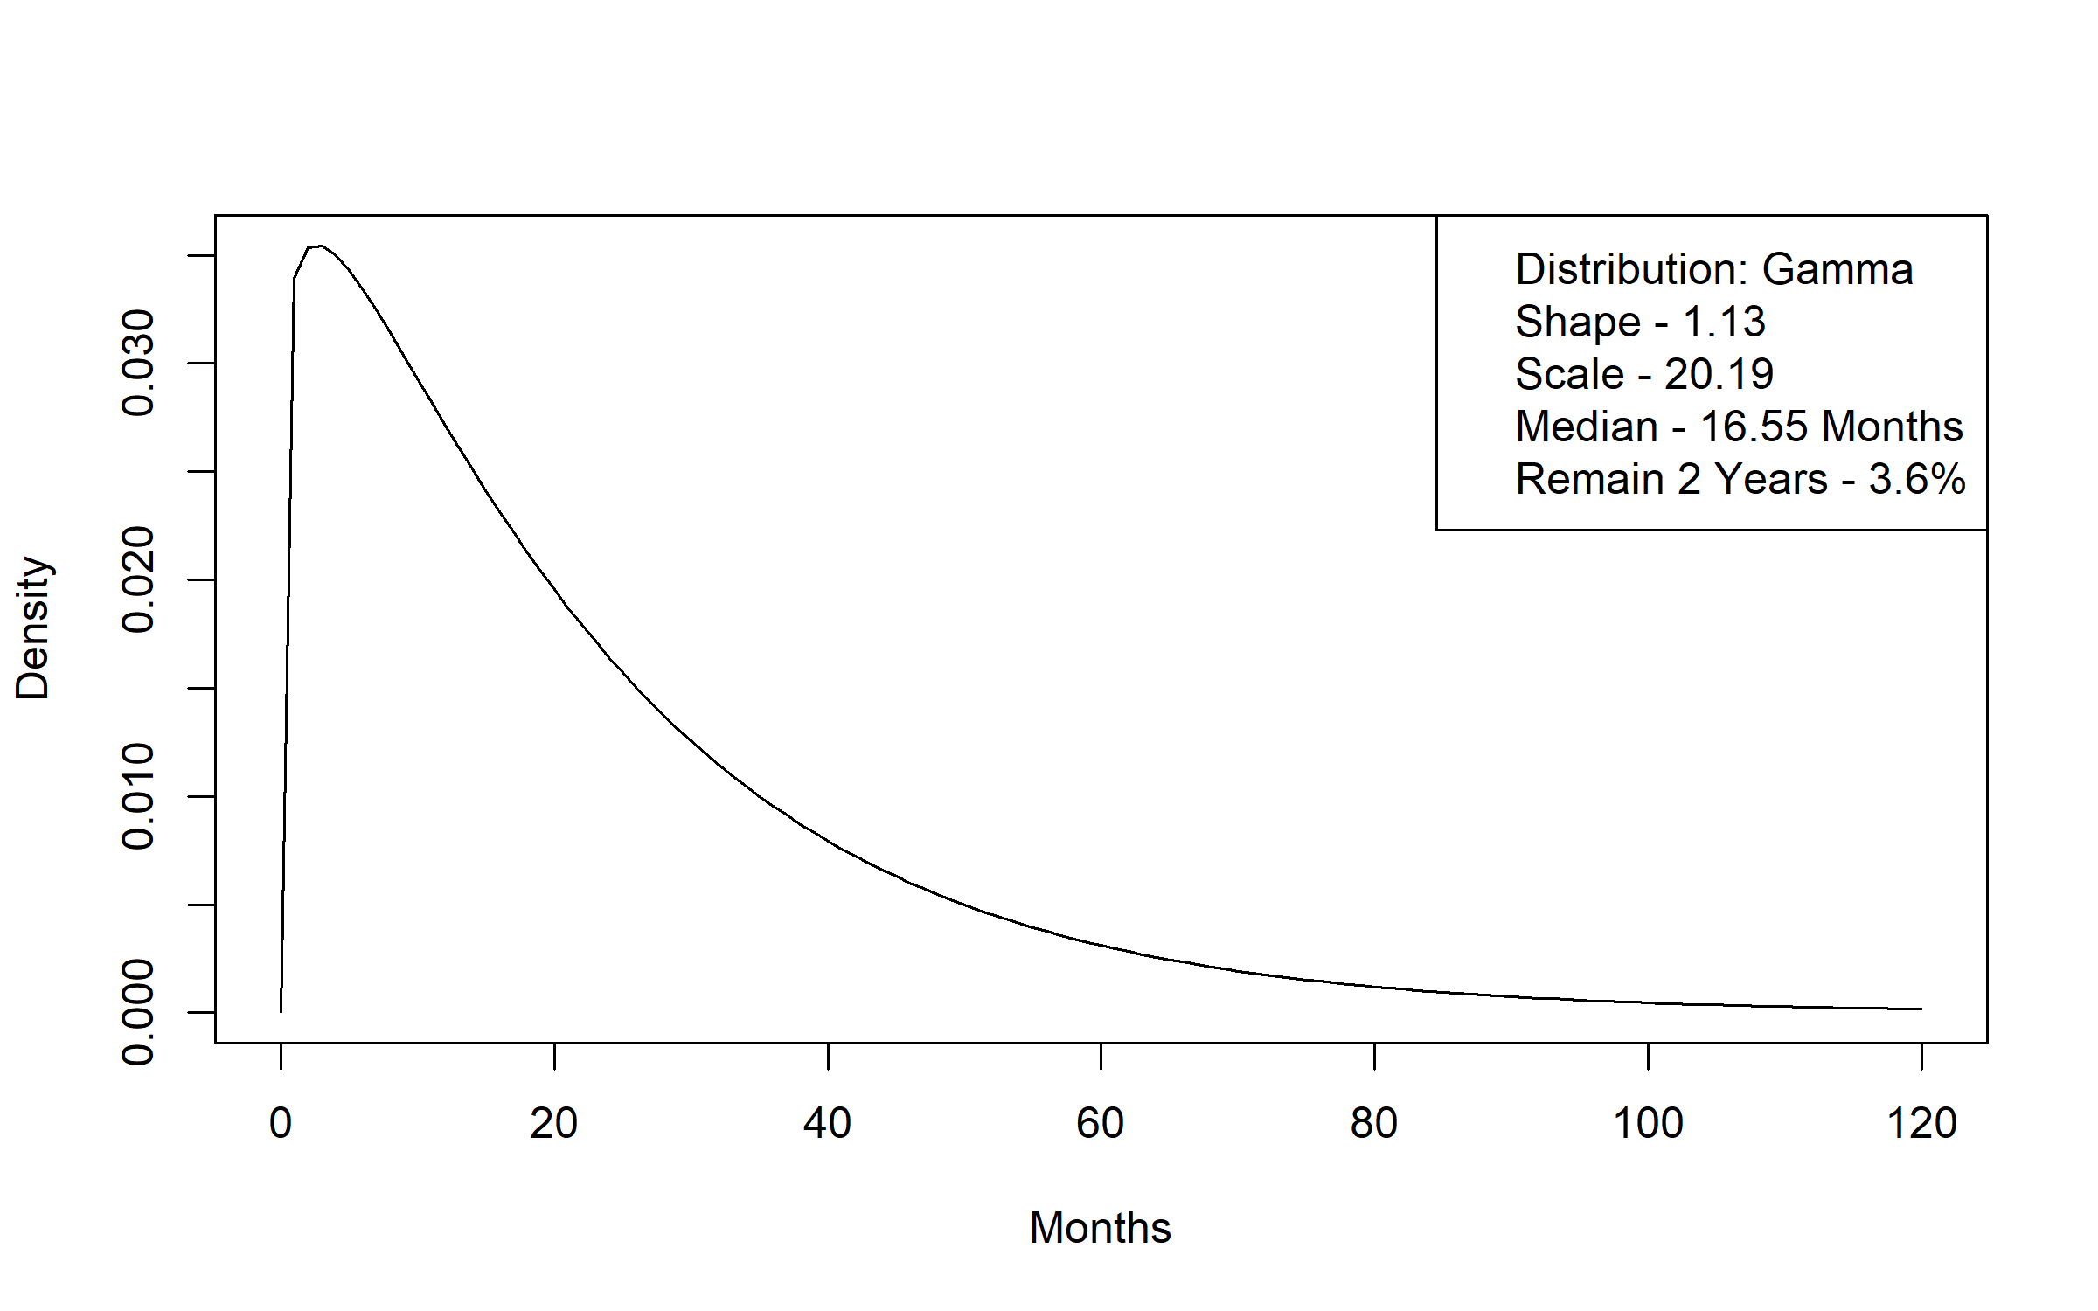
Figure A 24 Personal Care Assistant without a Waiver to Elderly Waiver Community Time to Transition Distribution
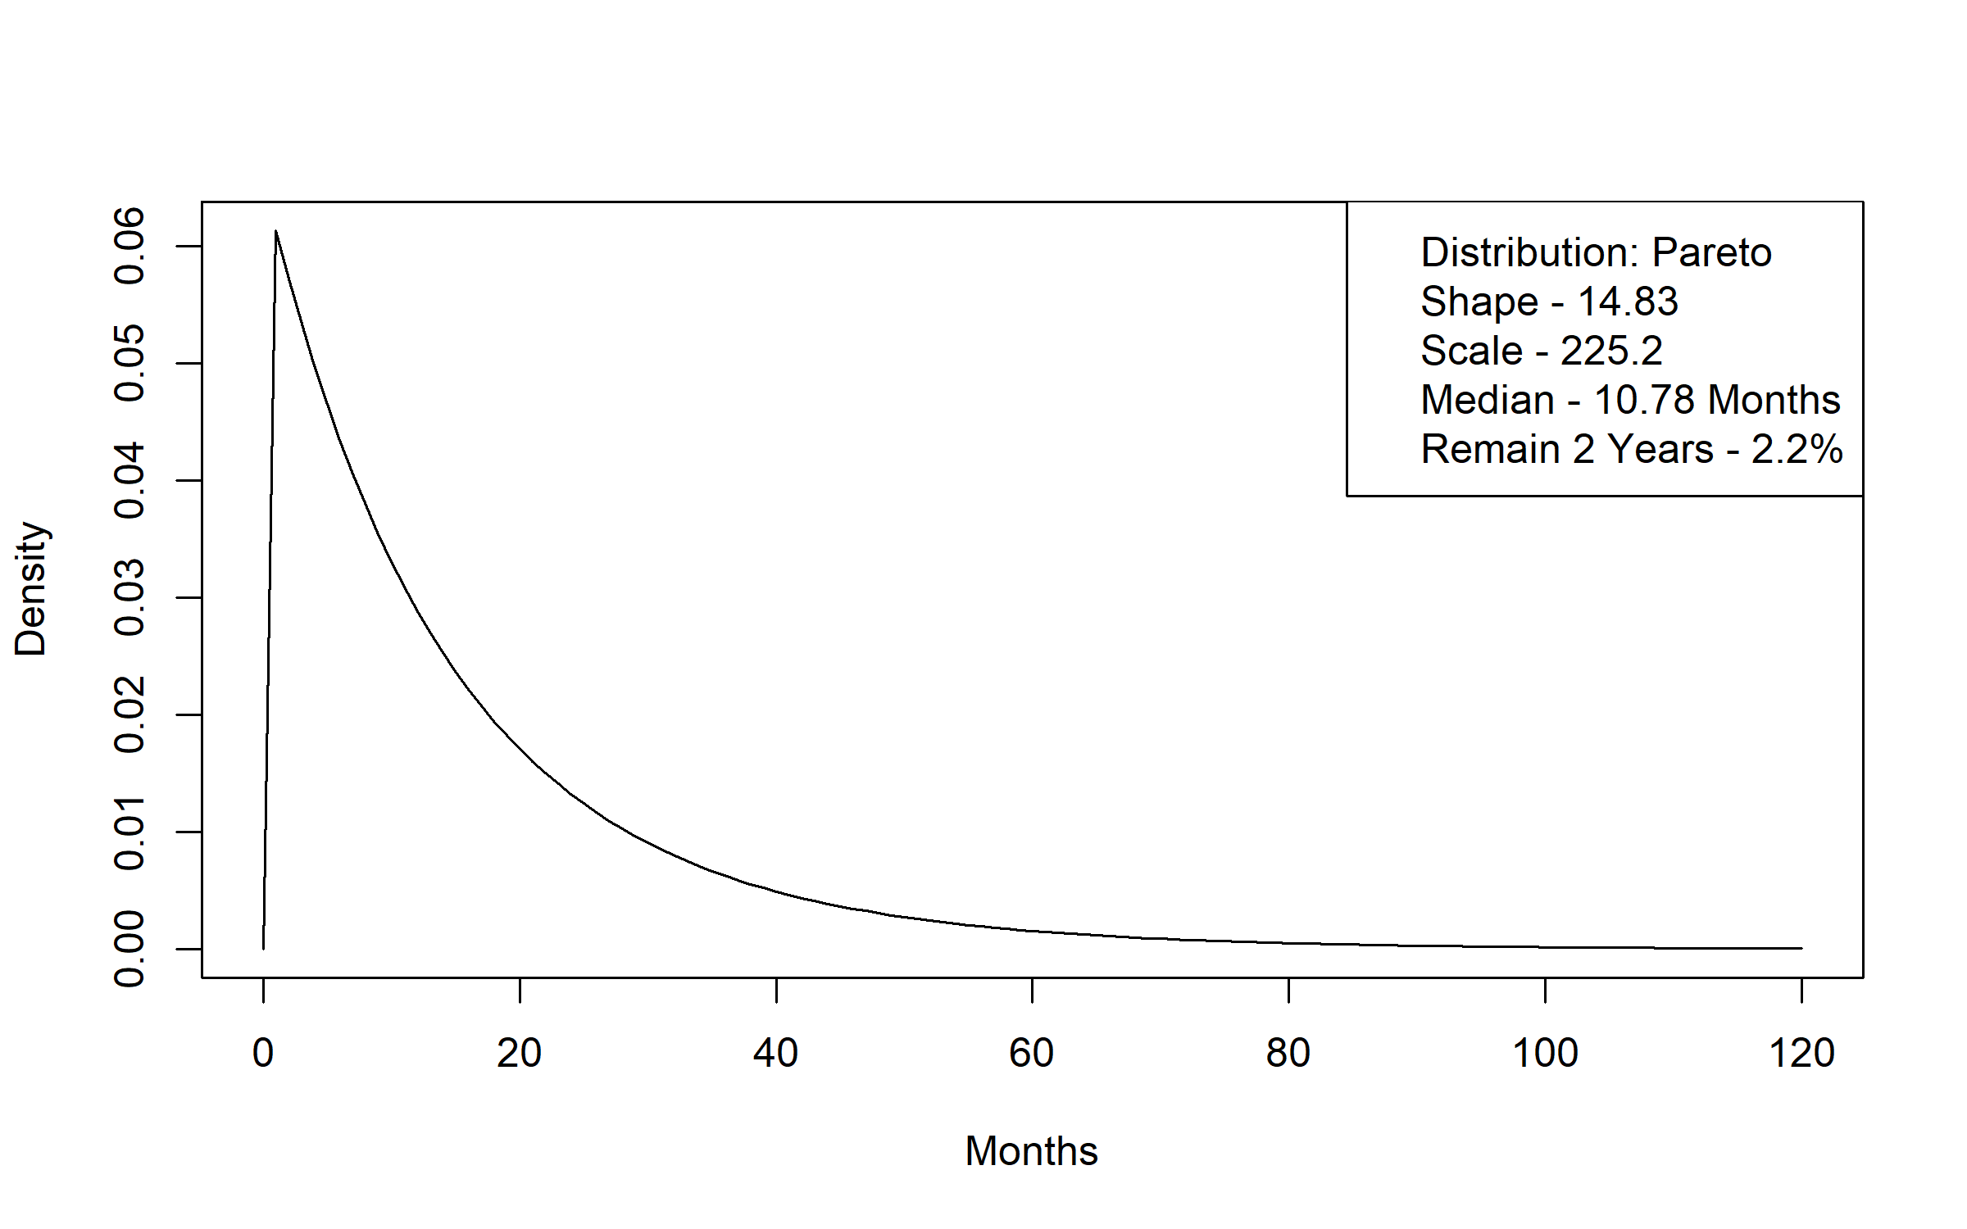
Figure A 25 Personal Care Assistant without a Waiver to Elderly Waiver Residential Time to Transition Distribution
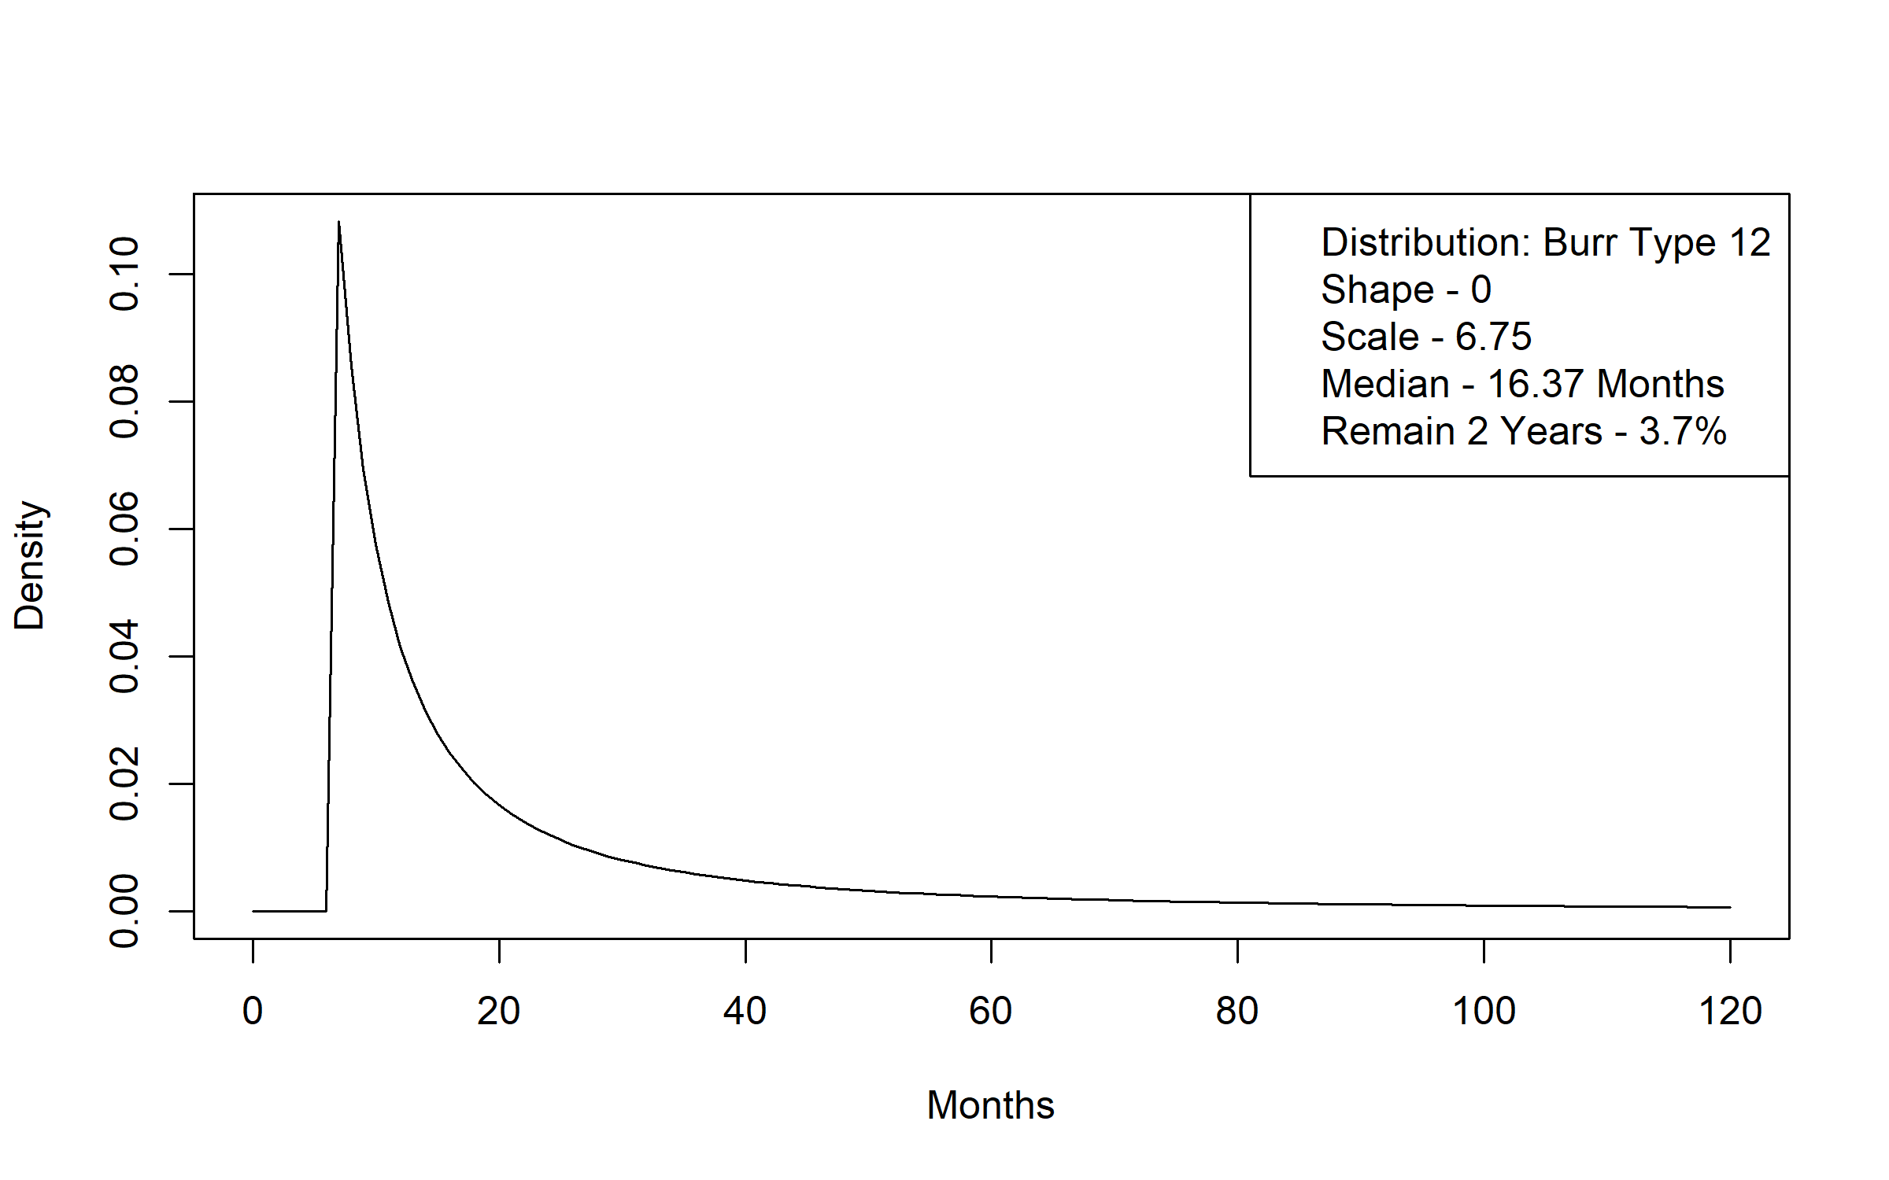
Figure A 26 Personal Care Assistant without a Waiver to Medicaid without LTSS Time to Transition Distribution
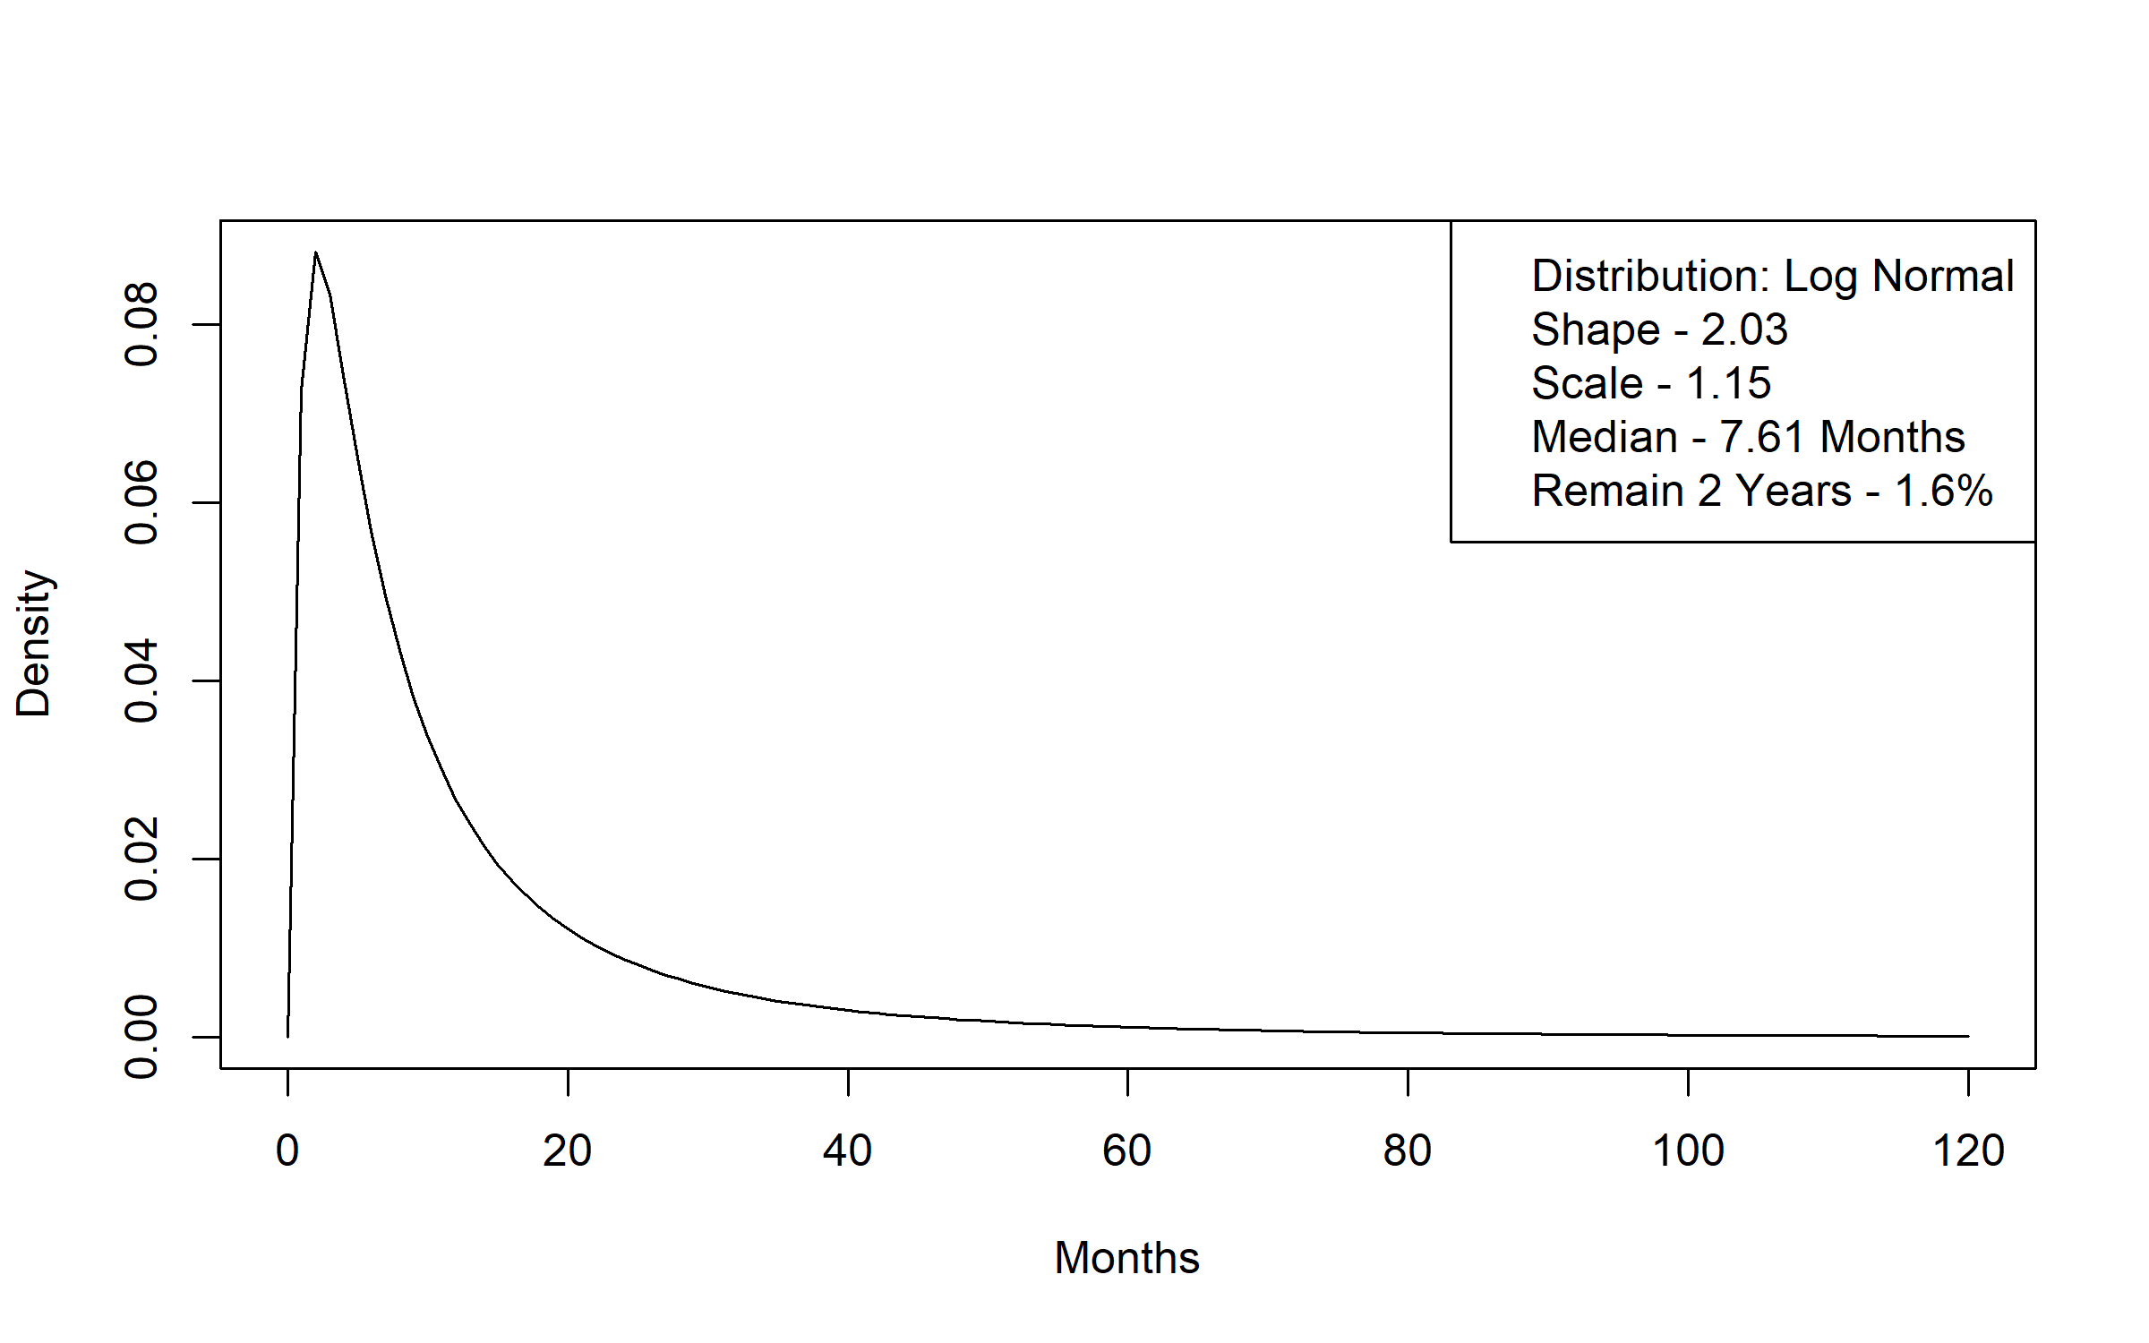
Figure A 27 Personal Care Assistant without a Waiver to Alternative Care Time to Transition Distribution
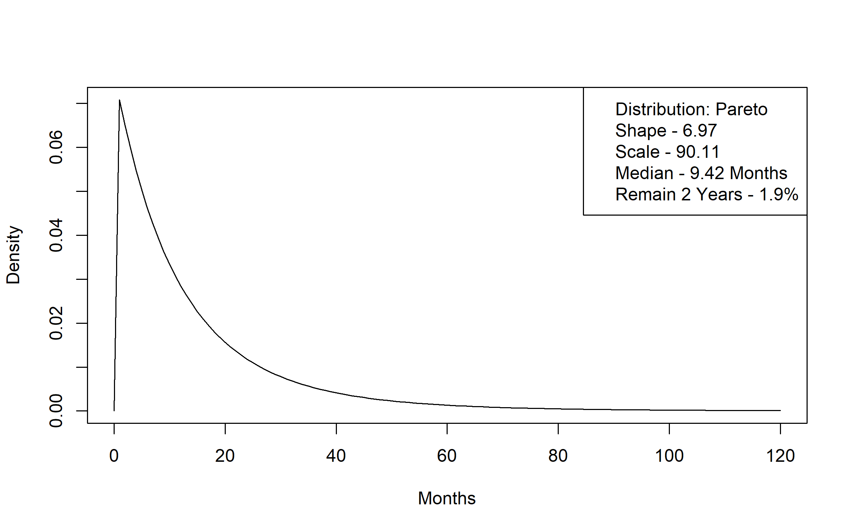
Figure A 28 Alternative Care to Death Time to Transition Distribution
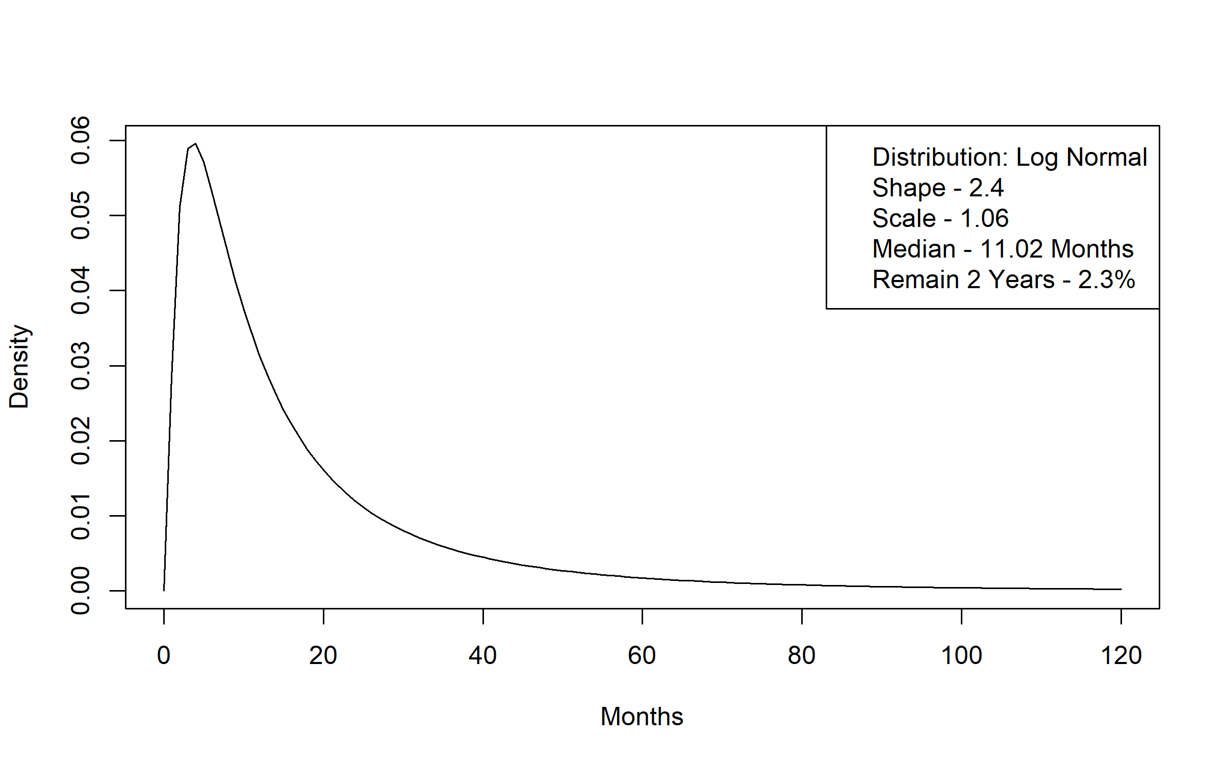
Figure A 29 Alternative Care Time to Elderly Waiver Community Time to Transition Distribution
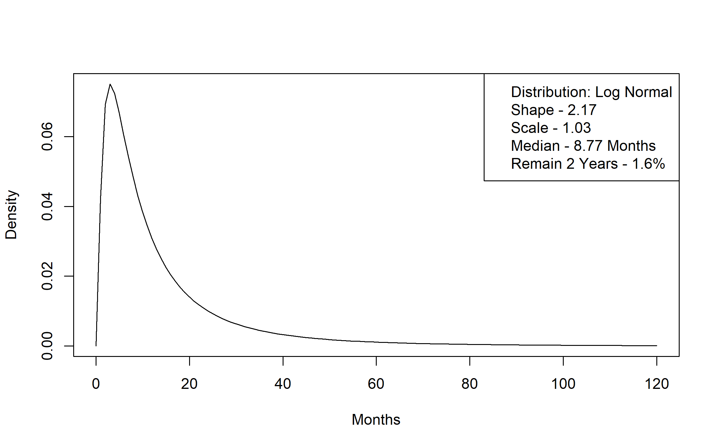
Figure A 30 Alternative Care Time to Elderly Waiver Residential Time to Transition Distribution
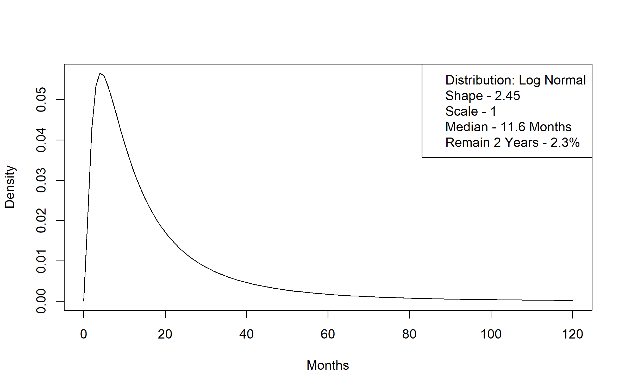
Figure A 31 Alternative Care Time to Medicaid Nursing Facility Time to Transition Distribution
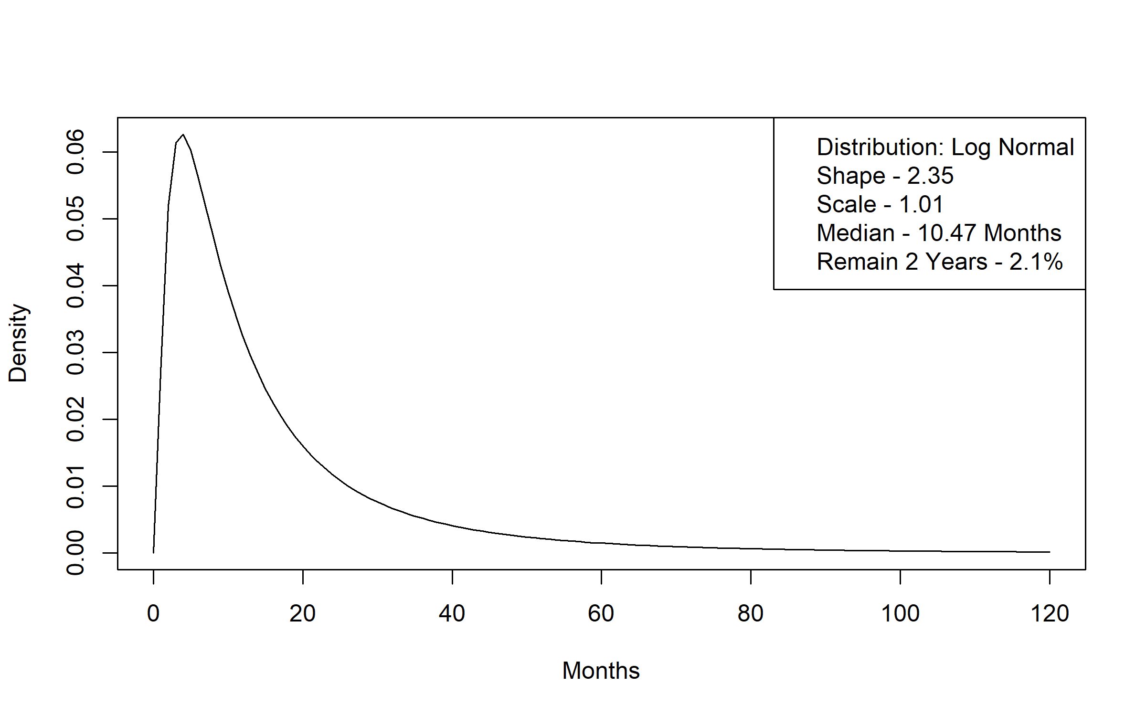
Figure A 32 Alternative Care Time to Medicaid without LTSS Time to Transition Distribution
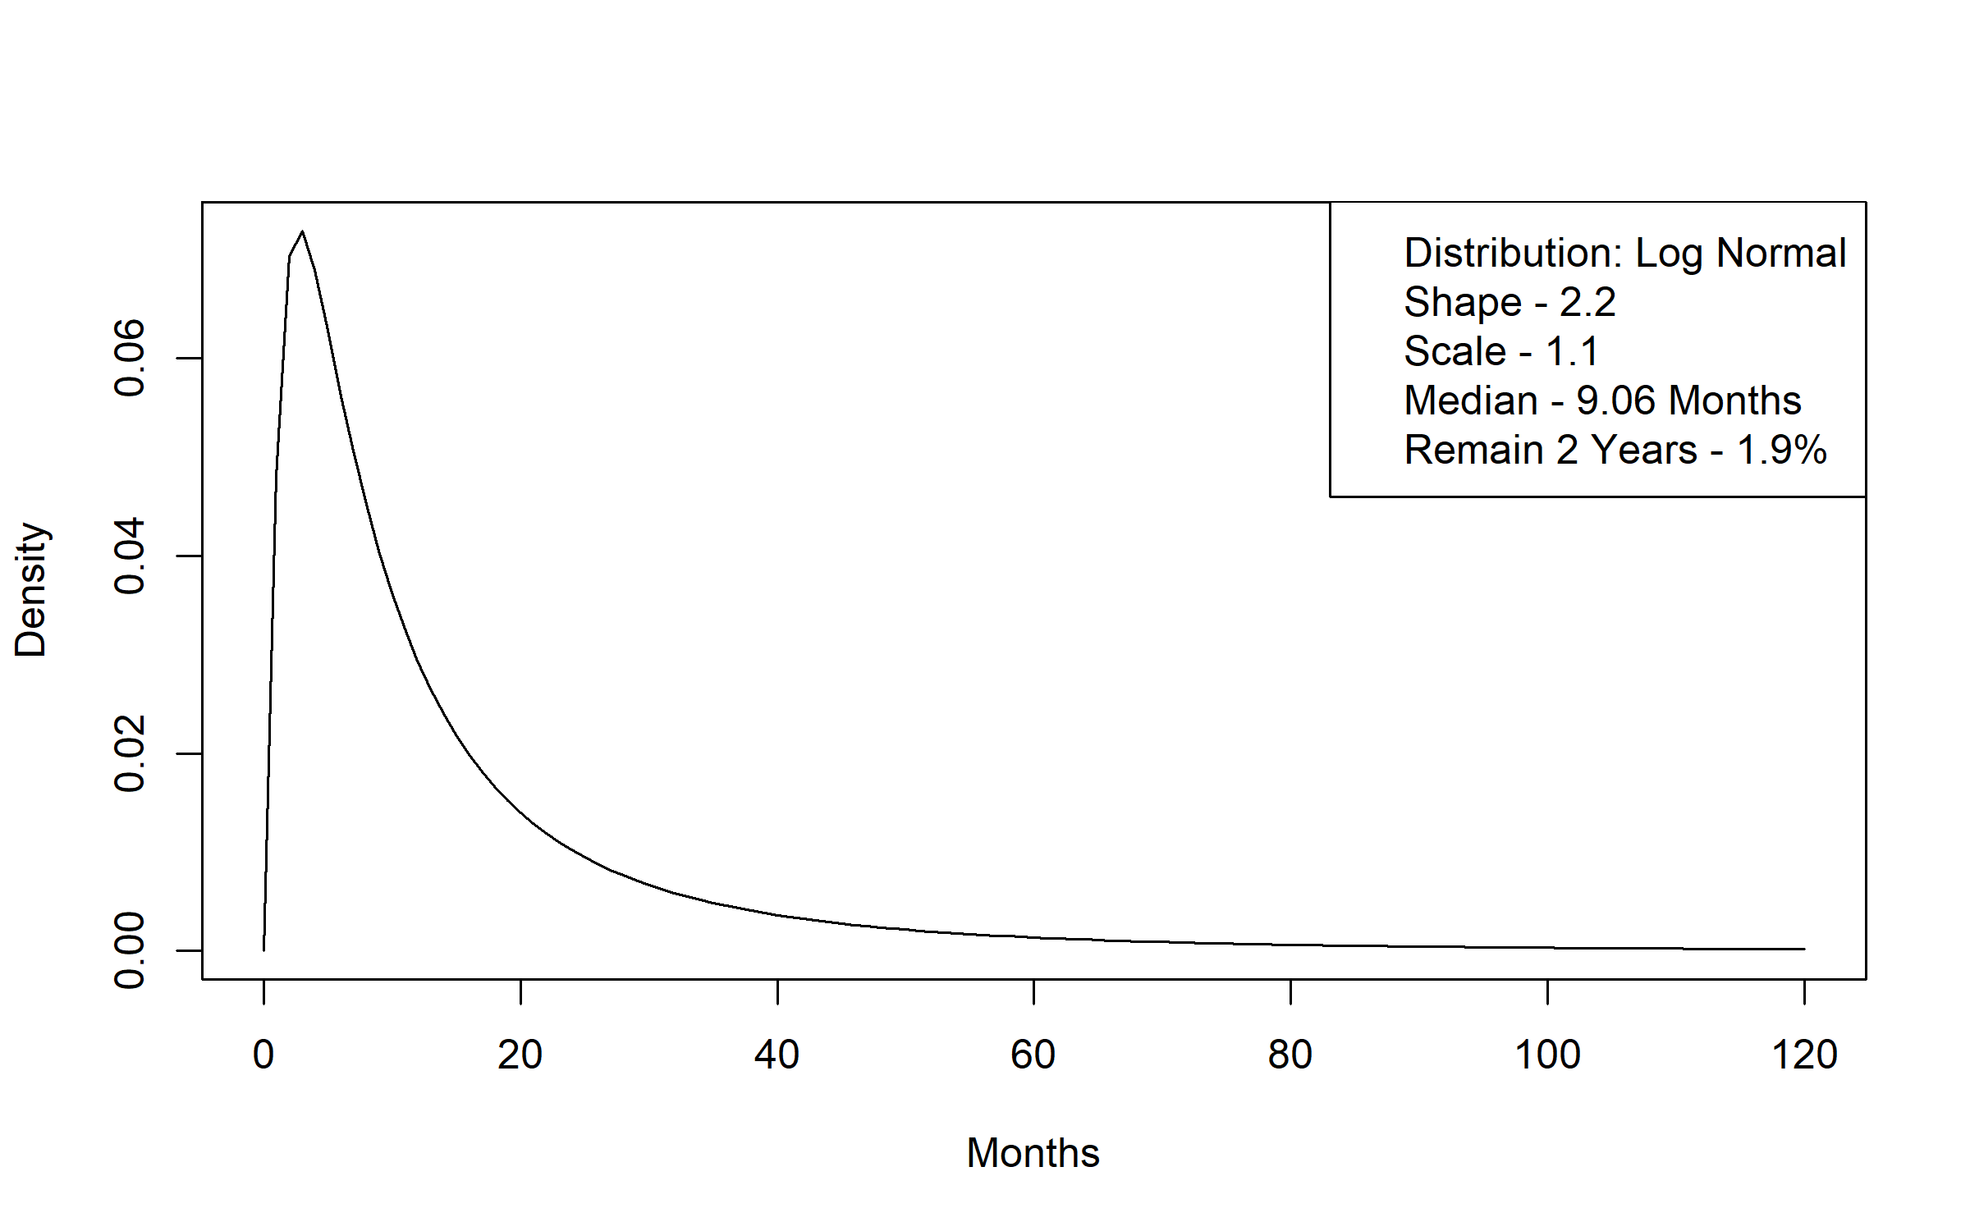
Figure A 33 Alternative Care Time to Personal Care Assistant without Waiver Time to Transition Distribution
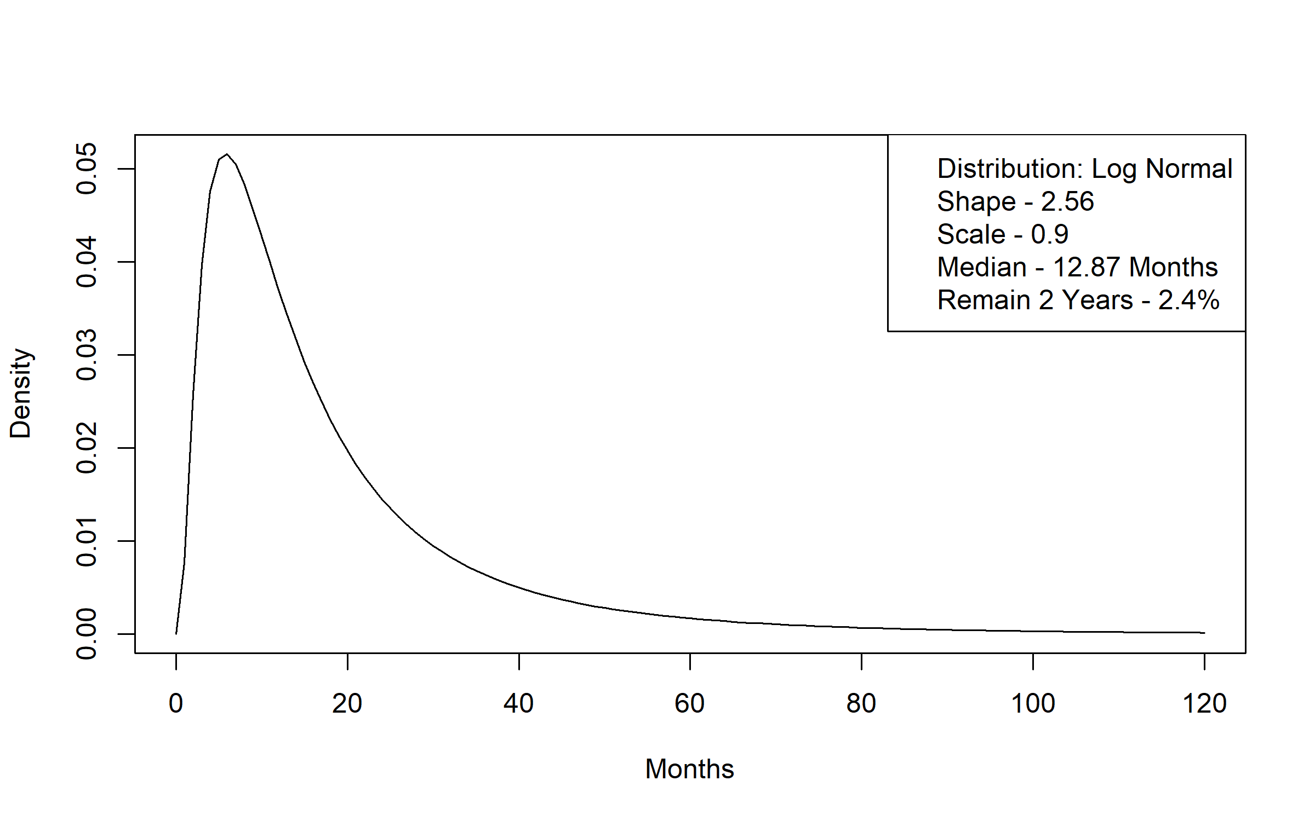
Figure A 34 Alternative Care Time to Non-Medicaid Nursing Facility Time to Transition Distribution
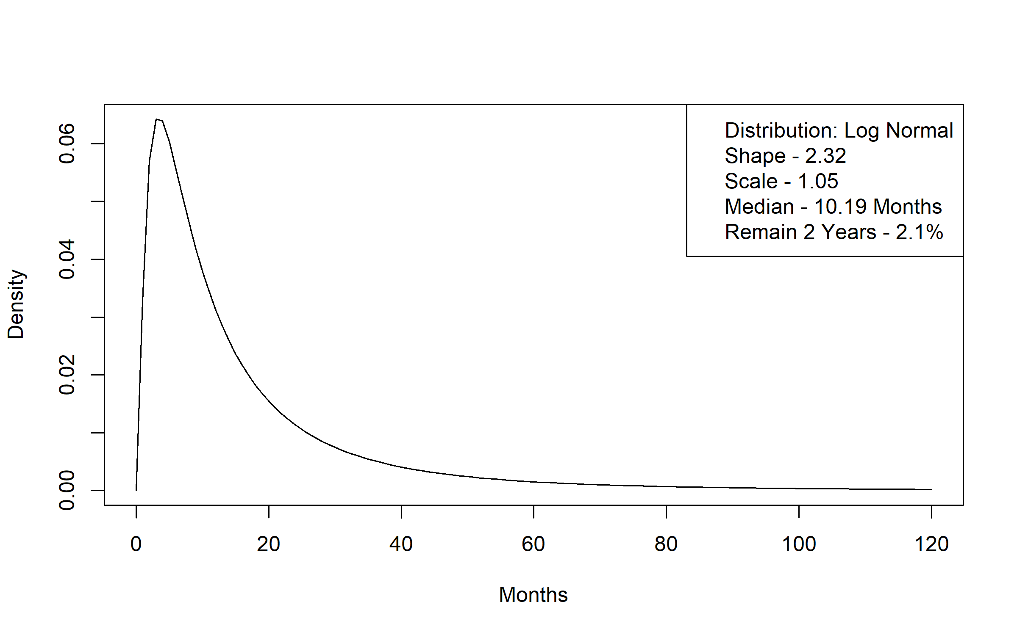
Figure A 35 Alternative Care Time to Non-Medicaid no LTSS Time to Transition Distribution
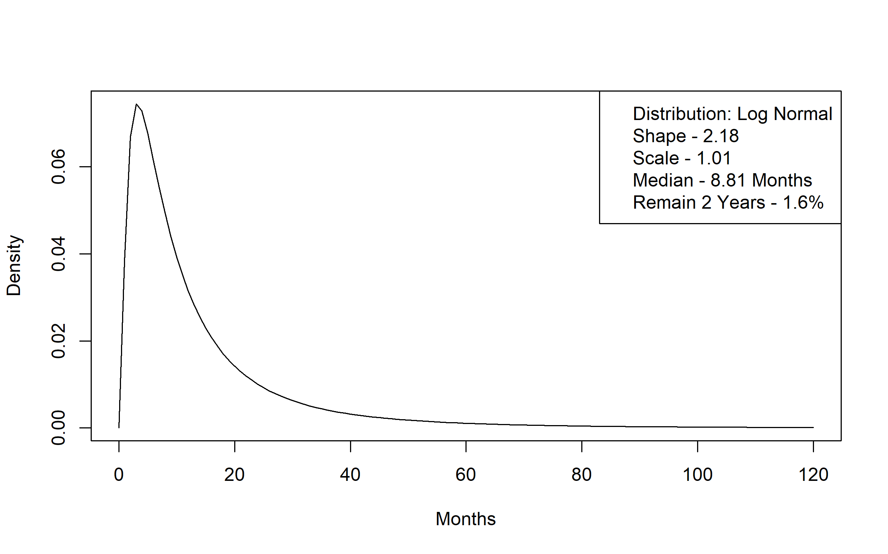
Figure A 36 Non-Medicaid Nursing Facility (91+ Day Stay) to Death Transition Distribution
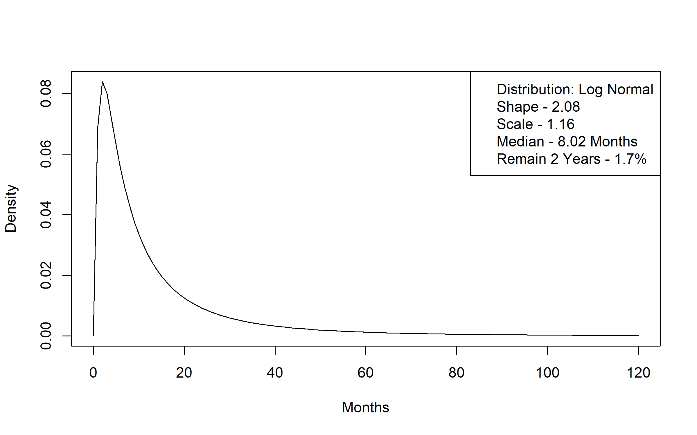
Figure A 37 Non-Medicaid Nursing Facility (91+ Day Stay) to Elderly Waiver Residential Time to Transition Distribution
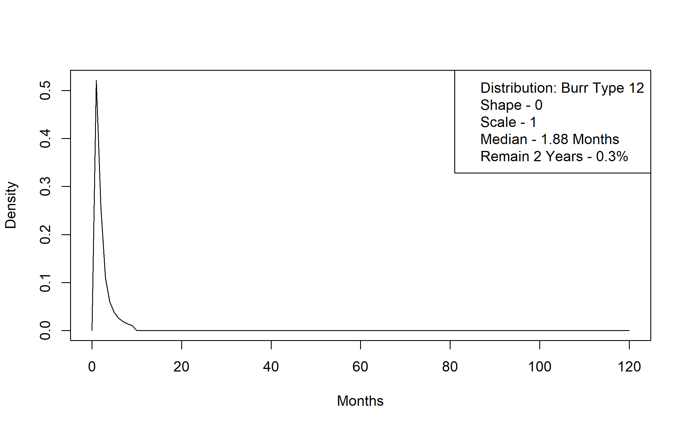
Figure A 38 Non-Medicaid Nursing Facility (91+ Day Stay) to Medicaid Nursing Facility Time to Transition Distribution
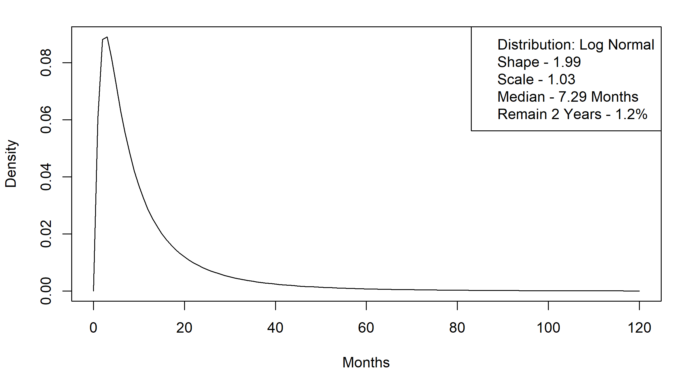
Figure A 39 Non-Medicaid Nursing Facility (91+ Day Stay) to Medicaid no LTSS Time to Transition Distribution
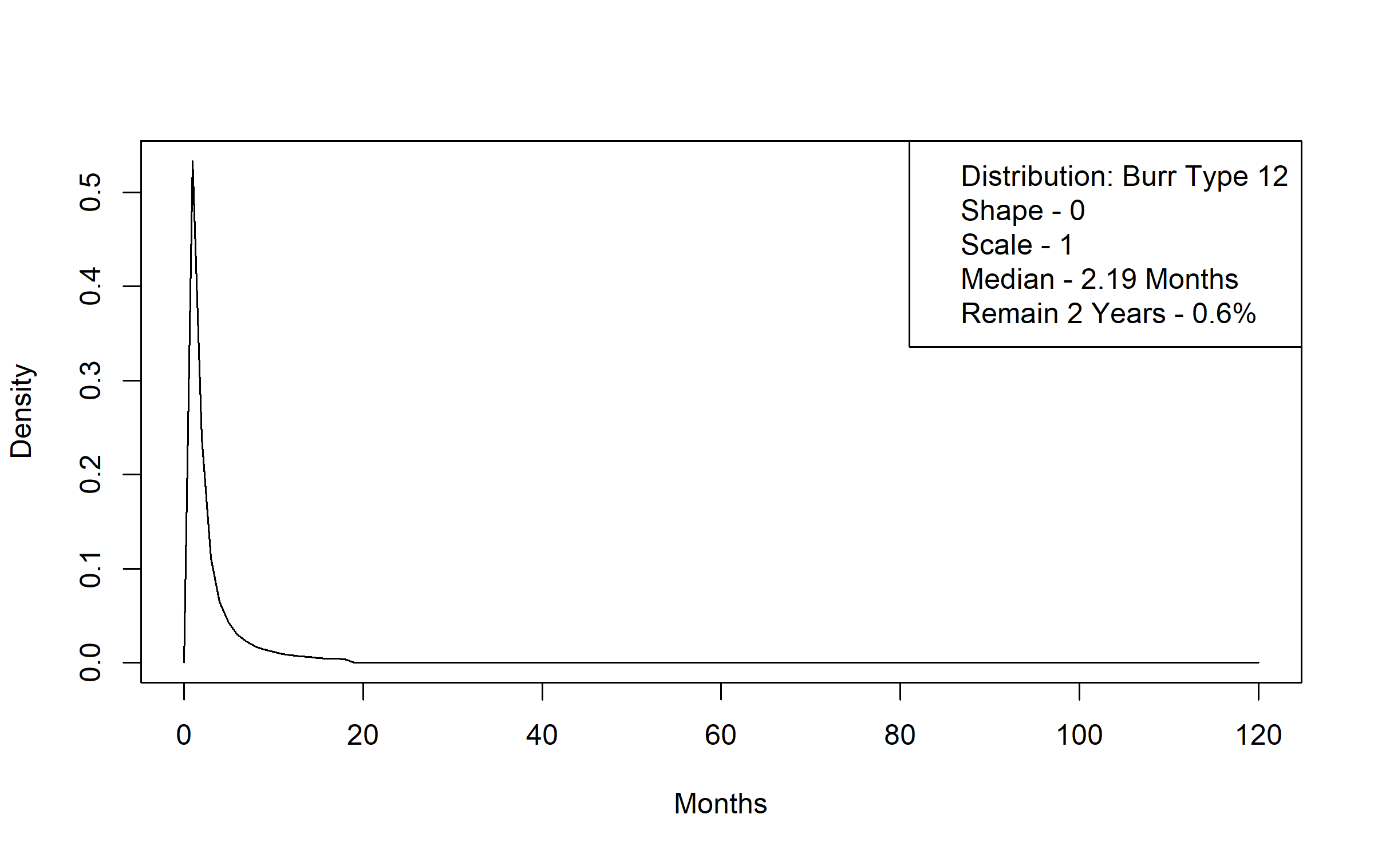
Figure A 40 Non-Medicaid Nursing Facility (91+ Day Stay) to Alternative Care Time to Transition Distribution
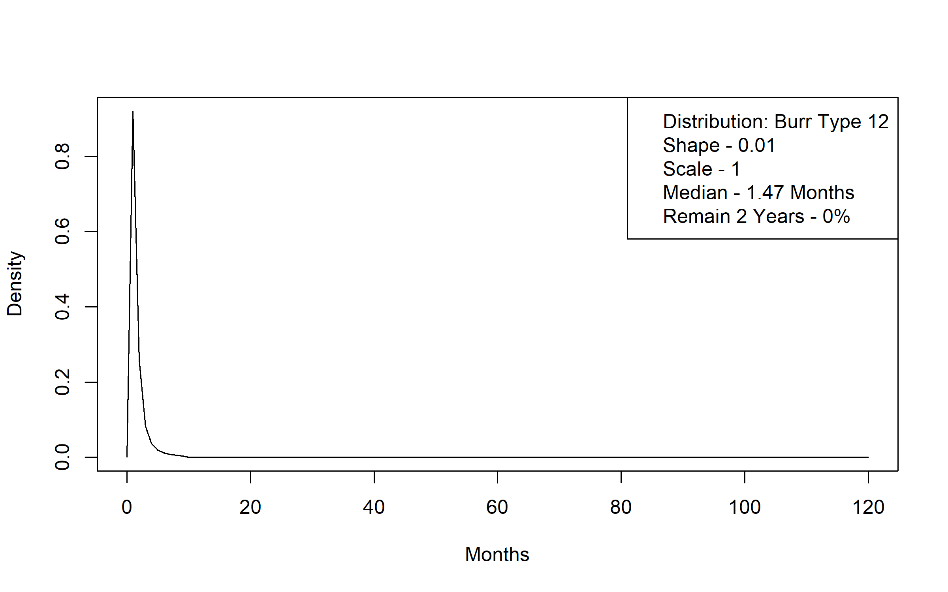
Figure A 41 Non-Medicaid Nursing Facility (91+ Day Stay) to Non-Medicaid no LTSS Time to Transition Distribution
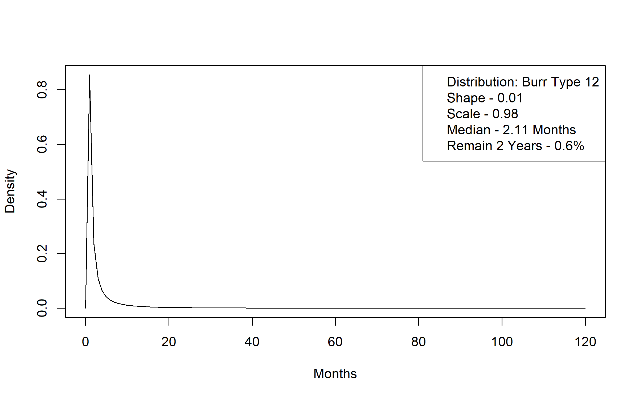
Figure A 42 Non-Medicaid no LTSS to Death Time to Transition Distribution
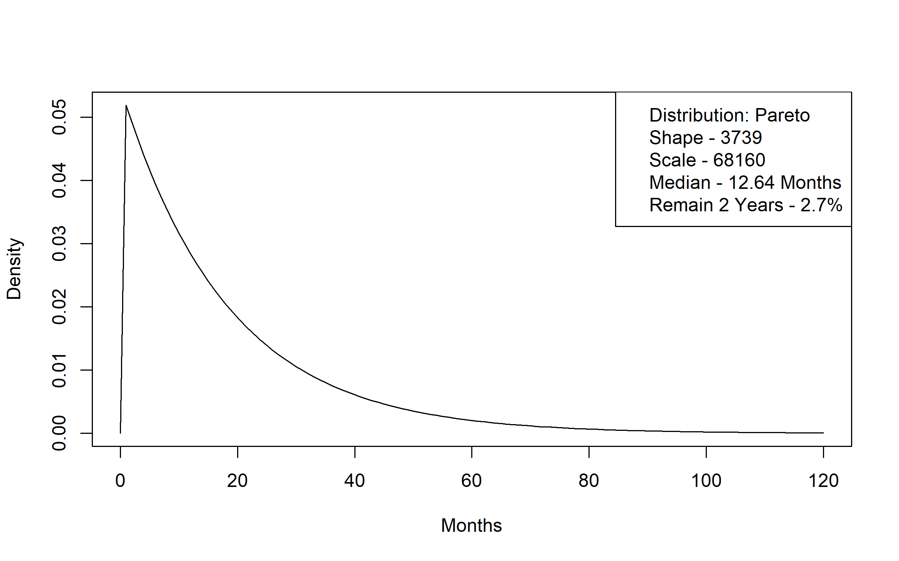
Figure A 43 Non-Medicaid no LTSS to Elderly Waiver Community Time to Transition Distribution
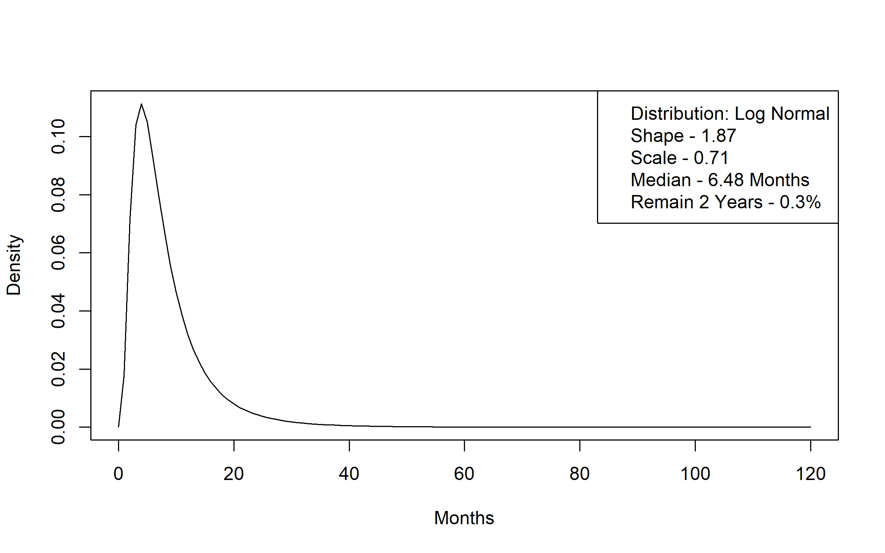
Figure A 44 Non-Medicaid no LTSS to Elderly Waiver Residential Time to Transition Distribution
Figure A 45 Non-Medicaid no LTSS to Medicaid Nursing Facility Time to Transition Distribution
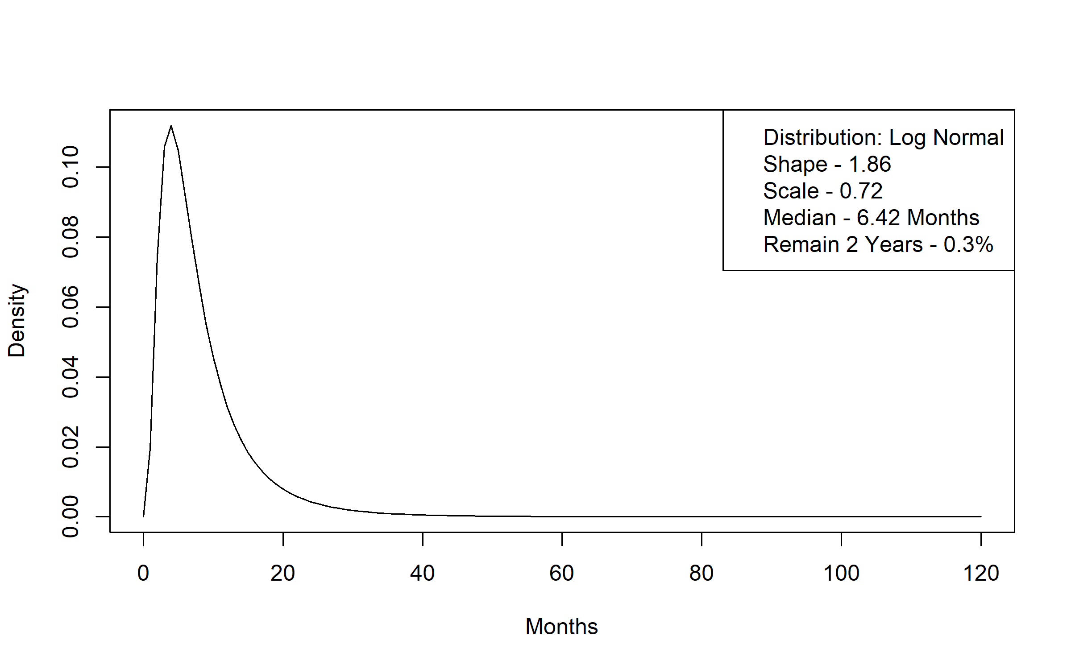
Figure A 46 Non-Medicaid no LTSS to Medicaid no LTSS Time to Transition Distribution
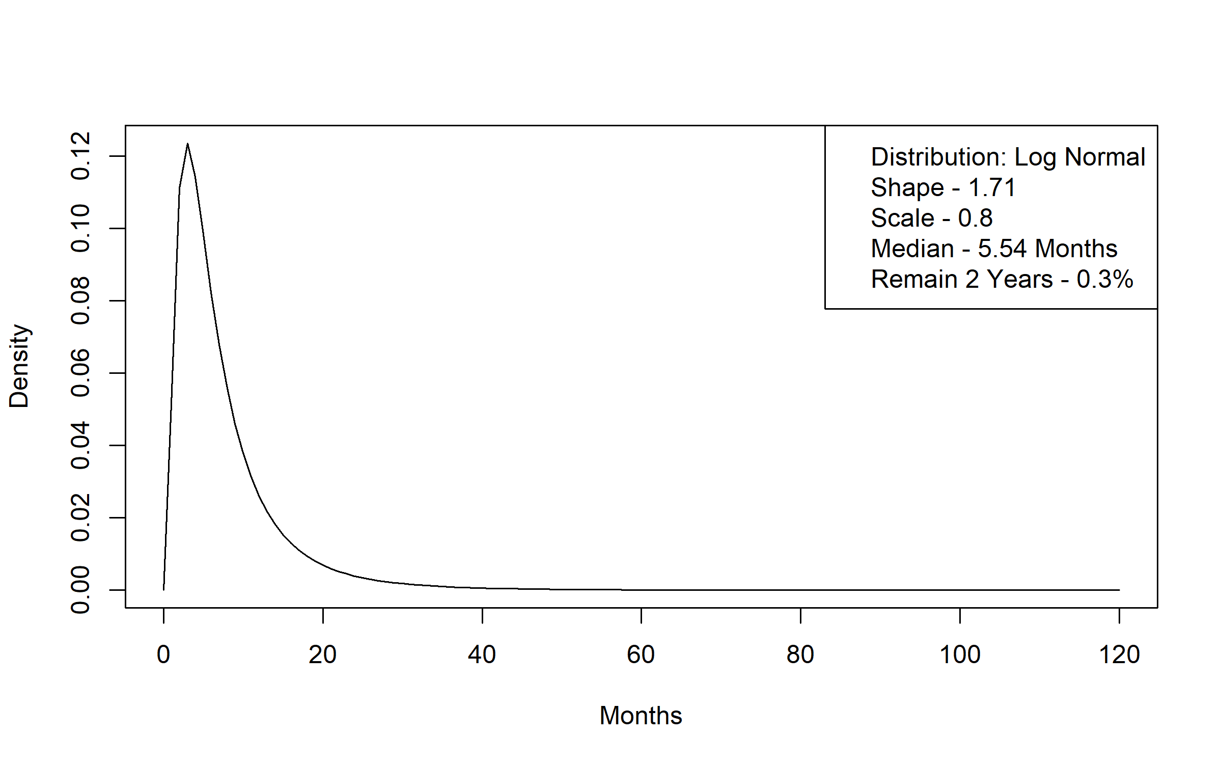
Figure A 47 Non-Medicaid no LTSS to Personal Care without a Waiver Time to Transition Distribution
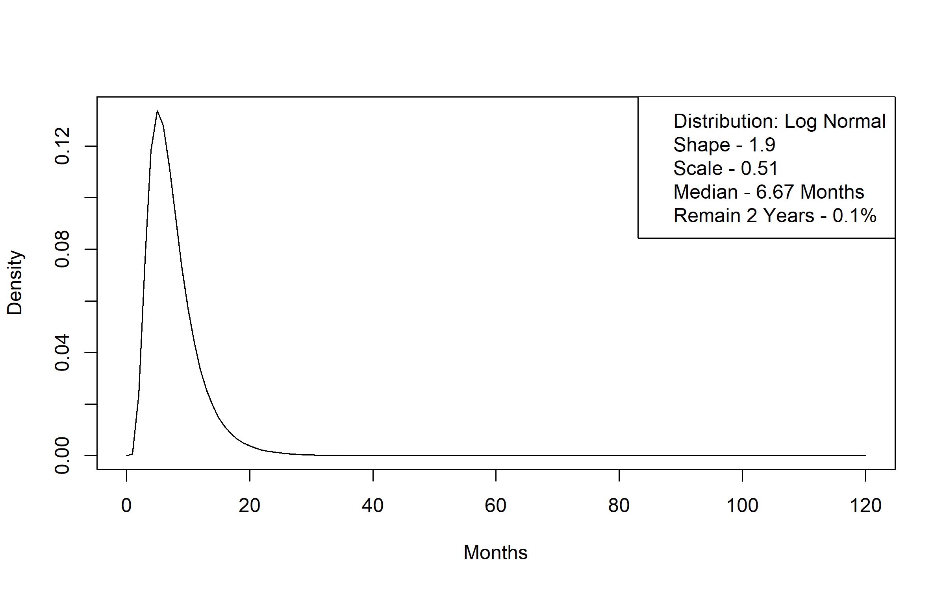
Figure A 48. Non-Medicaid no LTSS to Alternative Care Time to Transition Distribution
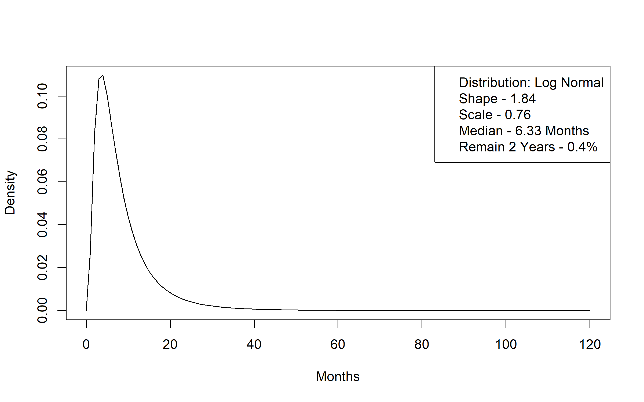

Figure A 49 Non-Medicaid no LTSS to Non-Medicaid Nursing Facility Time to Transition Distribution
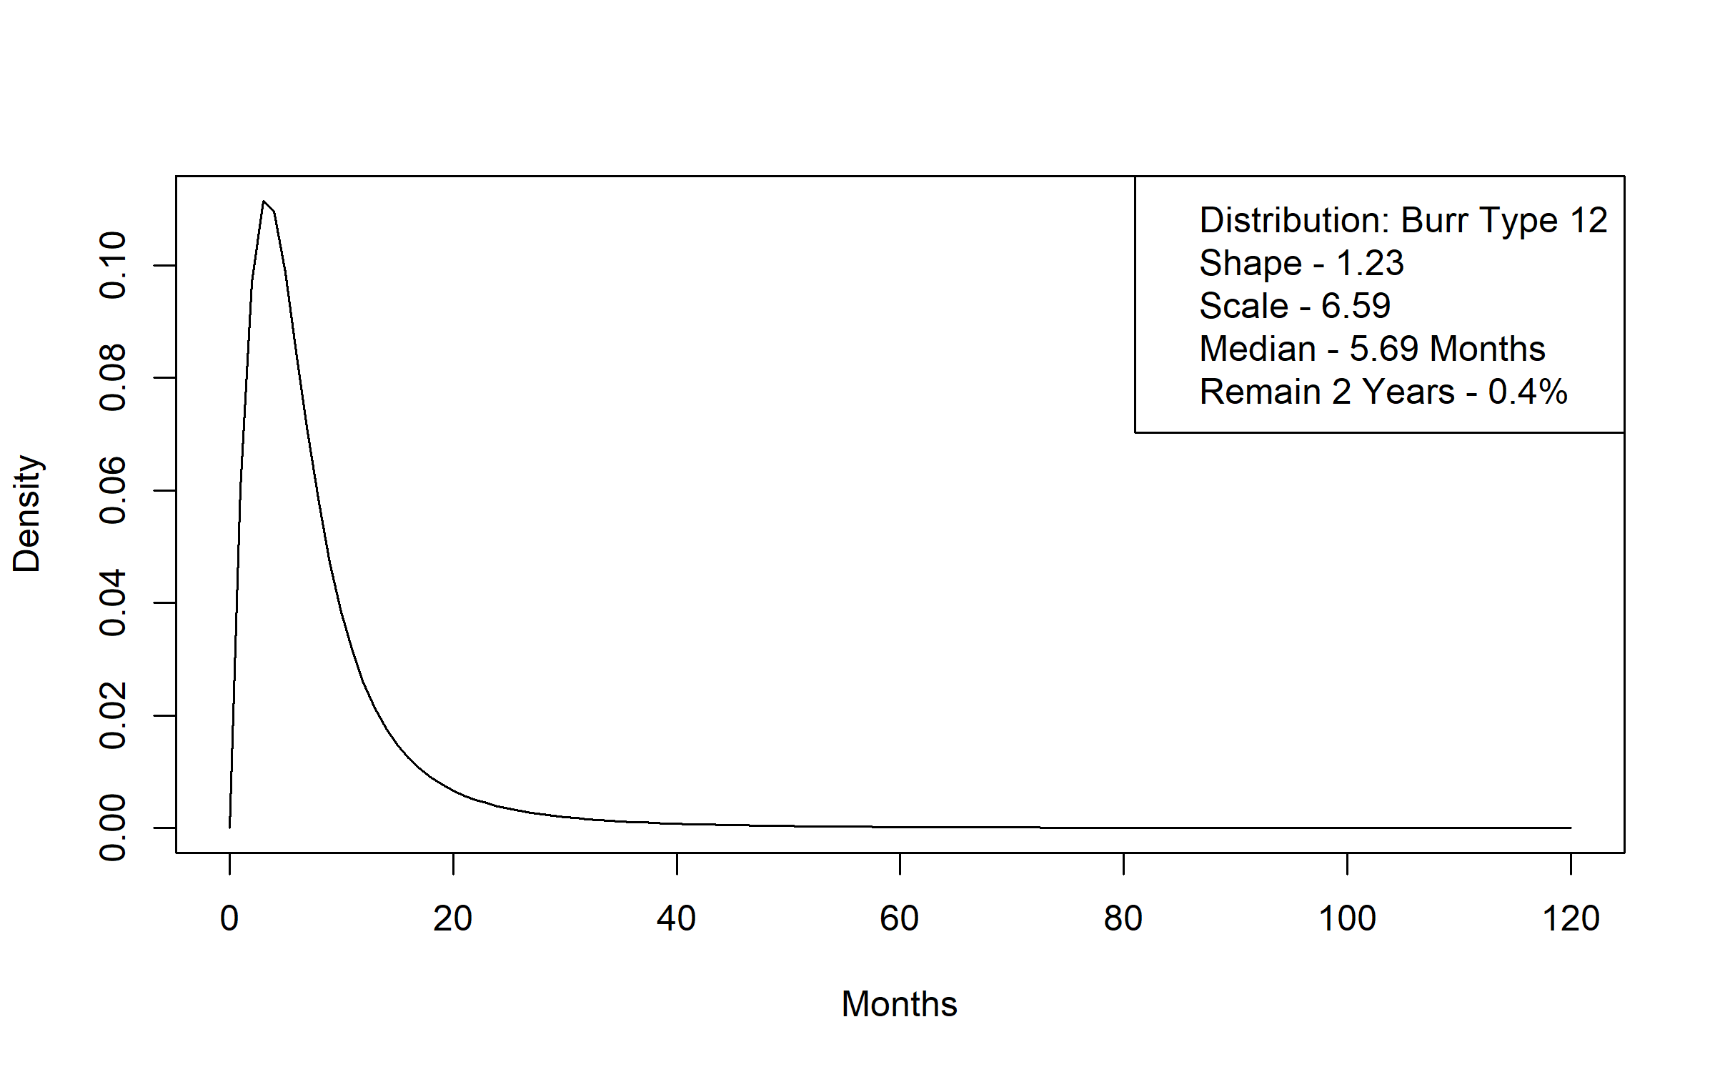

Table A.9 DHS Forecast Numbers used in Cost to Medicaid and Cost to Medicaid Growth Assumptions by Year and LTSS subgroup
 | 2023 | 2024 | 2025 | 2026 | 2027 | 2028 | 2029
EWC | 7.9% | 25.1% | 22.8% | 11.1% | 5.1% | 5.1% | 5.0%
EWR | 7.9% | 25.1% | 22.8% | 11.1% | 5.1% | 5.1% | 5.0%
MA NF | 9.7% | 11.2% | 3.1% | 4.3% | 5.8% | 4.9% | 4.3%
PCA | 3.5% | 7.3% | 20.7% | 9.3% | -0.6% | 2.1% | 1.6%
AC | 6.6% | 26.2% | 26.8% | 5.4% | 5.9% | 6.2% | 6.0%
NOT-MA NF | 9.7% | 11.2% | 3.1% | 4.3% | 5.8% | 4.9% | 4.3%
MA NF = Medicaid enrolled and residing in a Nursing Facility. EWR = Elderly Waiver Residential (primarily assisted living). EWC = Elderly Waiver living in Community setting. AC = Alternative Care. PCA = Personal Car Assistant not enrolled in a waiver program. NOT-MA NF = not Medicaid enrolled while residing in a Nursing Facility. DHS = Minnesota Department of Human Services. LTSS = Long Term Services and Supports.

Figure A 50. Assumed Monthly Nursing Facility Users per 1 Million Population for Females Age 65-74 across Scenarios
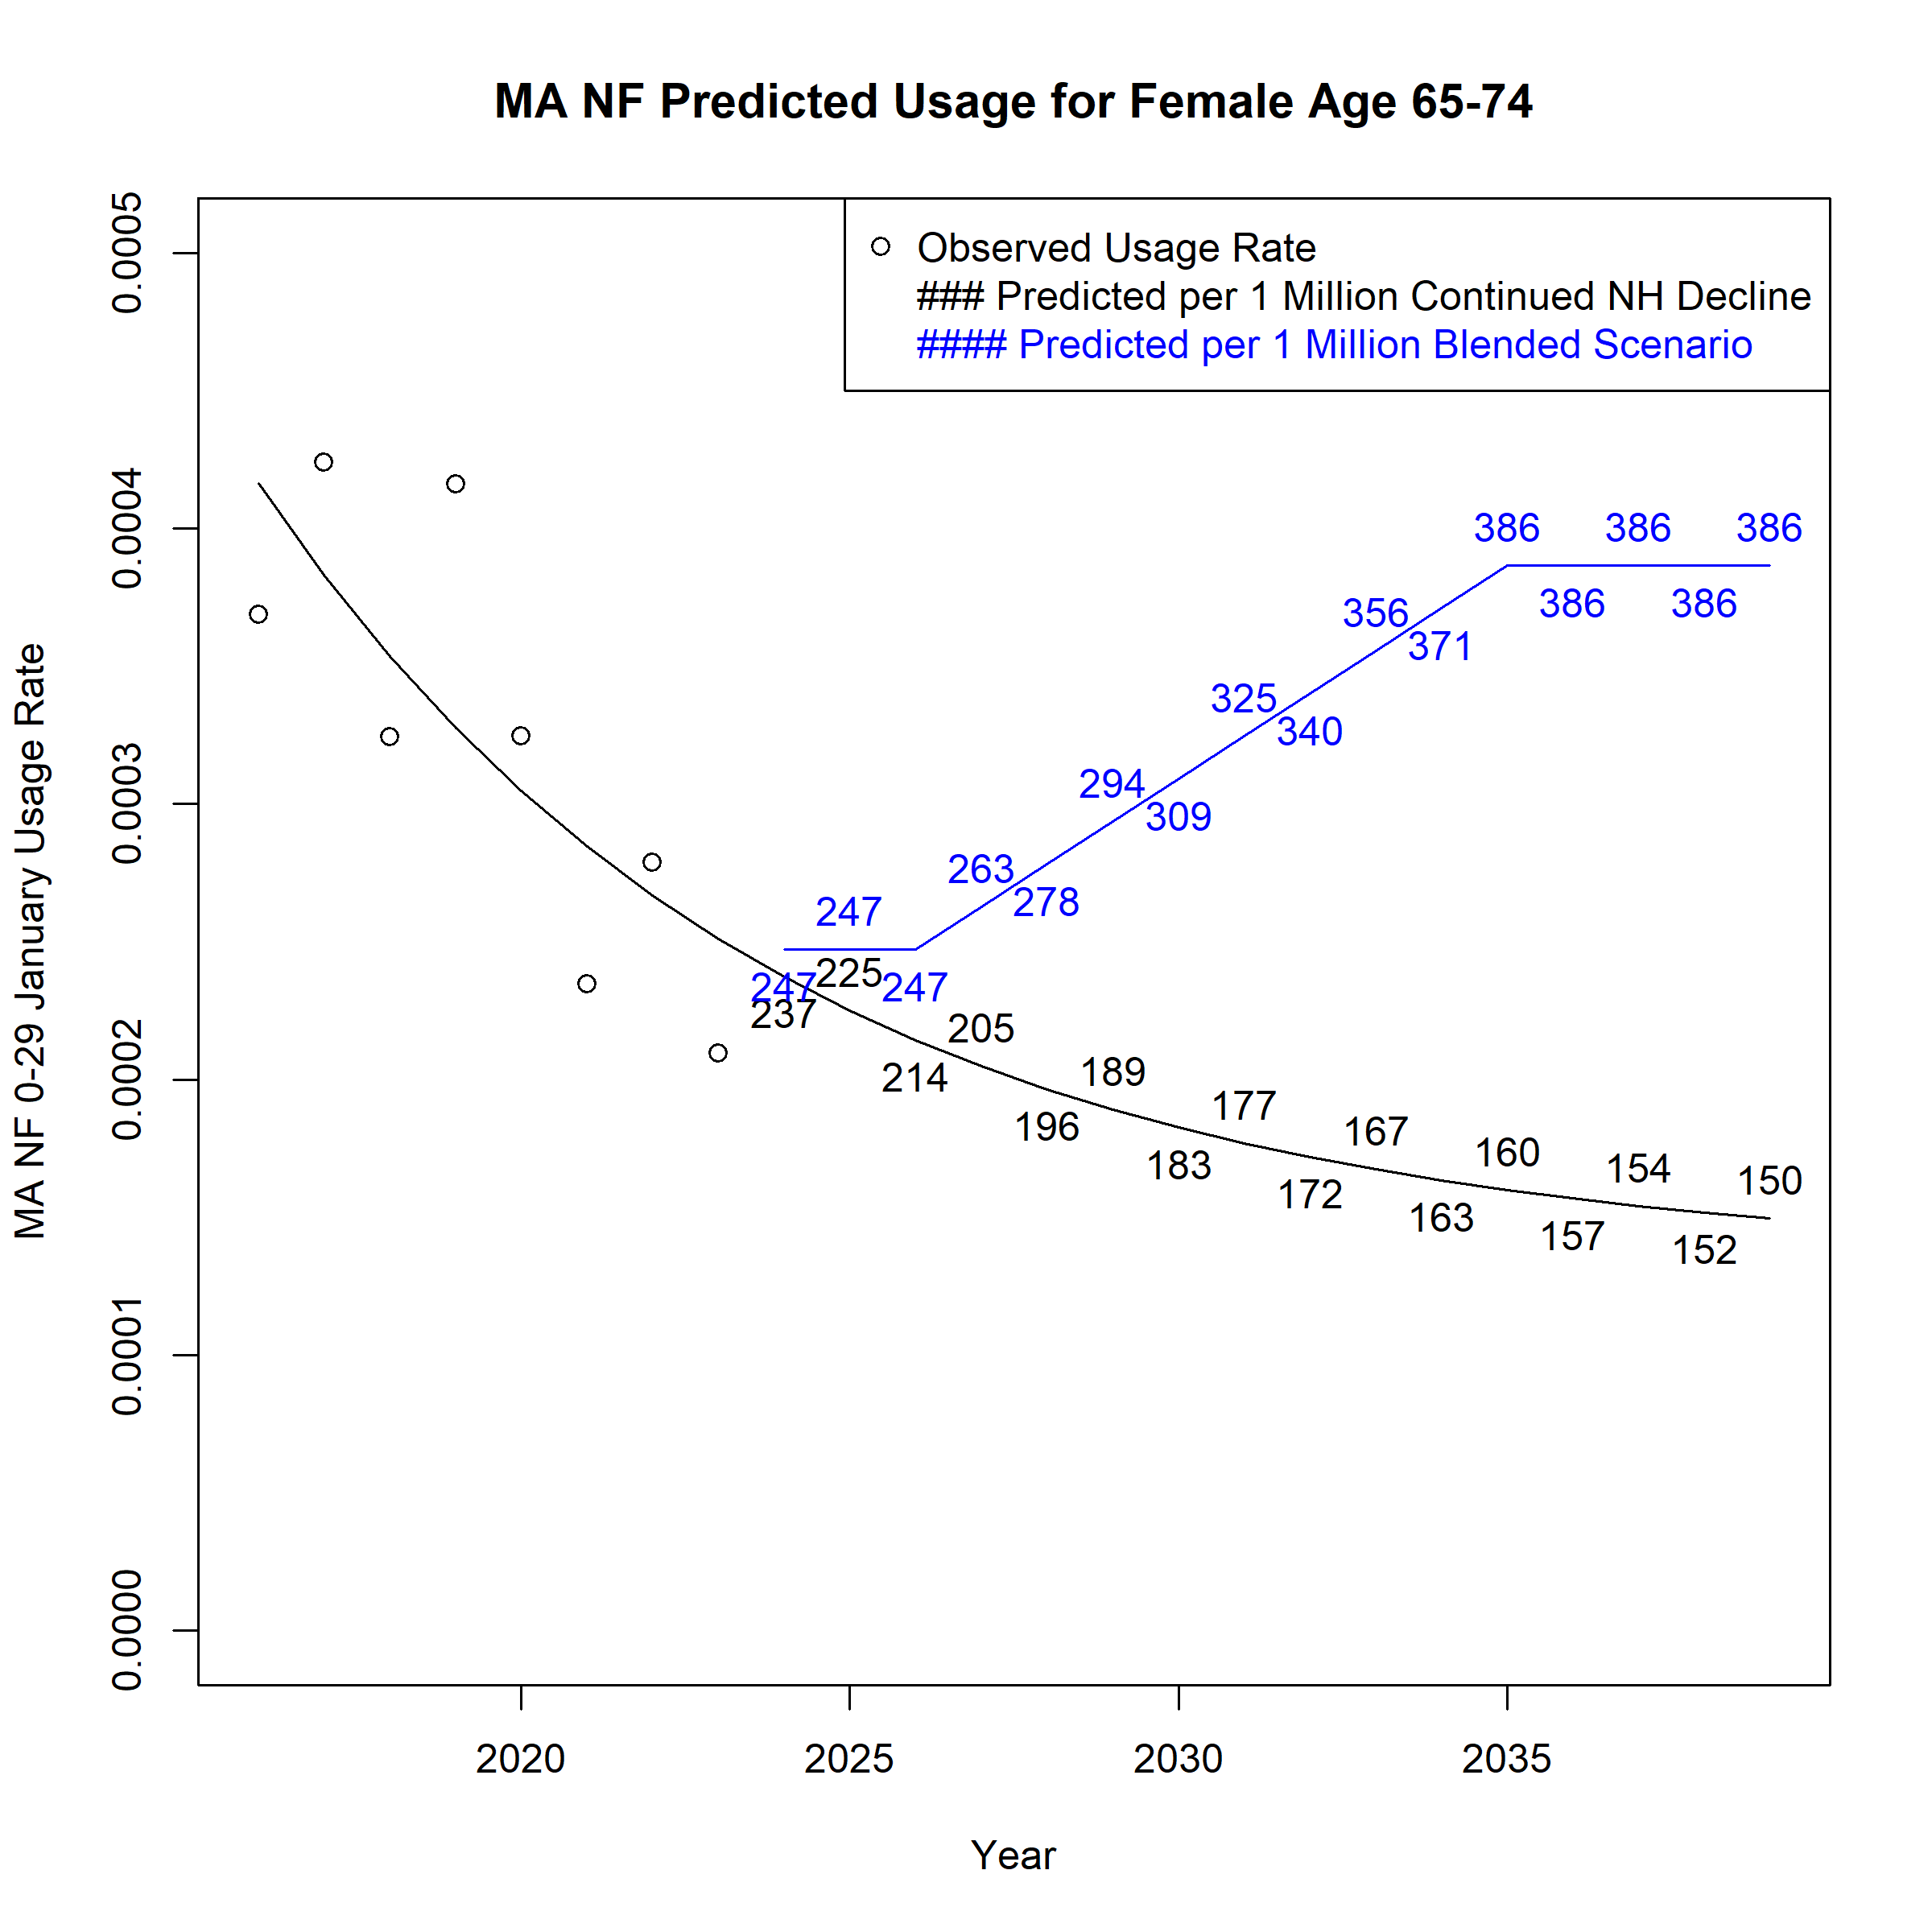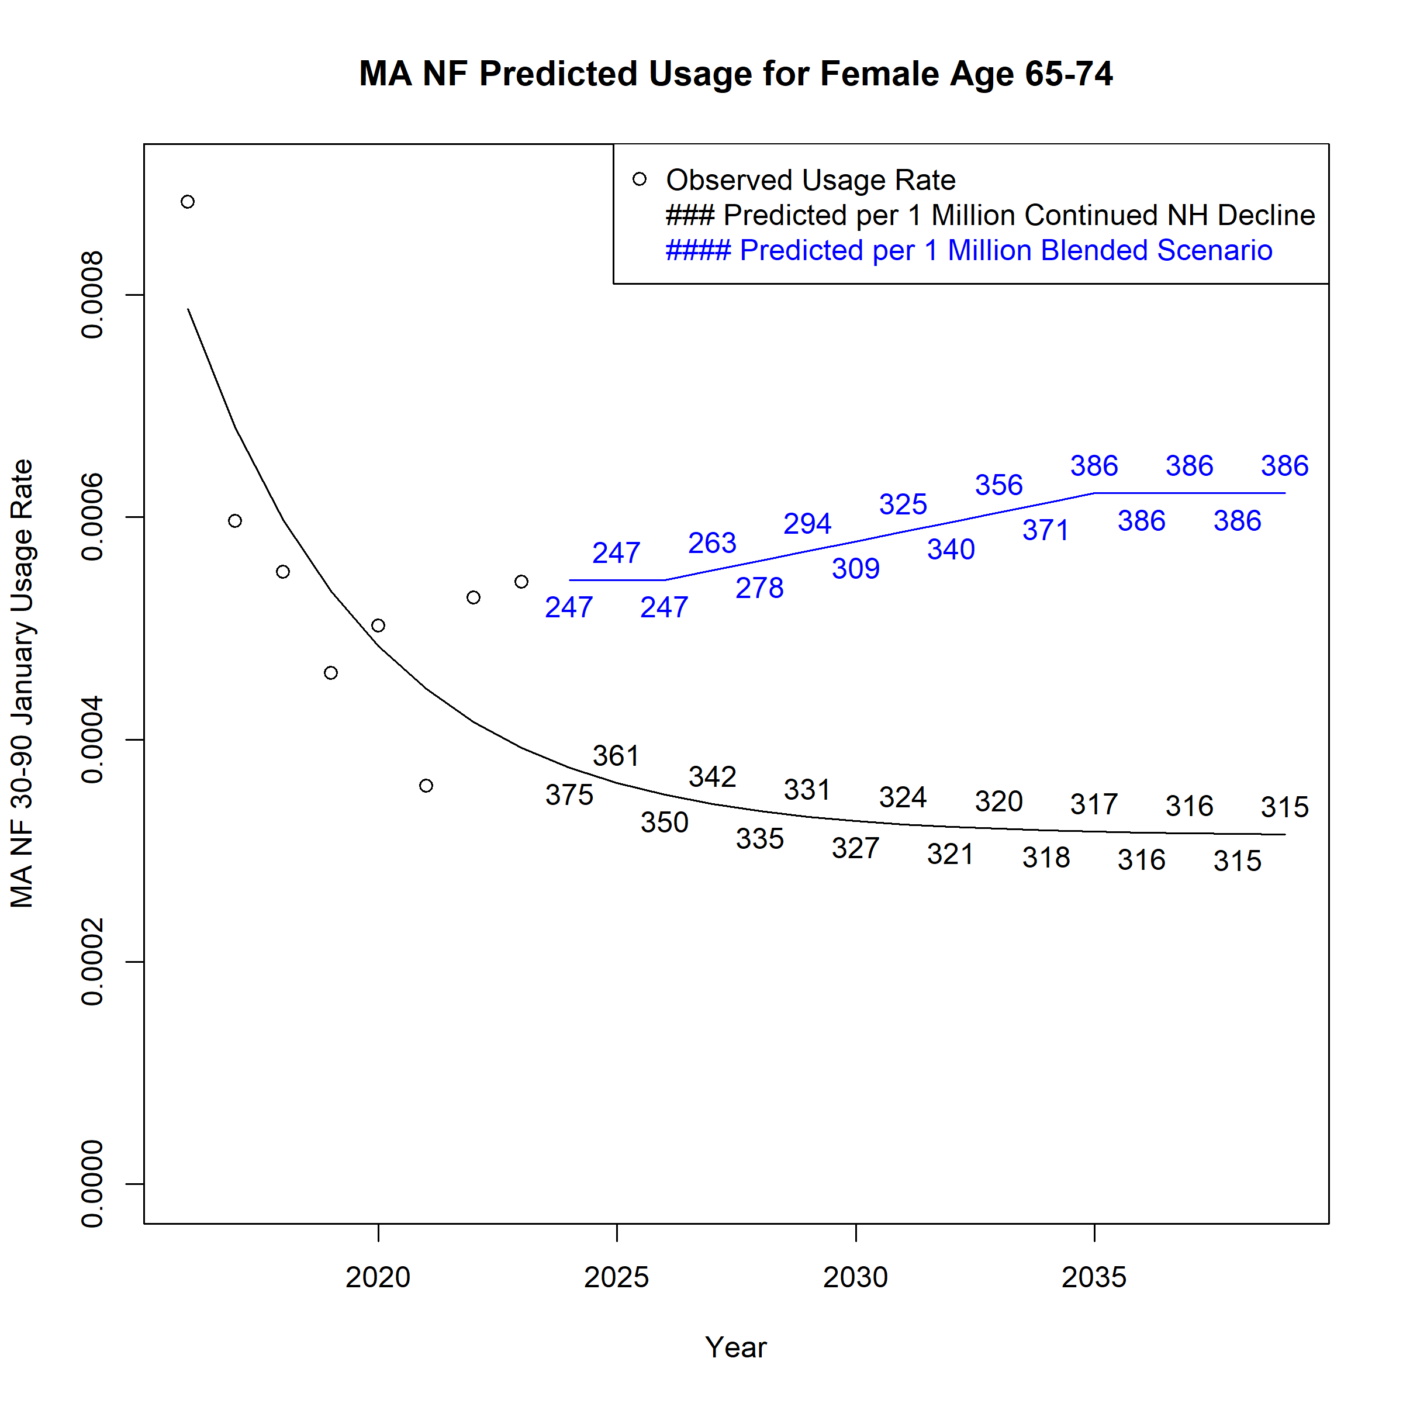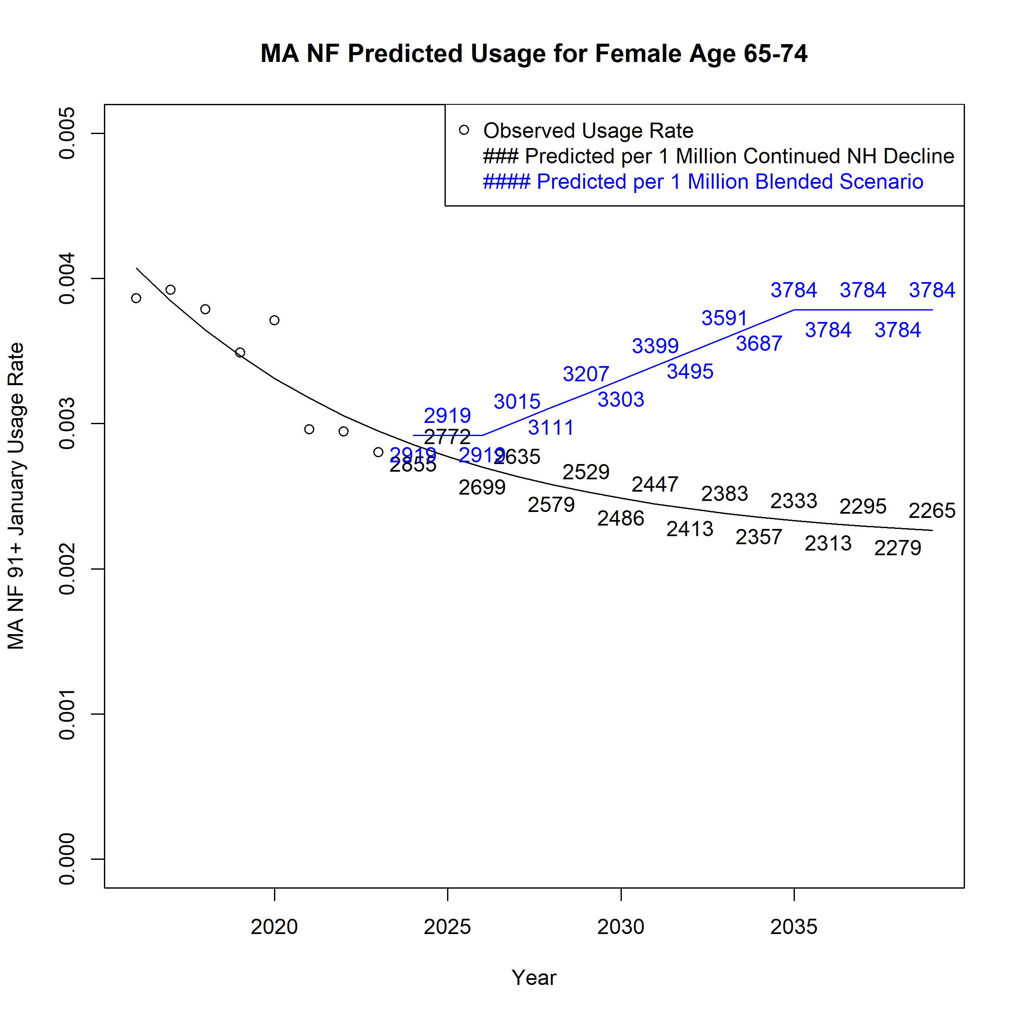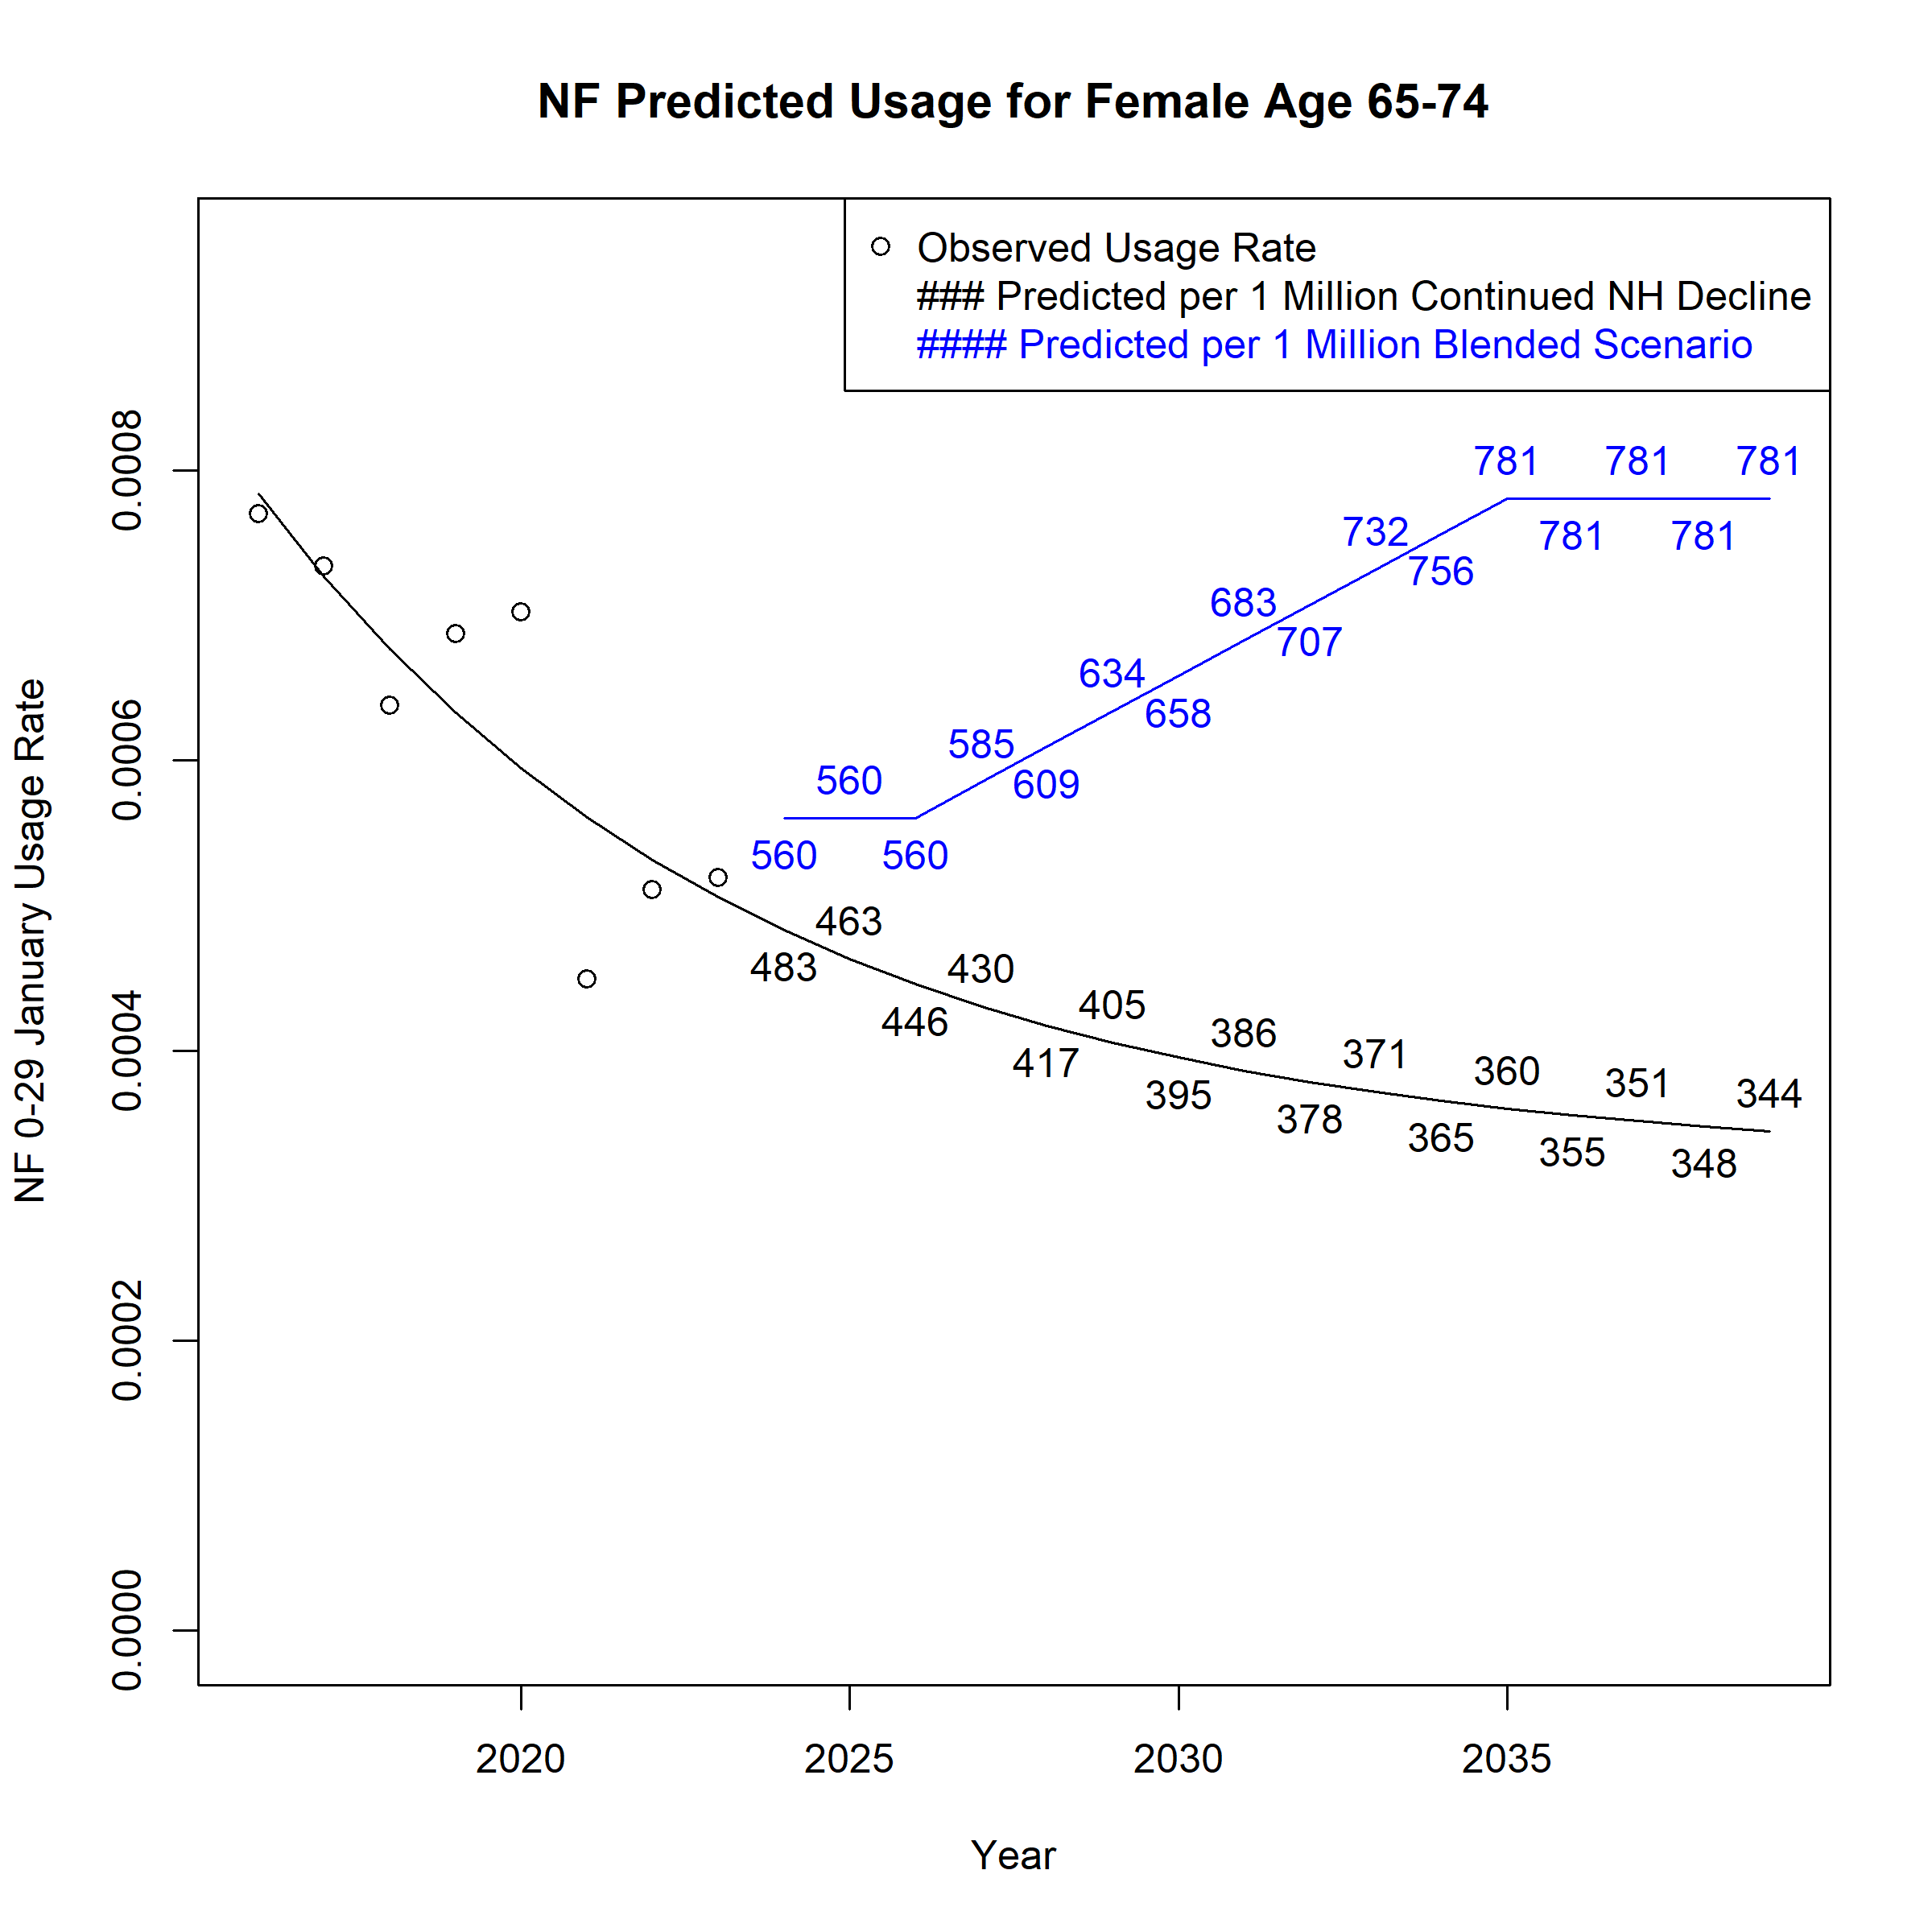
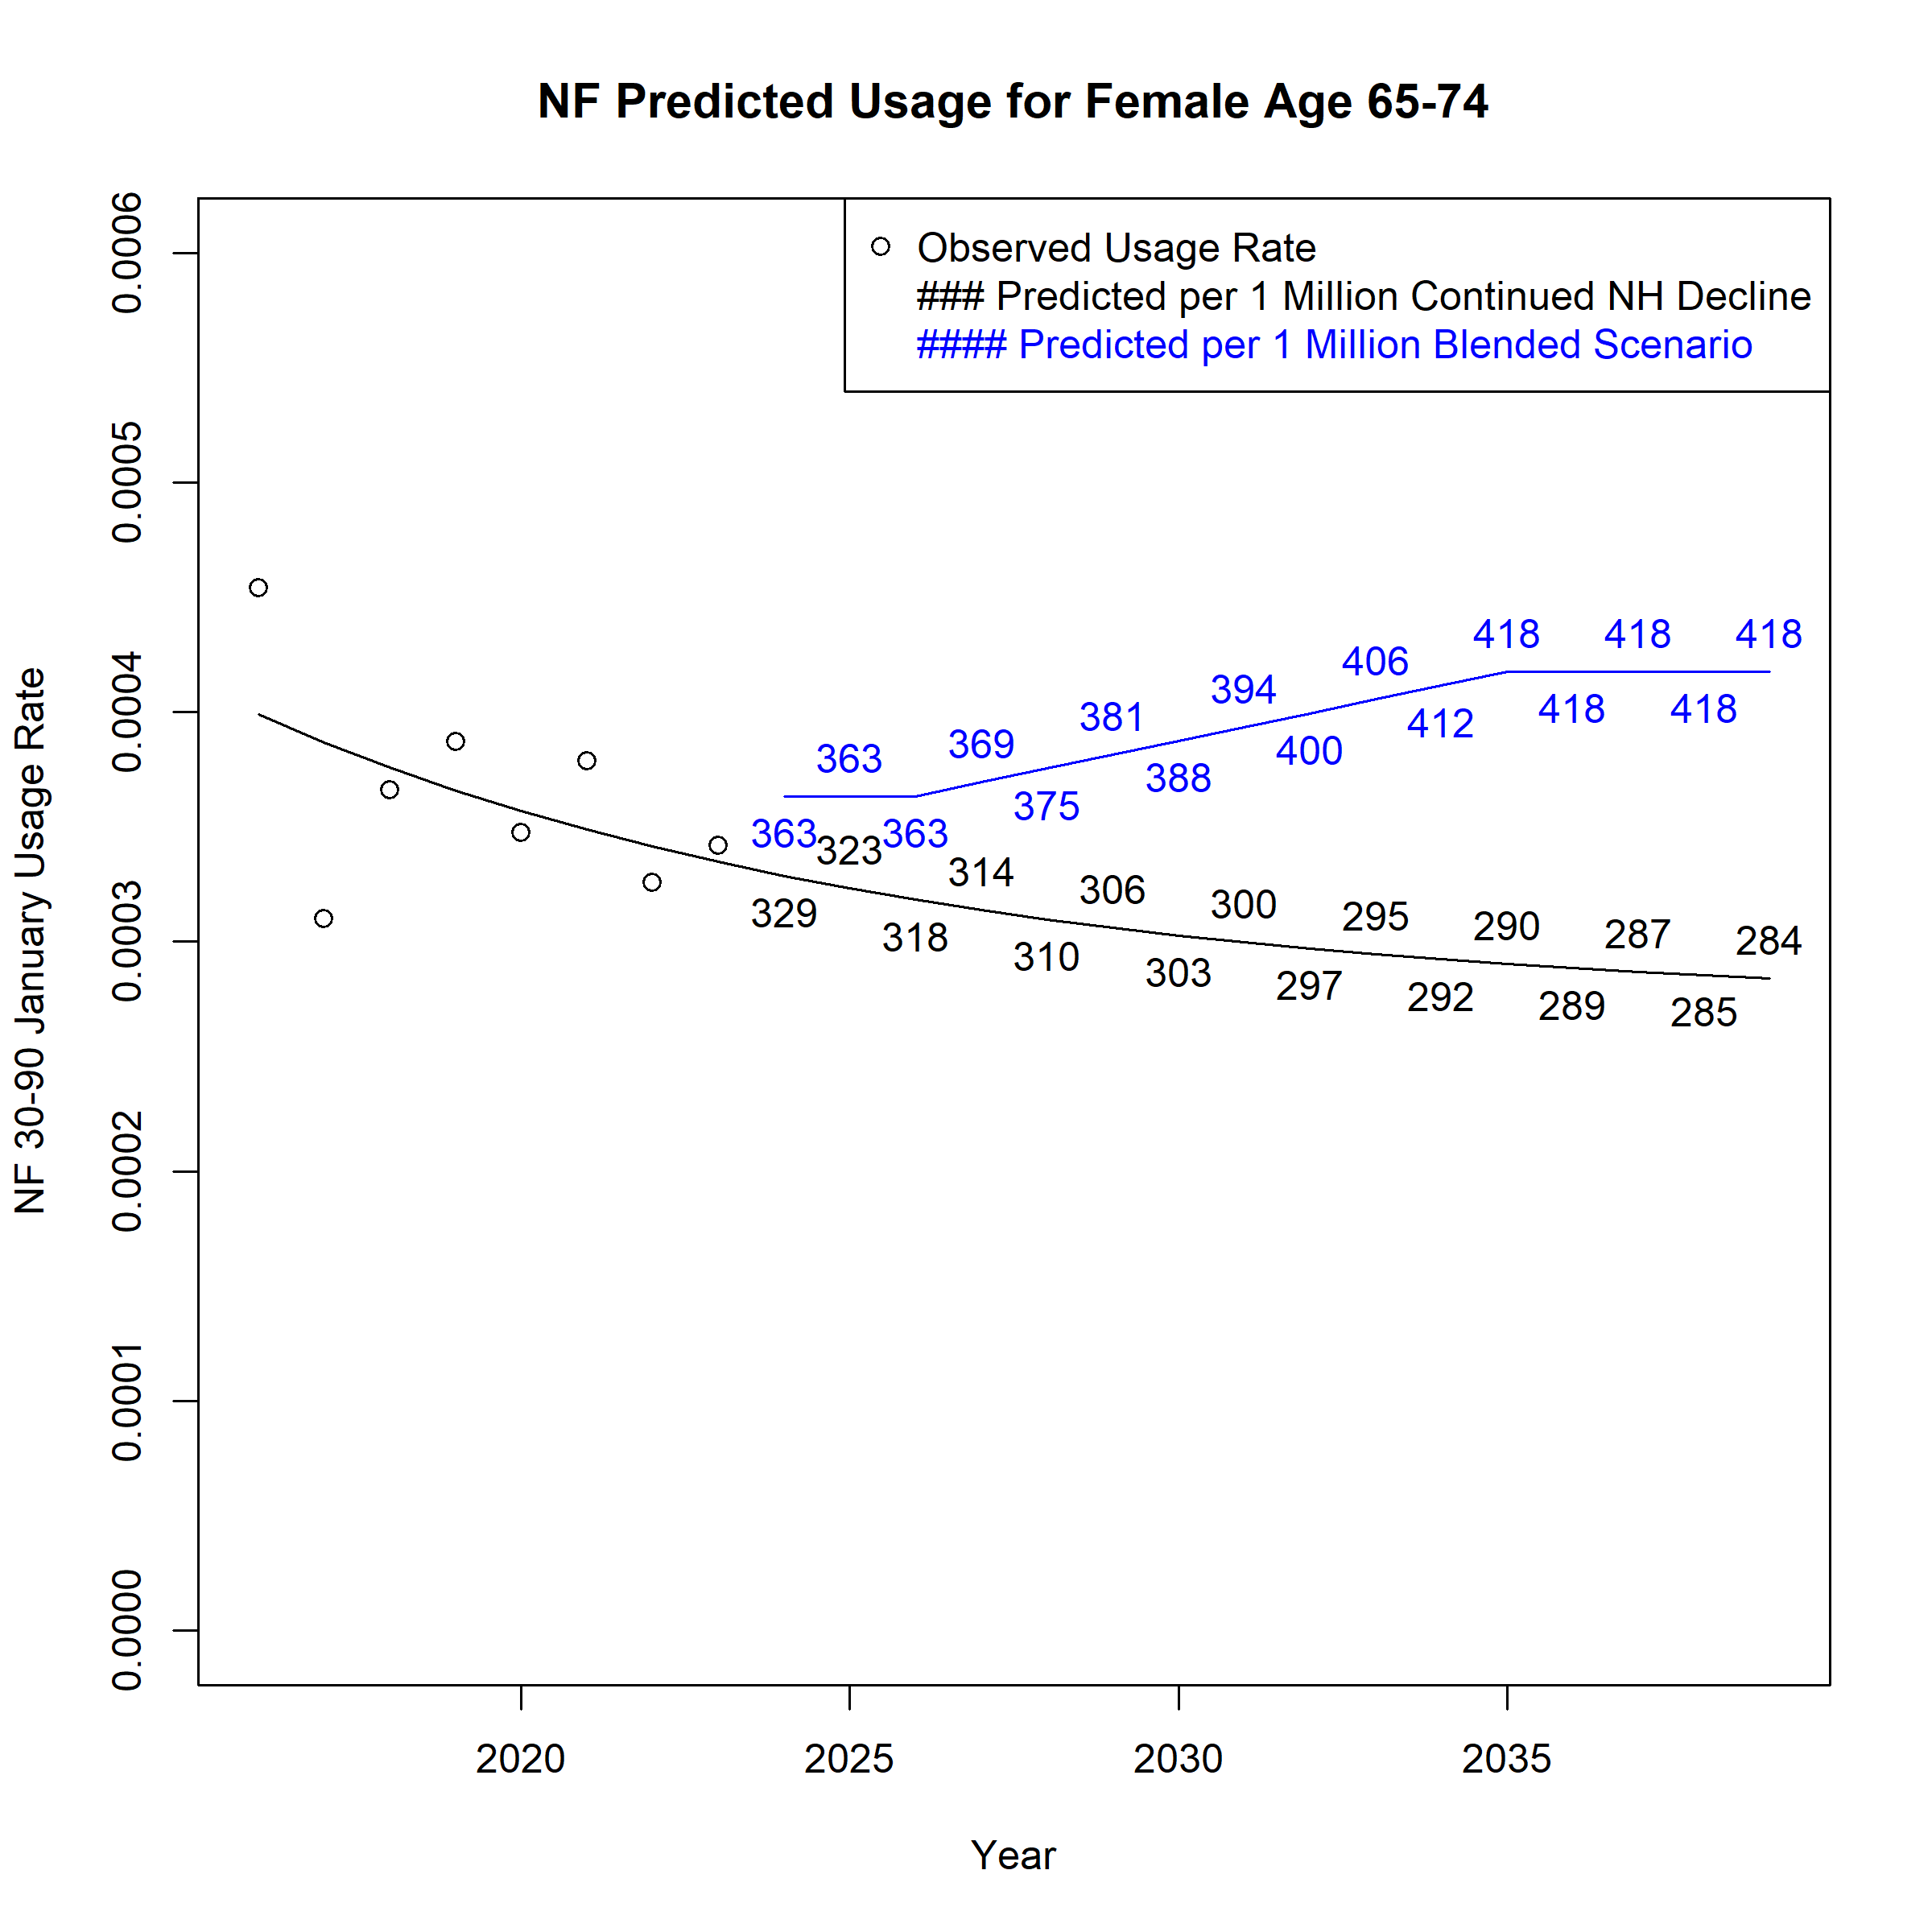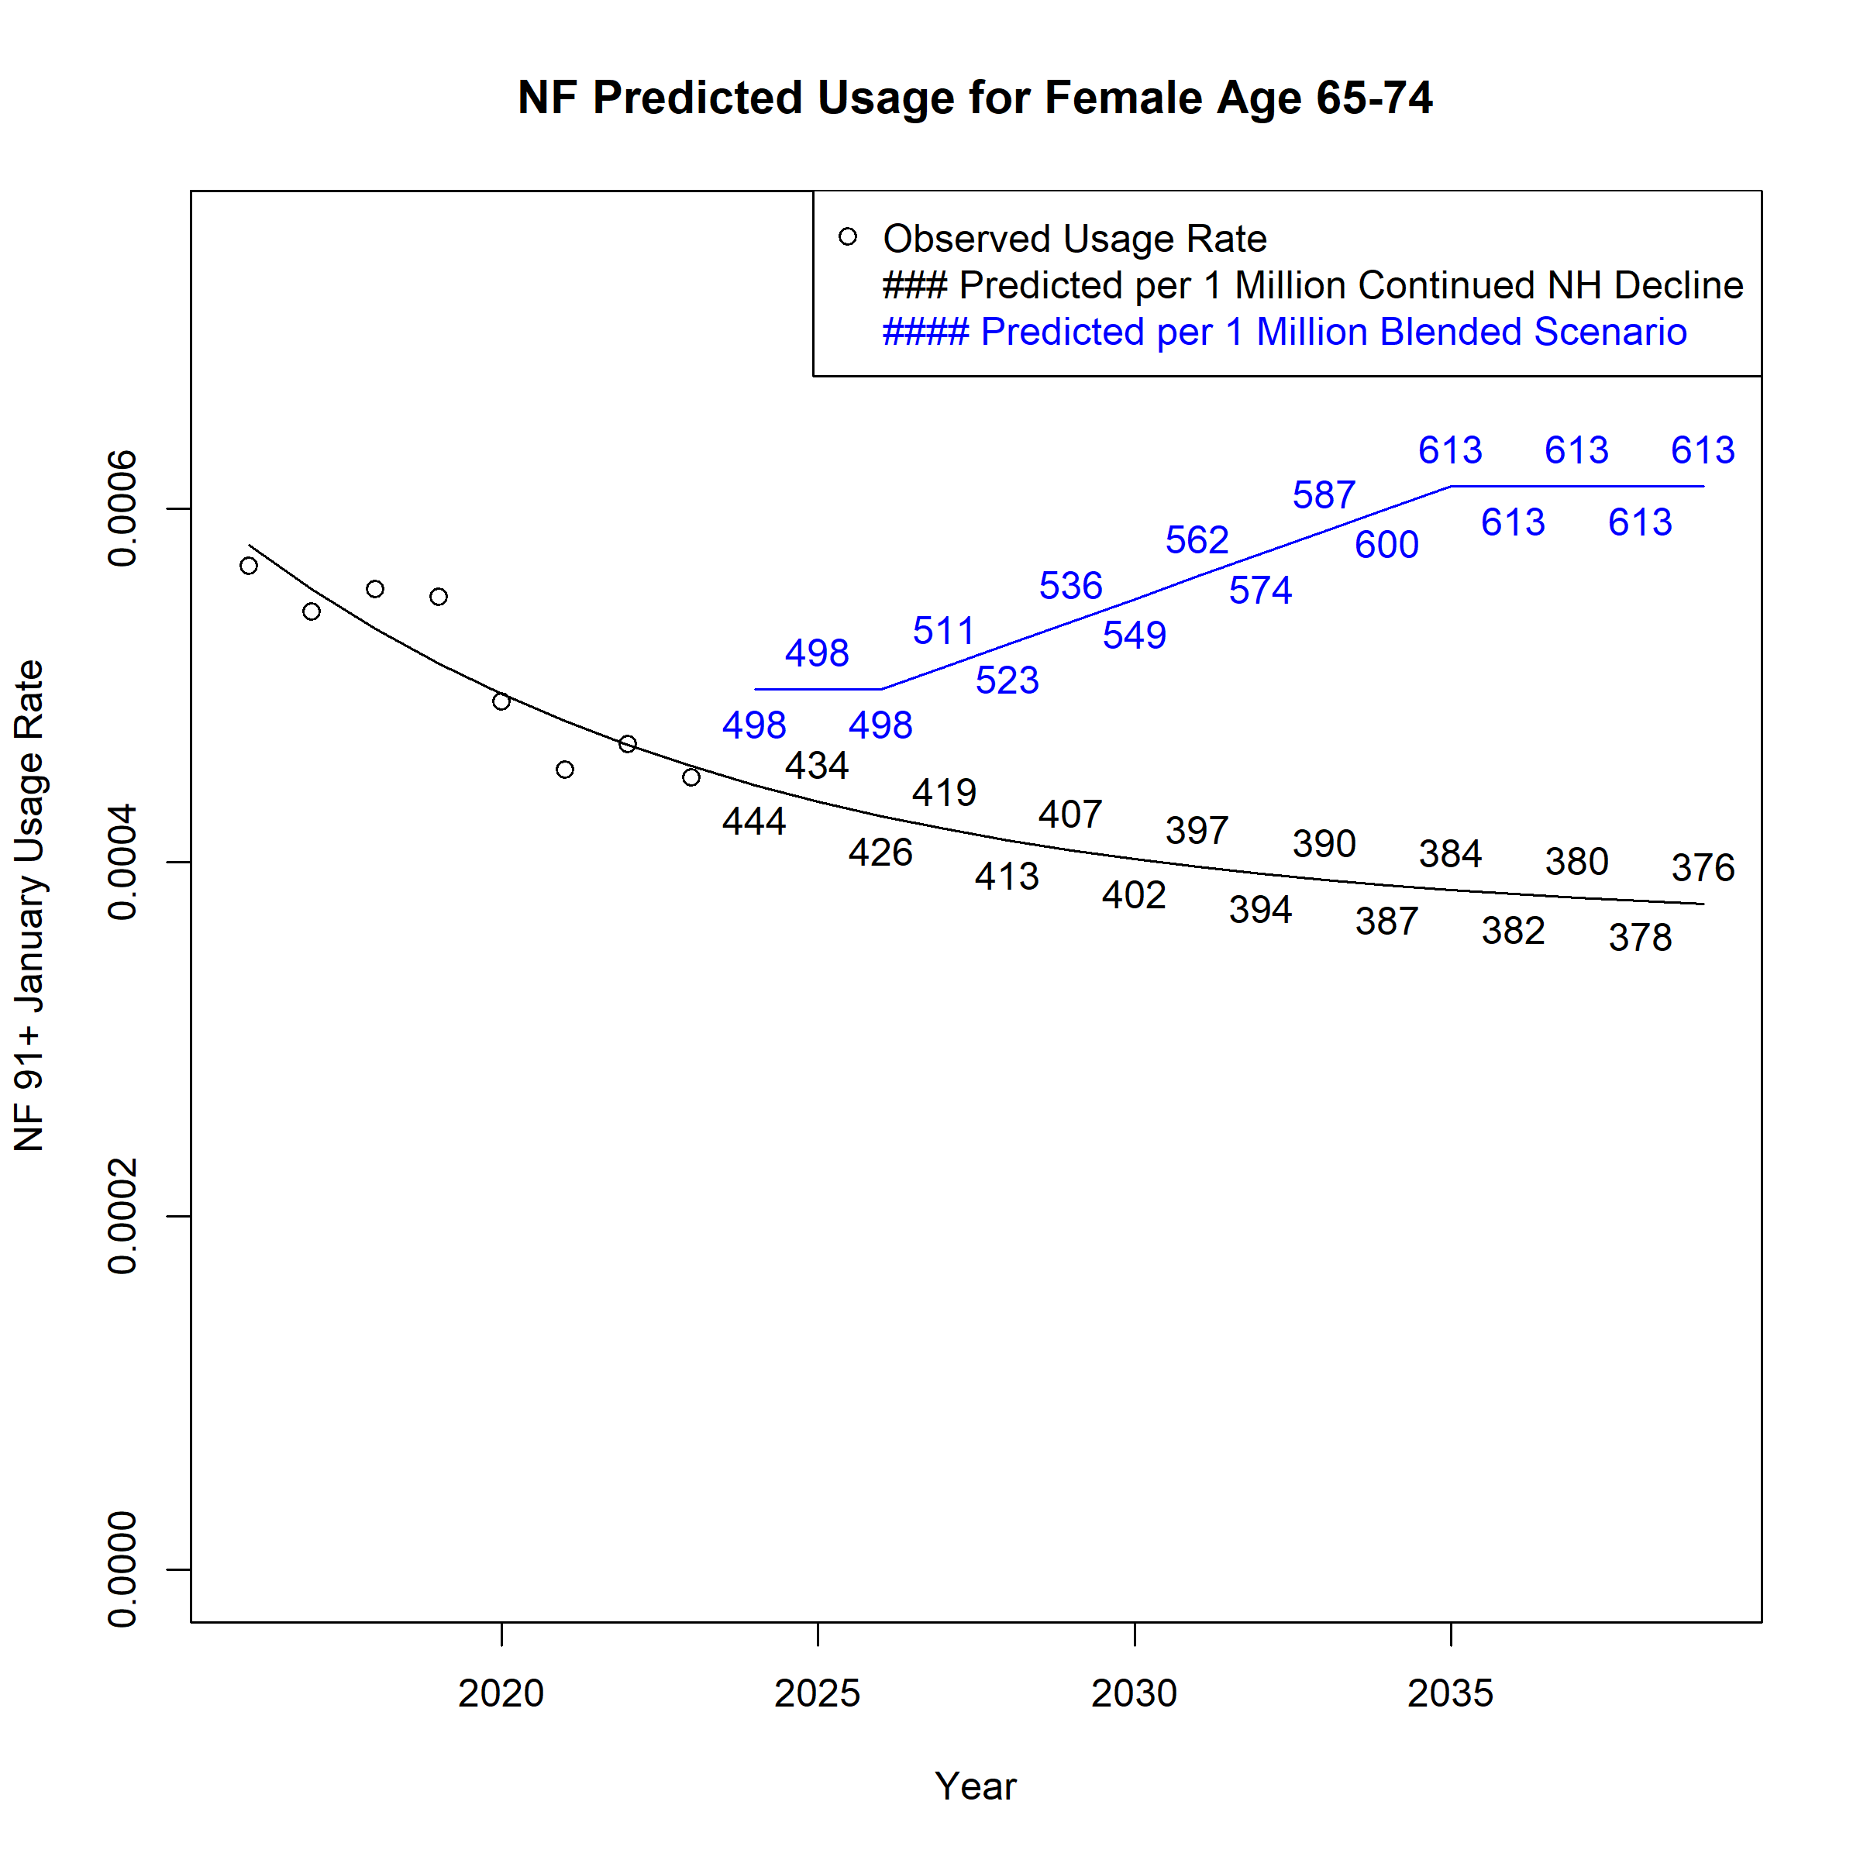
Figure A 51. Assumed Monthly Nursing Facility Users per 1 Million Population for Females Age 75-84 across Scenarios
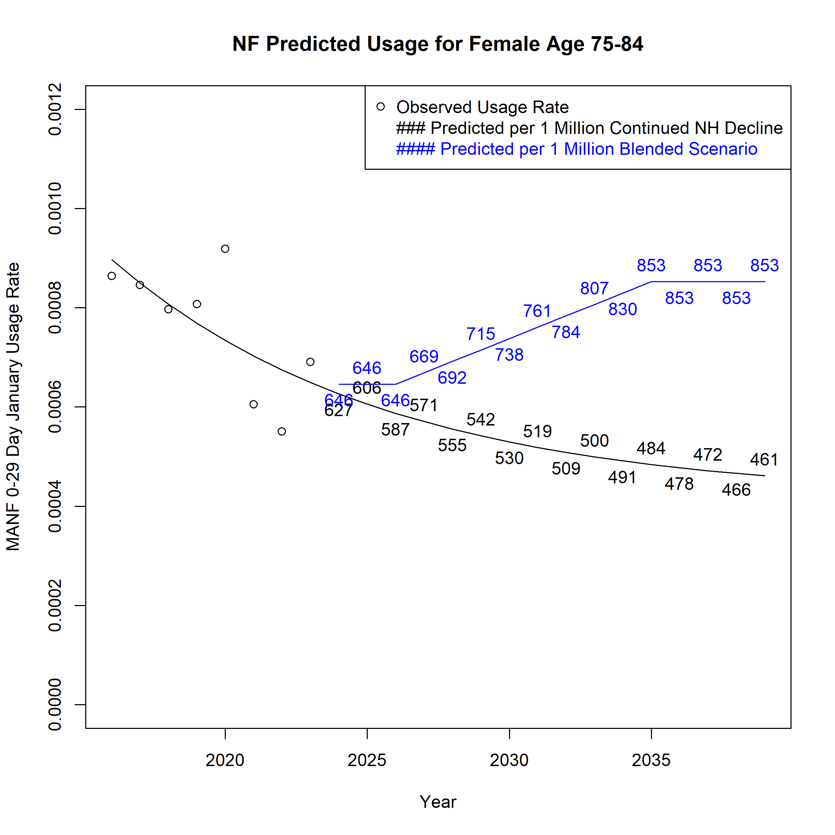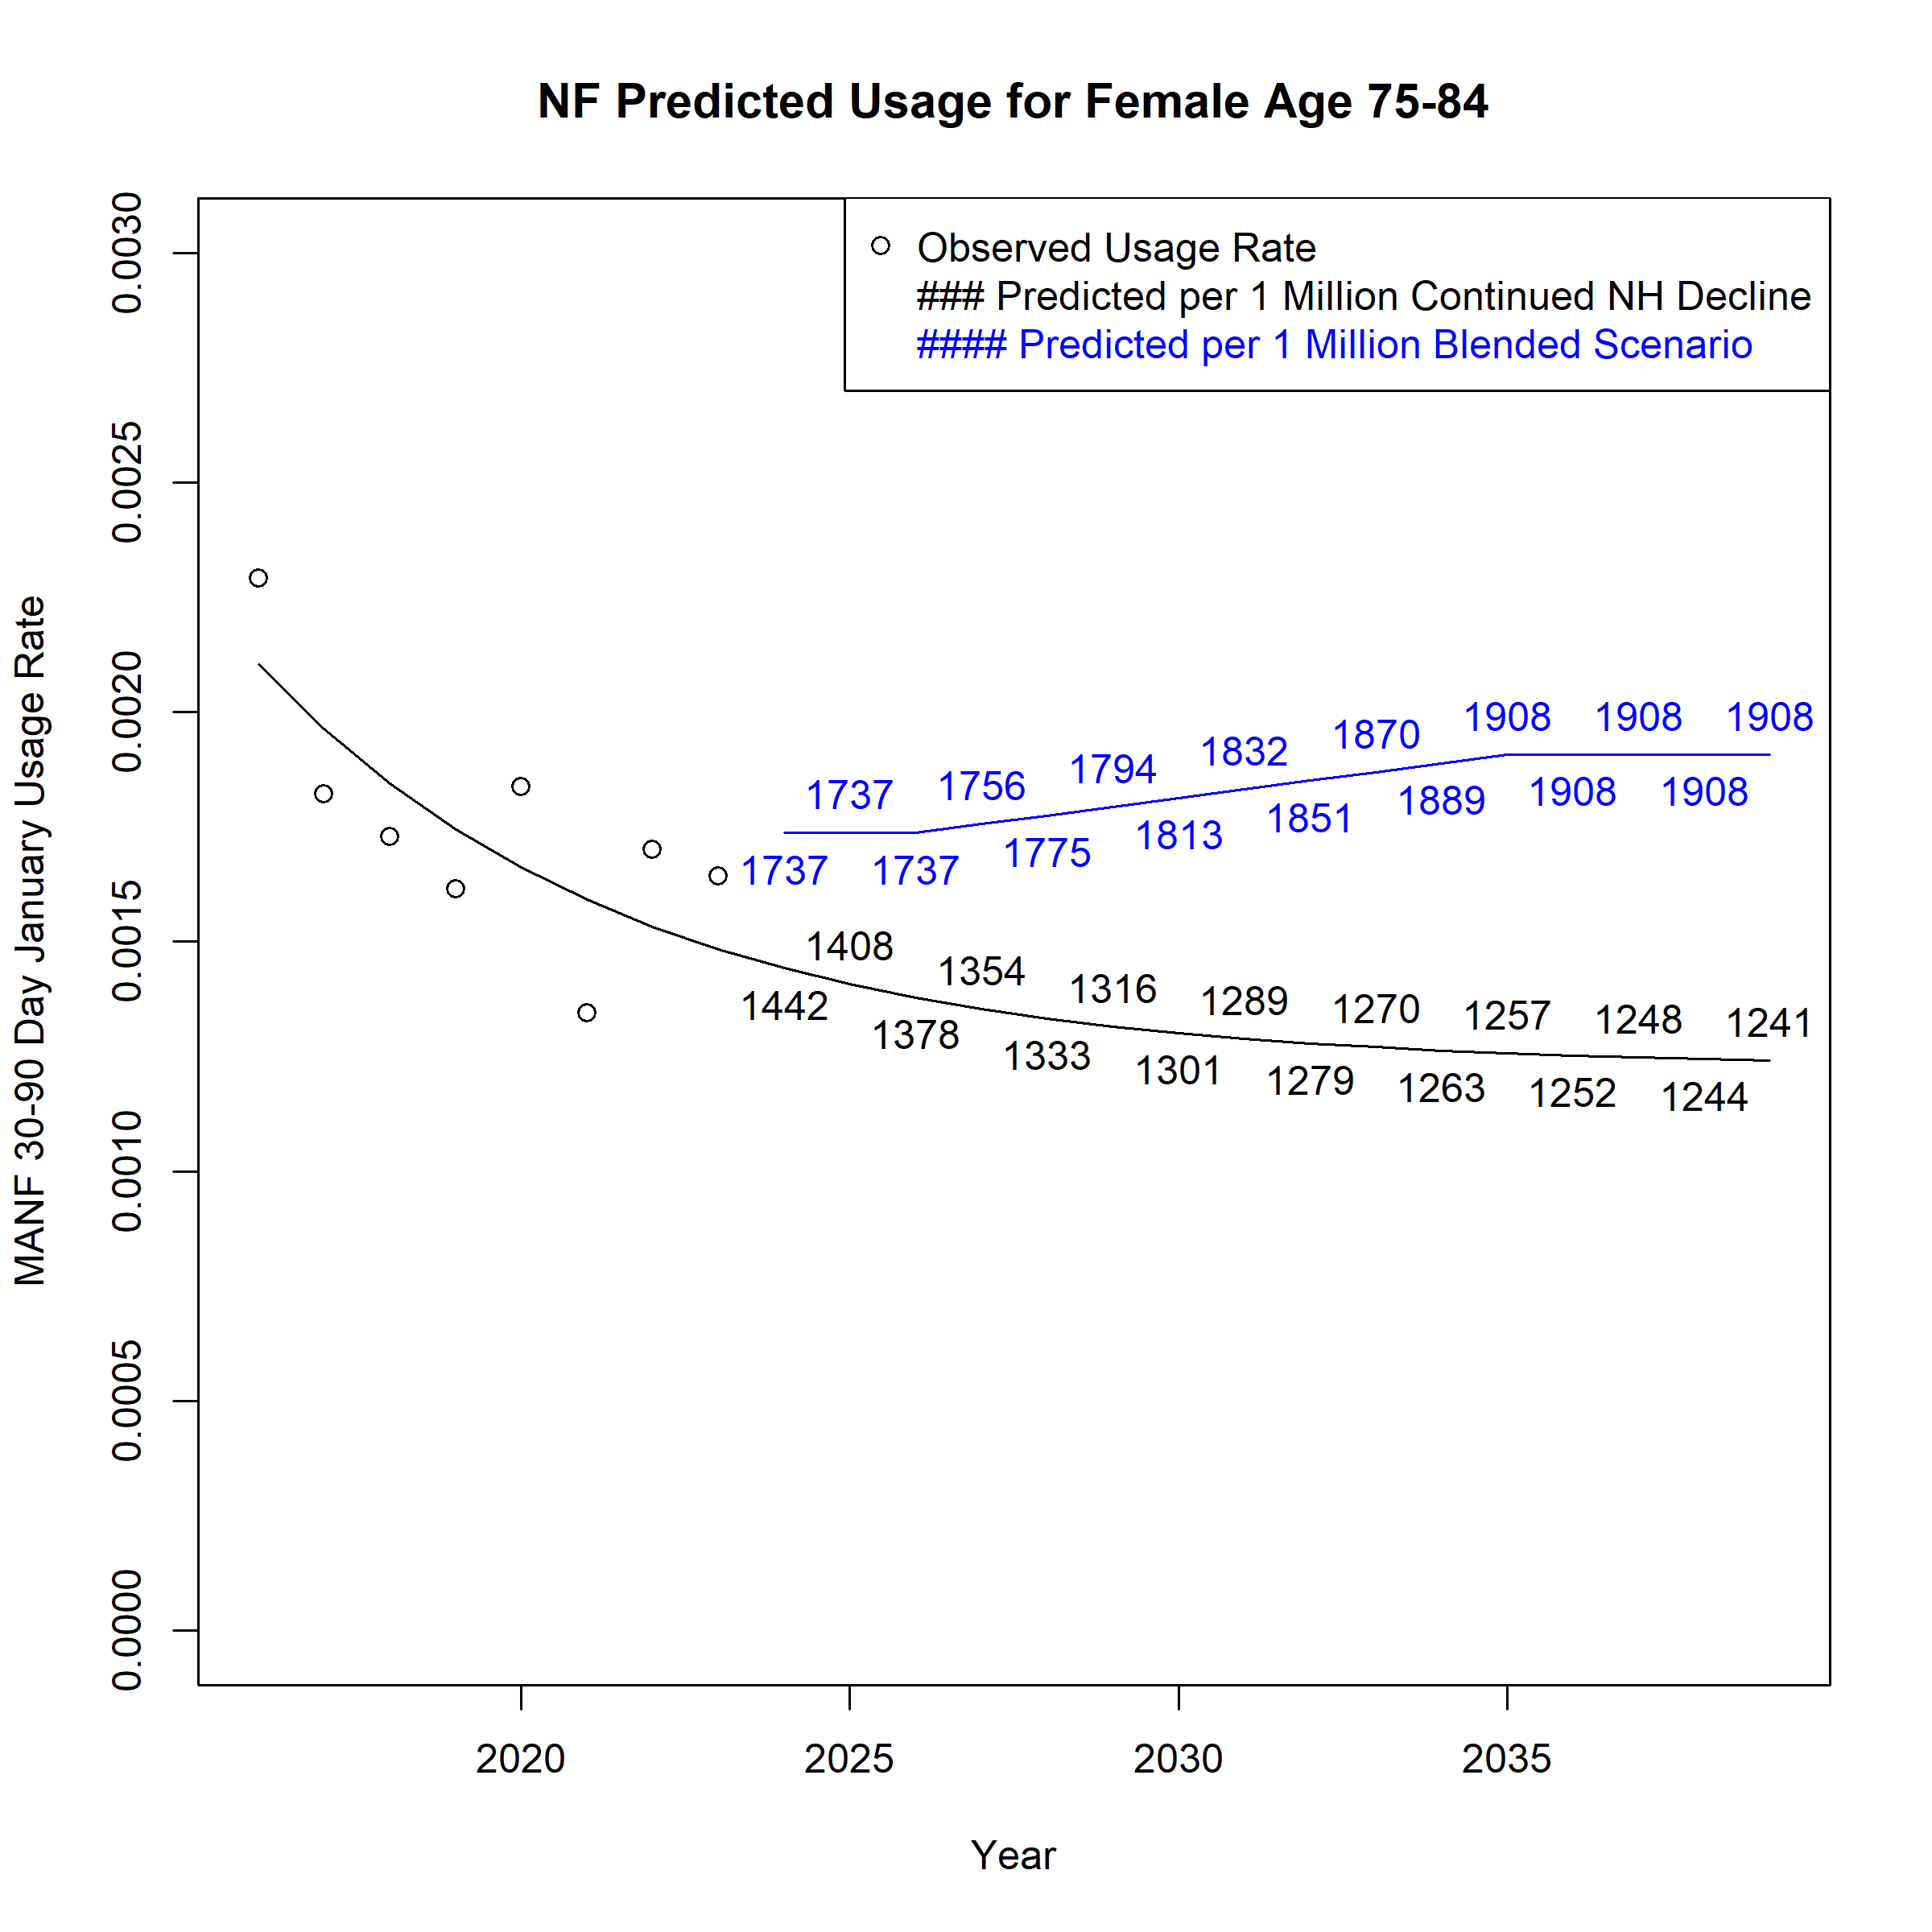
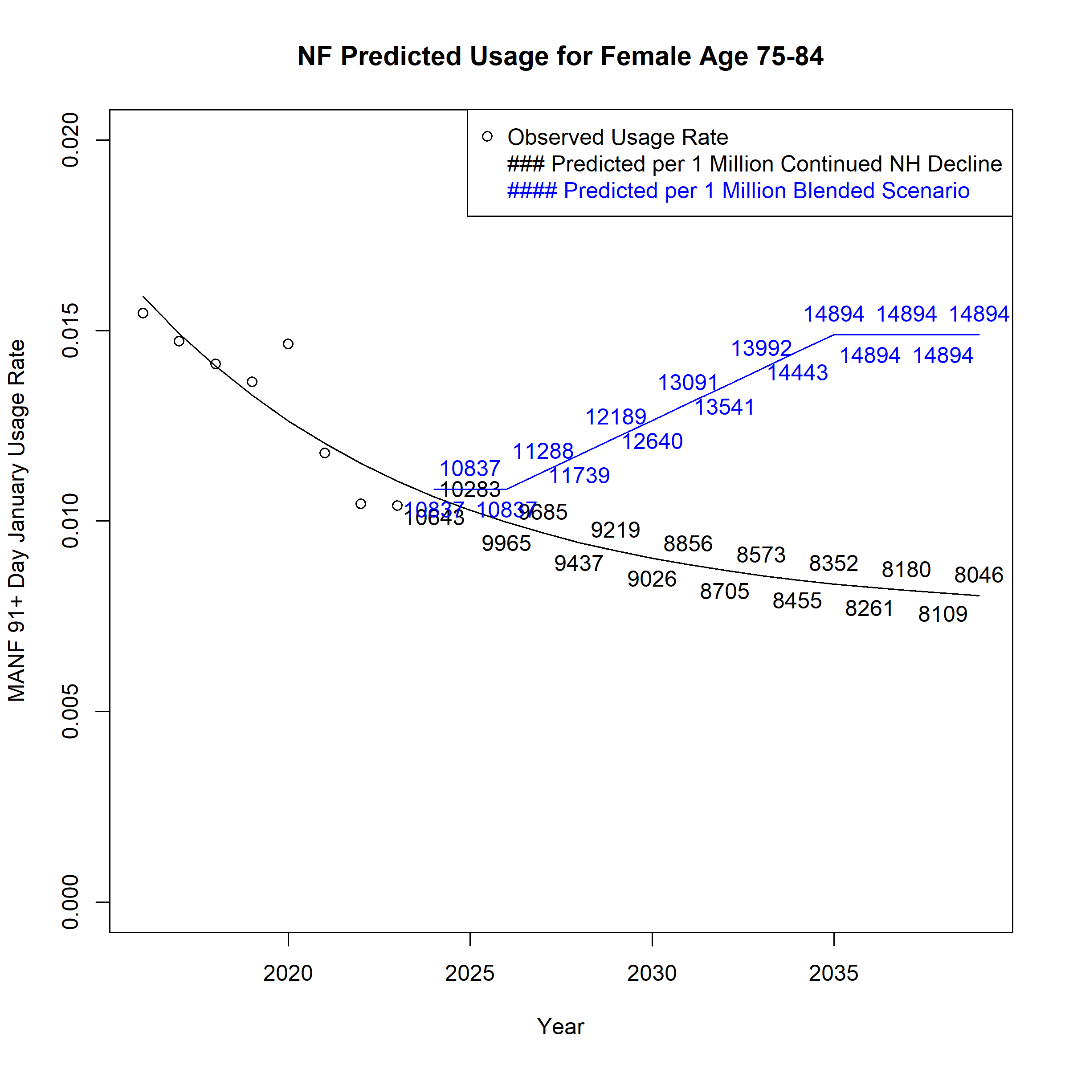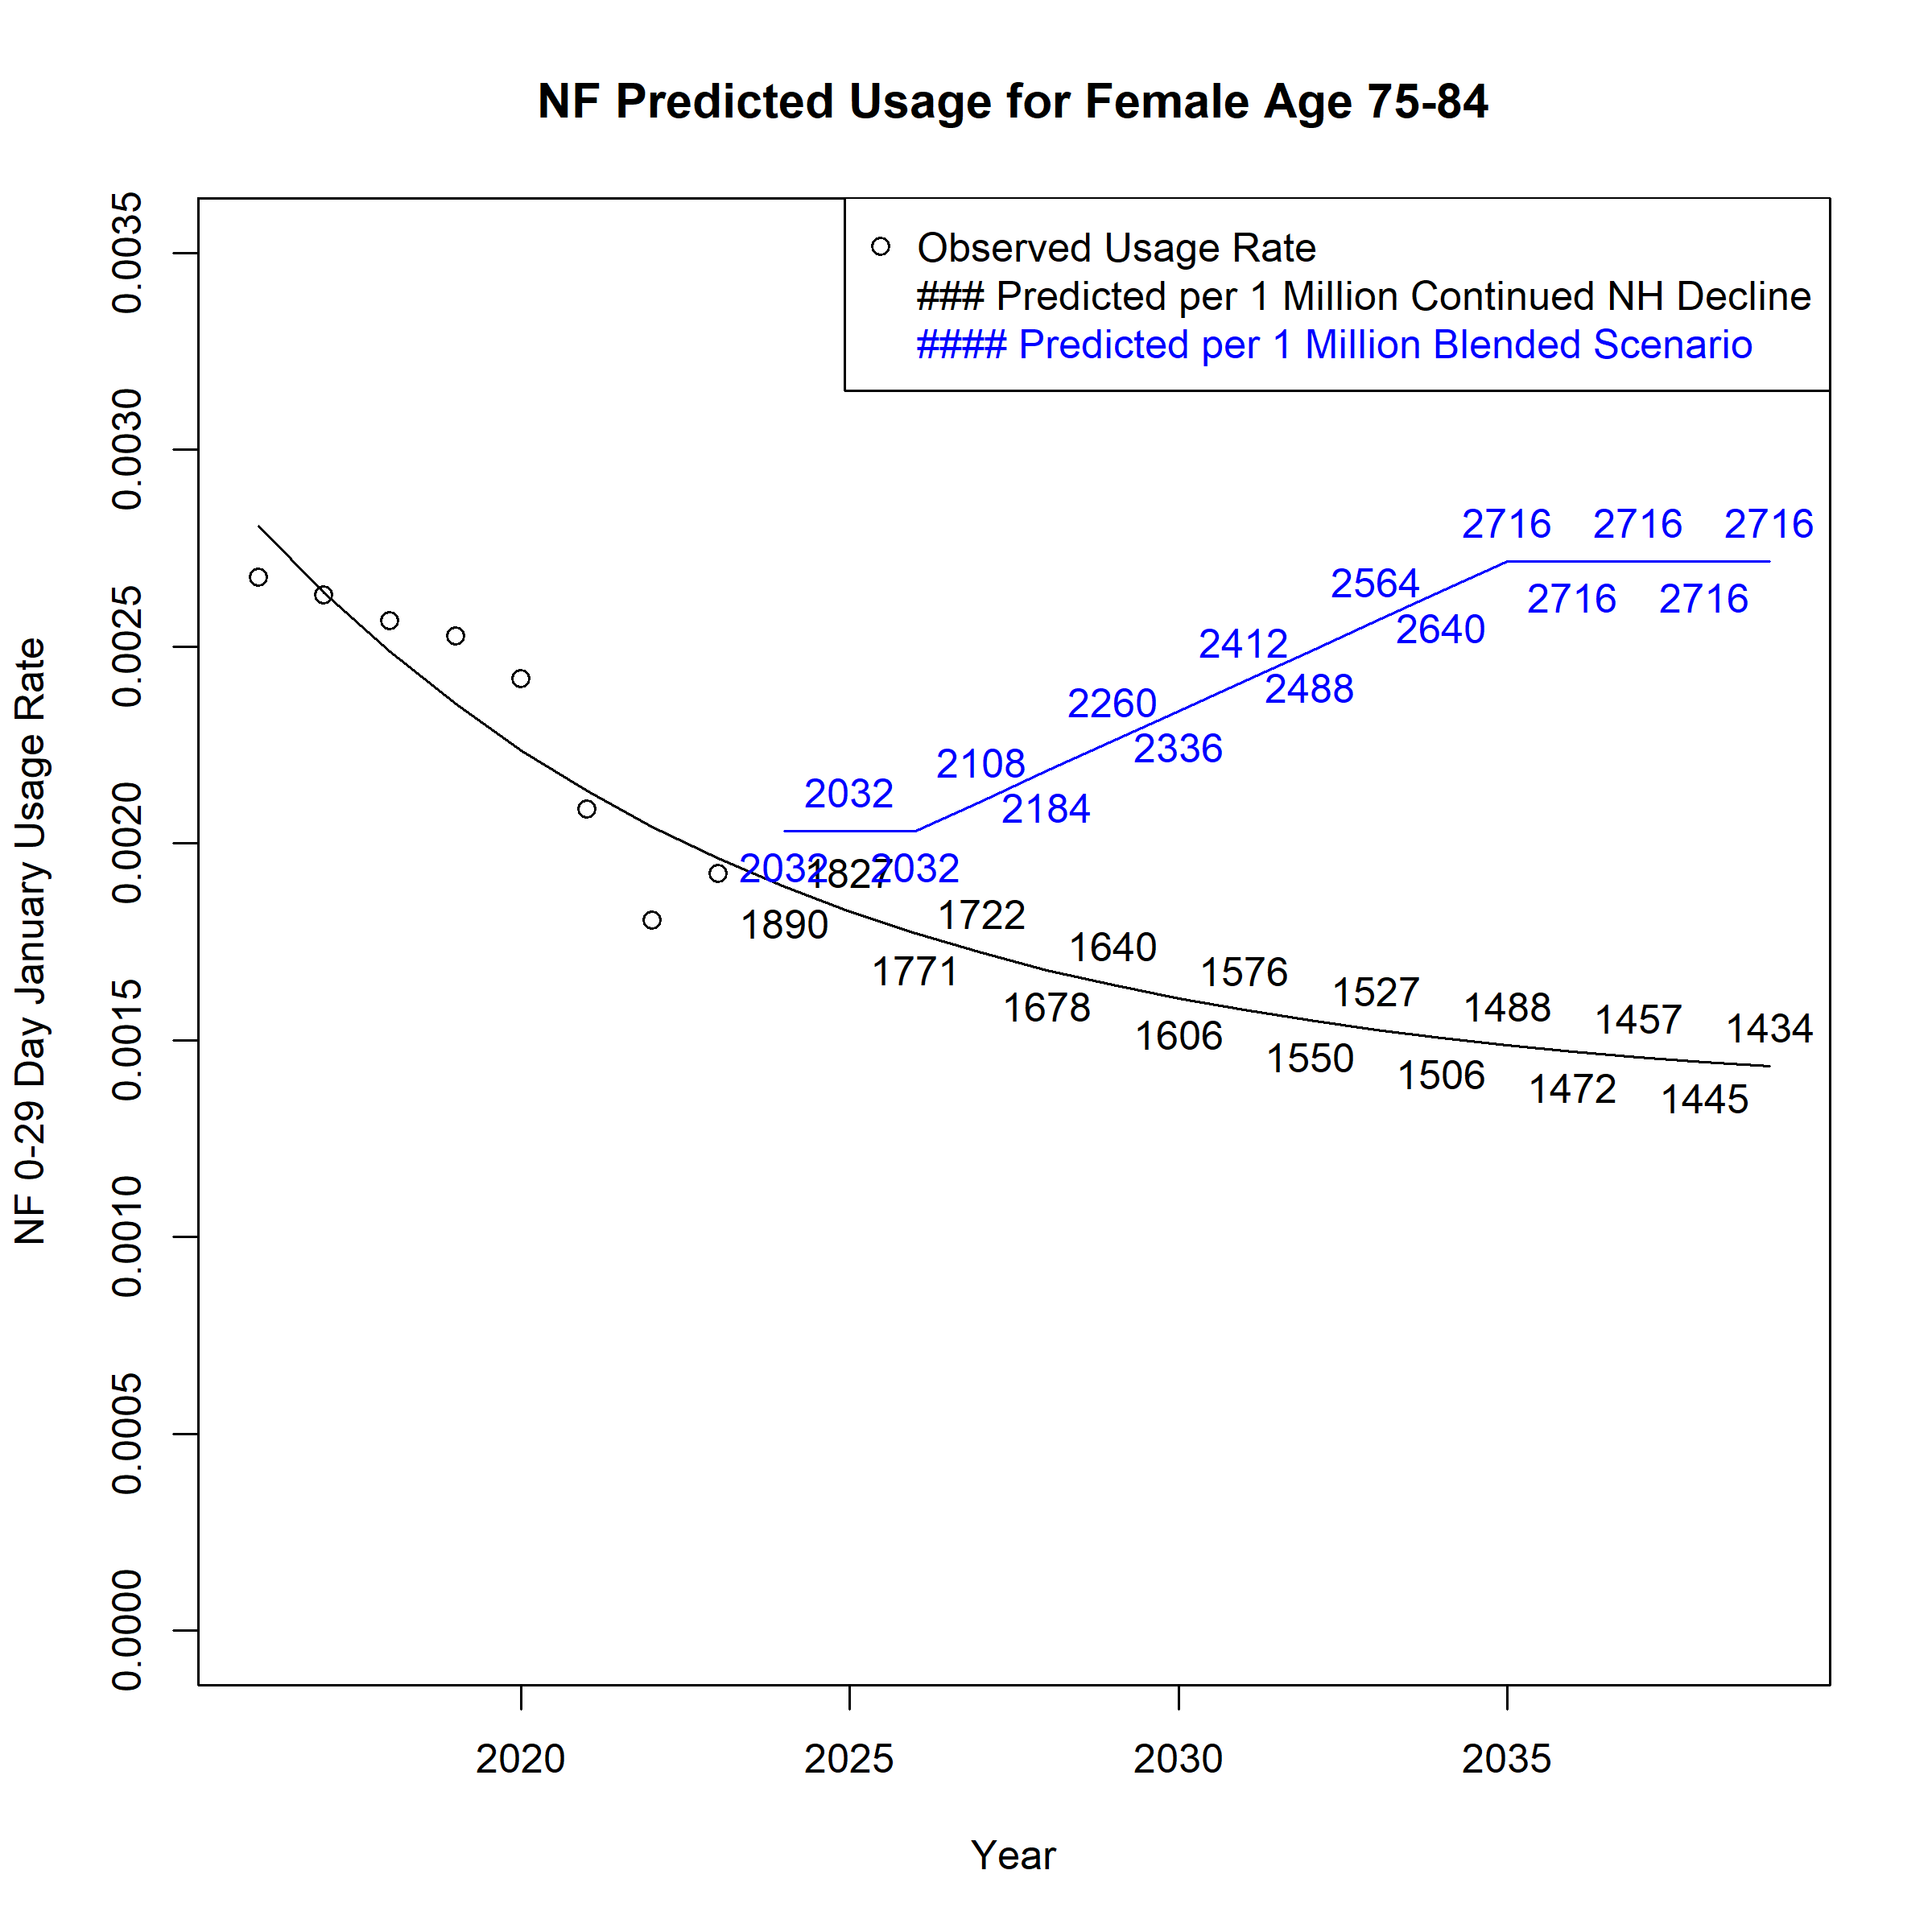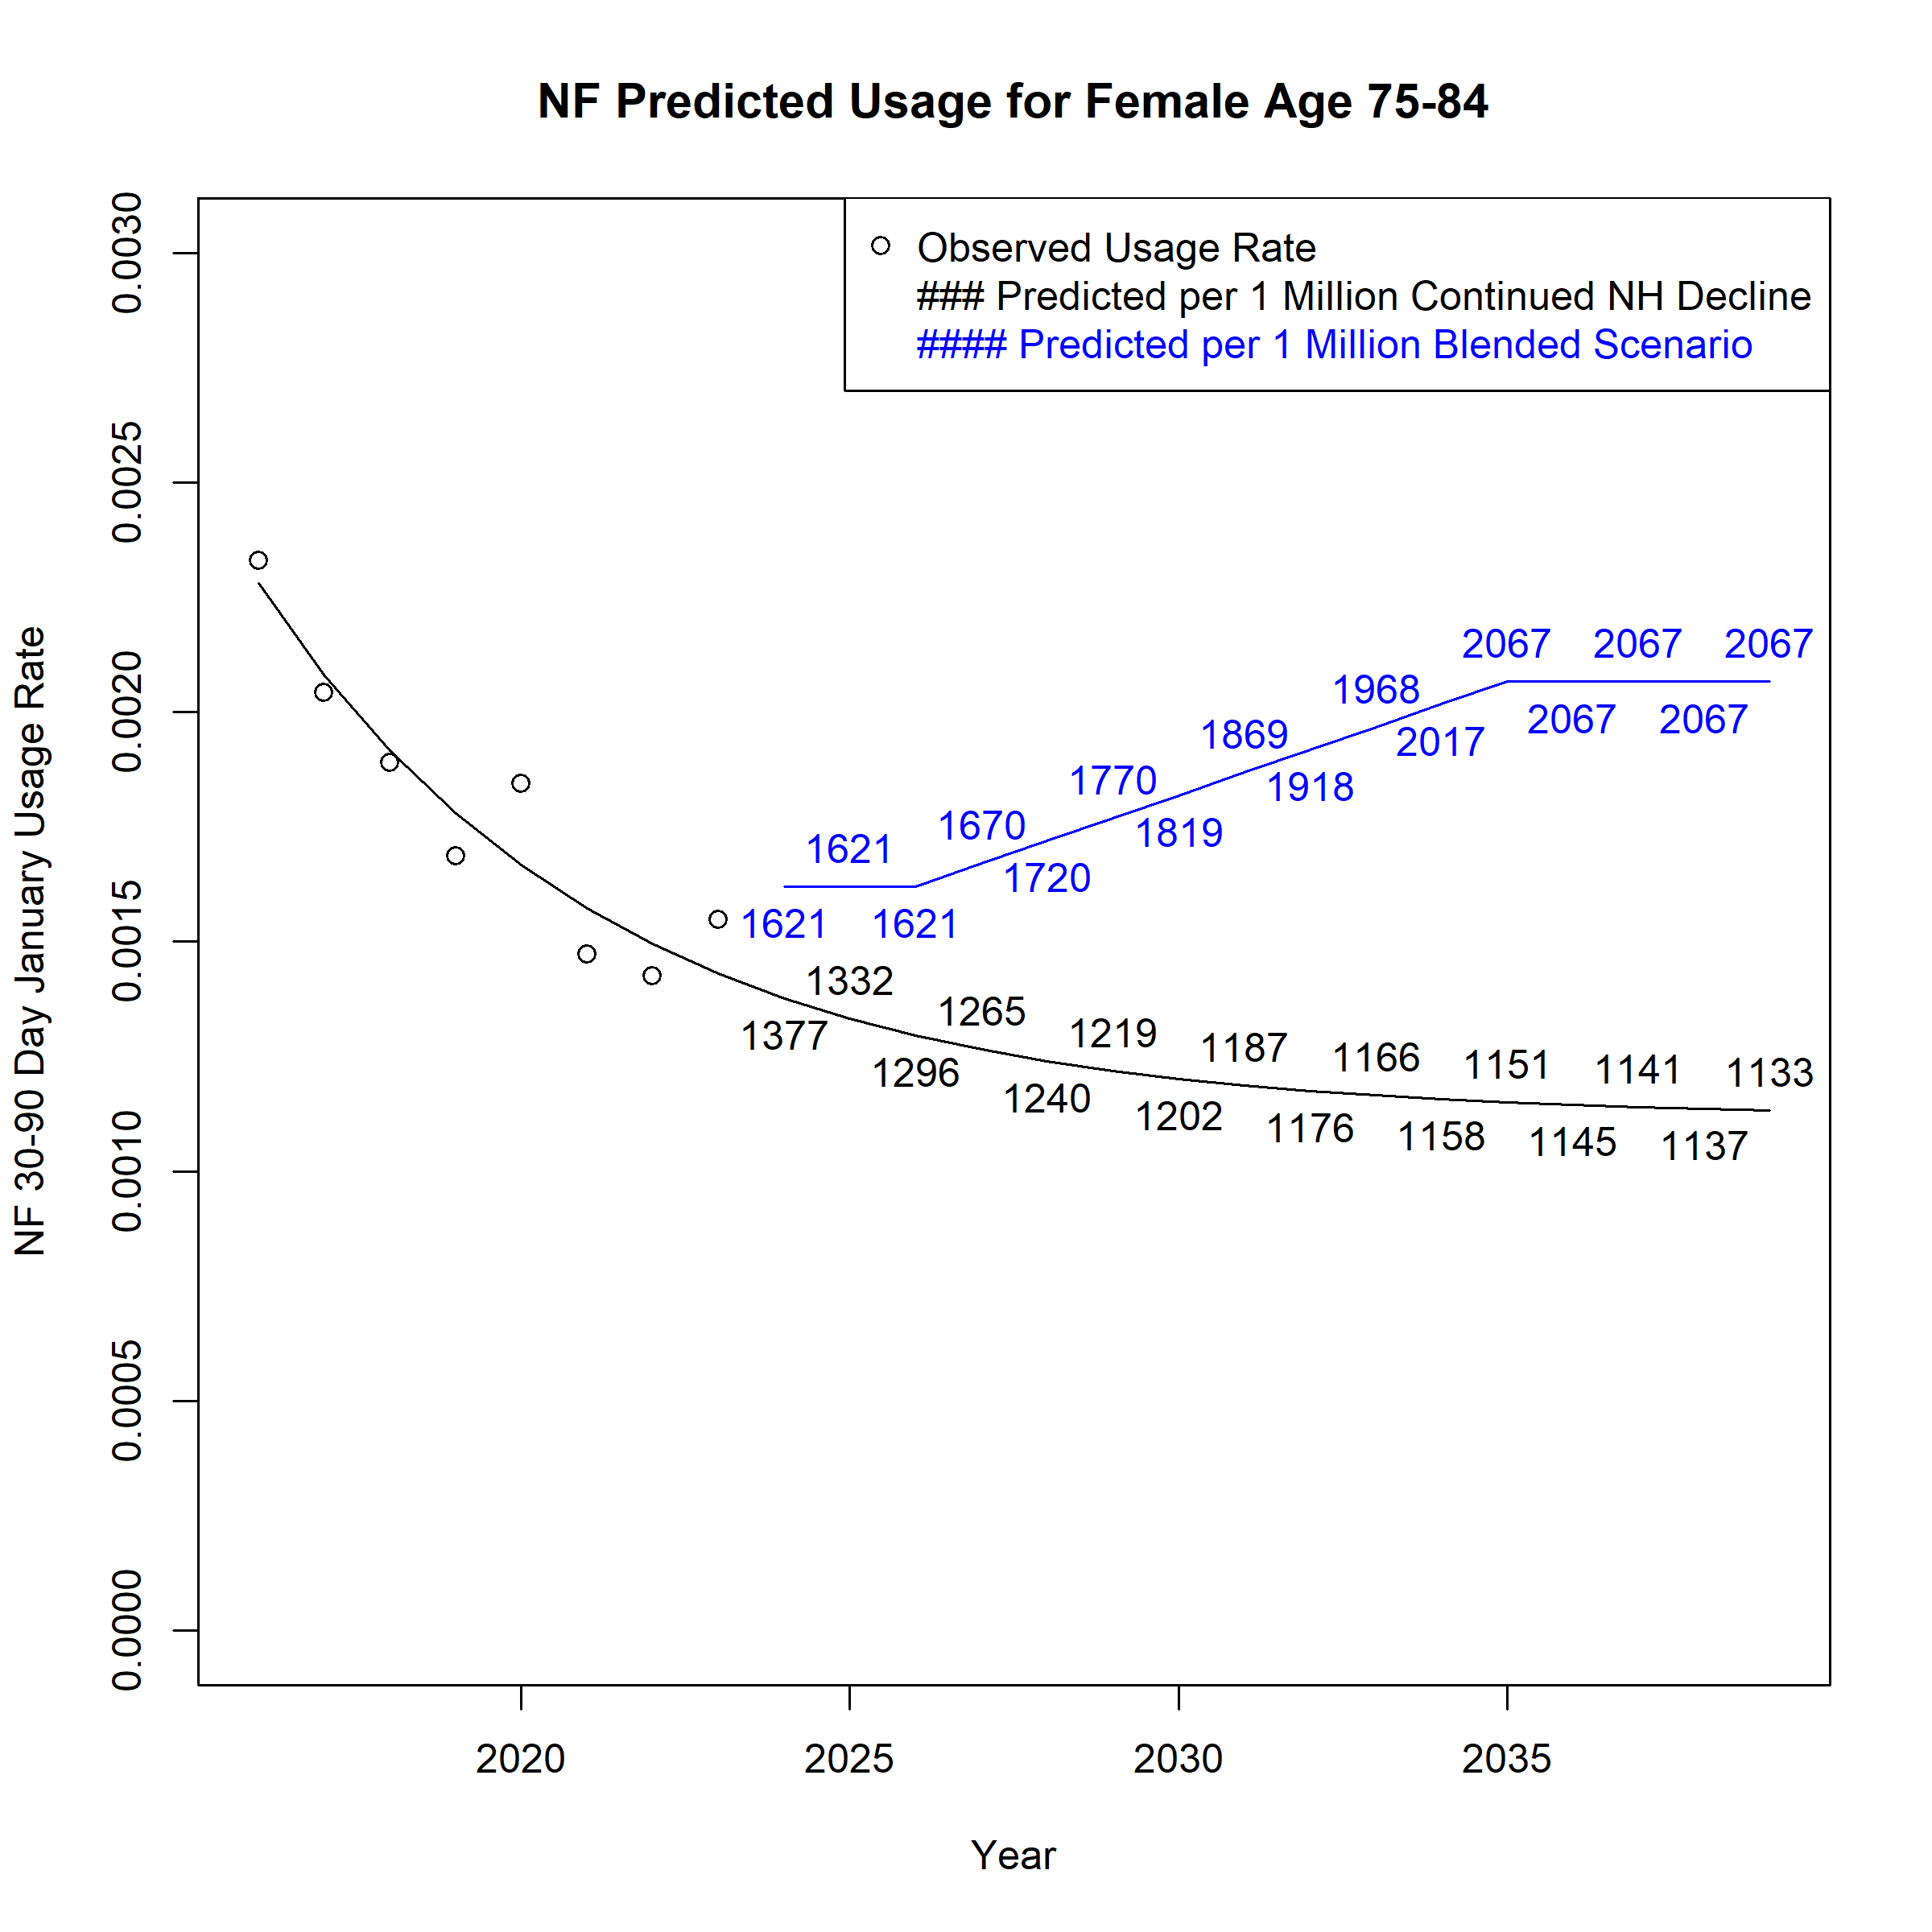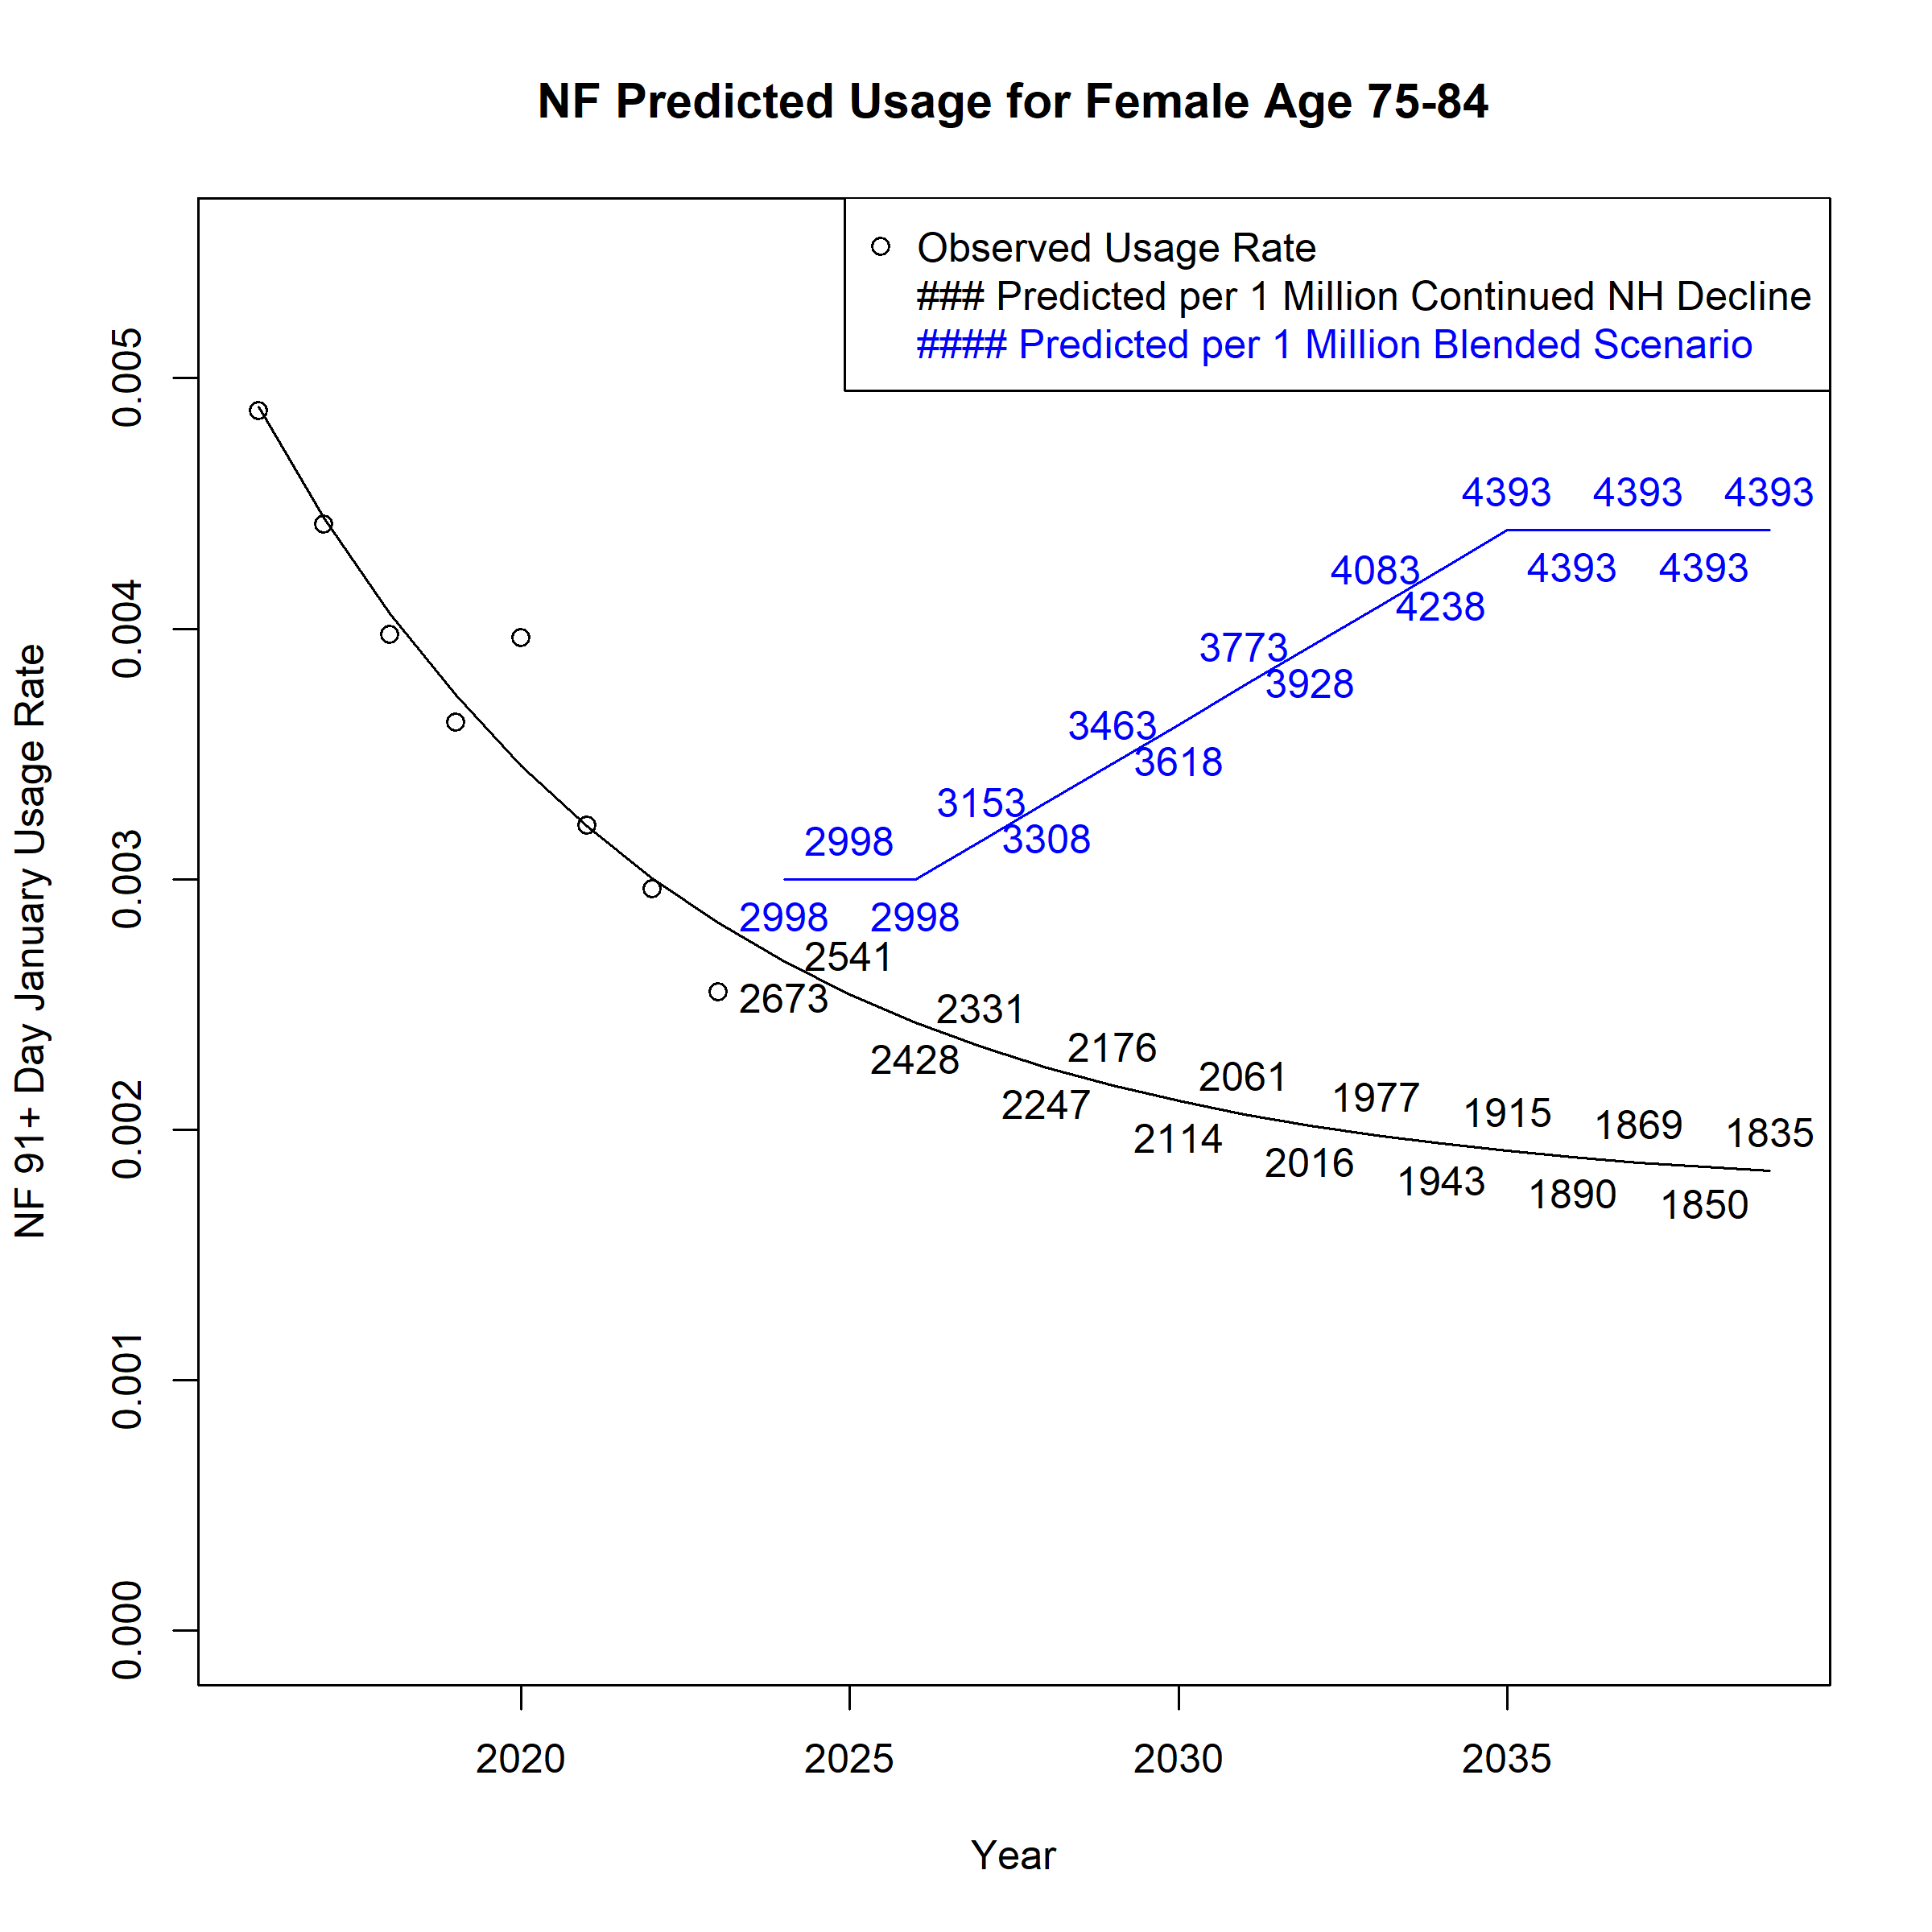

Figure A 52. Assumed Monthly Nursing Facility Users per 1 Million Population for Females Age 85 and above across Scenarios
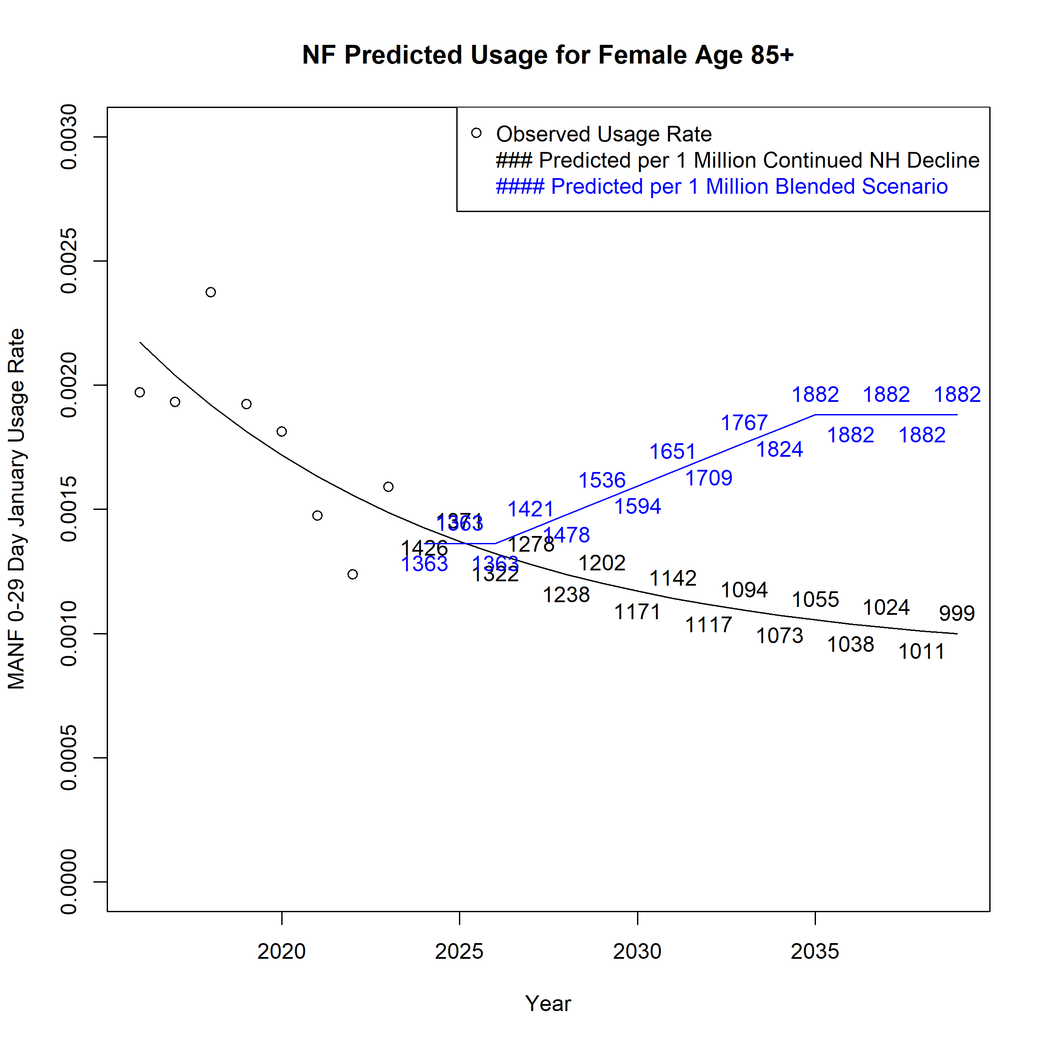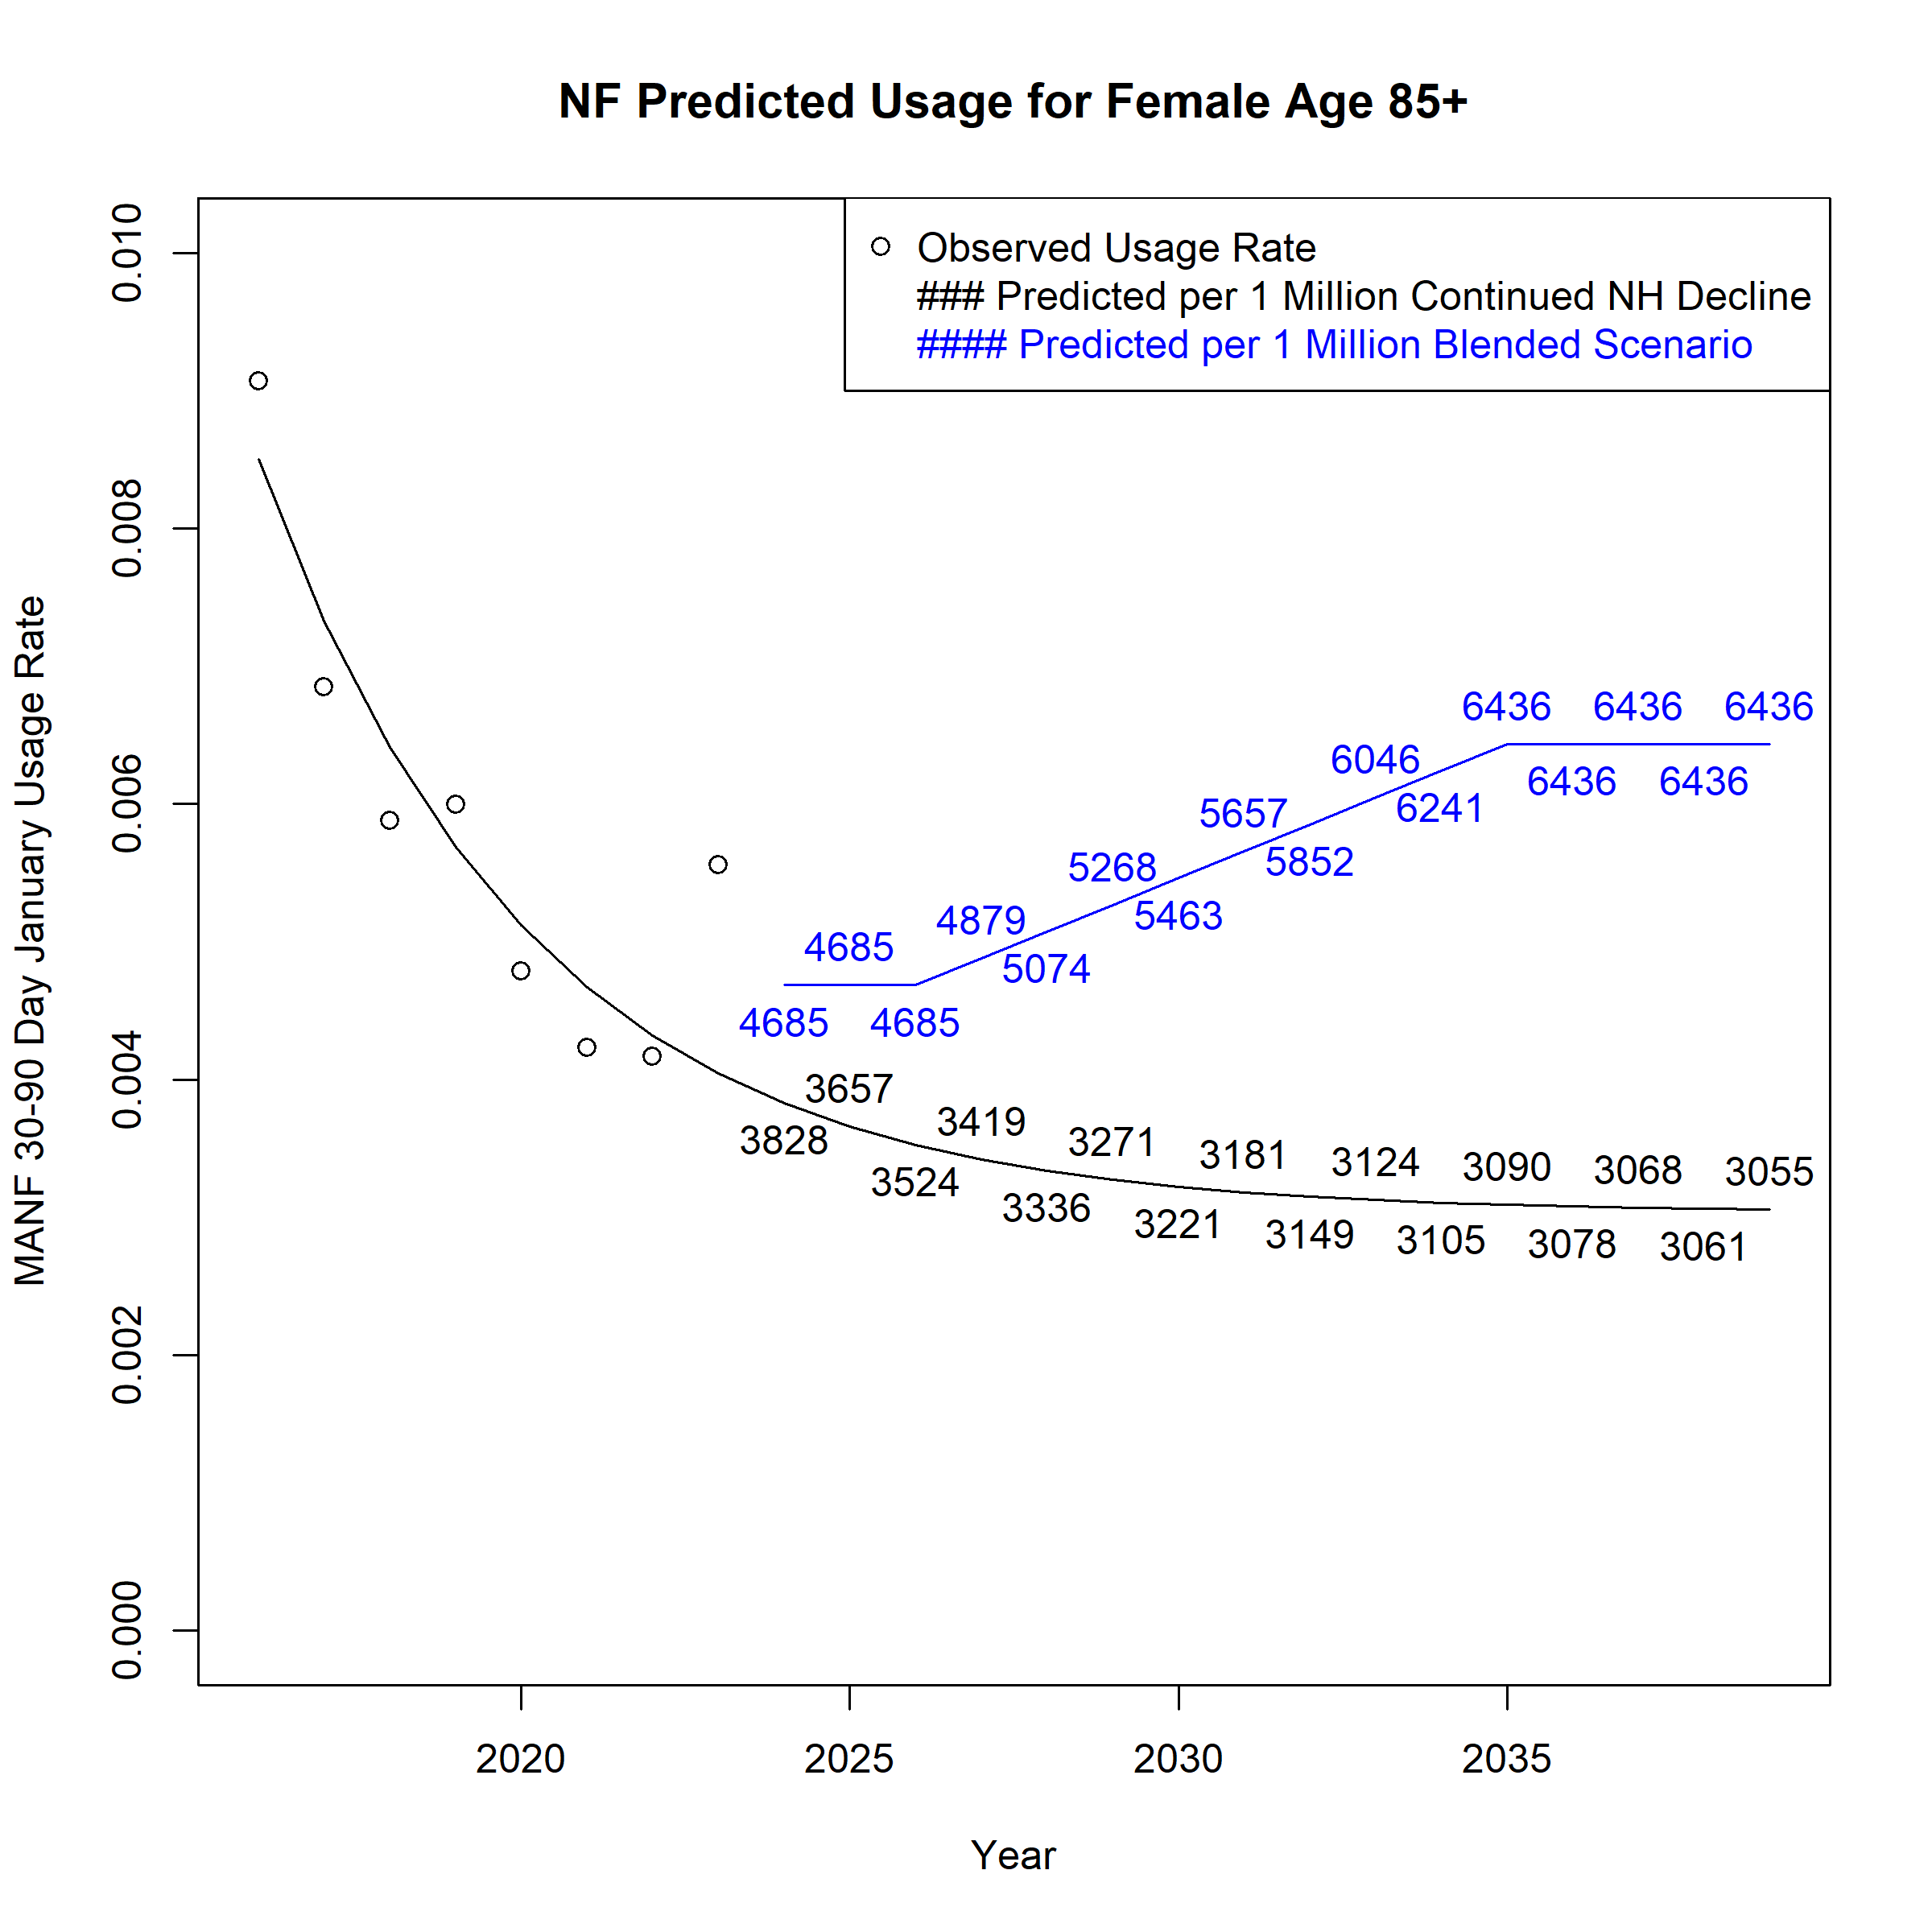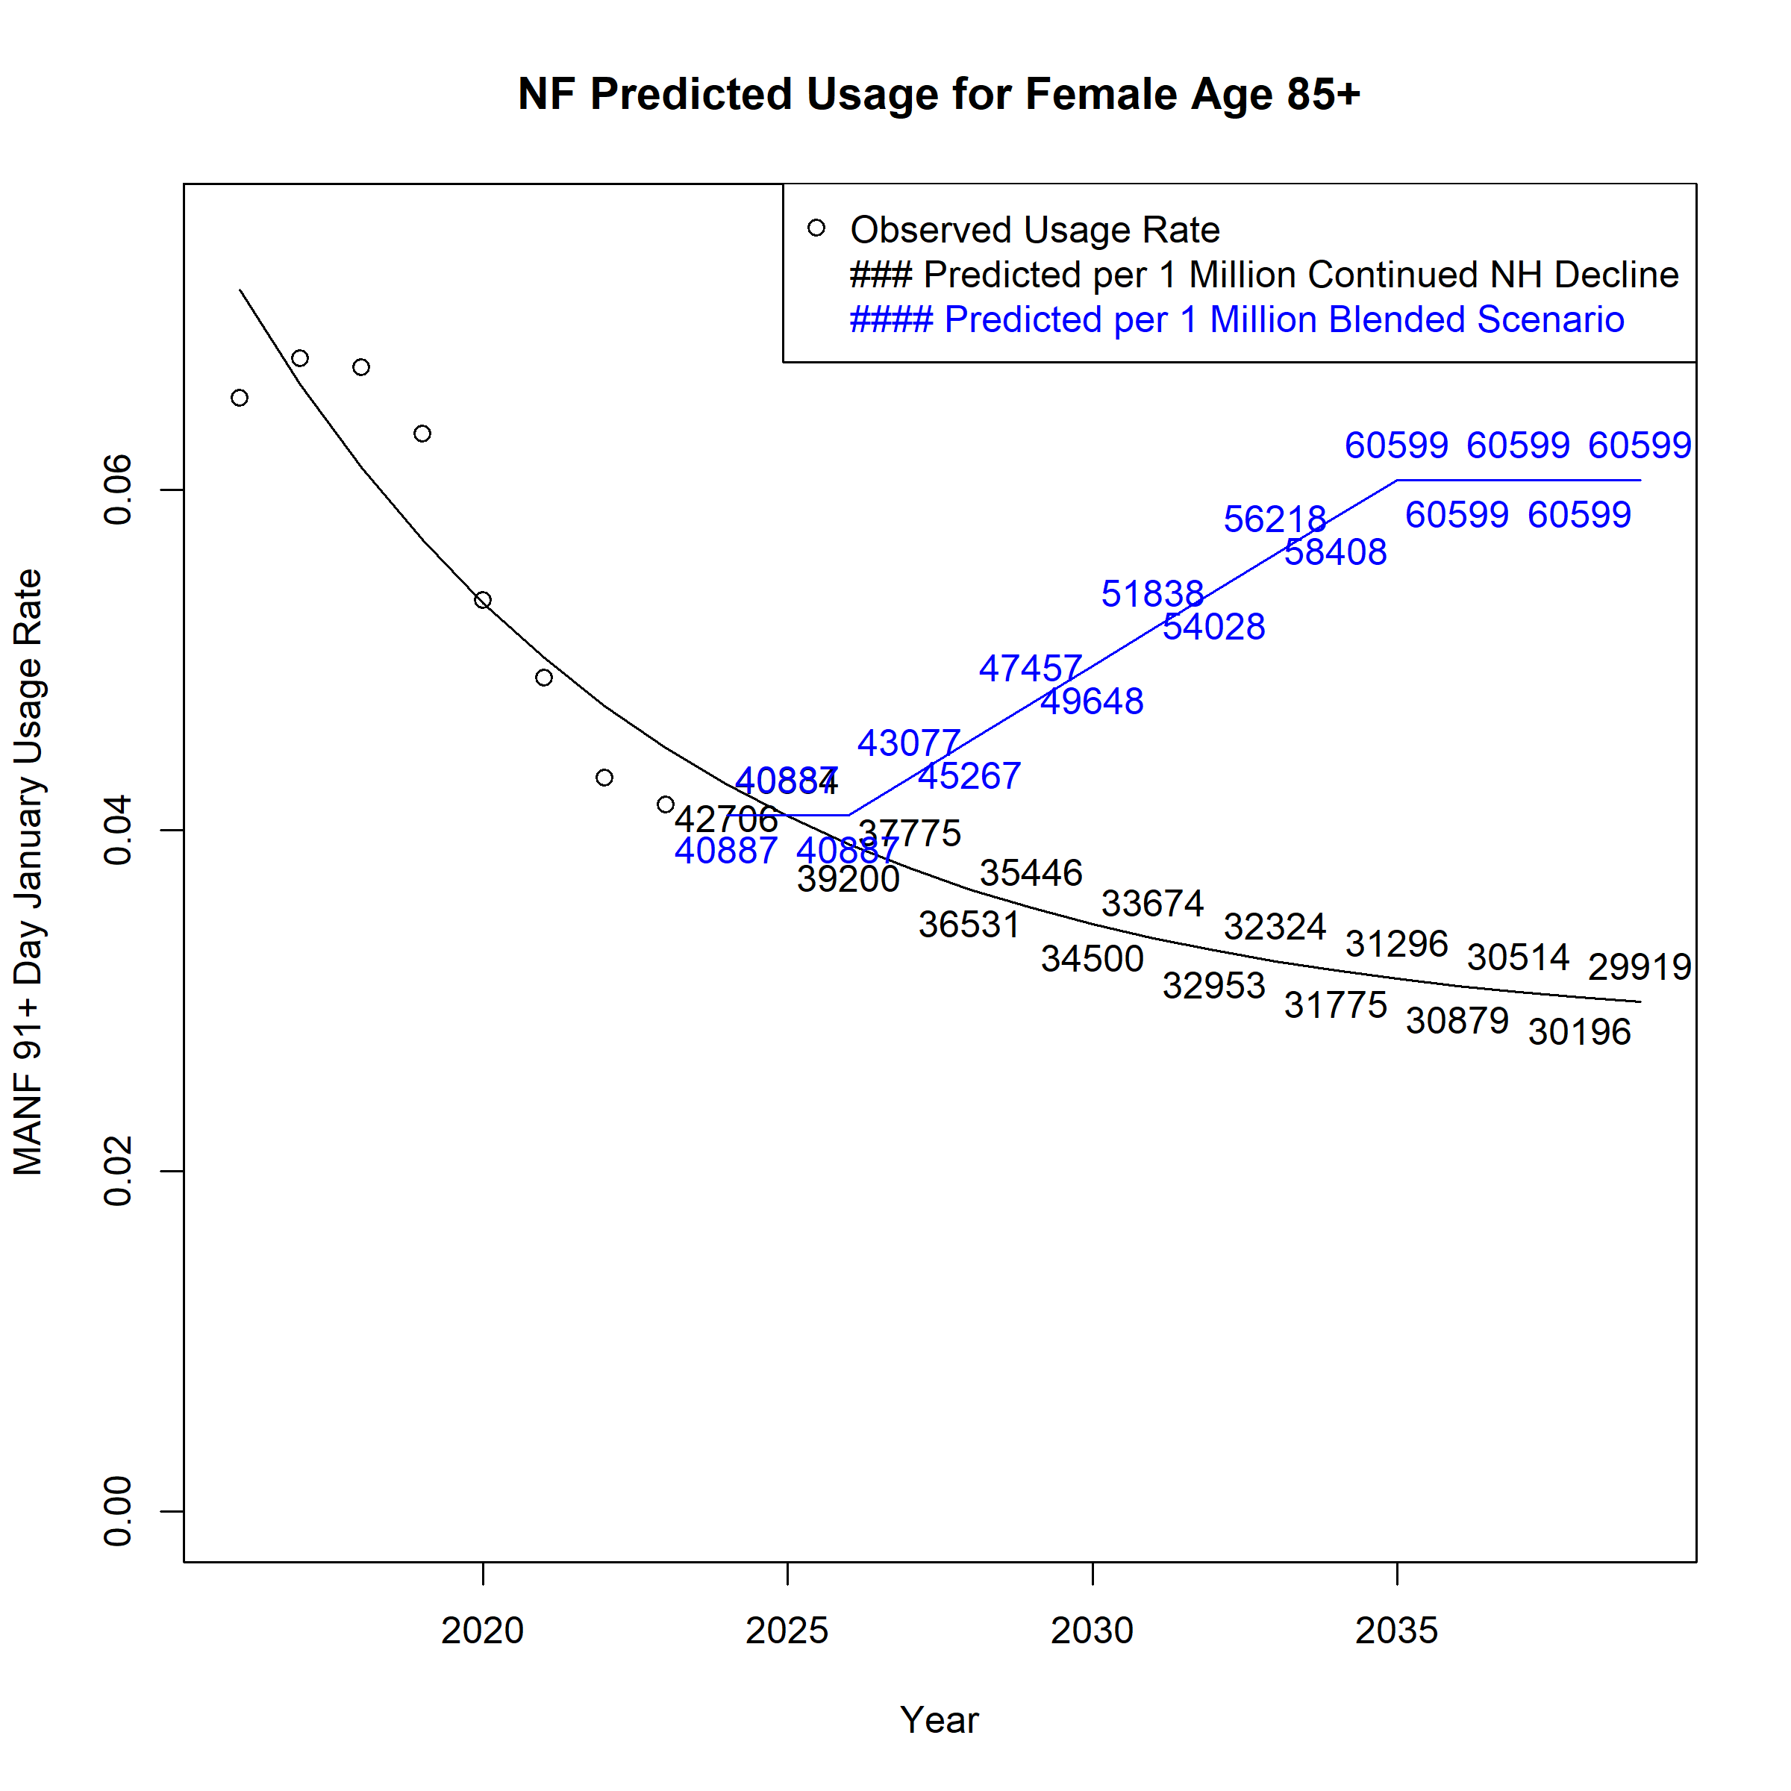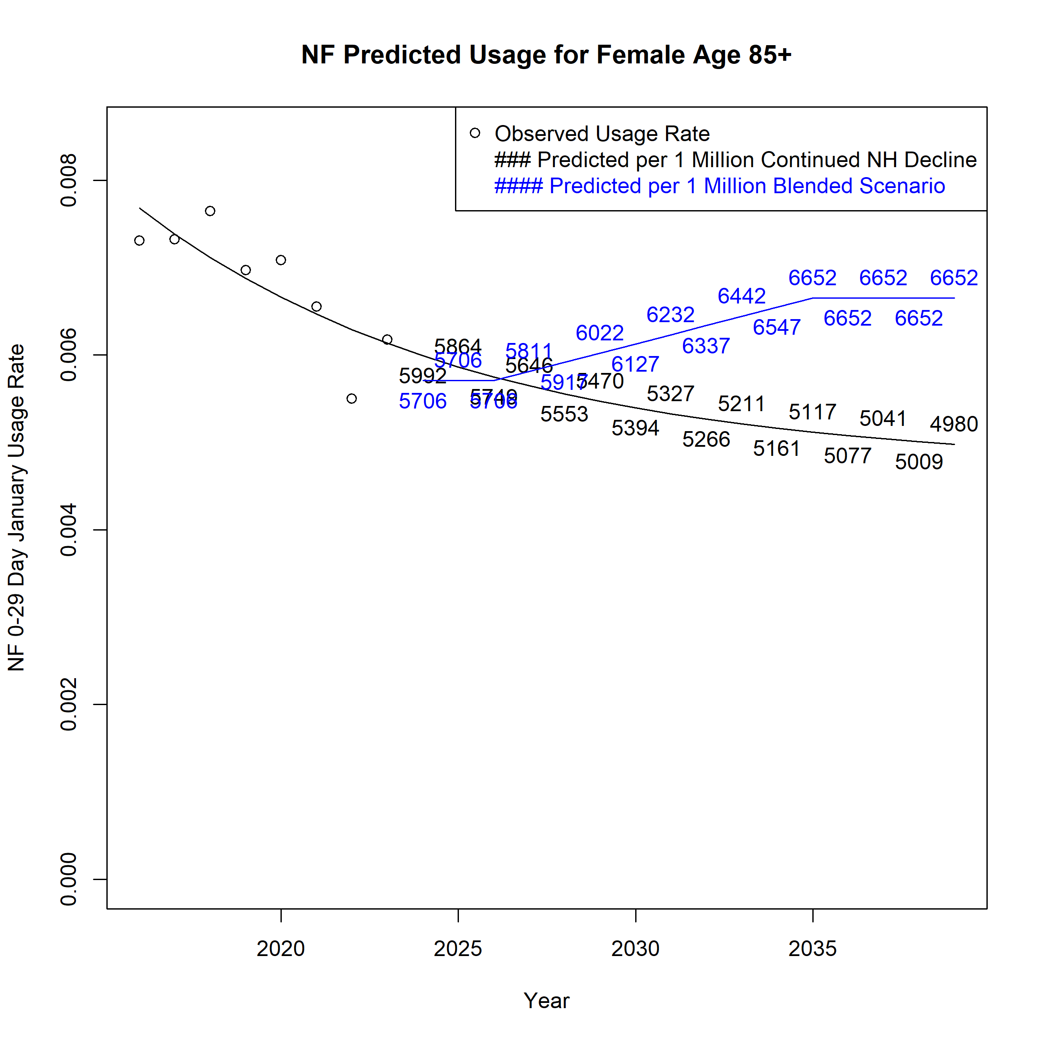
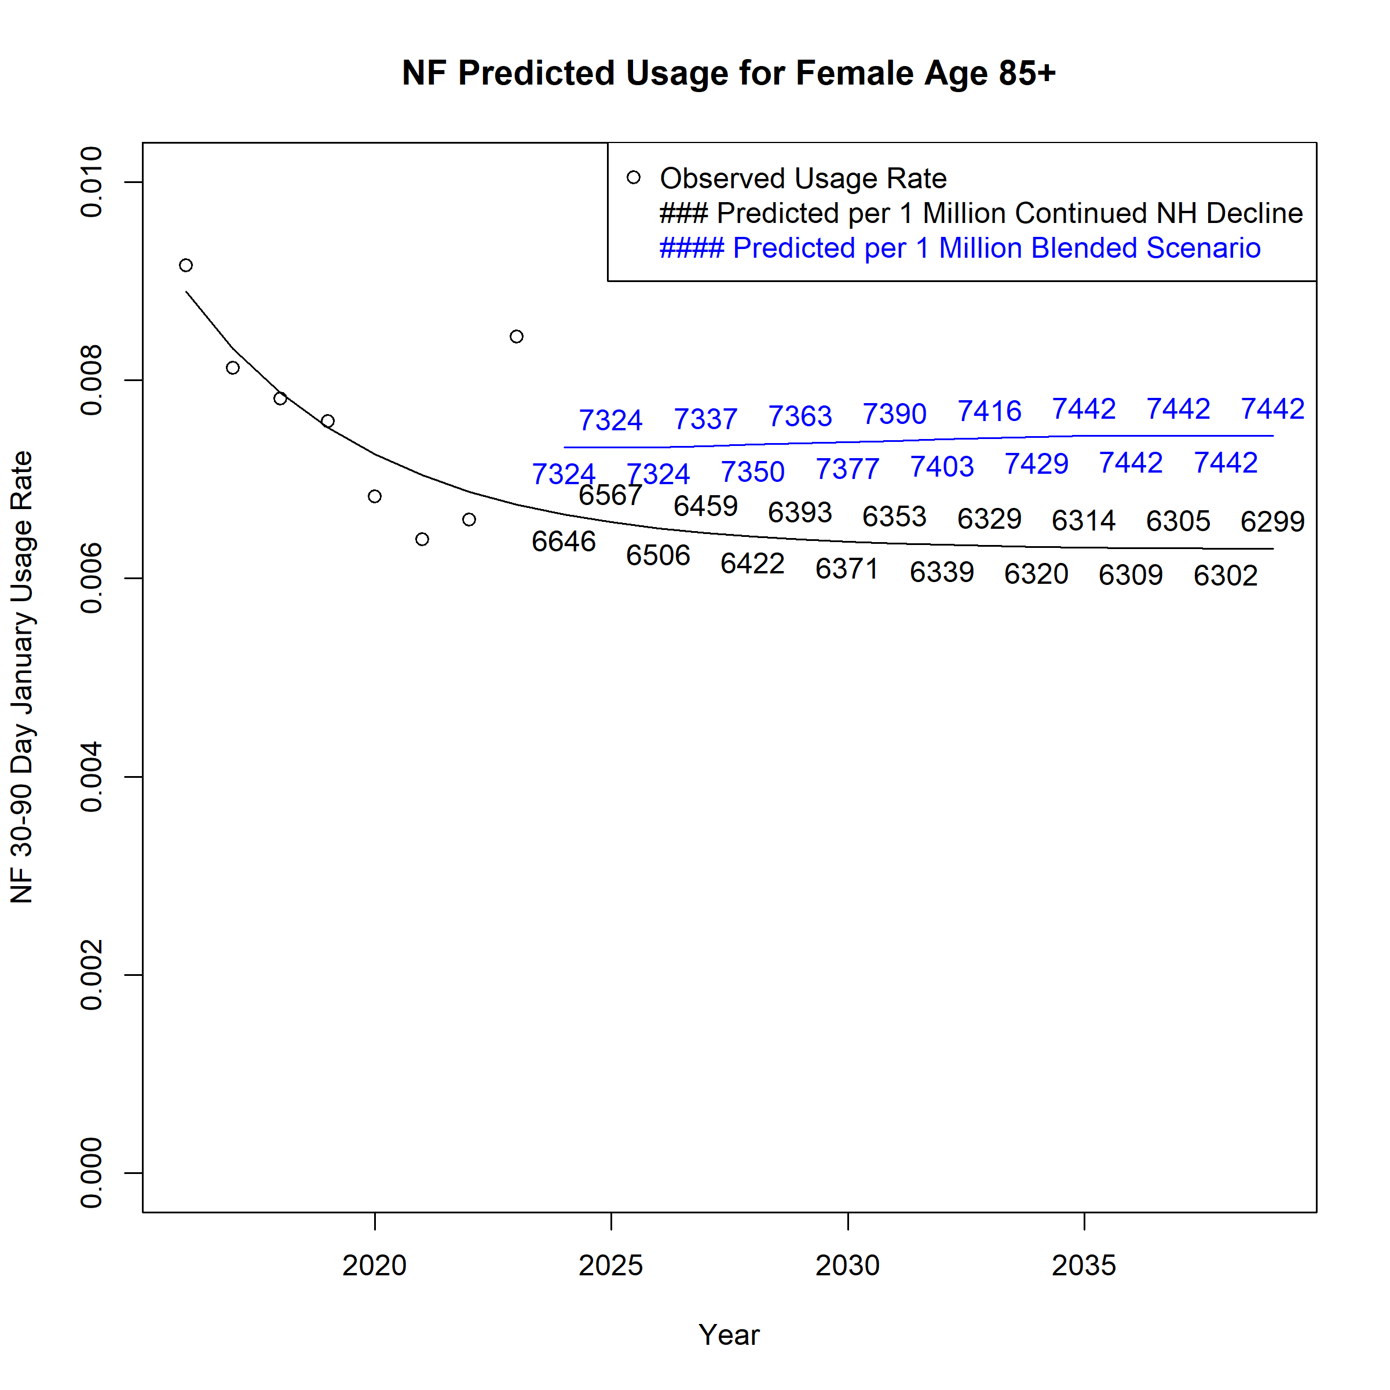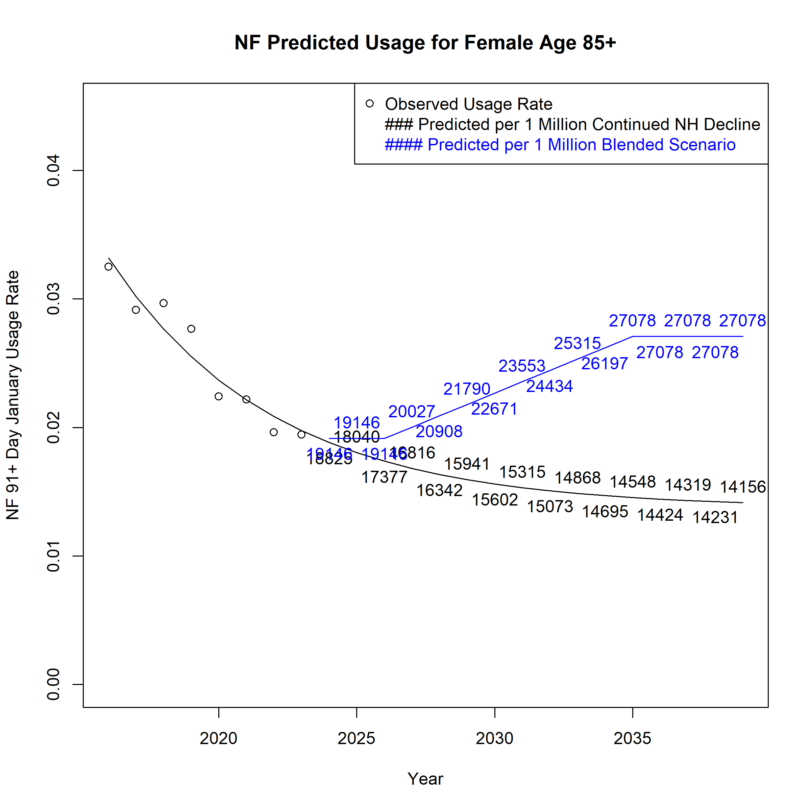
Figure A 53. Assumed Monthly Nursing Facility Users per 1 Million Population for Males Age 65-74 across Scenarios
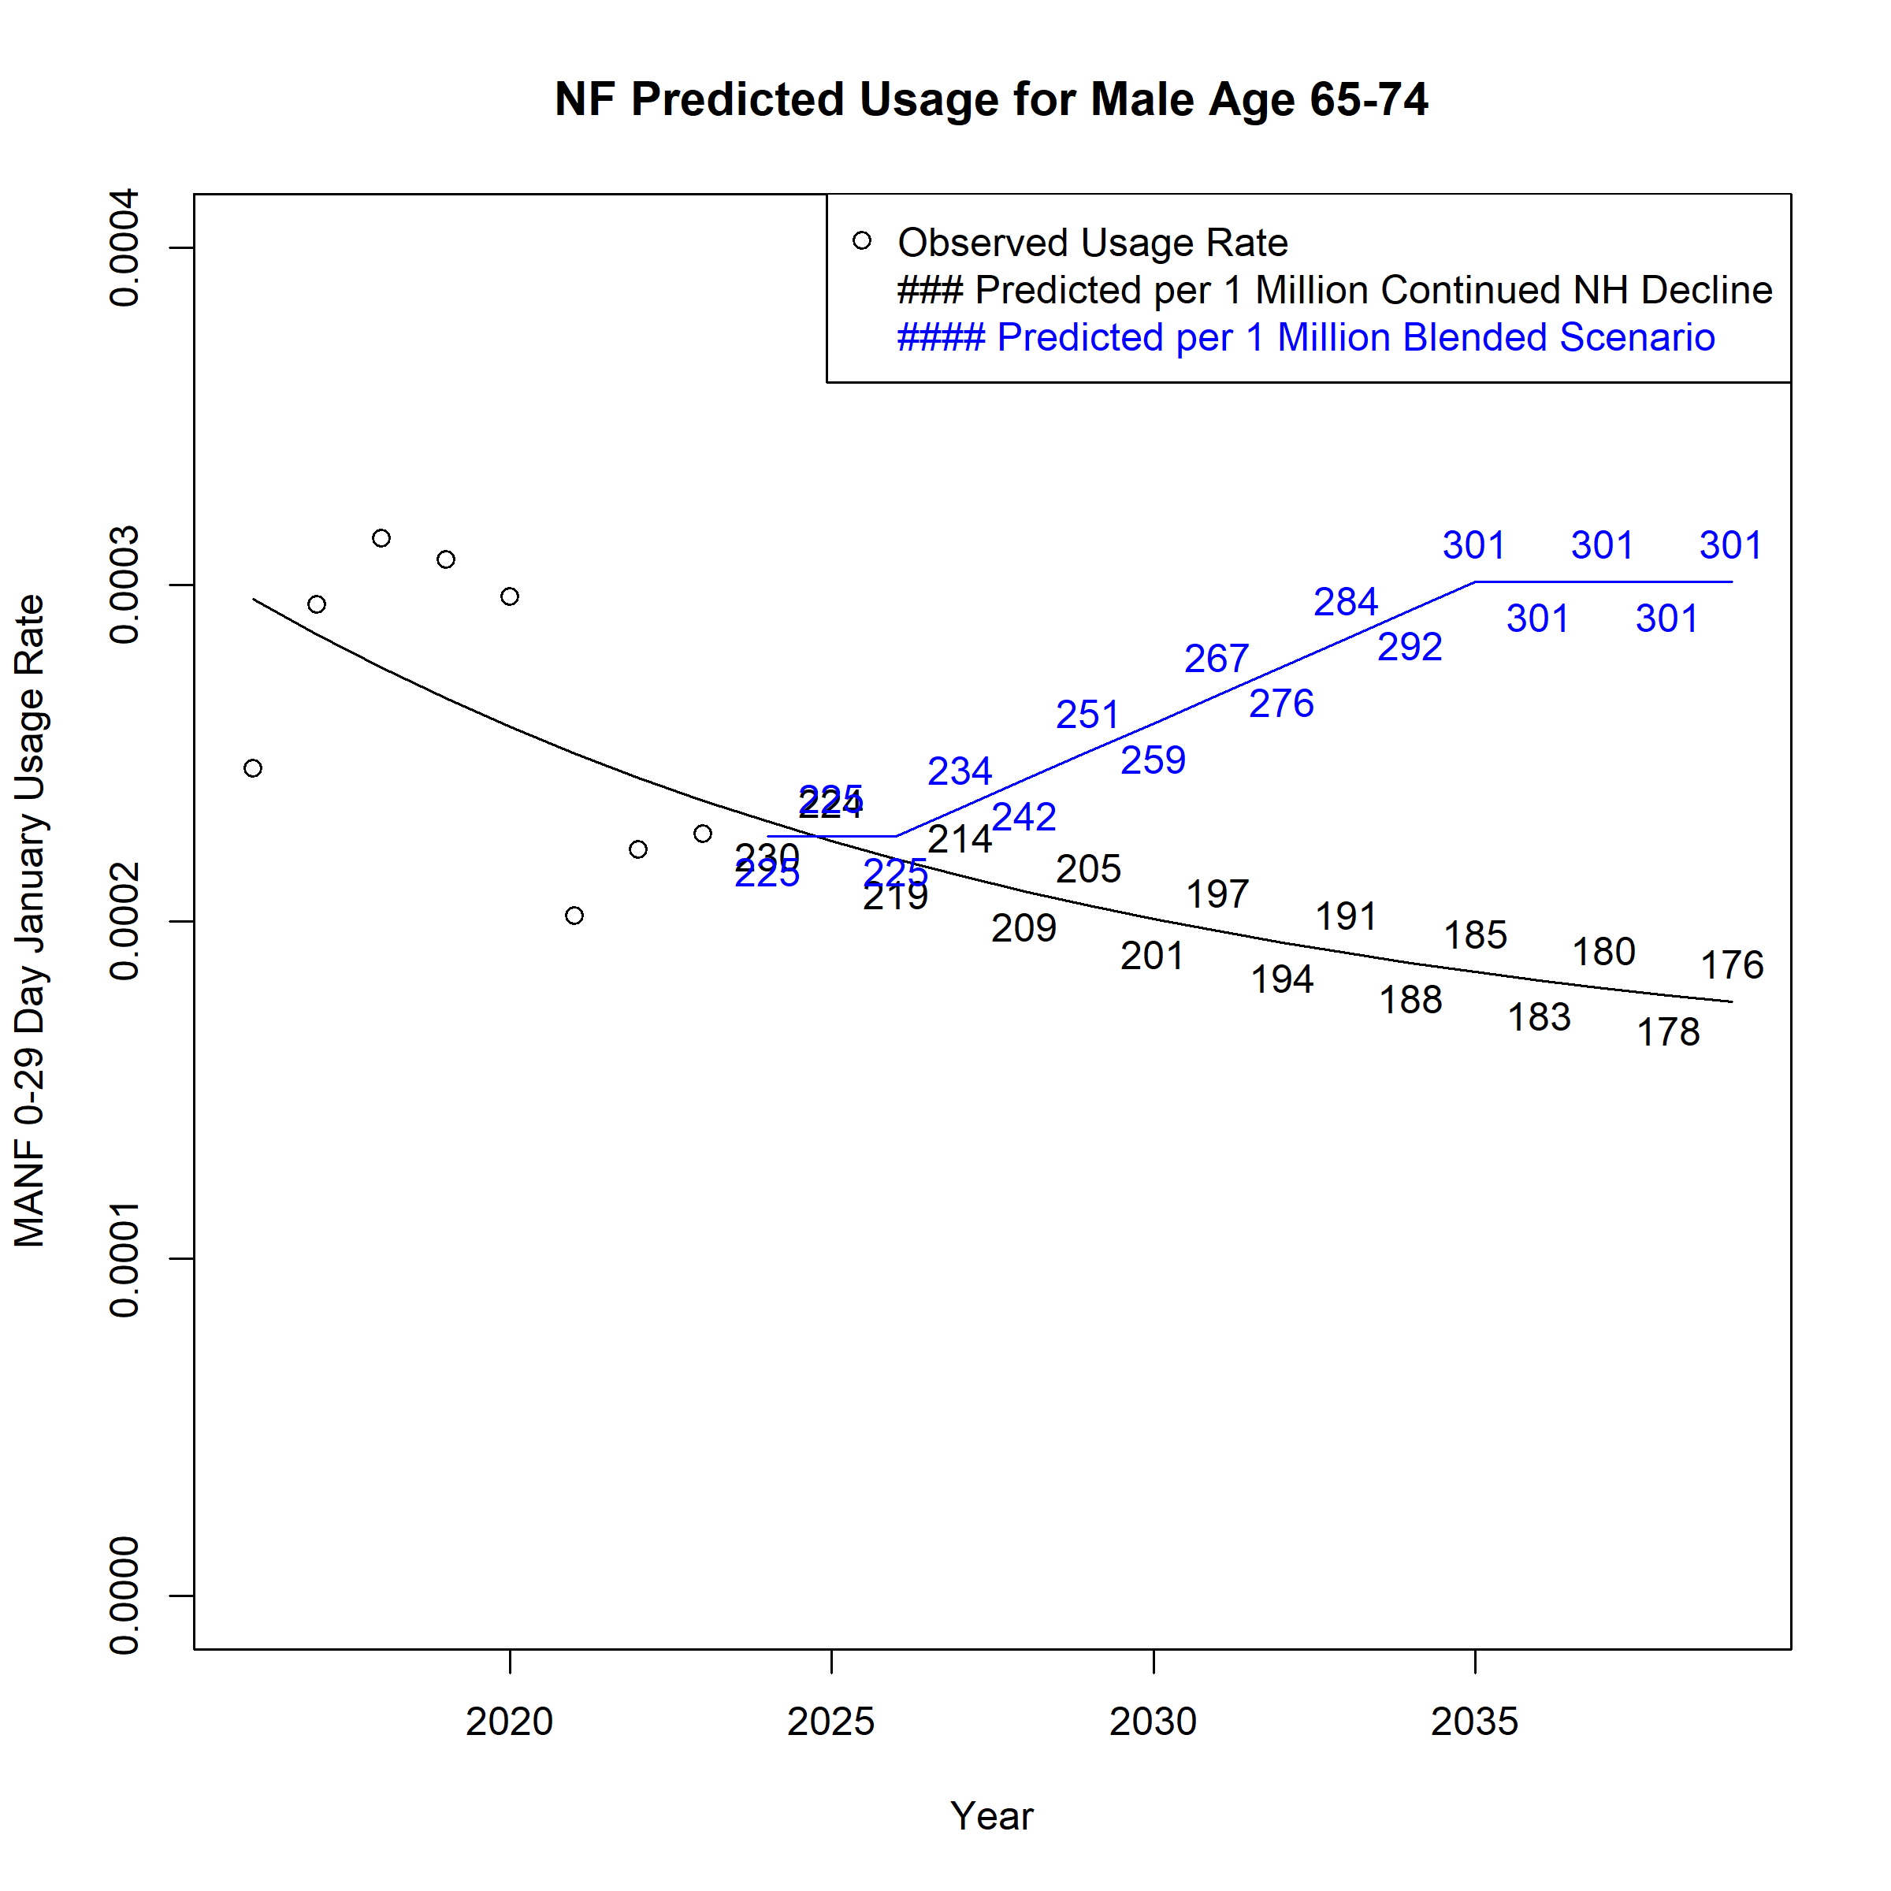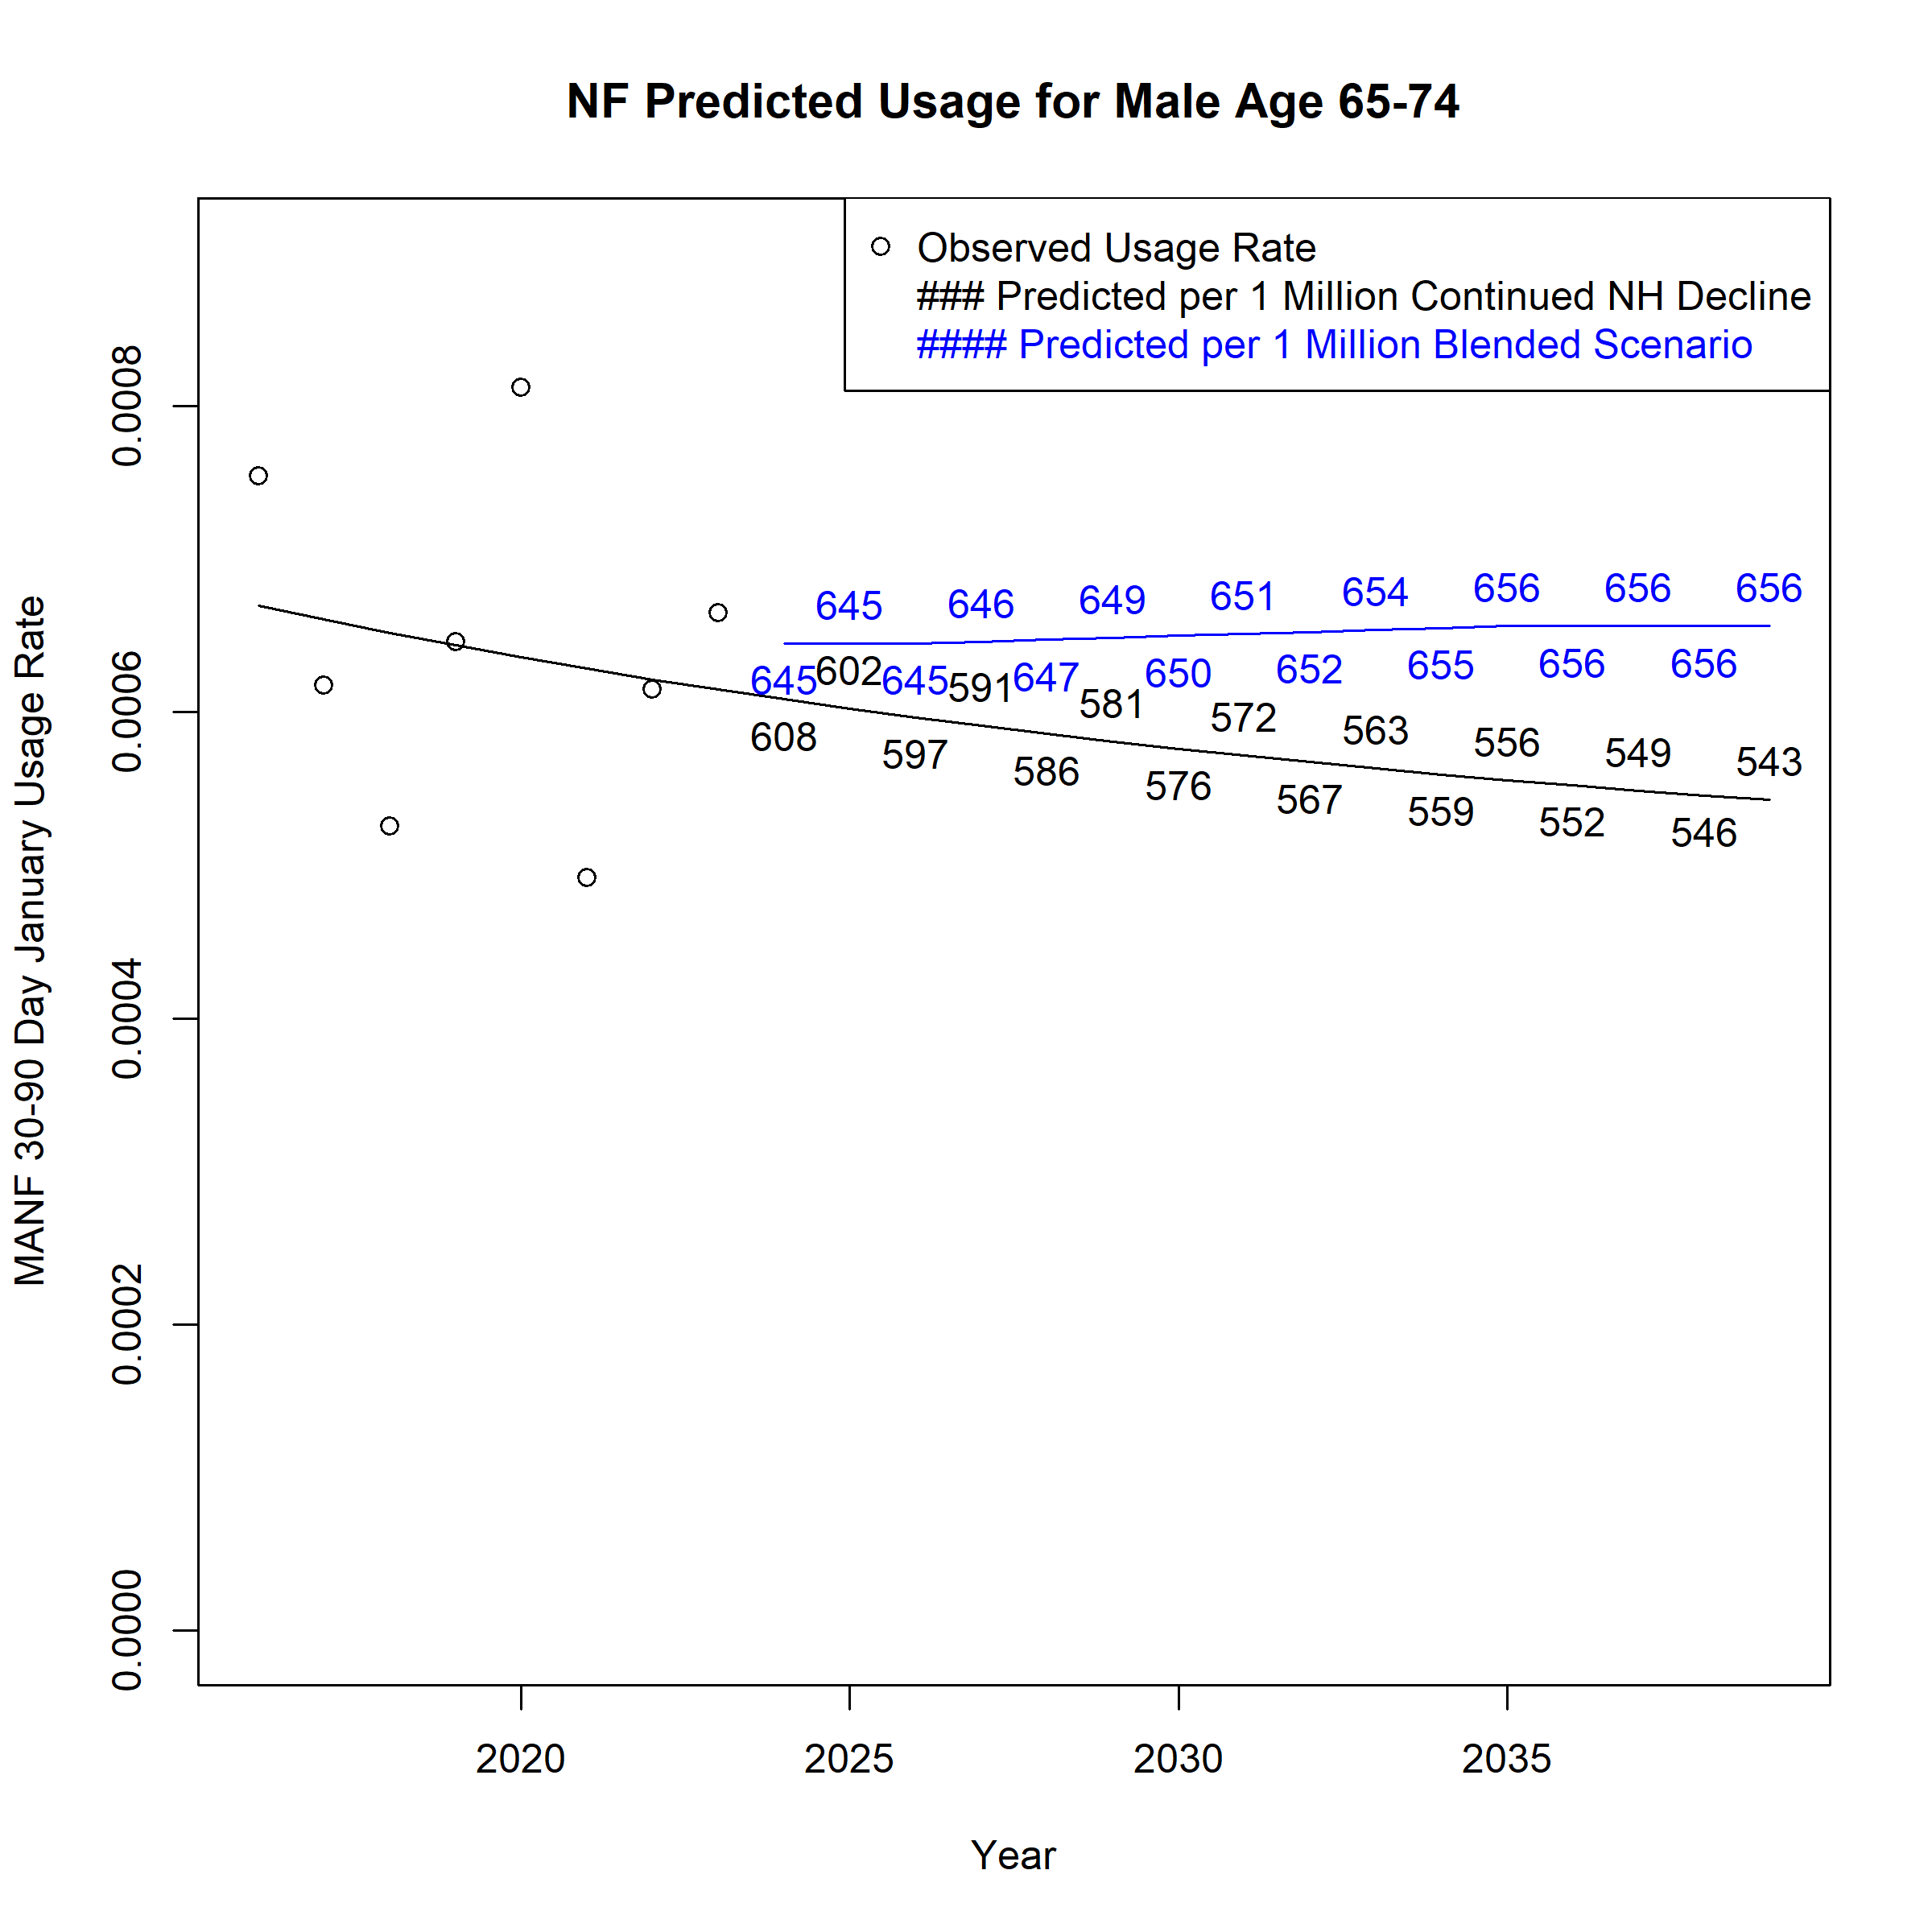

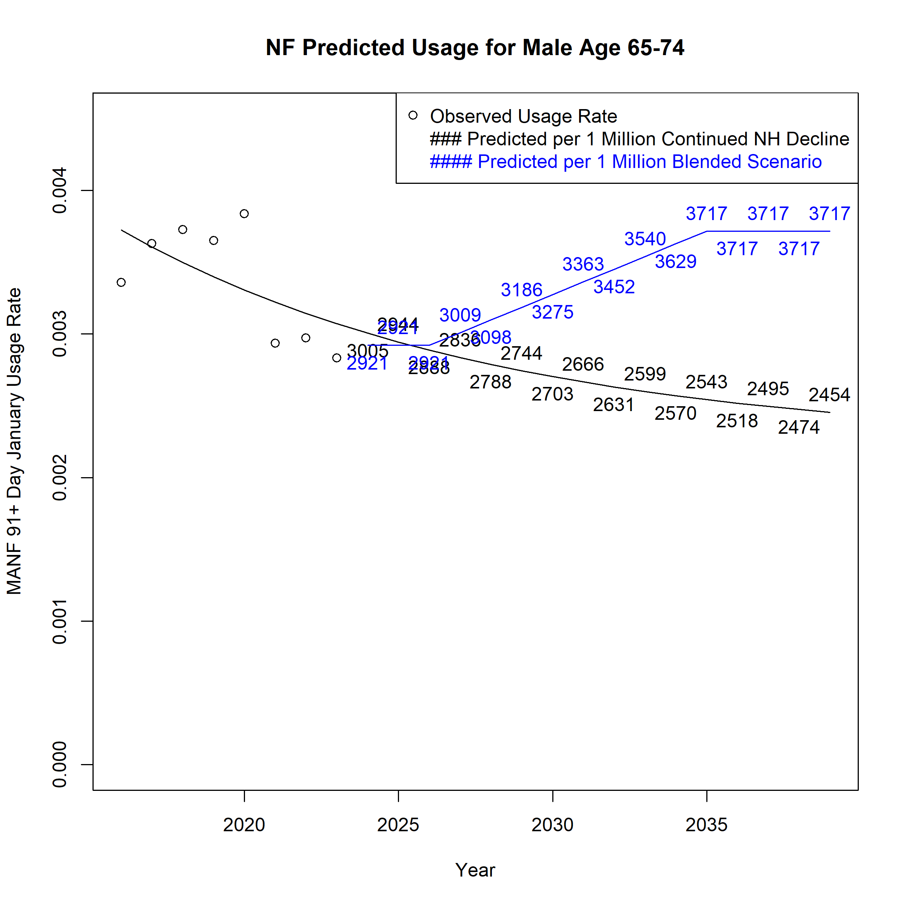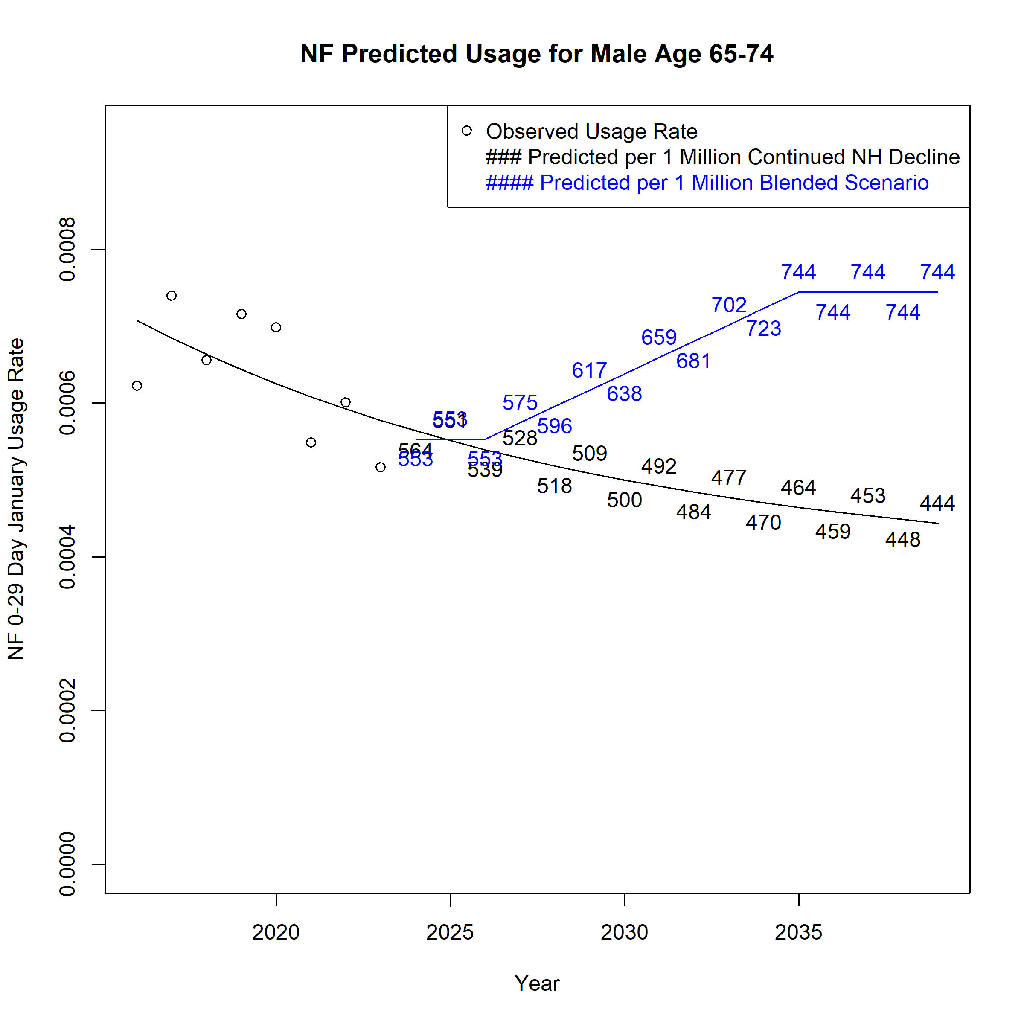
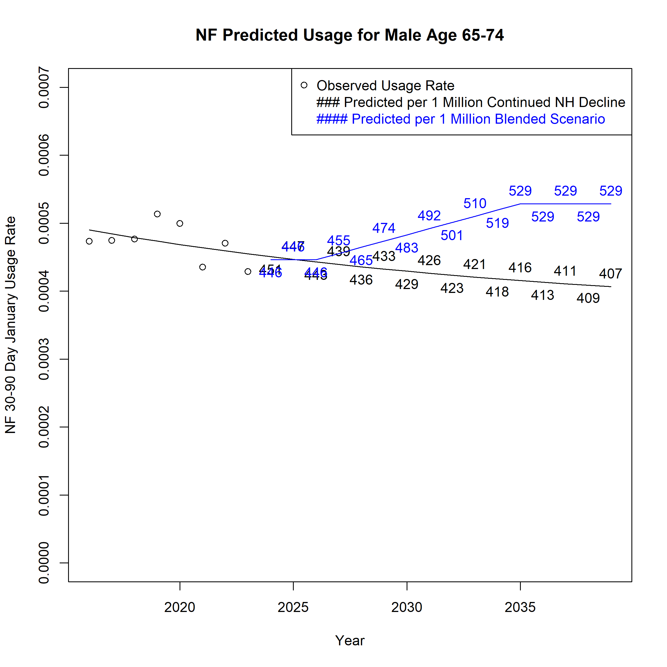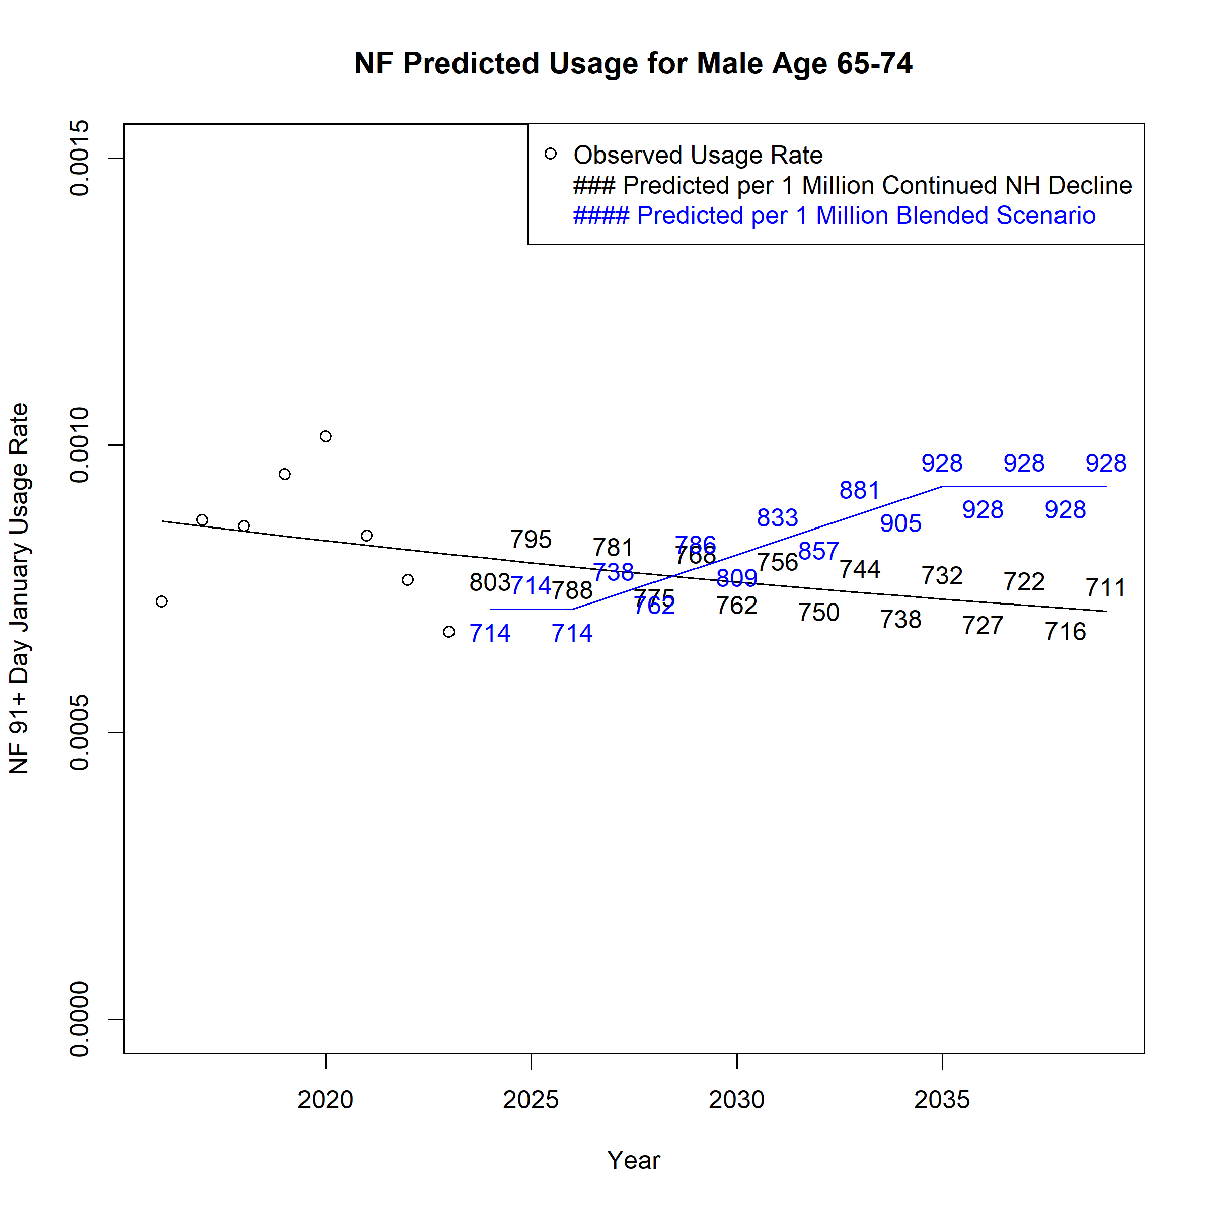

Figure A 54. Assumed Monthly Nursing Facility Users per 1 Million Population for Males Age 75-84 across Scenarios
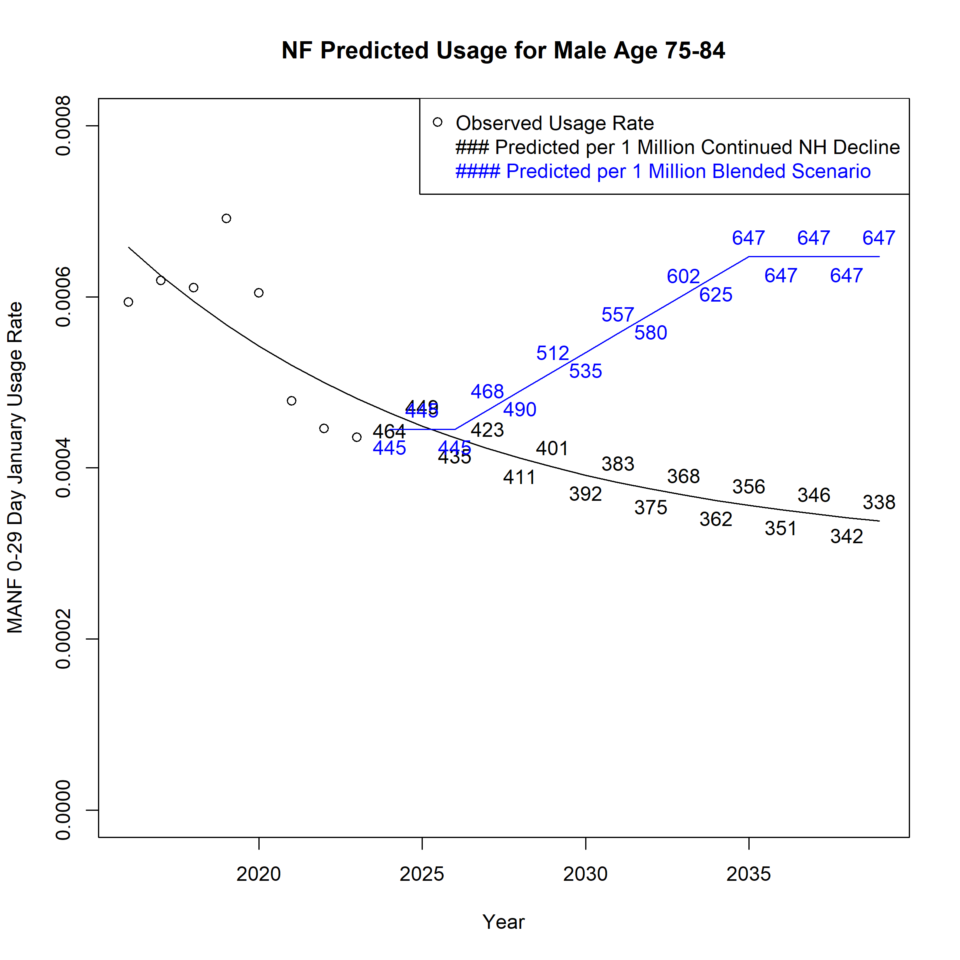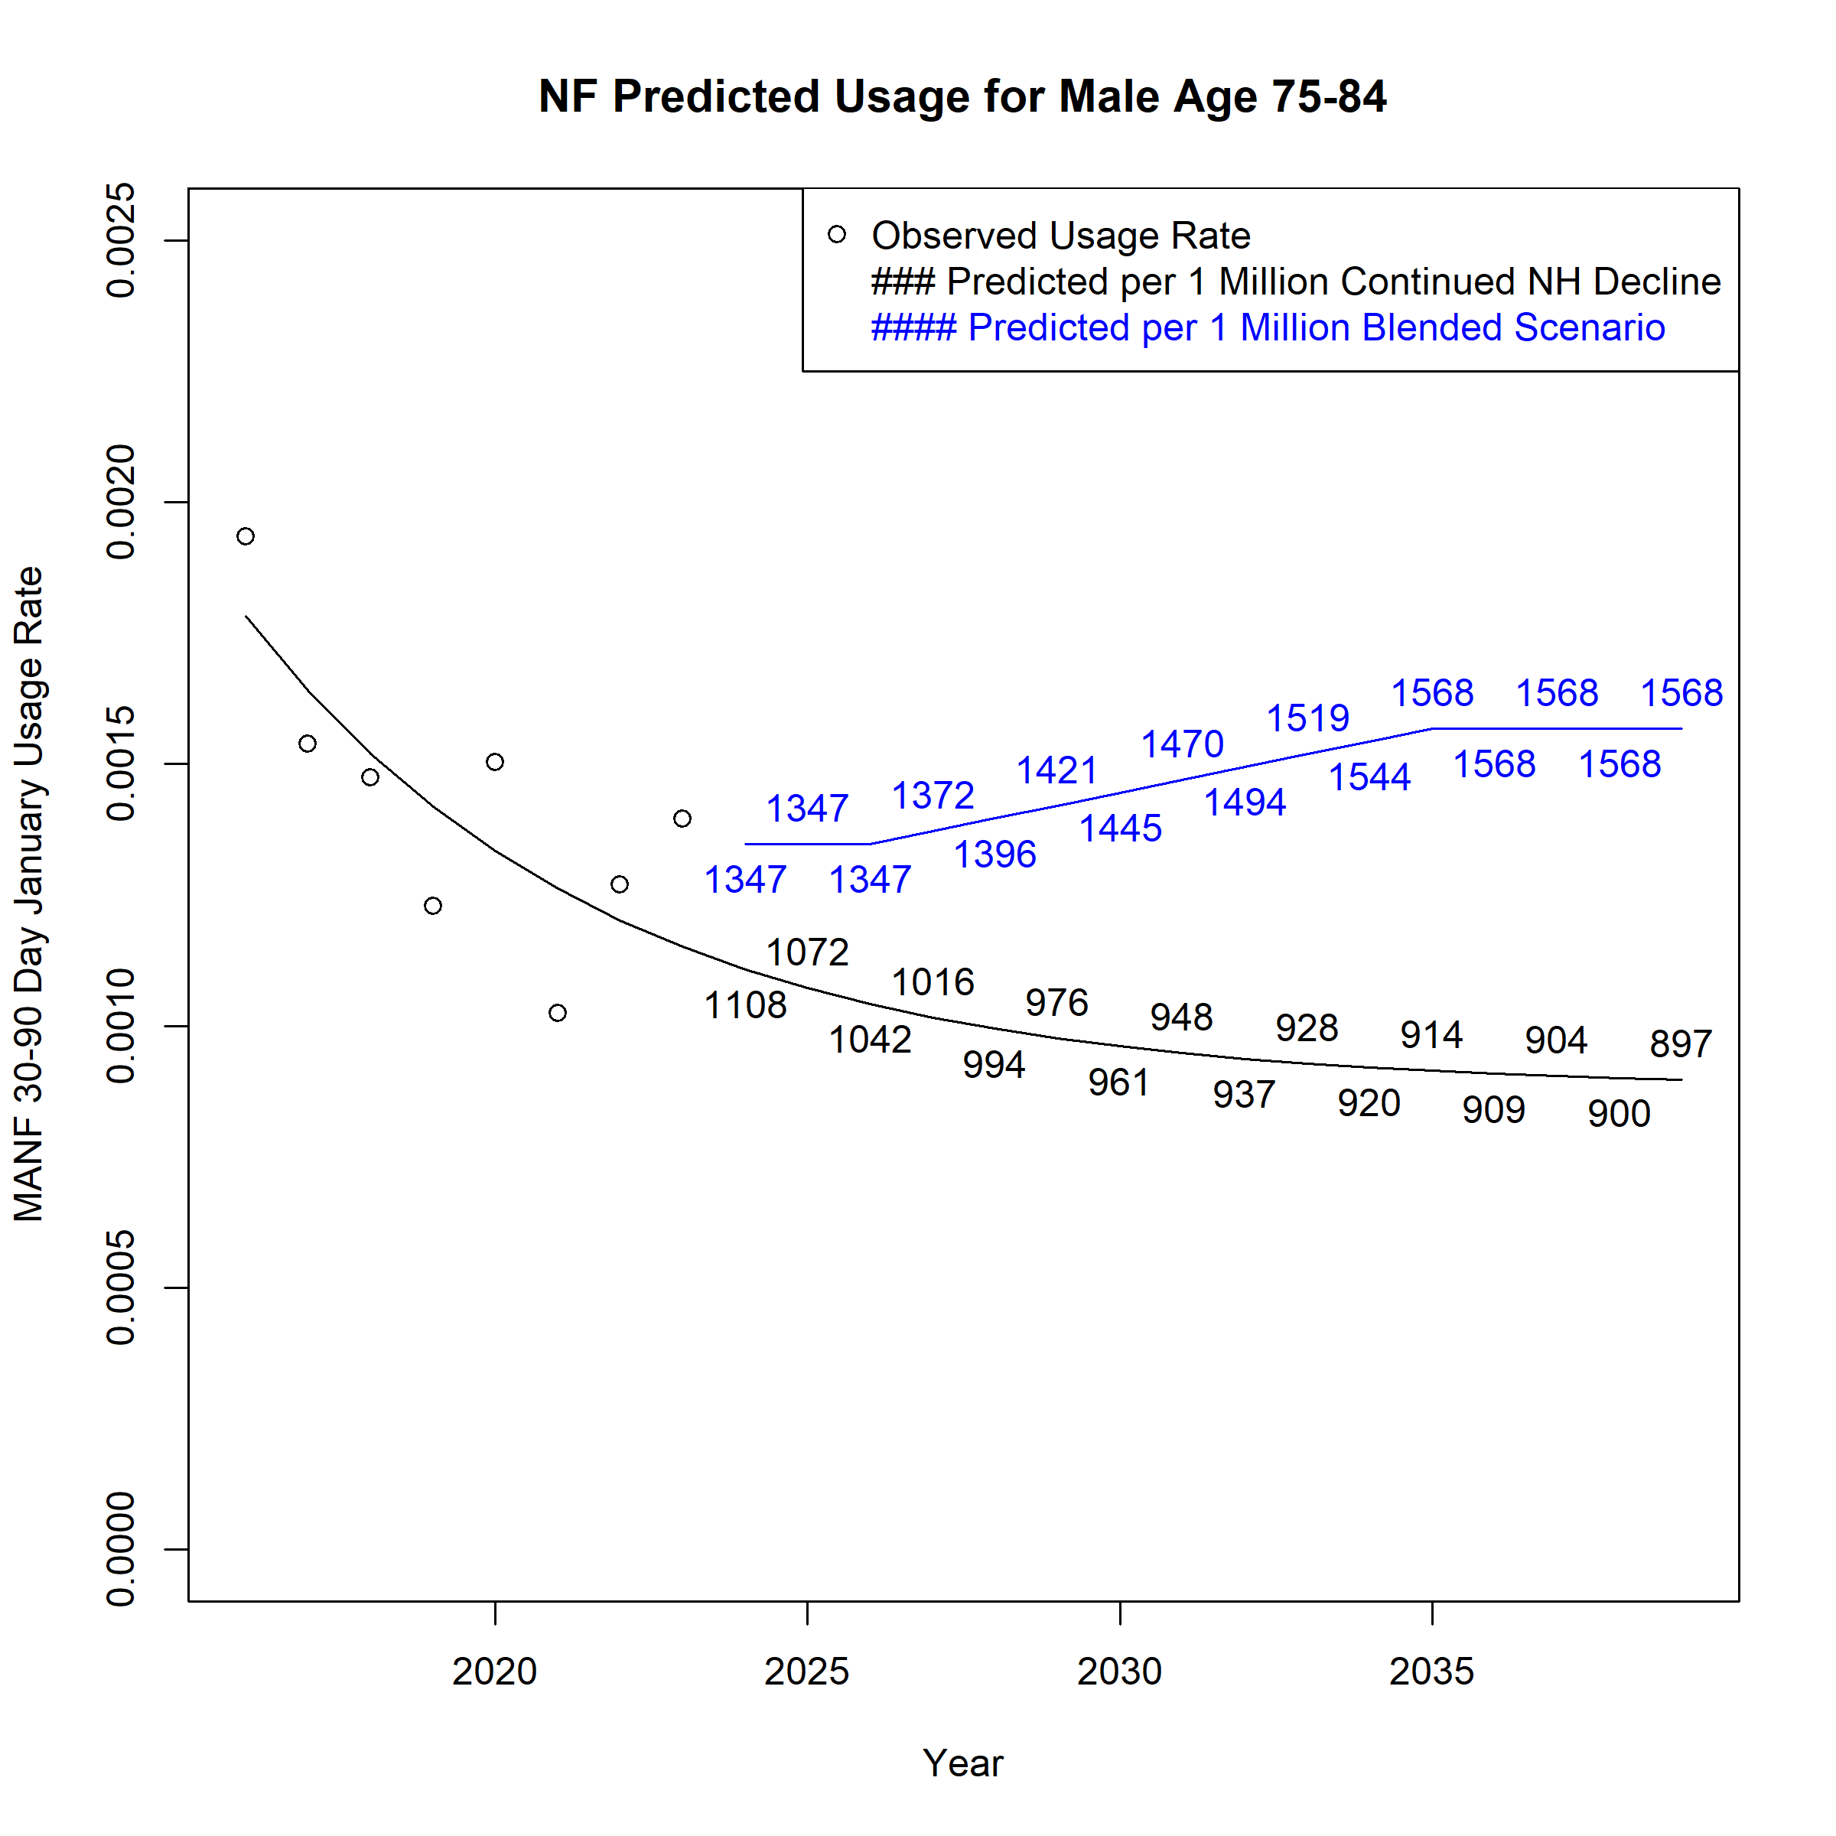

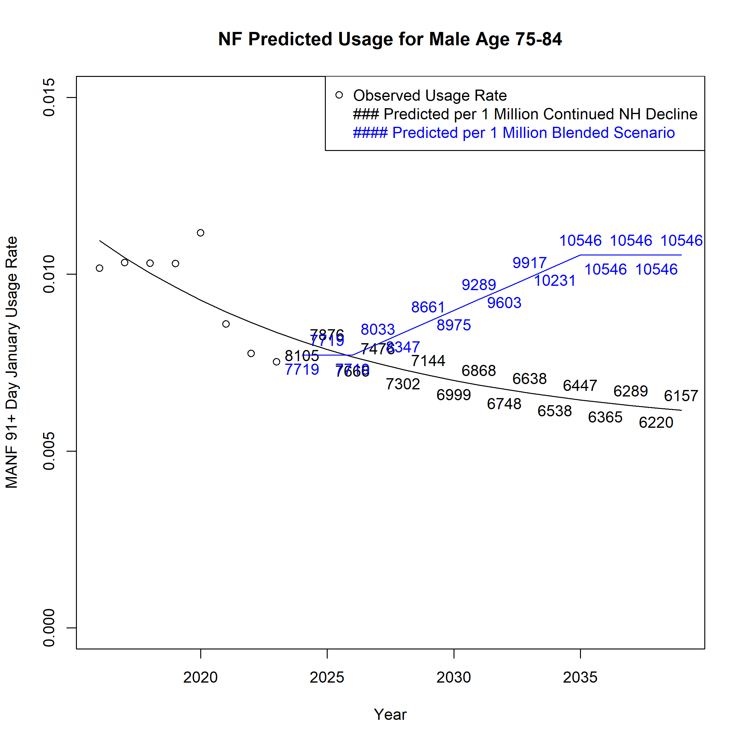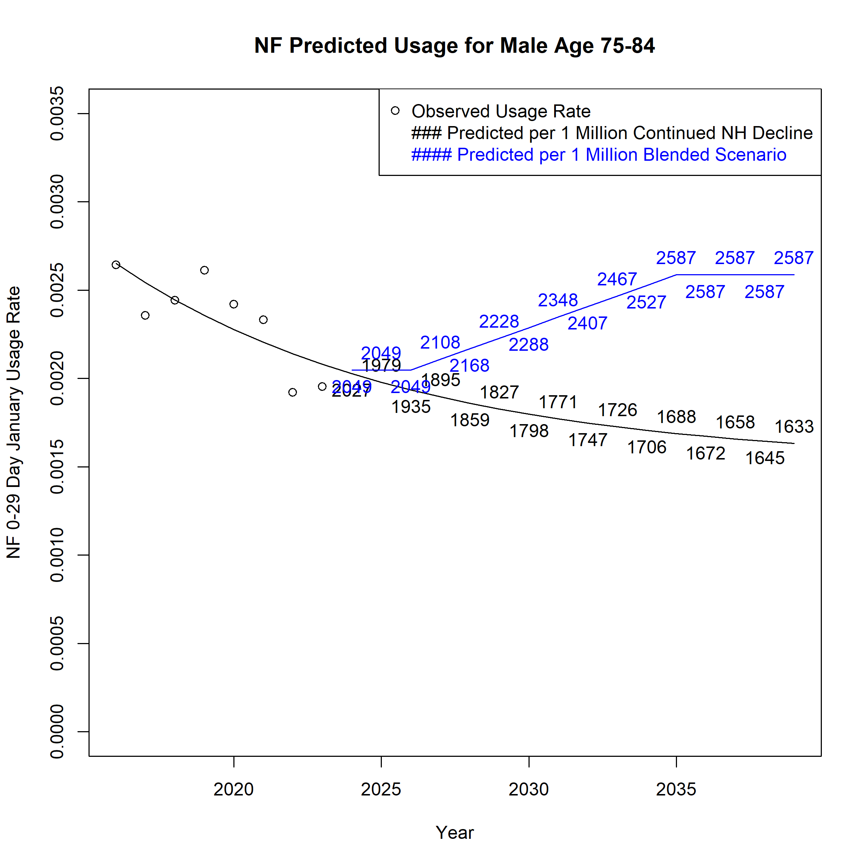
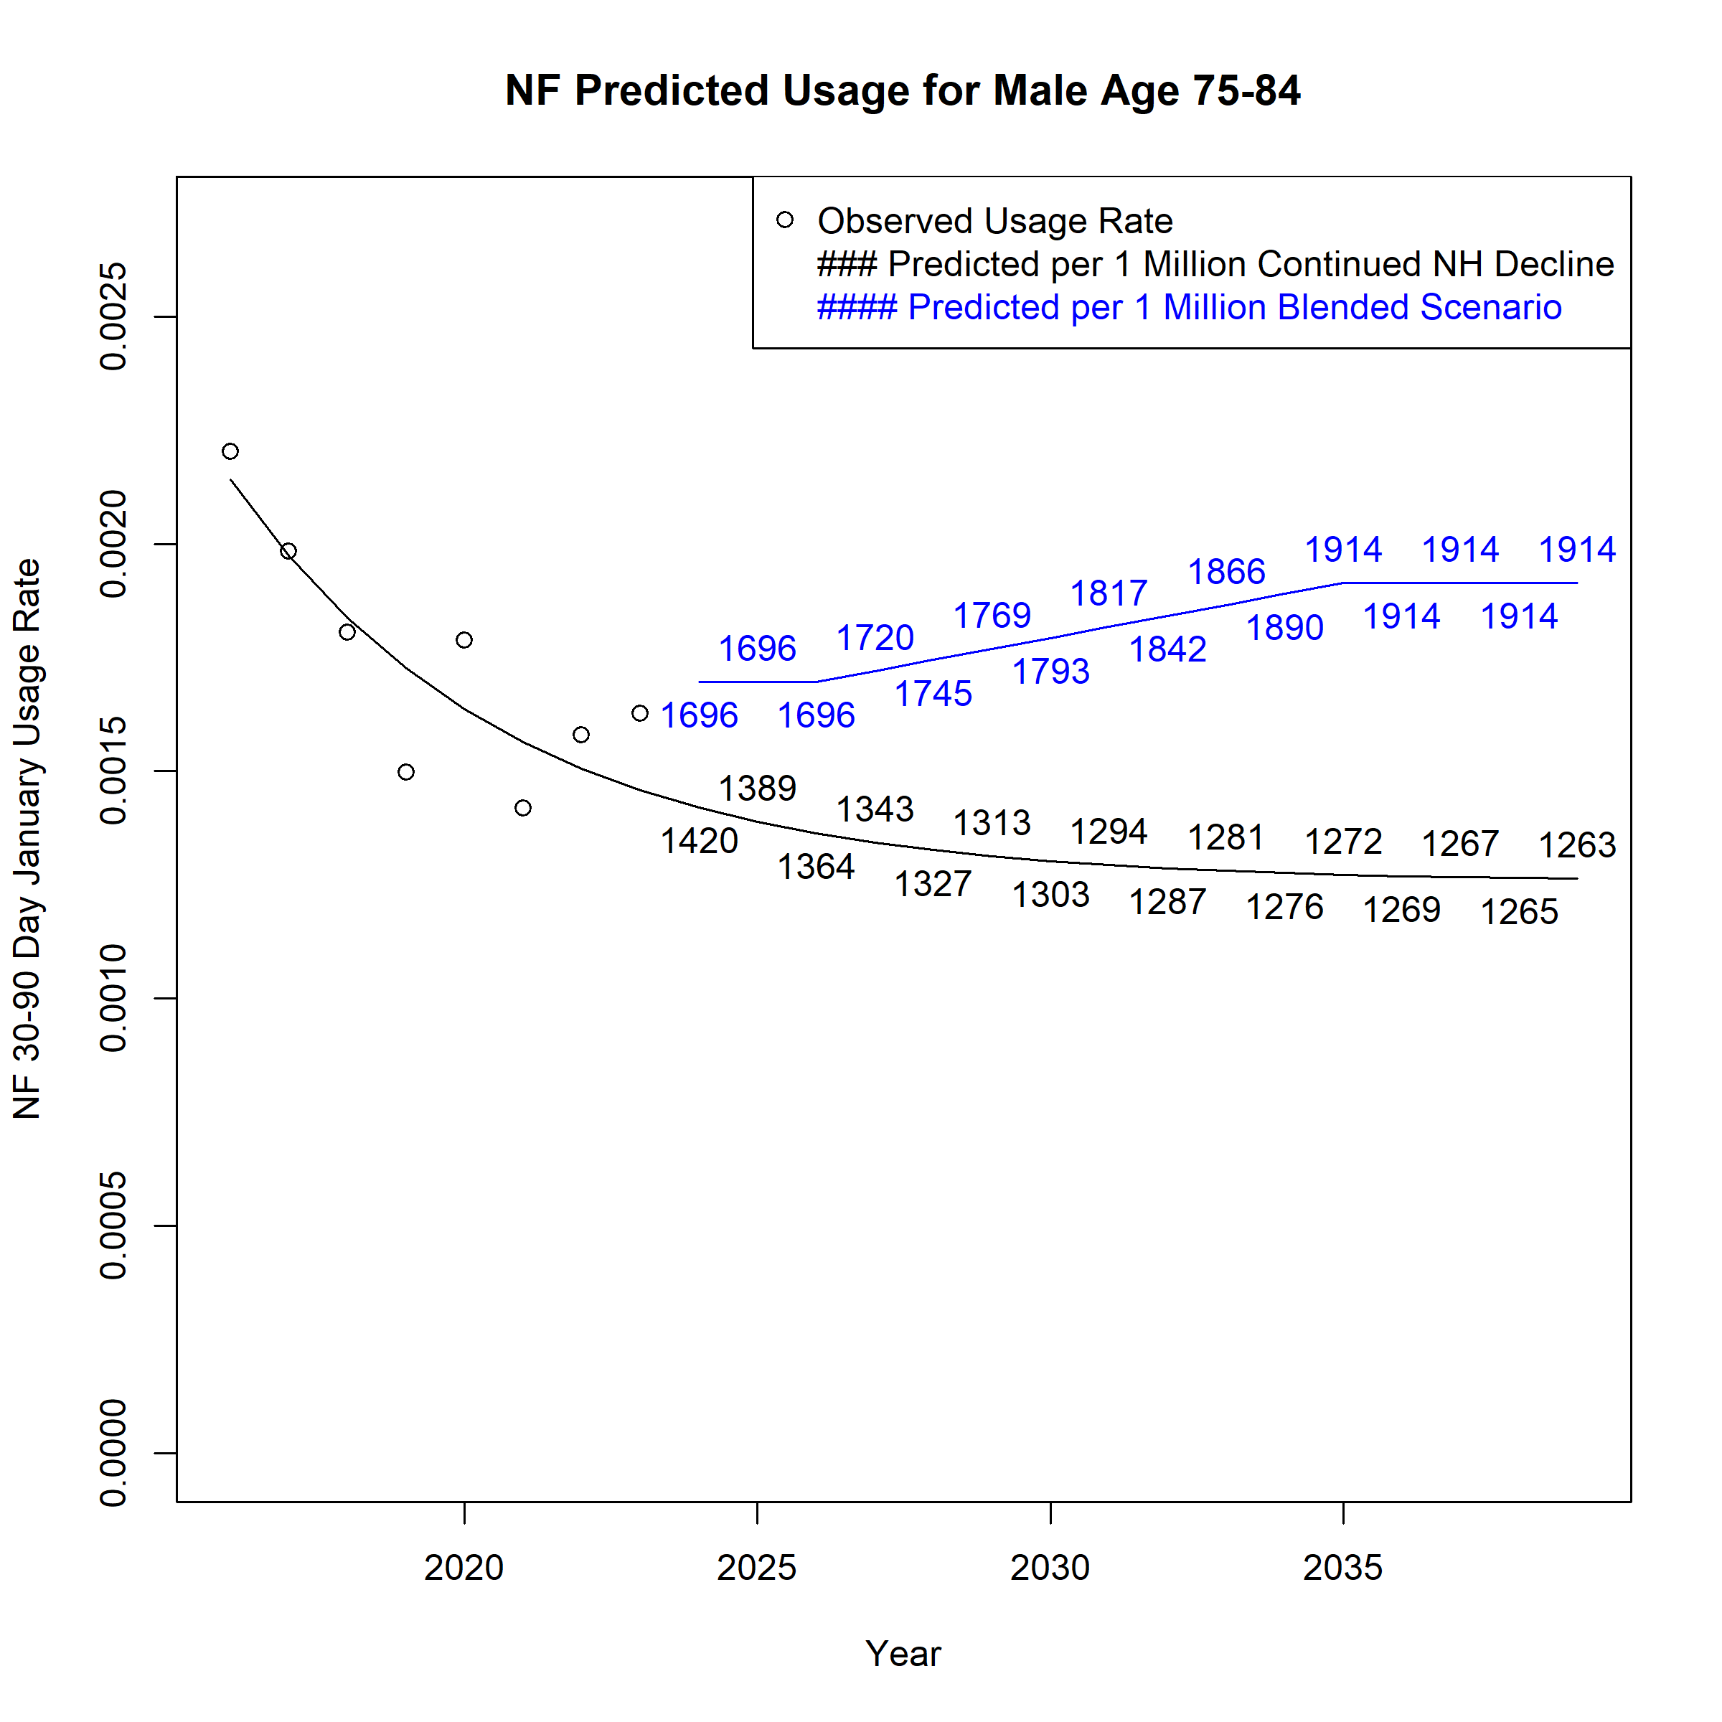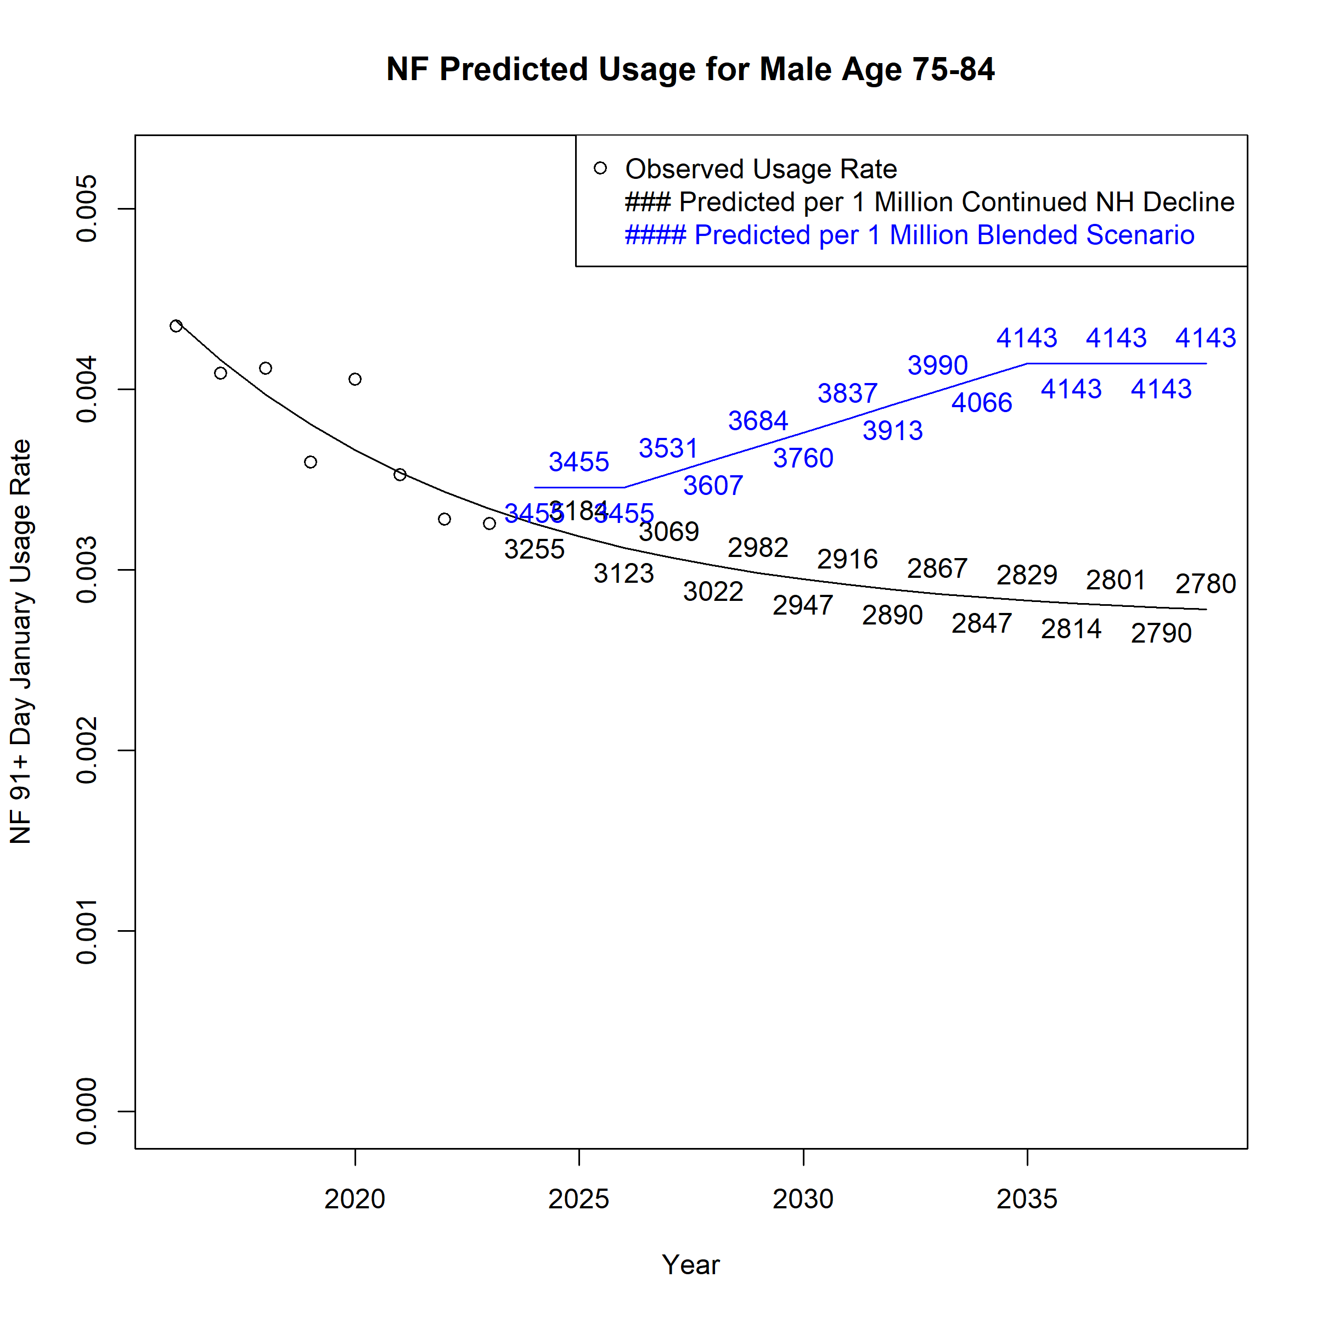
Figure A 55. Assumed Monthly Nursing Facility Users per 1 Million Population for Males Age 85 and above across Scenarios

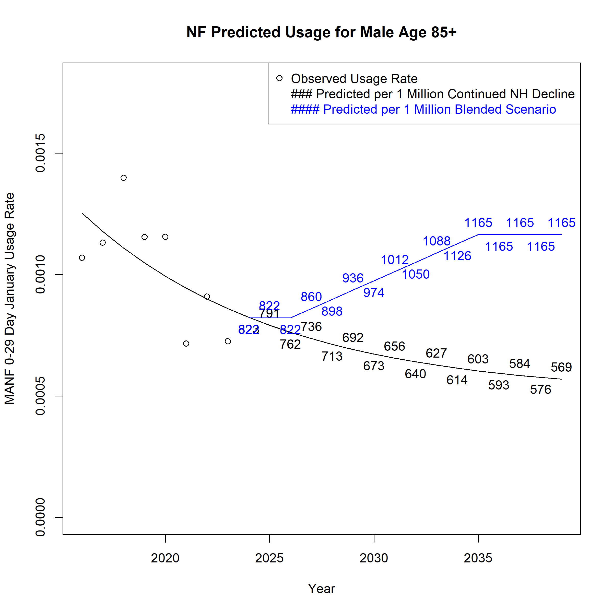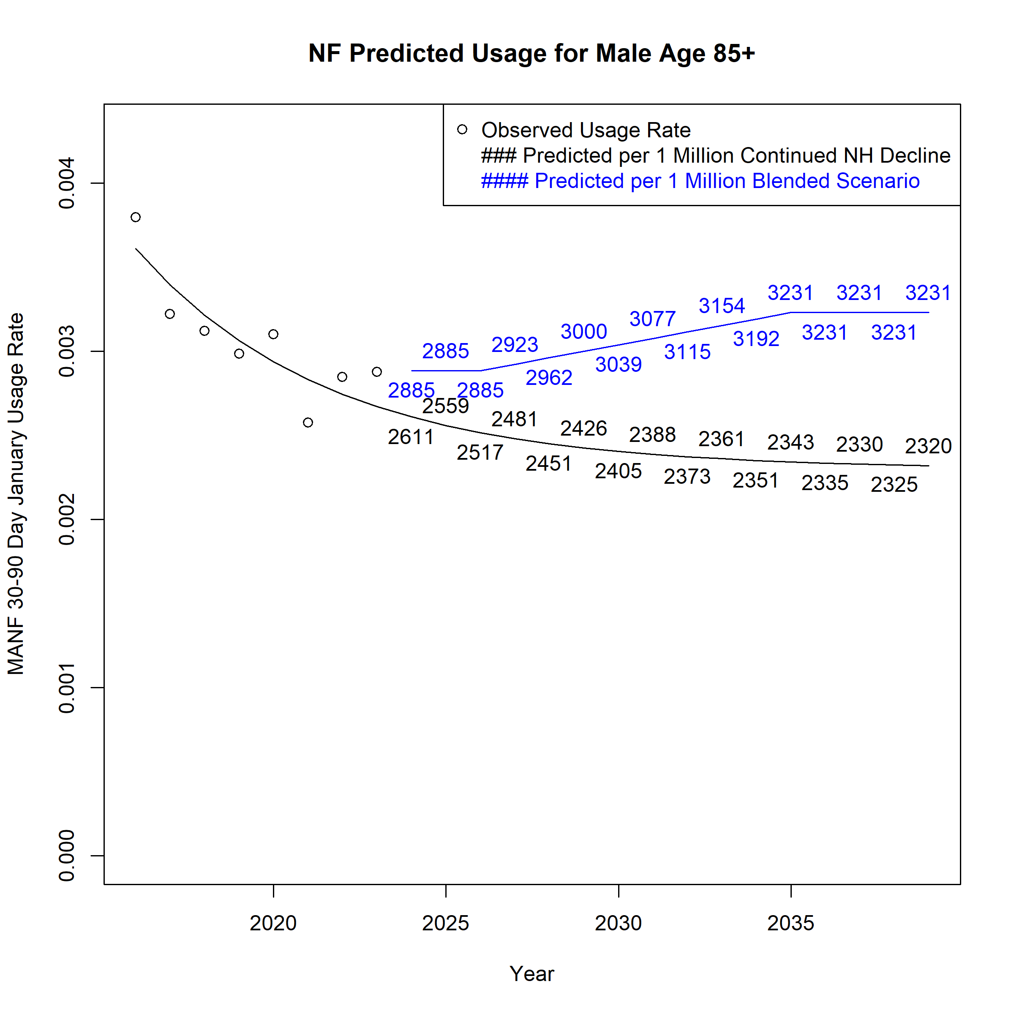
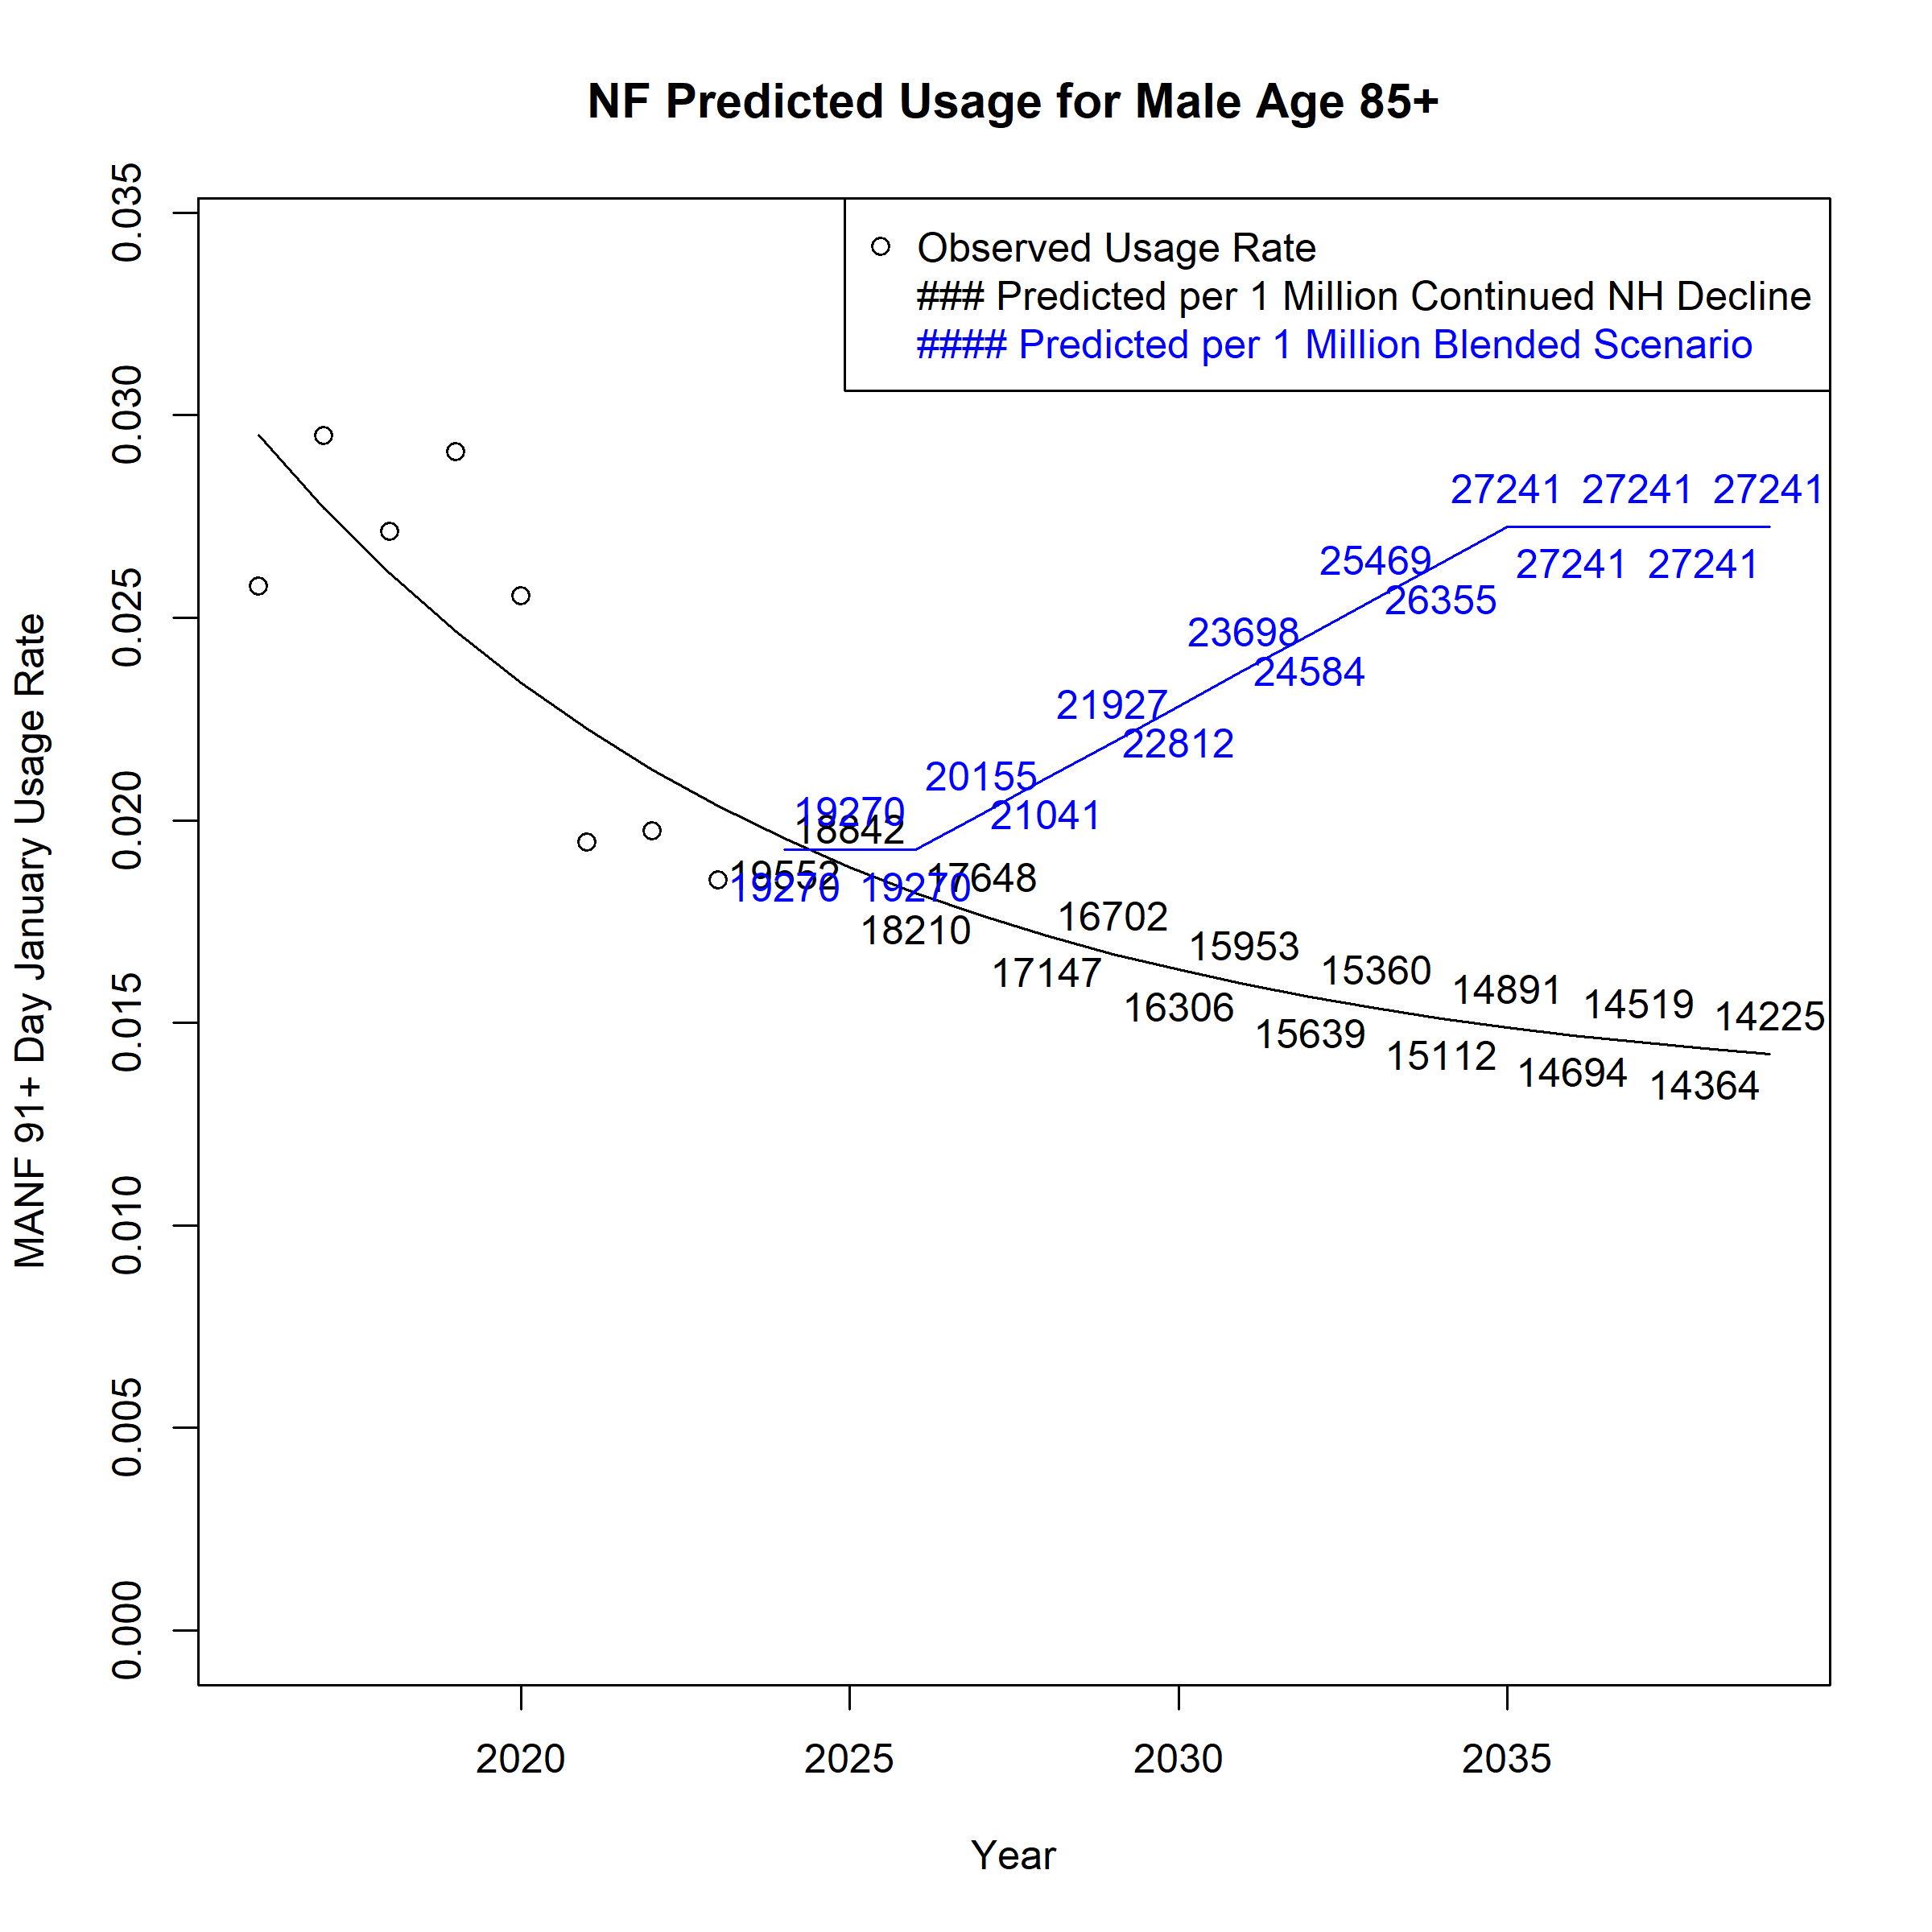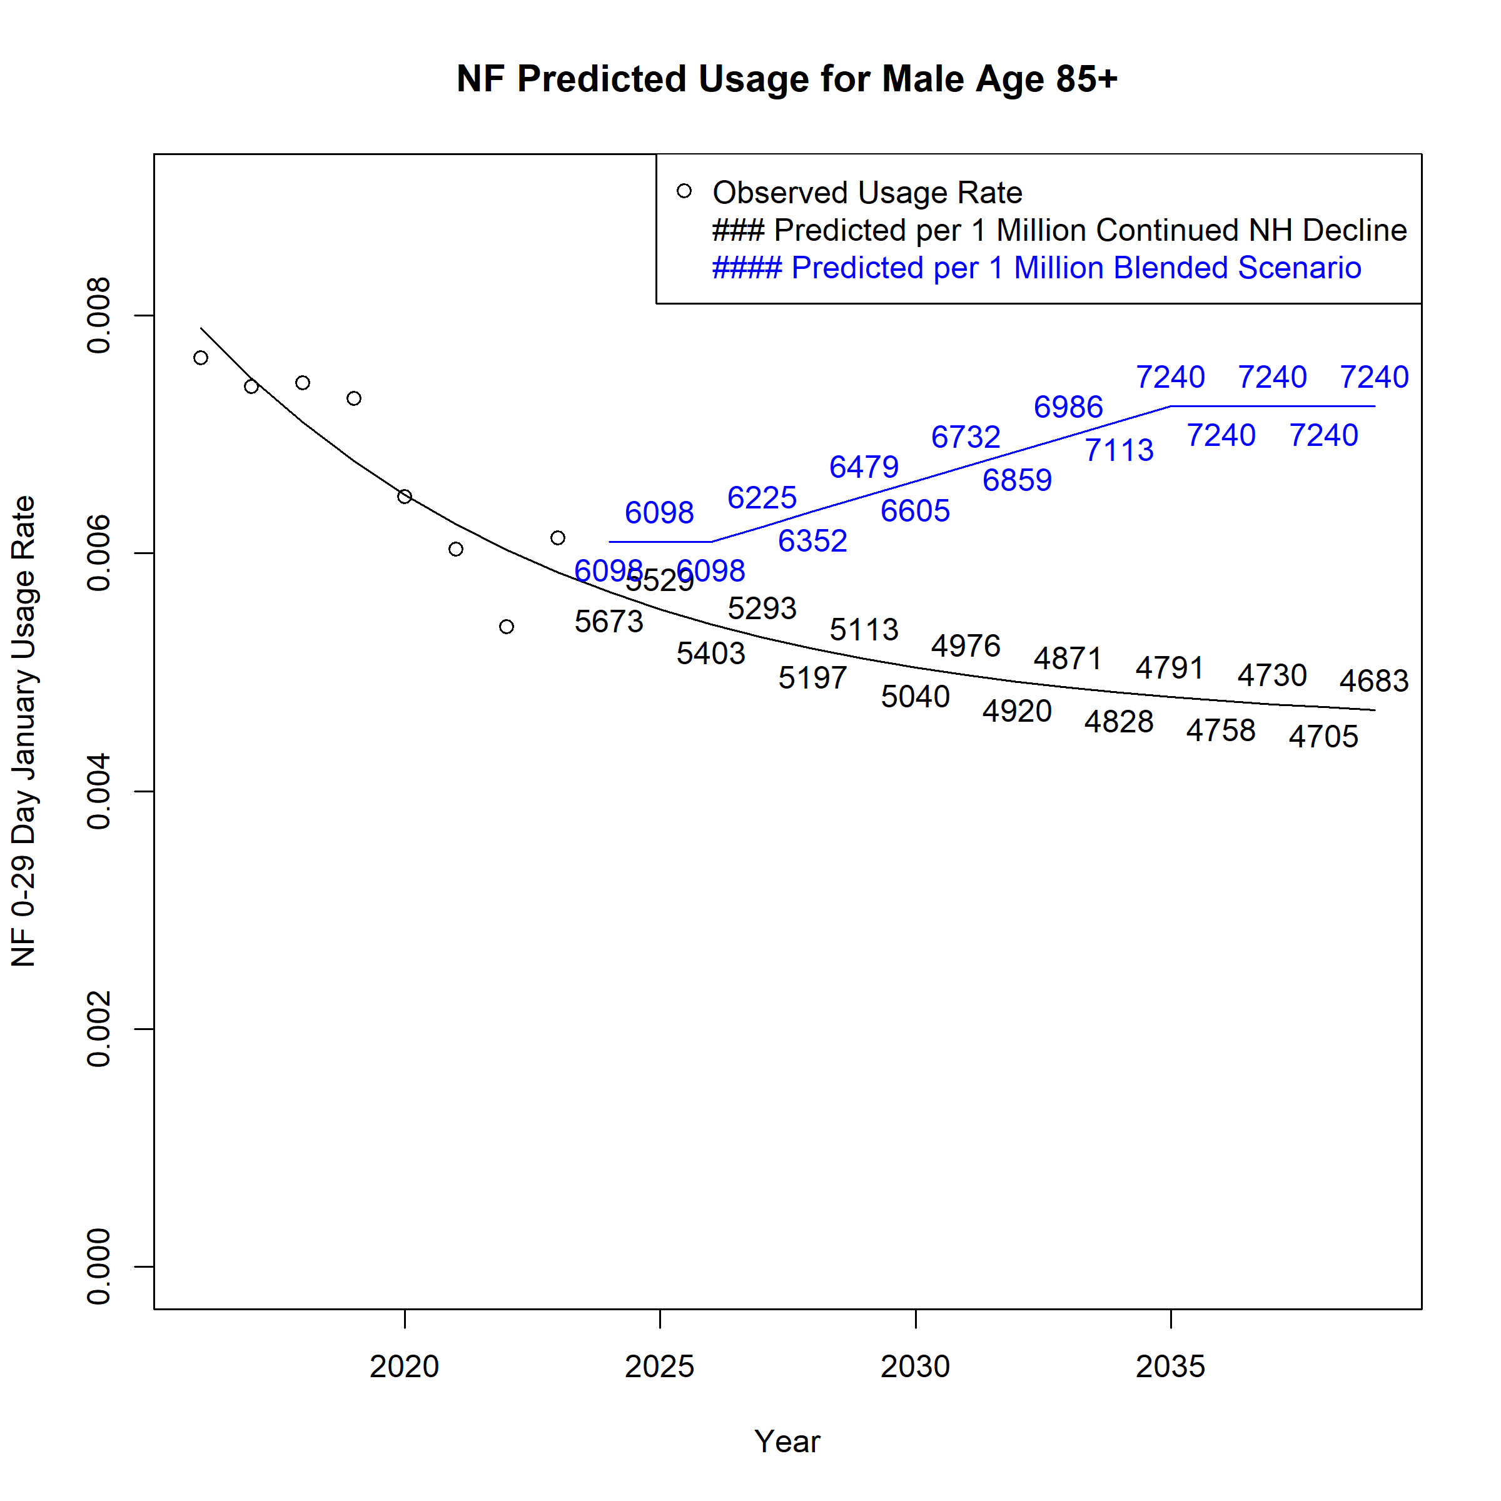
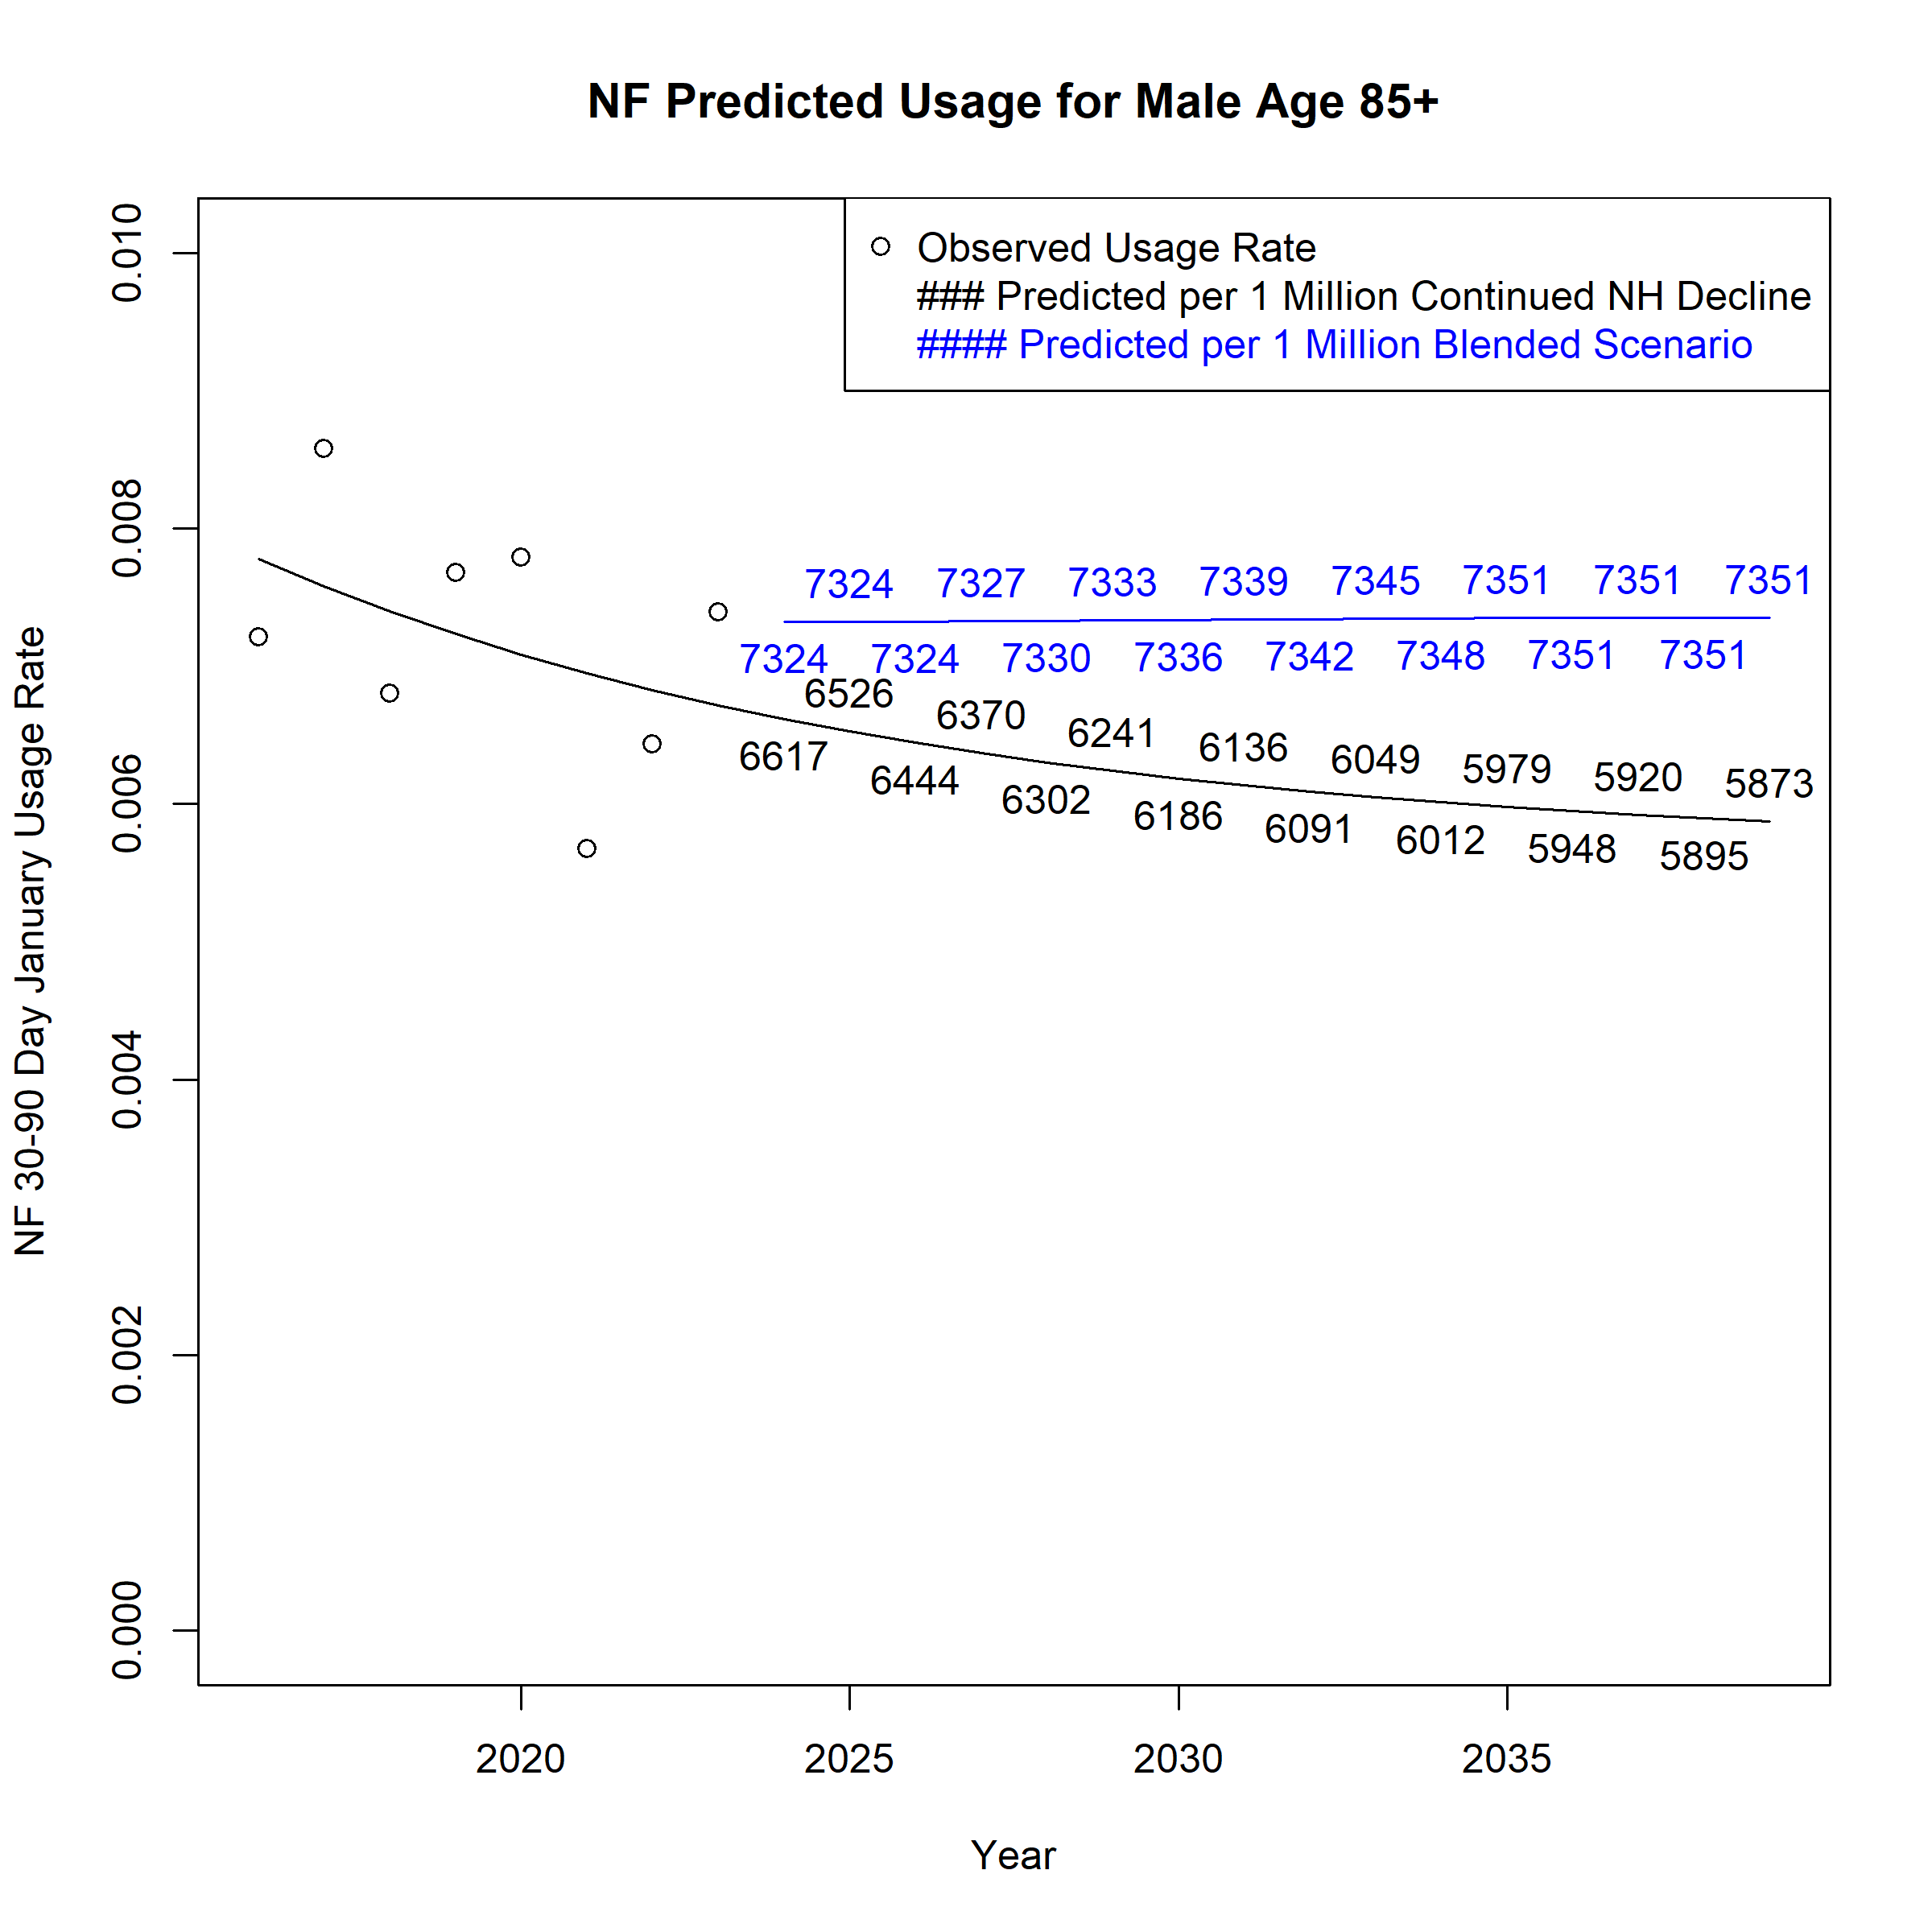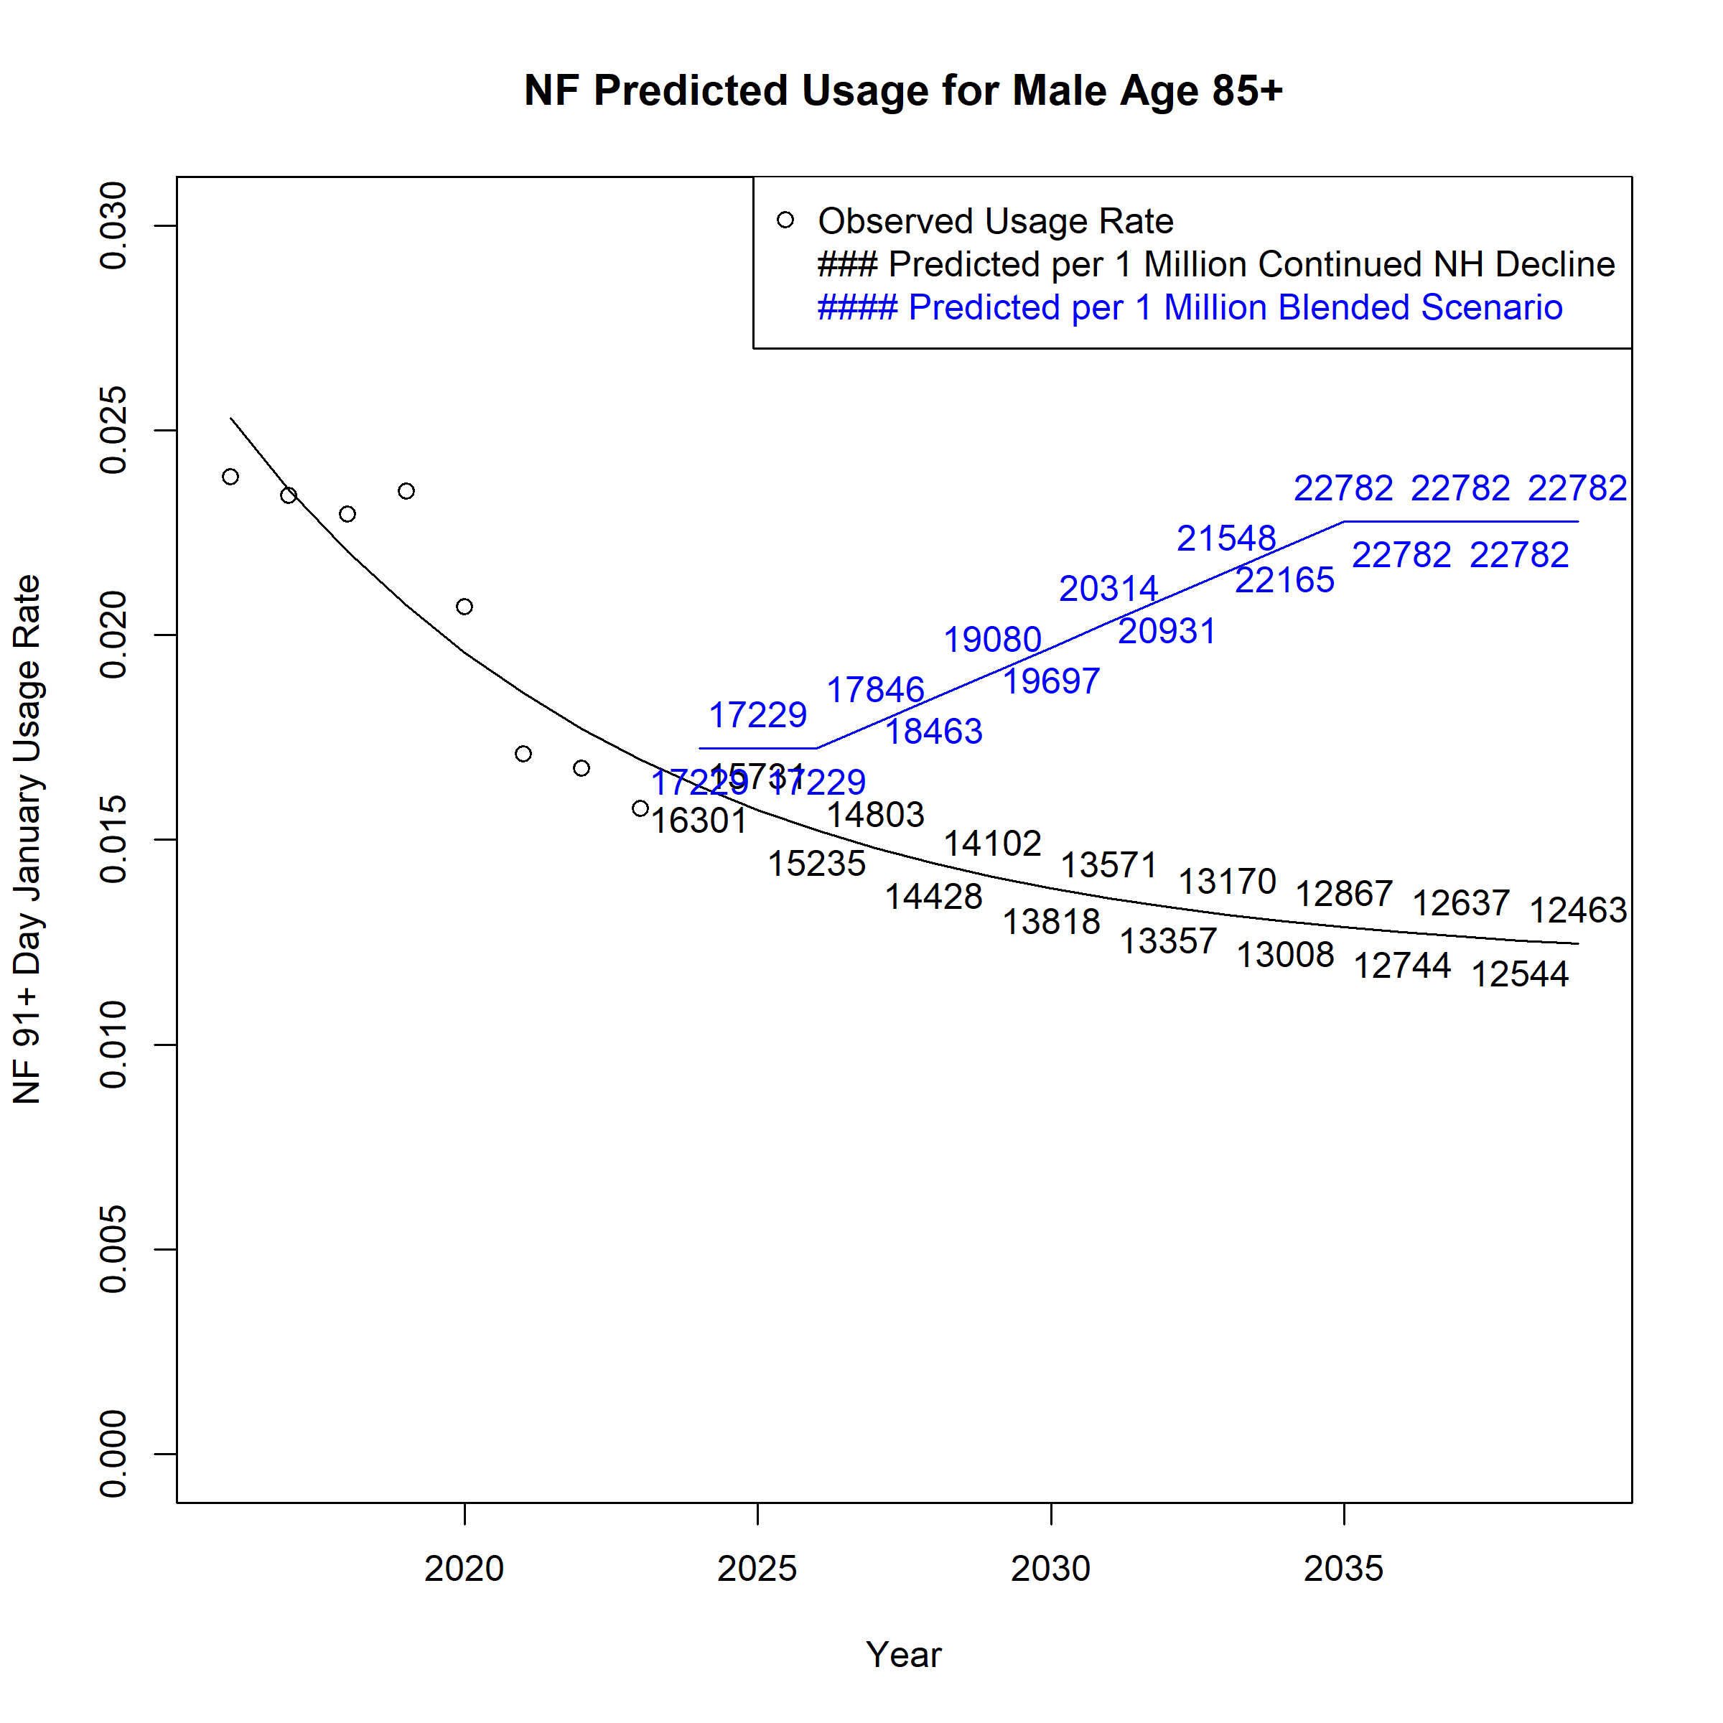

Figure A 56. Projected Monthly User Count by Scenario (Usage Rate*Population): Elderly Waiver Community
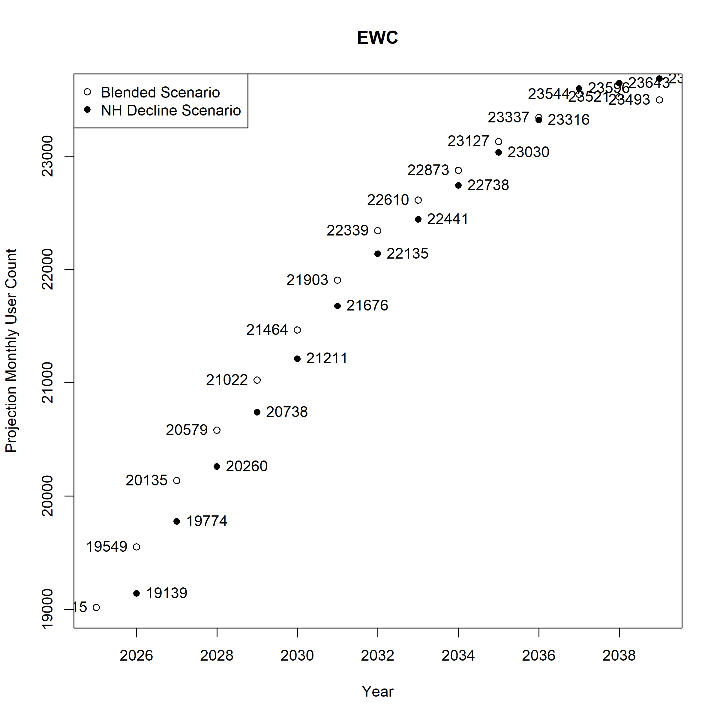
Figure A 57. Projected Monthly User Count by Scenario (Usage Rate*Population): Elderly Waiver Residential
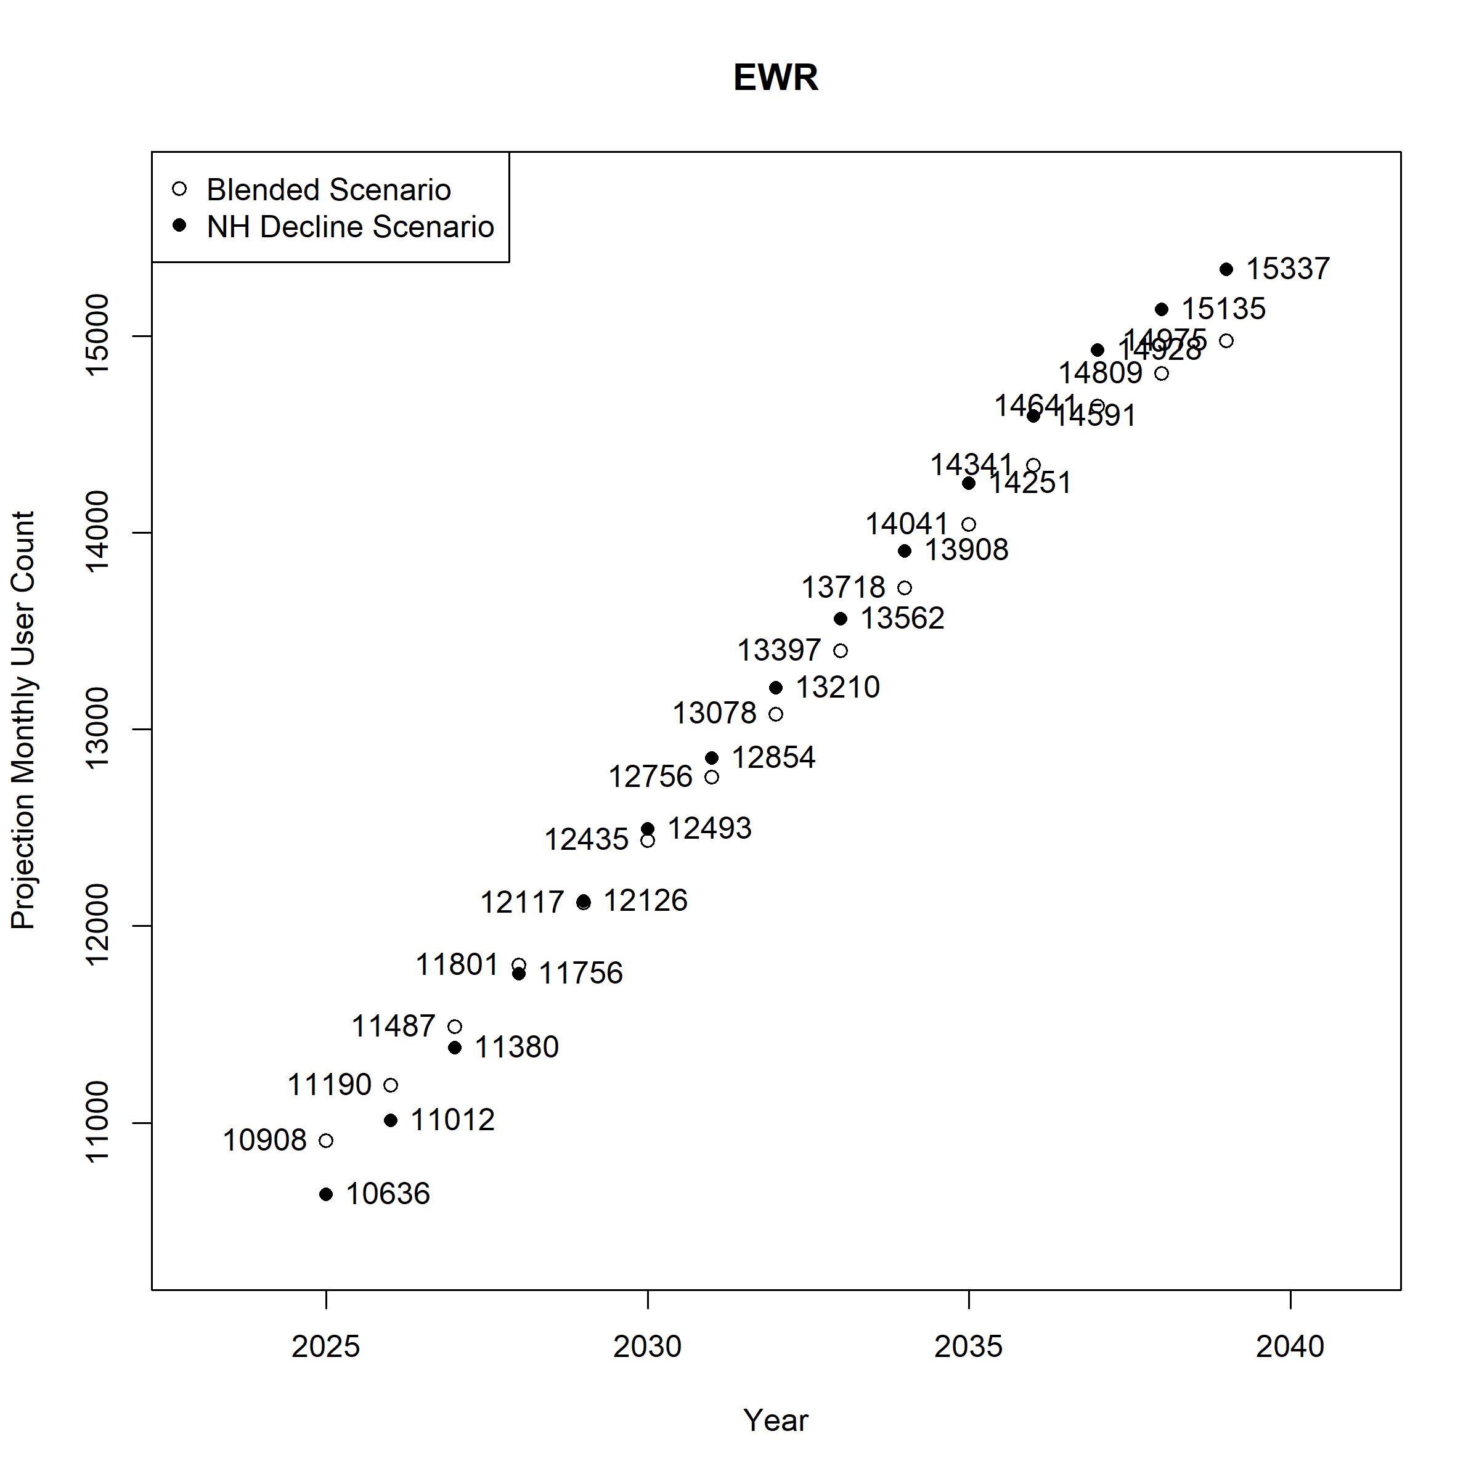
Figure A 58. Projected Monthly User Count by Scenario (Usage Rate*Population): Medicaid Nursing Facility 0-29 Day Stay
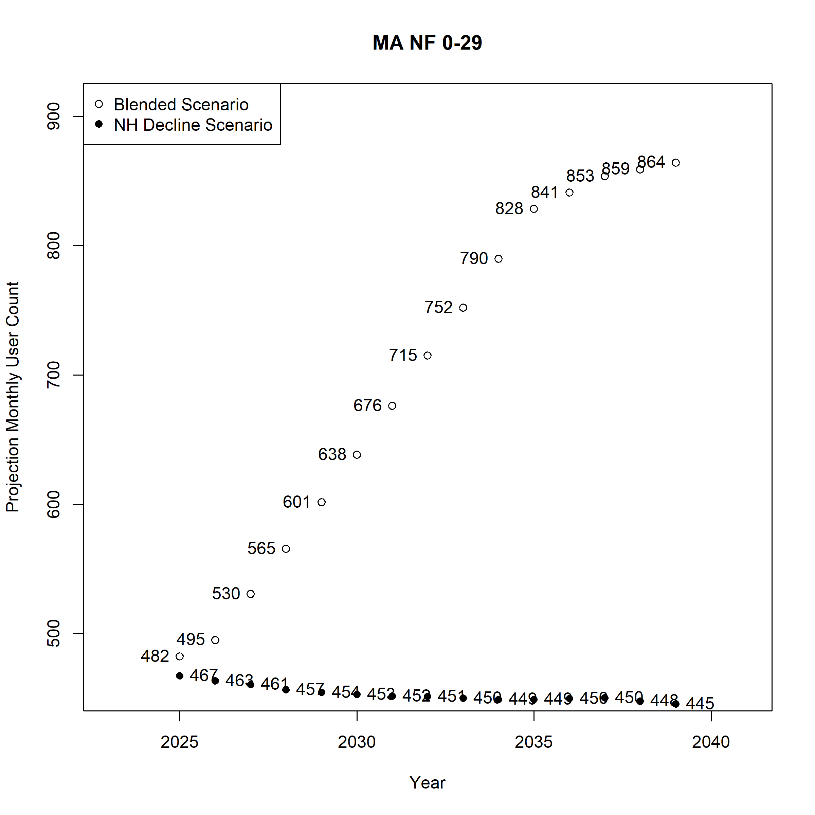
Figure A 59. Projected Monthly User Count by Scenario (Usage Rate*Population):Medicaid Nursing Facility 30-90 Day Stay

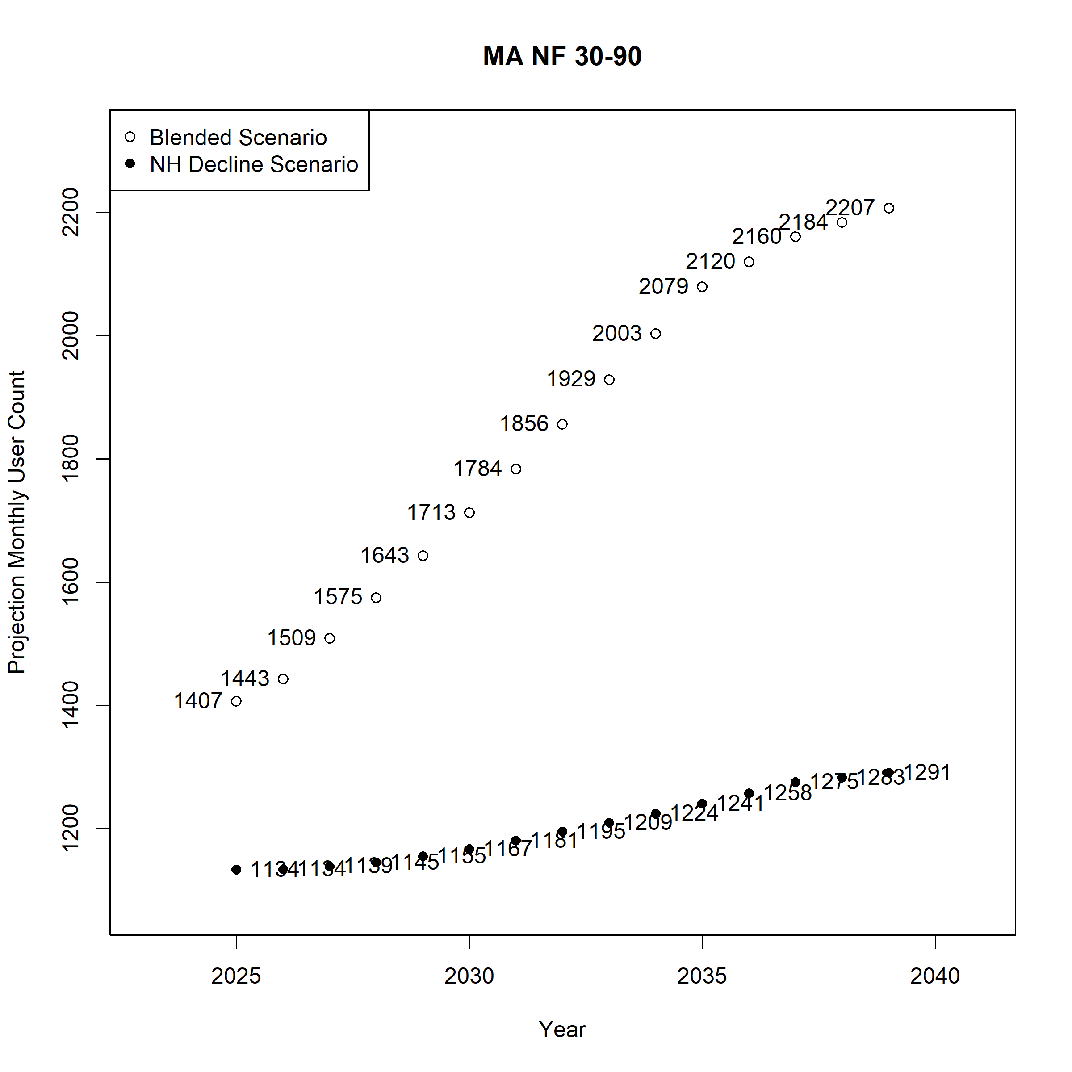
Figure A 60. Projected Monthly User Count by Scenario (Usage Rate*Population): Medicaid Nursing Facility Stay of 91 or more days
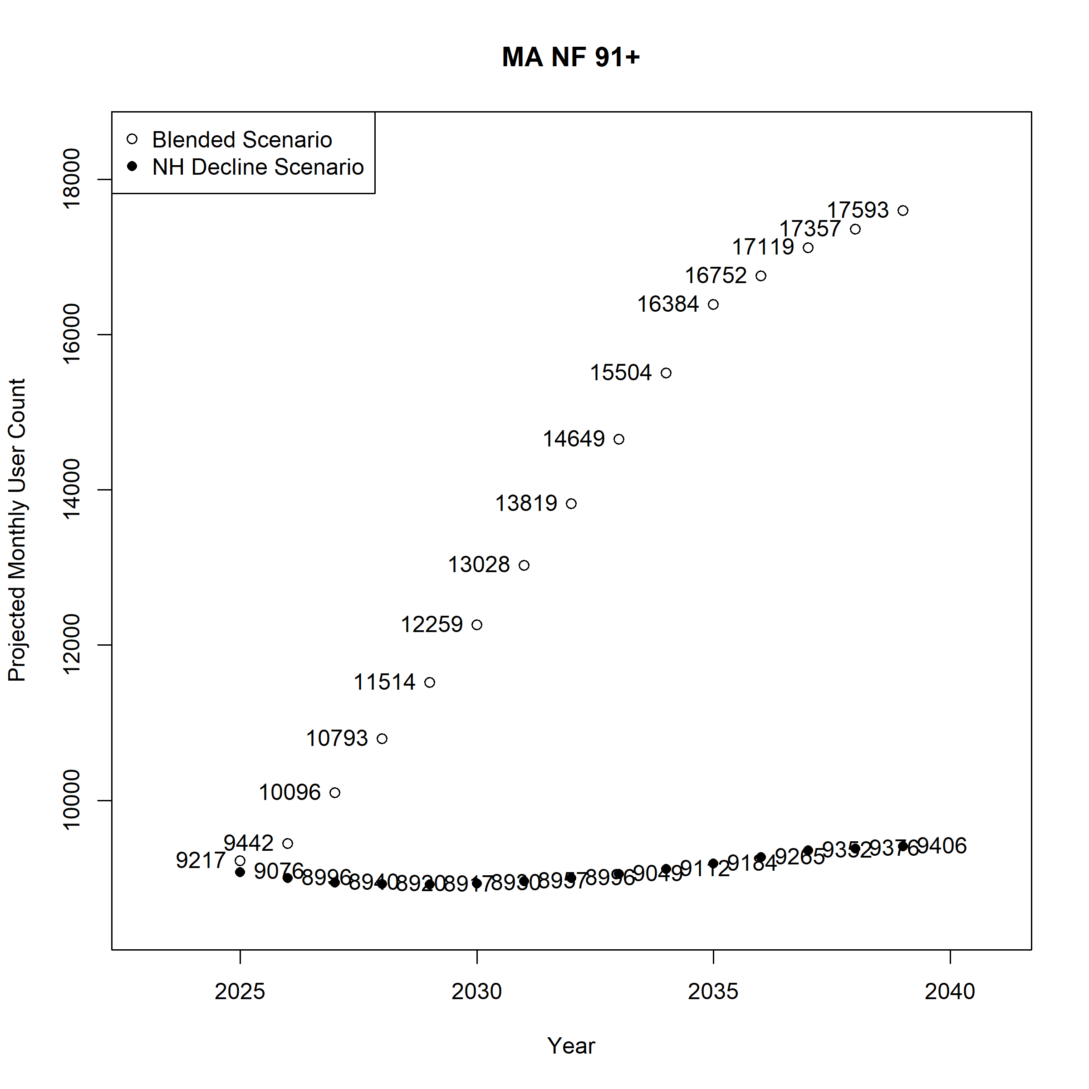
Figure A 61. Projected Monthly User Count by Scenario (Usage Rate*Population): Personal Care Assistant without Waiver
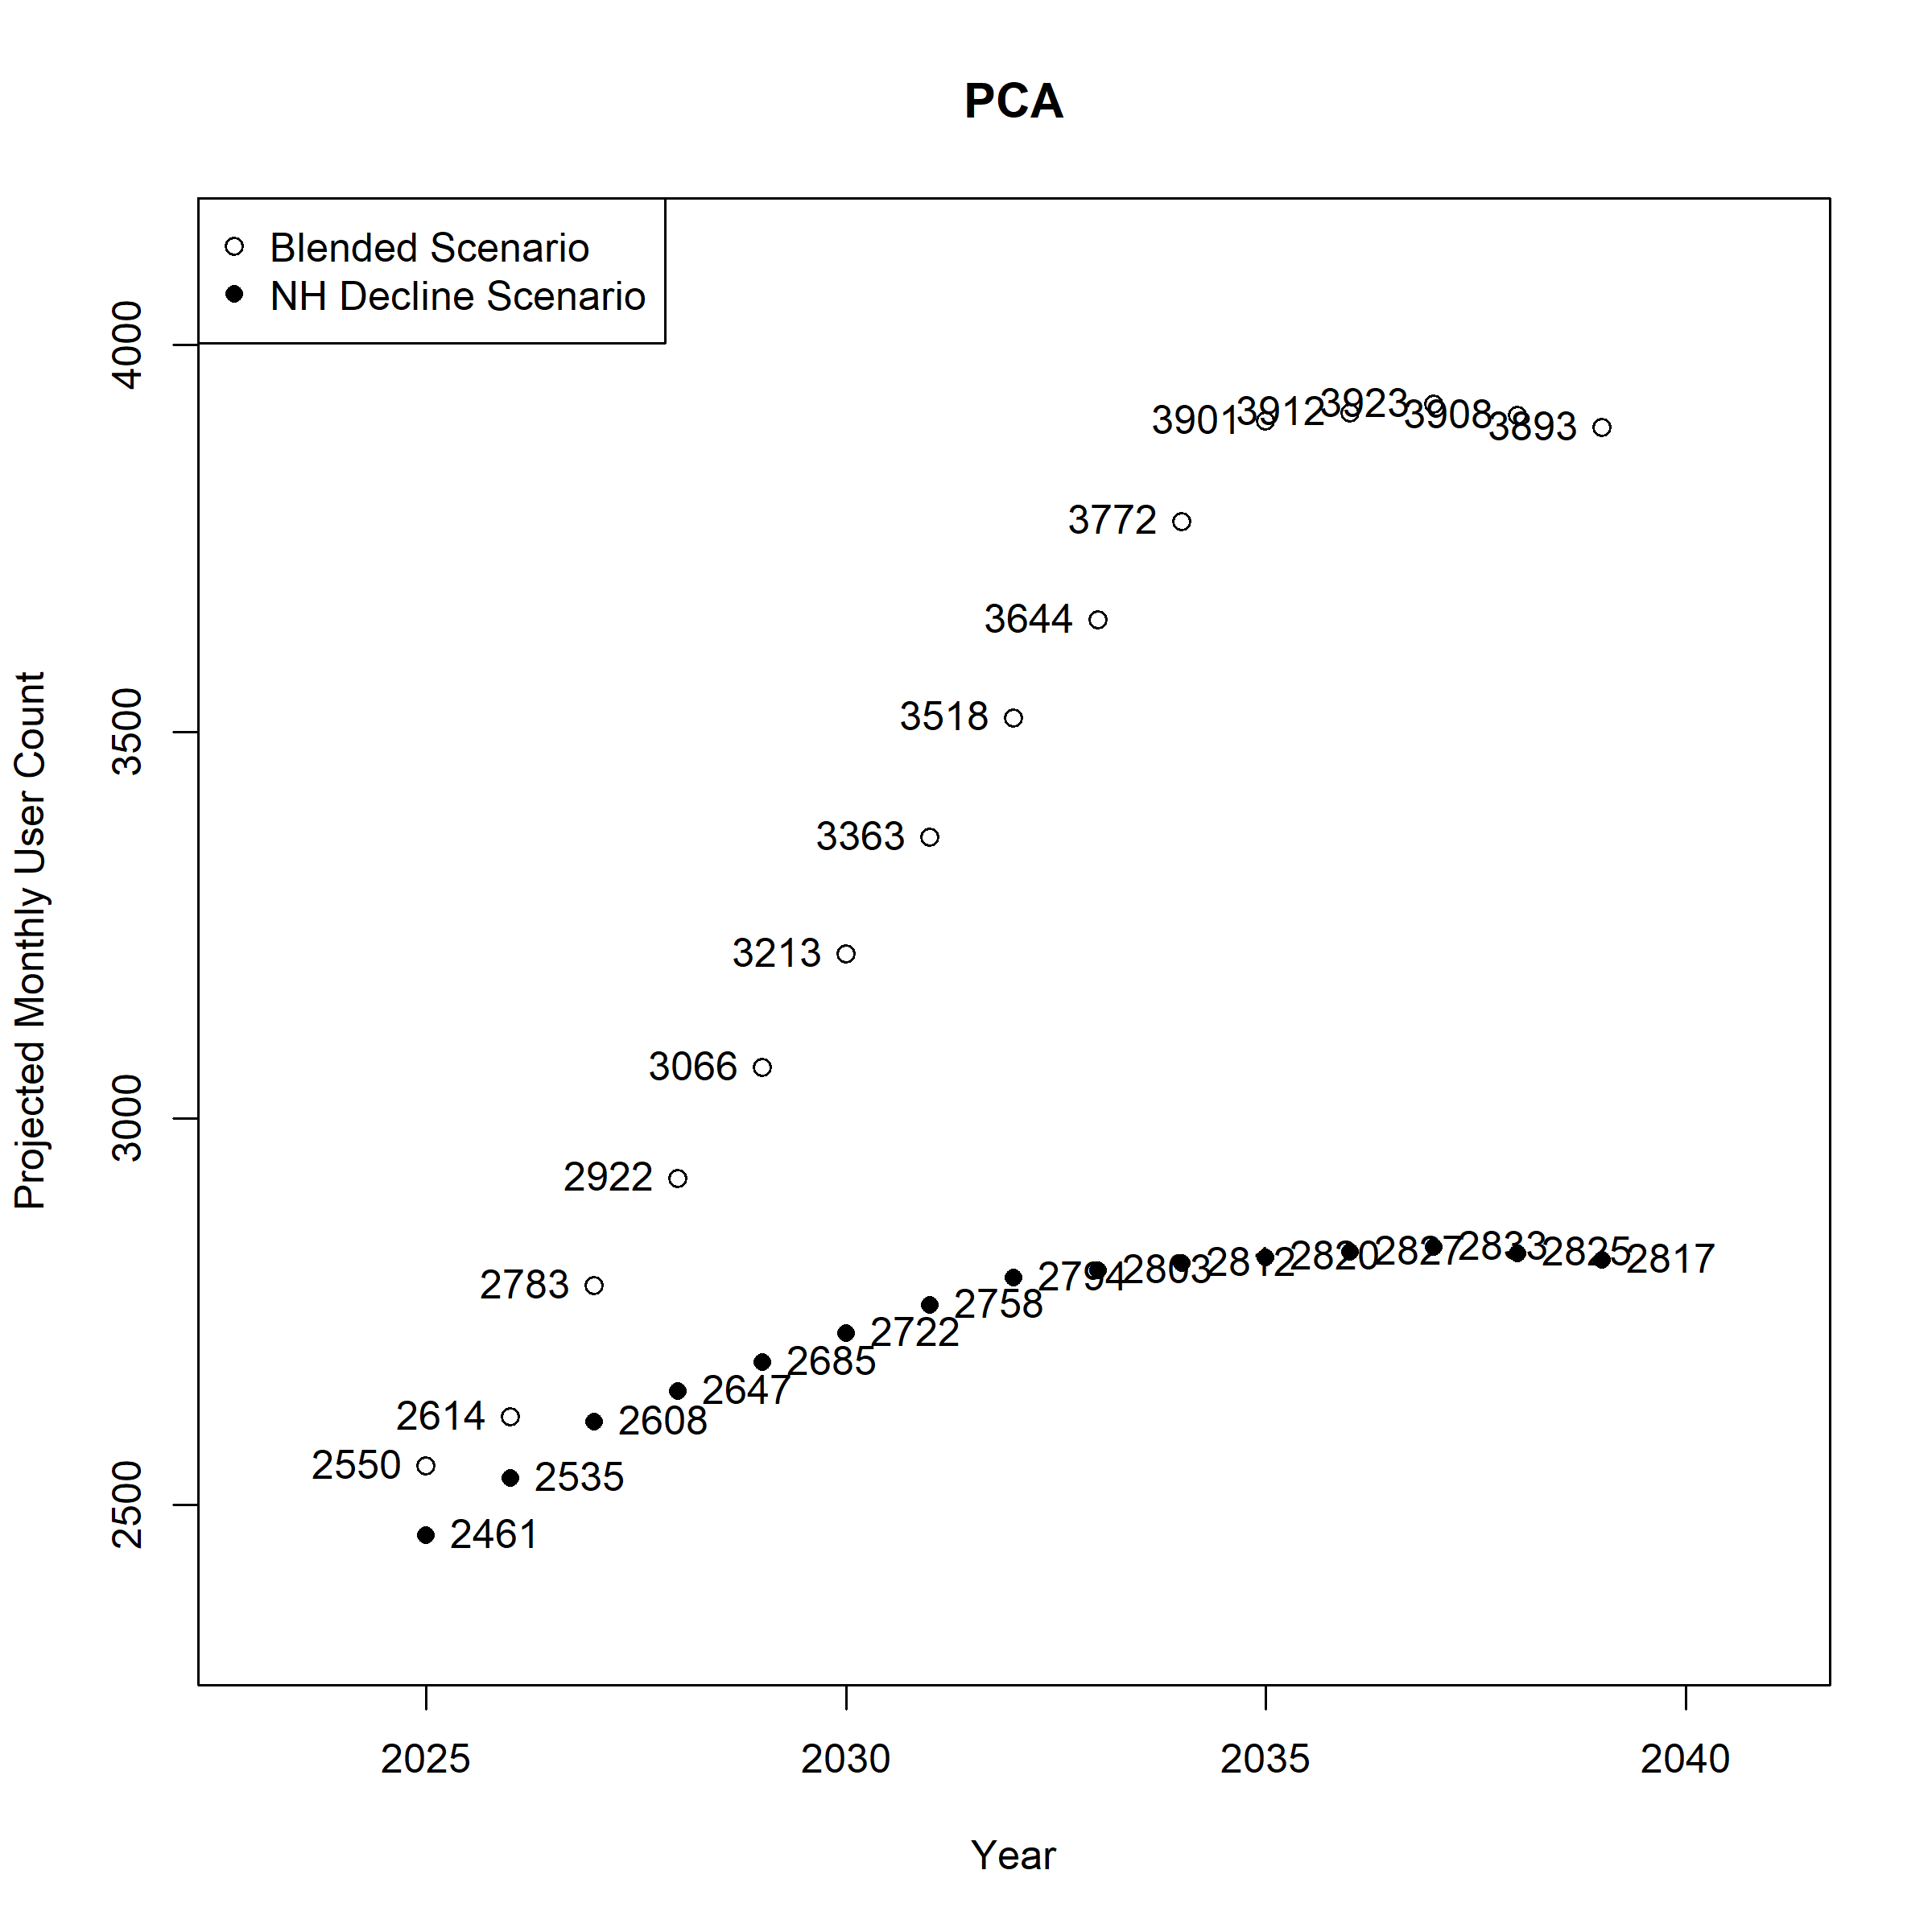
Figure A 62. Projected Monthly User Count by Scenario (Usage Rate*Population): Alternative Care
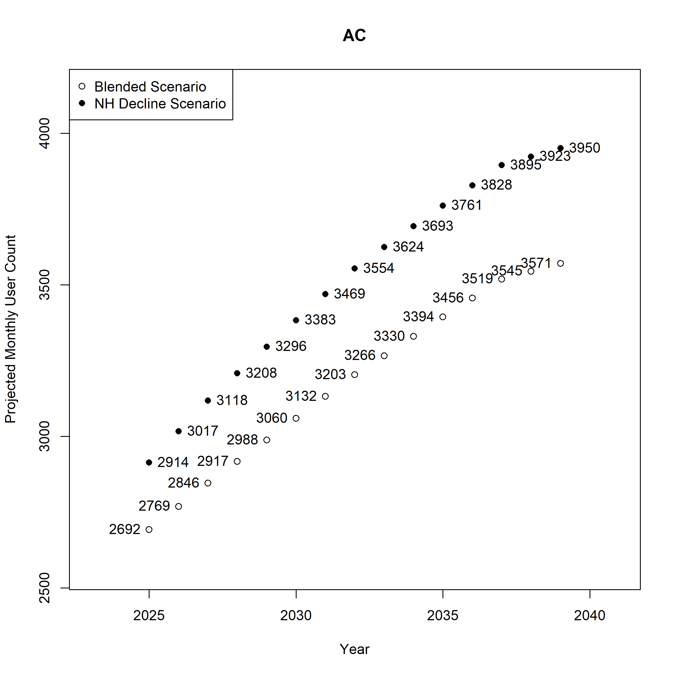
Figure A 63. Projected Monthly User Count by Scenario (Usage Rate*Population): Nursing Facility Stay of 0-29 Days
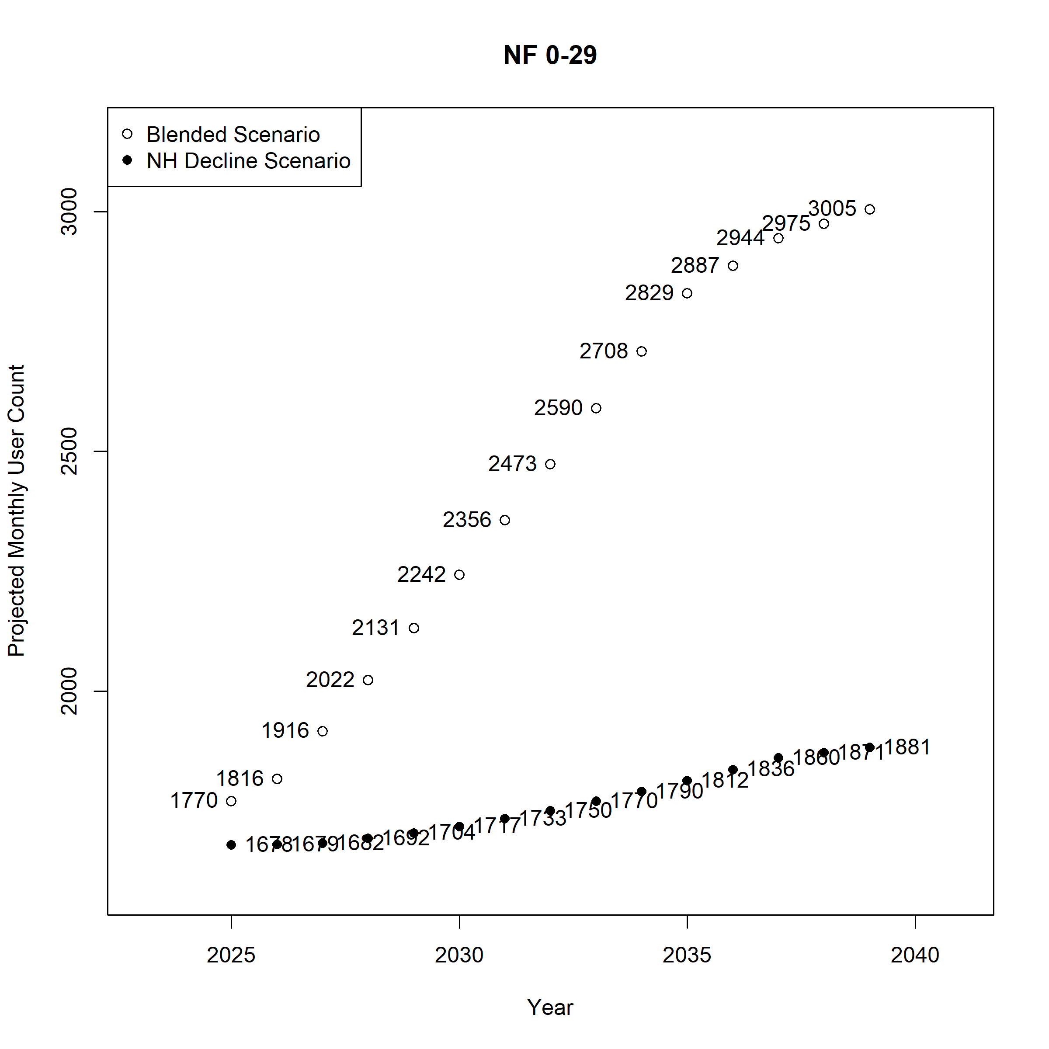

Figure A 64. Projected Monthly User Count by Scenario (Usage Rate*Population): Nursing Facility Stay of 30-90 Days
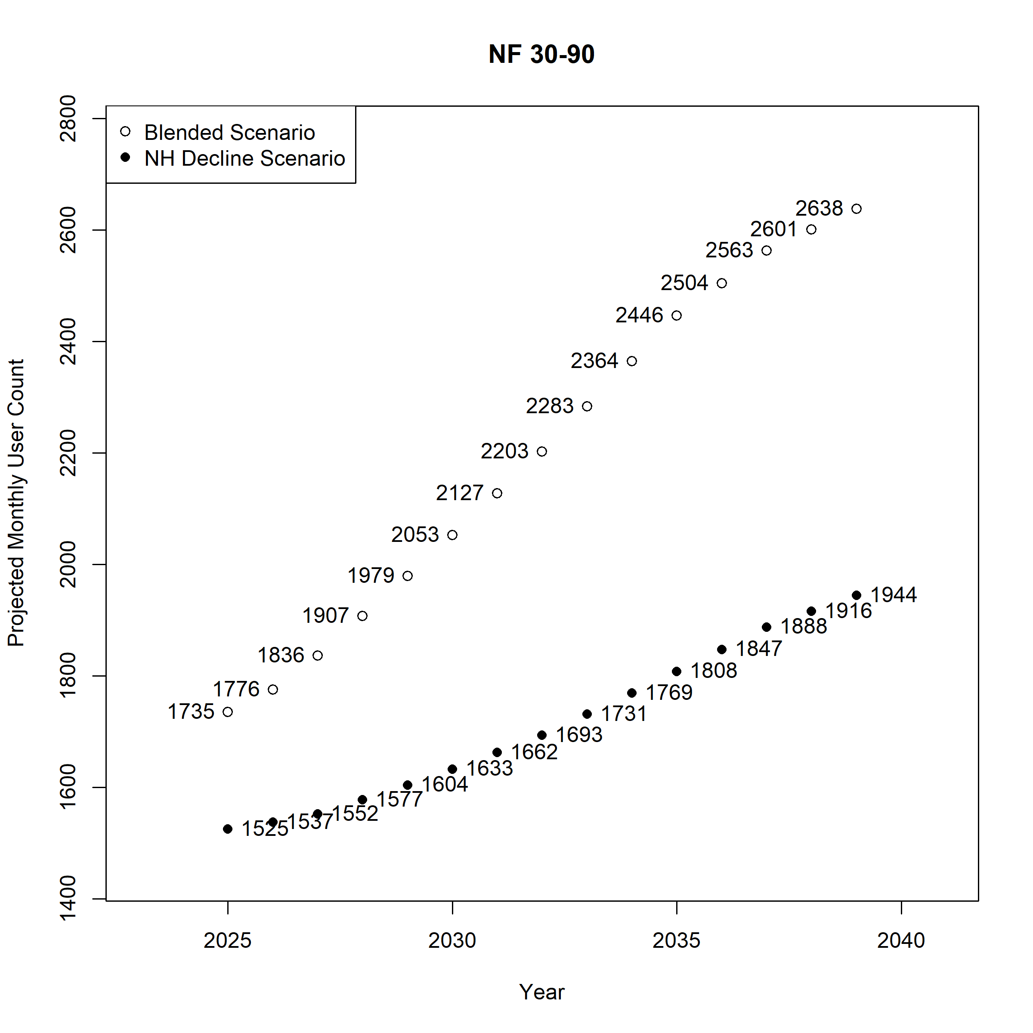
Figure A 65. Projected Monthly User Count by Scenario (Usage Rate*Population): Nursing Facility Stay of 91 or more Days

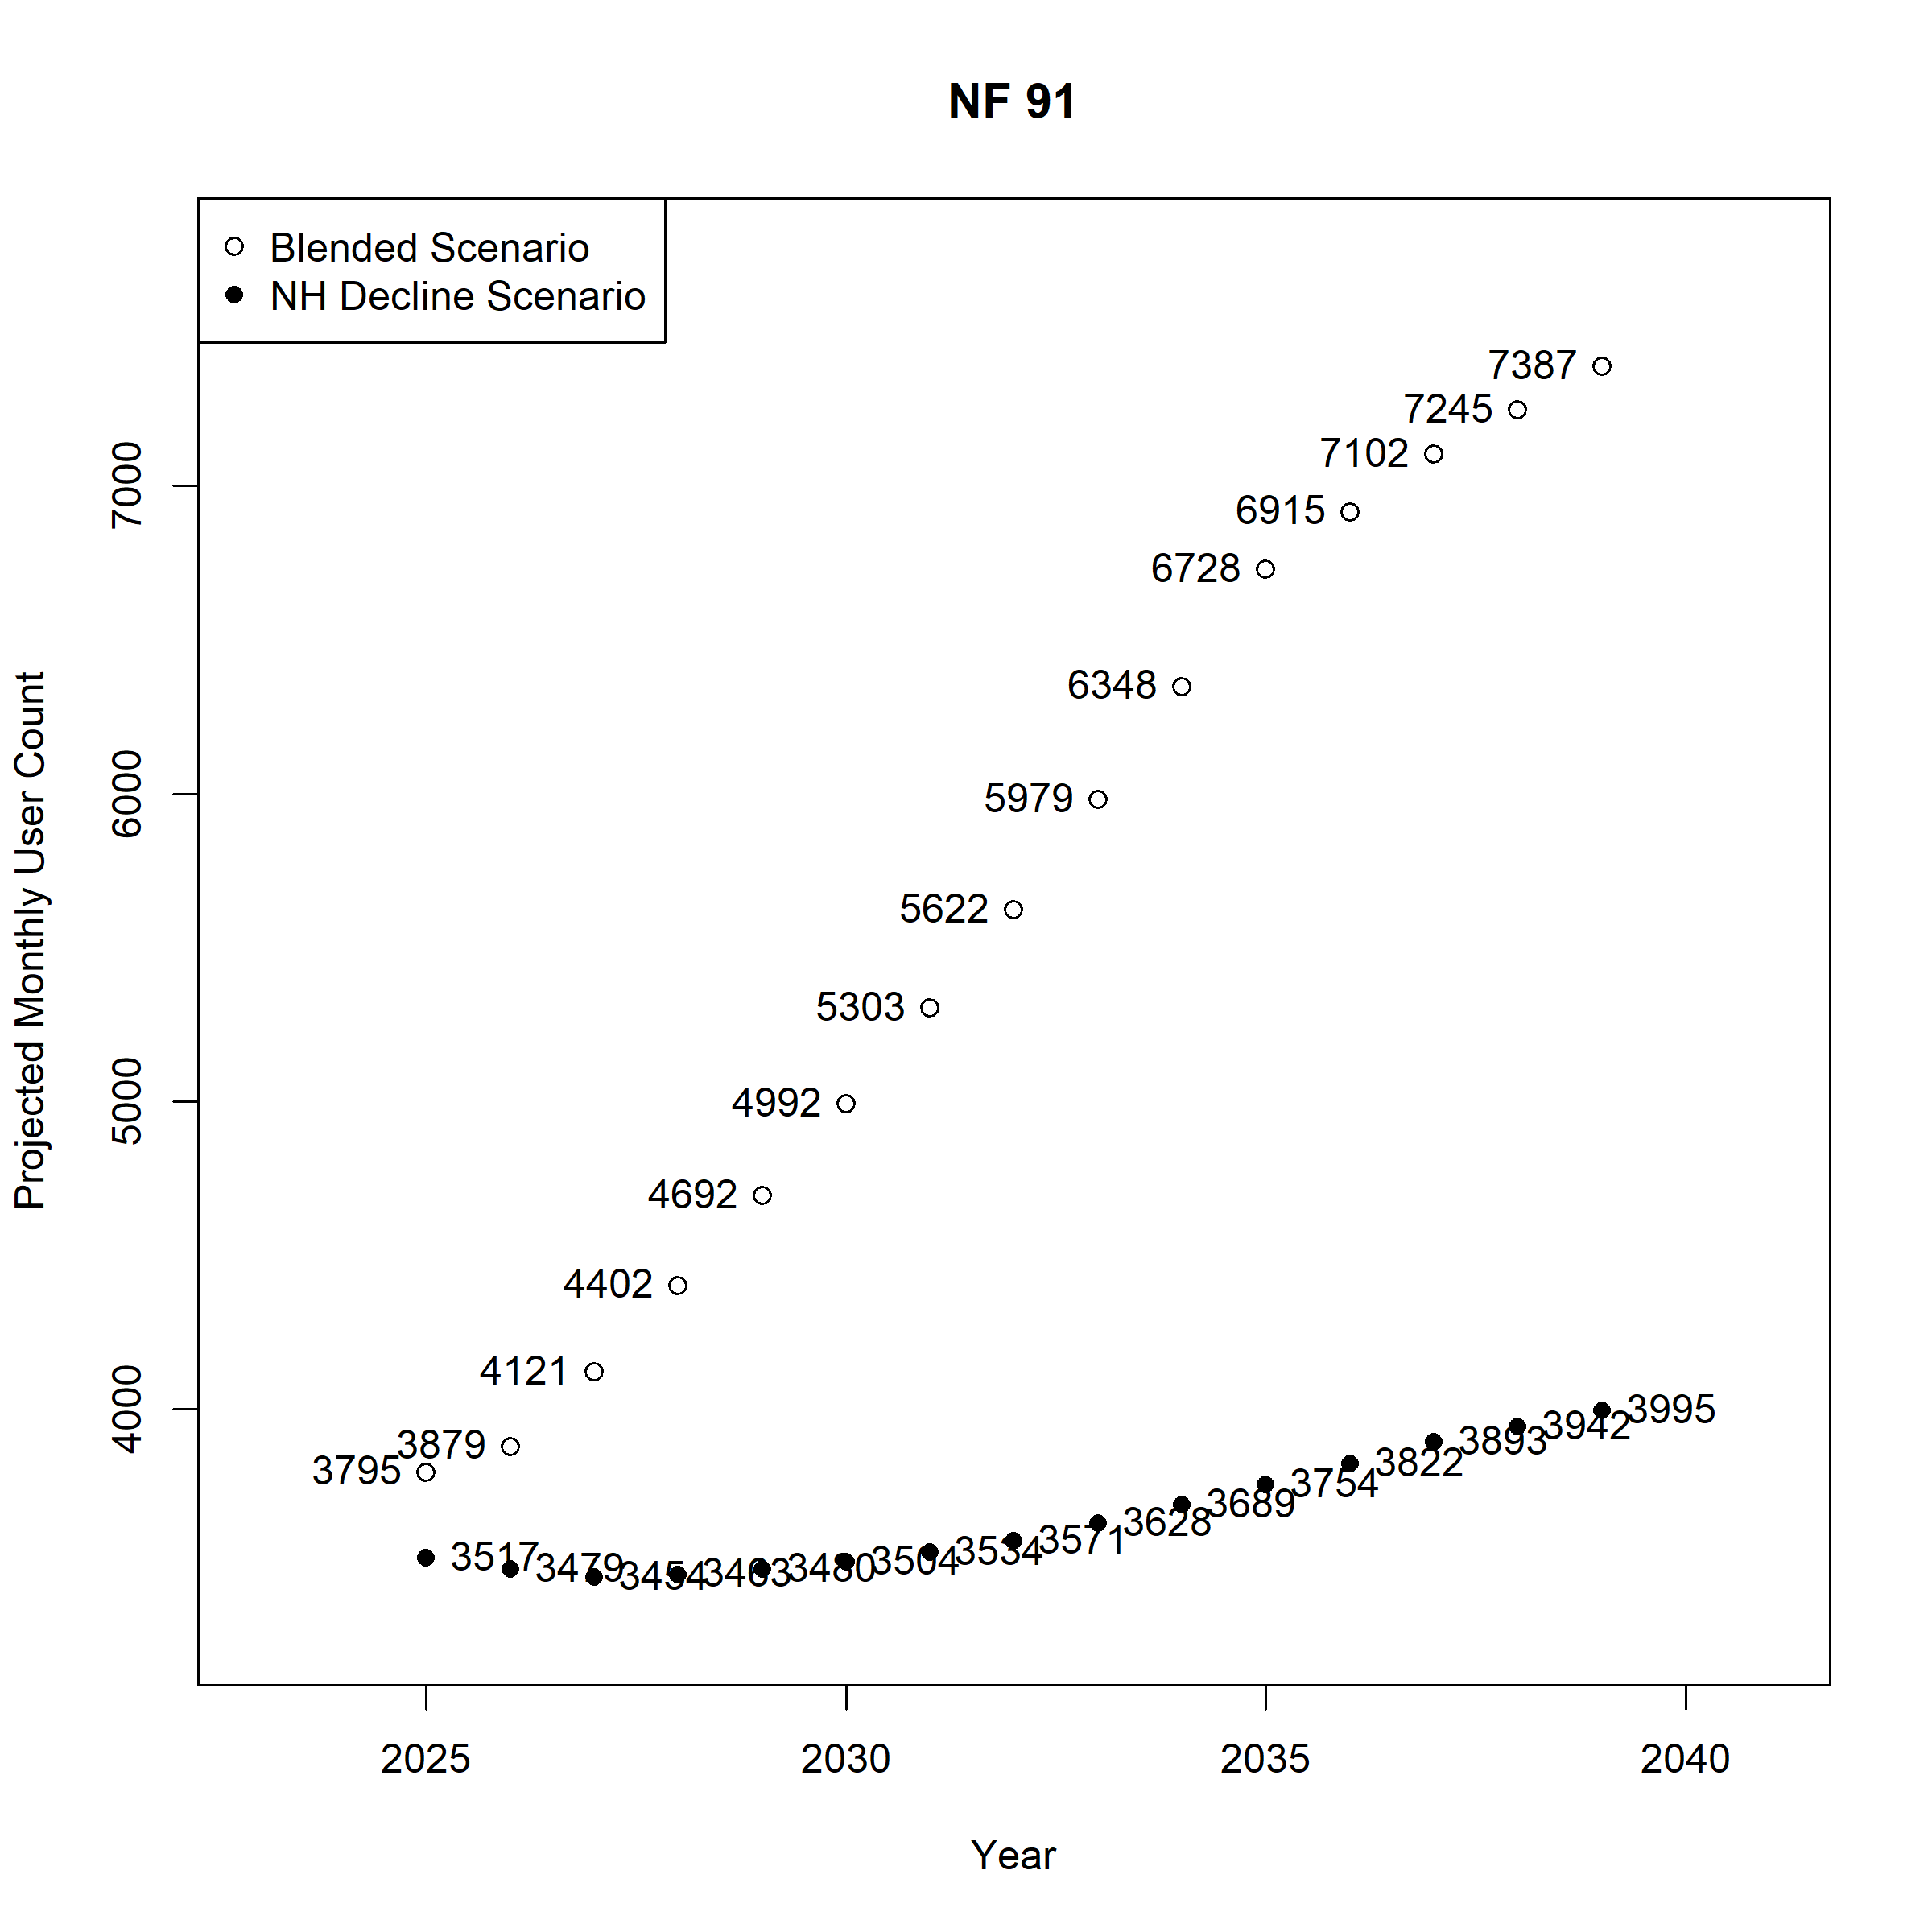

MNChoices Long-Term Care Screening Documents
Nursing Home Minimum Data Set (MDS) Assessment Instrument
Minnesota DHS Provider Manual
Minnesota State Demographic Center Population Projections

